Lab #4: Cell Phone Tower Placement

Hayden Atchley

23 September 2022

CE 414

The aim of this lab is to identify locations that would be suitable for a new cell tower in or near Utah County. Several requirements were stated:

* The new tower must be in an area of less than 20 towers per 10,000 km²
* The new tower must be within 1 km of a major road
* The new tower must be on terrain with less than a 5° slope

I used several datasets from <https://gis.utah.gov>, including a polygon shapefile of county boundaries, a polyline shapefile of roadways, and elevation rasters provided by the NED. I also used a point shapefile of cell towers from <http://www.mapcruzin.com/free-wireless-gis-maps/cellular-shapefile.htm>.

# The Model

I first combined all the raster datasets into a single raster. I then calculated the slope and calculated a new value of 1 for slopes less than 5 degrees, and 0 for all other values. I also calculated the kernel density for the cell towers, and identified areas of less than the required density. I combined these two rasters, resulting in a value of 1 for all areas with both suitable slope and tower density, and 0 for all others.

I selected major roads from the roadways shapefile and created a 1km buffer around them. I also selected Utah County from the counties dataset and set a 50 mile buffer around it. I used this Utah County buffer to clip the roadways buffer, and then ran “Extract by Mask” to extract the combined raster data that fell within this clipped roadways file. This resulted in a raster near major roads in Utah County designating suitable areas for a new tower. I then extracted the suitable locations into a separate raster dataset.

The final output datasets were a point shapefile of cell tower locations, a polyline shapefile of major roadways, and a raster of suitable tower locations, all clipped to the 50-mile buffer around Utah County. A screenshot of the model in the toolbox can be seen in Figure 1, and a diagram of the model is given in Figure 2.

# Results

Two prominent locations that I found to be suitable were near Vernon and near Fairview. Both of these locations are relatively low-density areas, so it makes sense that there currently aren’t many cell towers in these places. Though cell service may or may not be bad in these areas currently, and hence building a tower not immediately necessary, most areas are tending toward densification, and I’m not sure of any reason that these locations would be different. As such, it is important to anticipate demand in these areas, and so a cell tower will likely be necessary in the future.

A map showing these findings is given in Figure 3.

Figure : The model in the toolbox.

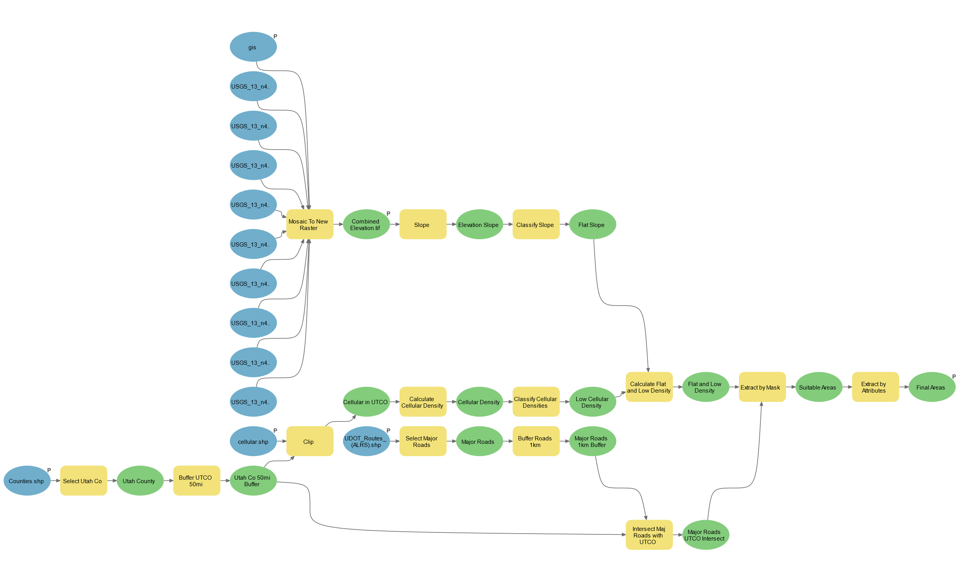

Figure 2: Diagram of model used in this lab



Figure 3: Map of results.

|  |  |
| --- | --- |
| **Item** | **Points** |
| Assignment Title, Name, Date, Course | 1/1 |
| Brief report of the requirements of the project and why the project is useful | 5/5 |
| Describe your model  List each of the tools used: (1 pt.)  List tool settings applied for the analysis (could someone repeat the assignment using your lab report?): (1 pt.)  List all input, intermediate, and output datasets: (1 pt.)  Describe each input dataset including type (point, line, polygon, raster) and the source of the data: (1 pt.)  Describe each output dataset (point, line, polygon, raster): (1 pt.) | 5/5 |
| One or more full pages (8.5 x 11) showing your model (5 pts.)  All text in the graphics is readable (10pt. font minimum) (2 pts.)  All tools and datasets are shown (2 pts.) | 9/9 |
| Describe the specific areas recommended for new towers. (3 pts.)  Do you agree with the results of the model or did you find anything different than expected? (2 pts.) | 5/5 |
| Make a full page (8.5 x 11) map showing the results of your cell tower analysis.  Map Title: (1 pt.)  Neat Line: (1 pt.)  North Arrow: (1 pt.)  Scale Bar: (1 pt.)  Text box with author name, date, map projection: (1 pt.)  Suitable locations for new cell phone towers clearly shown: (5 pts.)  All datasets clearly symbolized: (1 pt.)  Visible base map showing road data: (1 pt.)  Data points showing existing cell phone towers: (1 pt.)  Zoomed to an appropriate scale for viewing analysis results: (1 pt.)  All text is legible on printed map: (1 pt.) | 15/15 |
| Create a Toolbox Interface for your model and include a screen capture of it including input and output data parameters. | 10/10 |
| **Bonus Task:** Repeat the lab exercise with a different dataset. Include in your report what data you used, how you acquired it, and what you may have changed to complete the exercise. Include an additional full-page map showing your results. | Instructor’s  Discretion |