Lab #5: Mapping Avalanche Risk

Hayden Atchley

30 September 2022

CE 414

The aim of this lab is to assess the avalanche risk near Snowbird Ski Resort in Utah.

A polygon shapefile of the ski resorts in Utah was obtained from <https://gis.utah.gov>, as was an elevation data raster (provided by the NED). The avalanche risk was assessed according to the following table:

Table 1: Avalanche Risk Based on Altitude, Slope, and Aspect

|  |  |  |  |
| --- | --- | --- | --- |
|  | **Altitude (meters)** | **Slope (degrees)** | **Aspect (degrees)** |
| **Low (1)** | 0 - 2200 | -1 - 25  60 - 90 | 180 - 225 |
| **Moderate (2)** | 2200 - 2400 | 25 - 30  55 - 60 | 135 - 180  225 - 270 |
| **Considerable (3)** | 2400 - 2600 | 30 - 32  50 - 55 | 90 - 135  270 - 315 |
| **High (4)** | 2600 - 2800 | 32 - 35  45 - 50 | 315 - 360  45 - 90 |
| **Extreme (5)** | 2800 - 10000 | 35 - 45 | -1 - 45 |

# The Model

I first selected Snowbird from the shapefile of resorts, then extracted the elevation raster with Snowbird as a mask. This gave me an “extracted elevation” raster that I further used. I started by assessing each of these risk factors independently: I calculated the slope and aspect resulting in respective rasters, and then reclassified these and the elevation rasters according to their risk category (1­–5). These resulted in classed rasters for elevation, slope, and aspect. This process is shown in the model in Figure 1.

From there I used three methods to combine these classifications into an overall risk level. The first was based on a series of conditionals; this was the method given in the lab instructions. I also separately used an additive and multiplicative average (arithmetic and geometric means) to create different possible classification maps.

# Results

The original results (based on the series of conditionals) resulted in a rather sparse classification map (Figure 2). There are a few areas of high and extreme risk, but hardly any areas in other categories (the “Low” risk category doesn’t appear at all). The areas that *are* represented do seem to make sense: the highest risks are near the tops of ridges on the northern side, where elevation and slope are quite high and the ground is more shaded. However, it seems odd to me that no low-risk areas are represented. My suspicion is that due to the nature of the conditional statement used to combine the data, only areas in which all three aspects had the same classification are shown, with all other areas showing as “No Risk”. This is clearly a non-optimal way to run this assessment.

In addition to this, I also averaged the risk levels from each aspect, using both an additive (algebraic) mean and a multiplicative (geometric) mean. These results are shown in Figure 3. These maps make much more intuitive sense to me, as all areas are represented (including low-risk areas). The additive approach leans toward higher risk classifications than the multiplicative approach, but this makes sense as mathematically the geometric mean is smaller than the arithmetic mean.

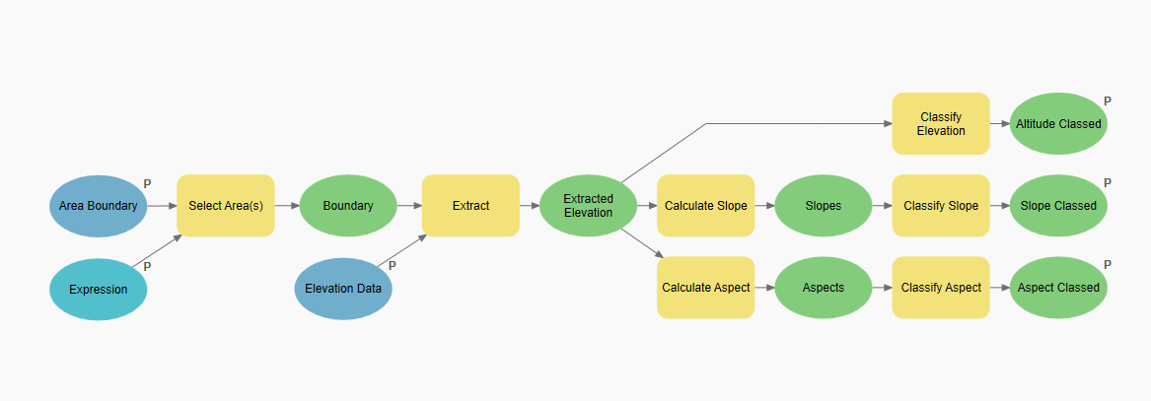

Figure 1: Diagram of model used in this lab.

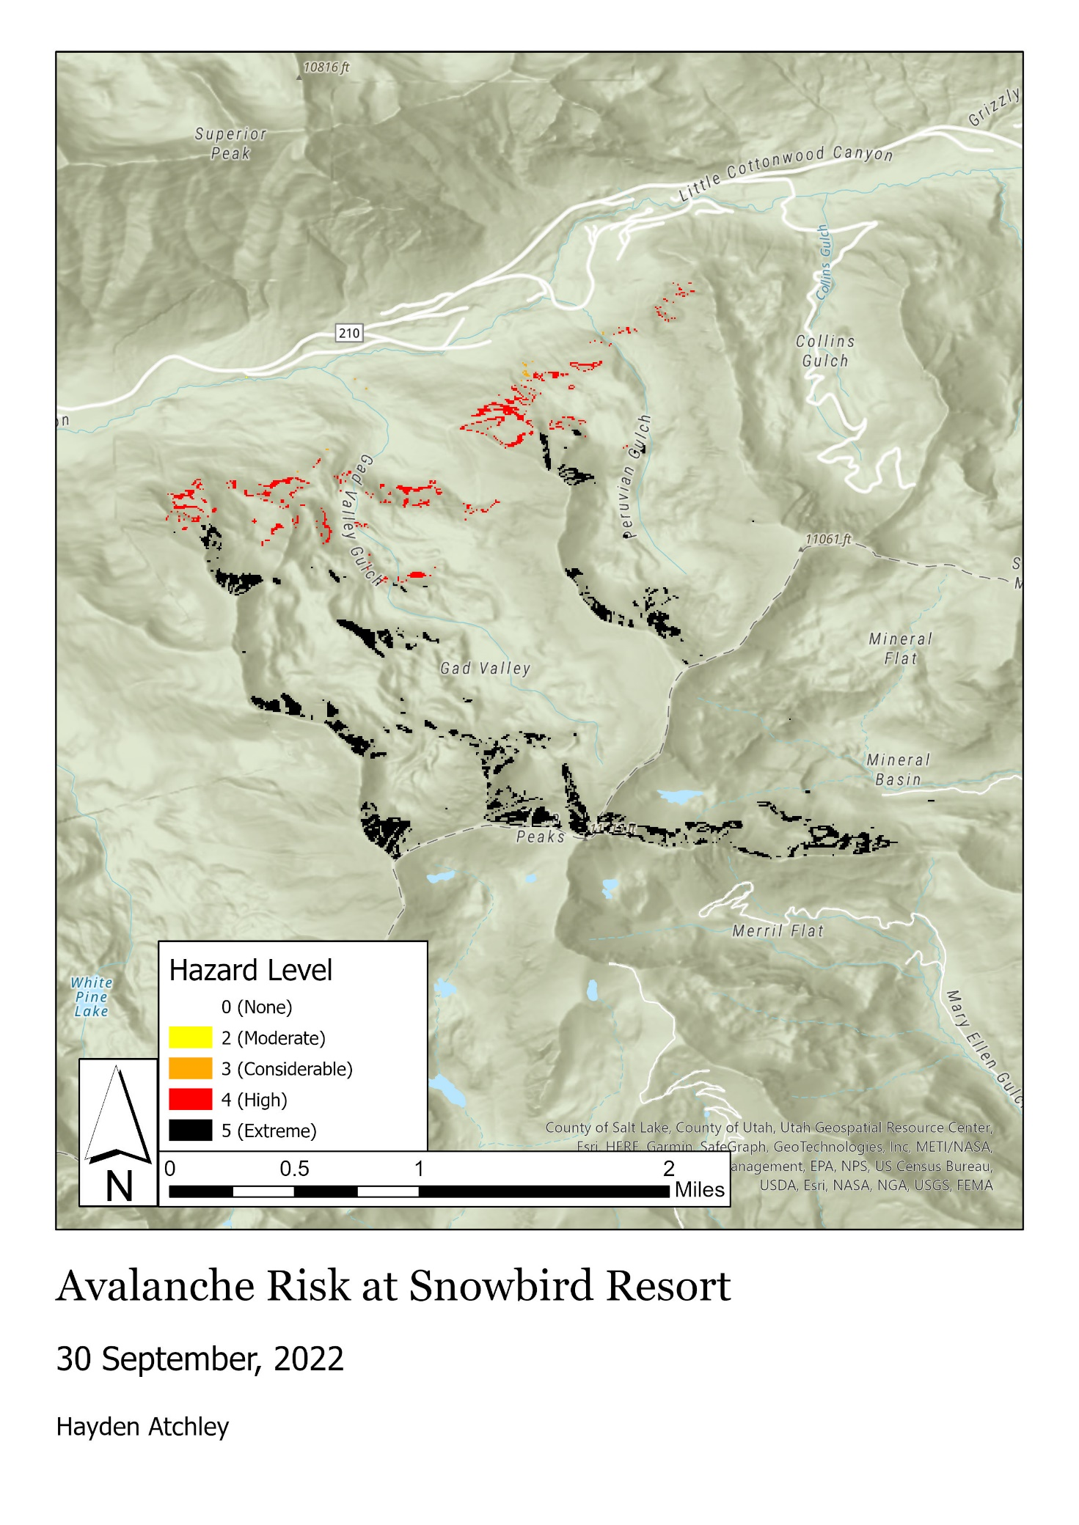

Figure 2: Map of original results.

Figure 3: Comparison of additive and multiplicative classification methods.

|  |  |
| --- | --- |
| **Item** | **Points** |
| Assignment Title, Name, Date, Course | 5/5 |
| Summary of the requirements of the project | 5/5 |
| Describe your model   * List each of the tools used: (2 pts.) * List tool settings applied for the analysis (could someone repeat the assignment using your lab report?): (2 pts.) * List all input, intermediate, and output datasets: (2 pts.) * Describe each input dataset including type (point, line, polygon, raster) and the source of the data: (2 pts.) * Describe each output dataset (point, line, polygon, raster): (2 pts.) | 8/10 |
| * One full page (8.5 x 11) showing your model (5 pts.) * All text is readable (10pt. font minimum) (3 pts.) * All tools and data sets are shown (2 pts.) | 10/10 |
| * What areas of your study area have the greatest risk of avalanche? (2 pts.) * Would you change the reclassifications and how? (2 pts.) * Are your results as expected or did you find anything interesting or different than expected? (1 pt.) | 5/5 |
| Make a full page (8.5 x 11) map showing the results of your avalanche hazard study of the Snowbird Ski Resort area.   * Map Title: (1 pt.) * Neat Line: (1 pt.) * North Arrow: (1 pt.) * Scale Bar: (1 pt.) * Text box with author name, date, map projection: (1 pt.) * Avalanche risk map image: (5 pts.) * Each risk category clearly symbolized: (1 pt.) * Labeled roads or other reference data: (1 pt.) * Labeled points indicating location of ski resorts in the study area: (1 pt.) * Zoomed to an appropriate scale for viewing analysis results: (1 pt.) * All text is legible on printed map: (1 pt.) | 14/15 |
| **I did the bonus task with two additional methods of combining the classifications** |  |