Hayden Atchley

Lab 1 – Walmart Site Selection
CE 414
2 September 2022

Project Requirements
The project was to identify potential locations for a new Walmart store. Several requirements were given for these locations, and were as follows:
- Proximity to other locations: Find locations at least 2 miles away from any existing Walmart.
- Proximity to major roads: Find locations that are within 2 miles of the I-15 freeway or a highway.
- Population Density: Located in a high-density population area with over 5000 people per square mile (Use 2010 Census data).
- Adequate Space: Walmart stores range from 51,000 ft² to 224,000 ft² with an average of 102,000 ft². Find locations where the average Walmart store size would fit without needing to demolish existing buildings.

Data Sources
Most of the data used was obtained from gis.utah.gov, including the data related to roadways, county boundaries, and census block populations. These data sources were all polygon shapefiles. I created an additional data set with existing Walmart locations, aided by Google Maps, which was a point shapefile.

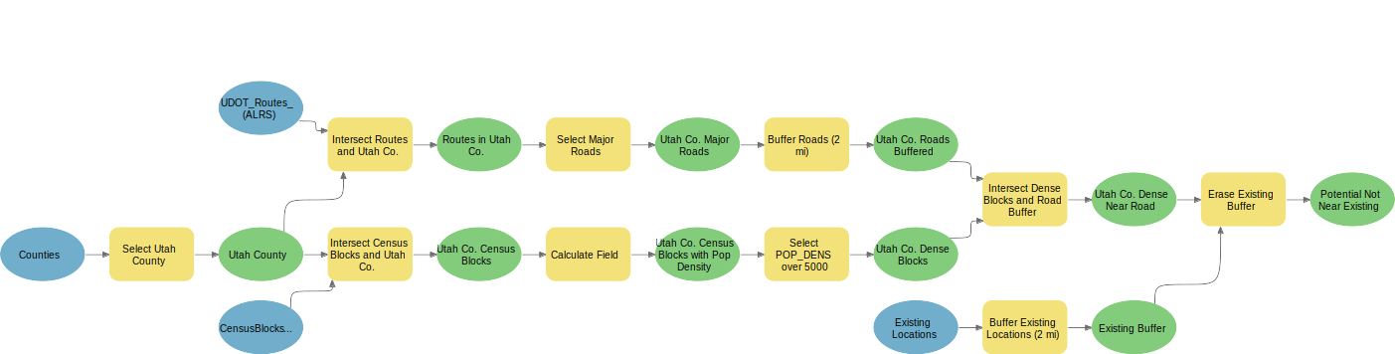
Figure 1: Model visualization.
The Model
Figure 1 is a visualization of the model I used. I selected Utah County from the set of county bondaries, and intersected that with both the Roads dataset and the Census Blocks dataset to obtain versions trimmed to Utah County.
From the trimmed Roads dataset I selected the major routes (I-15 and highways), which had CARTO values of 1, 2, 3, or 6. This created a polyline dataset of the major routes in Utah county. I then created a 2-mile buffer around these routes as per the requirements. I added a population density field to the trimmed Census Block dataset, calculating the population per square mile. I then selected counties with a population density of greater than 5000 people per square mile, and intersected this “Utah Co. Dense Blocks” dataset with the buffered Major Roads dataset. This created a polygon dataset of dense counties near a major road in Utah County.
I also added a 2-mile buffer to the “Existing Locations” point dataset I created. I then erased this dataset from the just-created “Utah Co. Dense Near Road” dataset. This resulted in a polygon dataset containing all the potential locations a new Walmart location could go given the project requirements.

Site Selection
I selected two specific locations from the dataset of potential locations, one in Saratoga Springs and one in Payson. I chose these locations due to how close they were to several “unserviced” high-density counties, as well as the availability of space in which to build (Figure 2). Of these two, I would recommend the location in Saratoga Springs, as this area is likely to grow significantly over the coming years, and there would be many new potential customers.
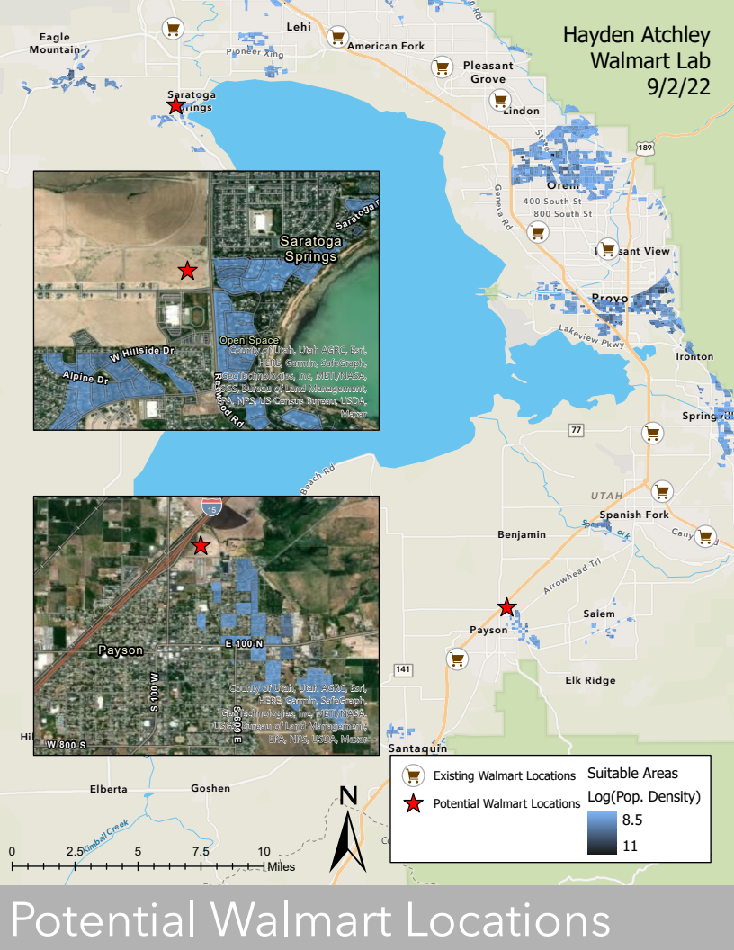
Figure 2: Map of potential Walmart site locations.

Rubric for Walmart Site Selection Project Report
Item | Points
Assignment Title, Name, Date, Course | 5/5
Summary of the requirements of the project | 5/5
Describe your model  - List each of the tools used: (2 pts.)  - List tool settings applied for the analysis: (2 pts.)  - List all input, intermediate, and output datasets: (2 pts.)  - Describe each input dataset including type (point, line, polygon, raster) and the source of the data: (2 pts.)  - Describe each output dataset (point, line, polygon, raster): (2 pts.) | 10/10
- One or more full pages (8.5 x 11) showing your model (5 pts.)  - All text is readable (10pt. font minimum) (3 pts.)  - All tools and data sets are shown and labels are informative (2 pts.) | 10/10
- Answer the following questions  - Where are the best locations for a new Walmart? (2 pts.)  - Which one site do you recommend and why did you select this location? (3 pts.) | 5/5
Make a full page (8.5 x 11) map showing the identified location(s) for the optimal Walmart site.  - Show current Walmarts and optimal locations for a new one: (5 pts.)  - Map Title: (1 pt.), Neat Line: (1 pt.), North Arrow: (1 pt.)  - Scale Bar: (1 pt.)  - All features (existing & future Walmart locations) are labeled: (1 pt.)  - Text box with author name, date, map projection: (1 pt.)  - Current Walmart locations marked with an appropriate graphical symbol: (1 pt.)  - Base map is visible: (1 pt.)  - Zoomed to an appropriate scale for viewing all features: (1 pt.)  - All text is legible on printed map: (1 pt.) | 12/15
Bonus Task: Repeat the lab exercise with a different store such as Target. Include in your report what data you used, how you acquired it, and what you may have changed to complete the exercise. Include an additional full-page map showing your results. | Instructor’s  Discretion

