BEAM BASED ALIGNMENT

quadcenter finds the center of the QF and QD magnets and records the position of the neighboring BPM.

Procedure:
- Move all insertion devices to their maximum gap position.
- Start Matlab and run aoinit
- Disable all programs that "lock" the corrector magnets or insertion devices.
- The magnet lattice should be setup almost as it is for user operation.
- Cycle of the storage ring magnets.
- RF cavities should be at the proper temperatures.
- Multi-bunch mode
- Fill to 45 mAmps. Reduce the fill rate to .2-.3 mAmps per shot so that the fill pattern is more even.
- Bump and booster to storage ring transport magnets off.
- Go to proper energy and load the proper magnet lattice.
- Turn off all skew quadrupoles.
- Make sure that all corrector magnets and BPMs are working properly. All BPMs must calibrate without errors.
- Run quadcenter
- Select a sector from the menu
- Select "Entire Sector" from the menu
- Run quadcenter once for each sector. After every three sectors or if any instability in the beam is noticed, cycle the storage ring. The quadcenter program will plot the results to the screen. Use quadplot to re-plot a particular data file. Fig. 1 shows an example plot. The top plot in Fig. 1 shows the raw data for all BPMs. The bow tie shape clearly shows the center of the quadrupole relative to the BPM. The second plot shows the least squares fit to the data. The third plot shows the least squares fit to the data when the outliers and lines with small slopes have been removed. Lastly, the four plot shows the computed quadrupole center for each BPM. The reported center is the average of all the individual BPM calculated centers after the outliers and lines with small slopes have been removed. The quadrupole center data will automatically be saved.
- The BPM offsets determined from quadcenter must manually be added to the PhysData file (setphysdata).

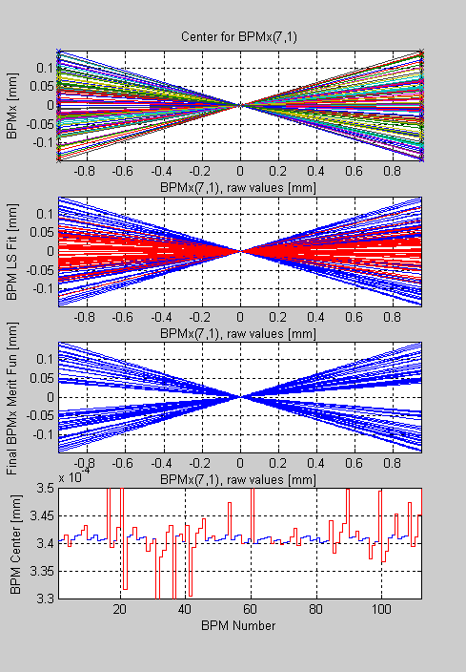
Fig. 1. Quadrupole Center of QF(7,1)

