Transferring CD Polynomials to MATLAB Database
J. Corbett, G. Portmann and J. Tanabe
October 11, 2006

Polynomials: Tanabe calculated CD transfer function polynomials based on Dell’Orco spreadsheet. The Excel file with raw data is CDXfer.xls. The polynomial coefficients are in BL12Xfer.doc in Table Main Coil Transfer Function. Note the n-1.

MATLAB: The polynomial coefficients for each of CD1-4 were transferred to magnetcoefficients.m. Note that, because of the way the data was fit,

(1) The ‘dc’ term was dropped from the table Main Coil Excitation in BL12Xfer.doc

(2) I0 was set to 1.0

(3) Leff was set to 1.0

(4) A scale factor of +/-1.0 was used to control the sign of the kick
Only CD3 has a ‘negative’ kick.

(5) A factor of B-rho is needed to make MATLAB transfer functions
(radian vs. amp) agree with Tanabe transfer functions (BLeff vs. amp)
These are included in cdmagnettest.m for benchmark purposes (see below).

Benchmark: The code cdmagnettest.m was used to check the Excel fitting results against the MATLAB middlelayer. For this test we transferred the magnetic measurement currents (Imag), the measured B*Leff (BL) and fitted (ExRep) from the Excel spreadsheet to cdmagnettest.m. We then plotted the transfer function (a) as computed by MATLAB, (b) as computed by EXCEL and (c) as measured. The agreement was good except at low currents where the contribution of the missing ‘dc’ term is more significant than at high currents. Since the MATLAB code is too convoluted to change the only way to make perfect agreement would be to re-fit the data without a dc-term. Nevertheless the data is accurate enough to operate SPEAR. An example of the output for CD4 is shown in Figure 1. We also verified that the fitted angles returned the correct (original) currents using k2amp.

Day-1 Configuration:
The design CD magnet deflections from SP3V83.m are:
ACD1 = +0.002000; % bend angles from Ringwall
ACD2 = +0.0048325;
ACD3 = -0.0148325;
ACD4 = +0.008000;

k2amp was used to calculate the Day-1 magnet currents:

radian amp
Current for CD1: +0.002 20.9632
Current for CD2: +0.0048325 64.0012
Current for CD3: -0.0148325 236.531
Current for CD4: +0.008 97.661

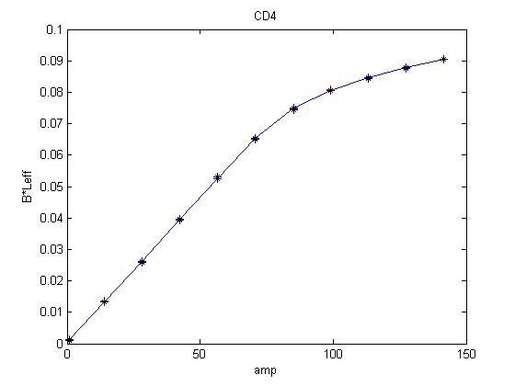
Figure 4: CD 4 Transfer Function (MATLAB, EXCEL, Measurement)

