Date: 2004/6/7
Prof. S.Y. Lee said that the horizontal tune shift of SWLS is caused from the orbit shift in the transverse and the sextupole of the SWLS.

Consider a ideal 3 pole super-conducting wave-length shifter (SWLS) with the pole width 0.2 meter. The field-strength ratio of each pole is 1:2:1 and the peak field is 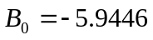Tesla. Using an electron reference particle with energy 1.5 GeV, i.e., the momentum rigidity is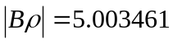, to pass through such a insertion devices, we can model and study the beam dynamic effects.
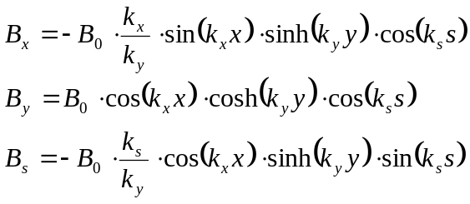
For the case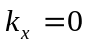, the effective focusing strength calculated by the estimated formula is
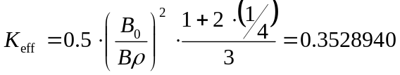

In the following, we will use MATLAB TPSA toolbox to model the SWLS and extract the transfer matrix from the linear part of the obtained TPS map. With the transfer matrix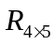, we can study the effective focusing strength, roll-off effects, and the feed-down effects with orbit shift.

Case 1: kx = 0 w/o roll-off effect
ks = 15.7808
kx = 0
ky = ks
- No orbit shift: The reference particle passes through the field center along the longitudinal axis.
The linear matrix R obtained from the linear part of TPS map is
R =
1.000000 | 0.602157 | 0 | 0 | 0
0 | 1.000000 | 0 | 0 | 0
0 | 0 | 0.936771 | 0.583368 | 0
0 | 0 | -0.209920 | 0.936771 | 0
0 | 0 | 0 | 0 | 1.000000
xKeff1 = (acosh(R(1,1))/L)^2 = 0
xKeff2 = (acosh(R(2,2))/L)^2 = 0
xKeff3 = (asinh(sqrt(R(1,2)*R(2,1)))/L)^2 = 0
yKeff1 = (acos(R(3,3))/L)^2 = 0.355040
yKeff2 = (acos(R(4,4))/L)^2 = 0.355040
yKeff3 = (asin(sqrt(-R(3,4)*R(4,3)))/L)^2 = 0.355040

- With orbit shift: The reference particle is traced and has orbit shift in the horizontal plane.
The max. orbit shift Xc(s) is 0.0124 meter.
The linear matrix R obtained from the linear part of TPS map is
R =
1.000000 | 0.602157 | 0 | 0 | 0
0 | 1.000000 | 0 | 0 | 0
0 | 0 | 0.936771 | 0.583368 | 0
0 | 0 | -0.209920 | 0.936771 | 0
0 | 0 | 0 | 0 | 1.000000
xKeff1 = (acosh(R(1,1))/L)^2 = 0
xKeff2 = (acosh(R(2,2))/L)^2 = 0
xKeff3 = (asinh(sqrt(R(1,2)*R(2,1)))/L)^2 = 0
yKeff1 = (acos(R(3,3))/L)^2 = 0.355040
yKeff2 = (acos(R(4,4))/L)^2 = 0.355040
yKeff3 = (asin(sqrt(-R(3,4)*R(4,3)))/L)^2 = 0.355040

Case 2: kx != 0 with roll-off effect
ks = 15.7808
kx = 3.6
ky = sqrt(kx^2+ks^2) = 16.1152

In order to prove it, the reference particle passing through the center of SWLS is used to check the TPS map. Since there is no orbit shift in the transverse, the sextupole will has no contribution on the horizontal tune shift effect.

Result:
- No orbit shift: The reference particle passes through the field center along the longitudinal axis.
The linear matrix R obtained from the linear part of TPS map is
R =
1.003535 | 0.603241 | 0 | 0 | -0.000030
0.011741 | 1.003535 | 0 | 0 | -0.000101
0 | 0 | 0.930003 | 0.581545 | 0
0 | 0 | -0.232304 | 0.930003 | 0
0 | 0 | 0 | 0 | 1.00000
xKeff1 = (acosh(R(1,1))/L)^2 = 0.019628
xKeff2 = (acosh(R(2,2))/L)^2 = 0.019628
xKeff3 = (asinh(sqrt(R(1,2)*R(2,1)))/L)^2 = 0.019628
yKeff1 = (acos(R(3,3))/L)^2 = 0.393498
yKeff2 = (acos(R(4,4))/L)^2 = 0.393498
yKeff3 = (asin(sqrt(-R(3,4)*R(4,3)))/L)^2 = 0.393498

Compare with the result, which includes the orbit shift in the transverse:
- With orbit shift: The reference particle is traced and has orbit shift in the horizontal plane
The max. orbit shift in the horizontal is about 0.0127 meter.
The linear matrix R obtained from the linear part of TPS map is
R =
1.003645 | 0.603474 | 0 | 0 | -0.000096
0.011710 | 1.003409 | 0 | 0 | -0.000202
0 | 0 | 0.929950 | 0.581337 | 0
0 | 0 | -0.232183 | 0.930184 | 0
0 | 0 | 0 | 0 | 1.000000
xKeff1 = (acosh(R(1,1))/L)^2 = 0.020239
xKeff2 = (acosh(R(2,2))/L)^2 = 0.018927
xKeff3 = (asinh(sqrt(R(1,2)*R(2,1)))/L)^2 = 0.019583
yKeff1 = (acos(R(3,3))/L)^2 = 0.393800
yKeff2 = (acos(R(4,4))/L)^2 = 0.392469
yKeff3 = (asin(sqrt(-R(3,4)*R(4,3)))/L)^2 = 0.393134
R11*R22-R12*R21=1
R33*R44-R34*R43=1

Conclusion:
By the analytic result, it shows that the main horizontal focusing effect comes from the field roll-off in the horizontal plane. The sextupole and orbit off-set can perturb the focusing effect but it is not the major part in this study case.

