


Technical and functional specifications
Version 1.0

Document organization

Signed and approved by

Written (date / signature) | Andrea Gazzarini (11/01/2011)
Reviewed (date / signature): | Tiziana Possemato (12/01/2011)
Authorized (date / signature): | Tiziana Possemato (12/01/2011)
Approved (date / signature): | Ivo Contursi (13/01/2011)

Table of contents
1 Introduction 11
1.1 Osee Genius modules overview 11
1.1.1 Osee Genius -I- 12
1.1.2 Osee Genius -S- 12
1.1.3 Osee Genius -Z- 12
1.1.4 Osee Genius -W- 13
2 Functional Area 13
2.1 Functional Area 1: text analysis components 13
2.1.1 Stop-words 14
2.1.2 Synonyms 14
2.1.3 Stemming 15
2.1.4 Article Elision 15
2.1.5 Ngramming 15
2.1.6 Lower casing 16
2.1.7 Diacritics 16
2.1.8 Phonemes 16
2.1.9 Stemming with language auto-detection 16
2.2 Functional Area 2: indexing 17
2.2.1 Datasources 17
2.2.1 Bibliographic records (Marc21 / MarcXml) 17
2.2.1 Digital documents 18
2.2.1 SKOS Thesaurus 19
2.2.1 Database 19
2.2.1 Emails 20
2.2.1 Custom 20
2.2.2 Keyword indexing 21
2.3 Functional Area 2: searching 22
2.3.1 “Simple” search 22
2.3.2 “Advanced” search 22
2.3.3 Faceted search 23
2.3.4 More Like This 23
2.3.5 Spell checking 23
2.3.6 Highlighting 24
2.3.7 Auto-completion 24
2.3.8 Search Enhancement Plug-ins 24
2.3.8 Holding Data (for bibliographic records) 24
2.3.8 Translation 25
2.3.8 Controlled vocabulary 25
2.3.8 Spatial Search 25
2.4 Functional Area 3: interfaces 26
2.4.1 HTTP 26
2.4.1 Search 26
2.4.1 Configurable view 27
2.4.1 Perspectives 27
2.4.1 Skinning 28
2.4.1 Tabbed search 31
2.4.1 Facets 32
2.4.1 Breadcrumb 33
2.4.1 Auto-completion 33
2.4.1 I18n (Internationalization) 34
2.4.1 Export 35
2.4.1 Send by e-mail 35
2.4.1 Browsing 35
2.4.1 ThGenius: the thesaururs explorer 36
2.4.1 Account 42
2.4.1 Circulation data 43
2.4.1 Community 44
2.4.1 Administration 45
2.4.2 Z3950 45
2.4.2 Conformance with BATH profile 2.0 46
3 Technical Area 72
3.1 Architecture 72
3.1.1 Osee Genius -I- 74
3.1.2 Osee Genius -S- 74
3.1.3 Osee Genius -Z- 75
3.1.4 Osee Genius -W- 75
3.2 Deployment perspective 76
3.2.1 Deployment scenario #1: four nodes 77
3.2.2 Deployment scenario #2: three nodes 78
3.2.3 Deployment scenario #3: two nodes 80
3.2.4 Deployment scenario #4: one node 81
3.3 Technology perspective 81
3.3.1 JEE Web components 81
3.3.1 Java Server Faces 81
3.3.1 Rich Faces 81
3.3.1 Apache Velocity 82
3.3.2 Enterprise Java Beans (EJB) 82
3.3.3 Apache log4j 82
3.3.4 Apache SOLR 82
3.3.5 Apache Nutch 82
3.3.6 Apache Tika 82
3.3.7 Jena 82
3.3.8 KEA & MAUI 82
3.3.9 Marc4j 83
4 References 83

Tables
ThGenius meta-attributes 38
Author Search – Keyword 47
Title Search – Keyword 47
Subject Search -- Keyword 47
Any Search -- Keyword 48
Author Search -- Keyword with right truncation 48
Author Search -- Exact Match 48
Author Search -- First words in field 49
Author Search -- First characters in field 49
Title Search -- Keyword and right truncation 49
Title Search -- Exact Match 49
Title Search -- First words in field 50
Title Search – First characters in field 50
Subject Search -- Keyword and right truncation 50
Subject Search -- Exact Match 50
Subject Search -- First words in field 51
Subject Search – First characters in field 51
Any Search -- Keyword and right truncation 51
Standard Identifier Search 51
Date of publication Search 52
Key Title Search – Keyword 52
Key Title Search -- Keyword and right truncation 52
Key Title Search -- Exact Match 53
Key Title Search -- First words in field 53
Key Title Search – First characters in field 53
Format / Type of material Search – Keyword 53
Format / Type of material Search – Phrase 54
Language Search – Keyword 54
Date of publication – Range Search 54
Possessing institution Search 54
Creator Search – Keyword 55
Title Search – Keyword 55
Subject Search – Keyword 55
Any Search – Keyword 56
Creator Search -- Keyword and right truncation 56
Title Search -- Keyword and right truncation 56
Title Search – Unanchored phrase 57
Subject Search -- Keyword and right truncation 57
Subject Search – Unanchored phrase 57
Any Search -- Keyword and right truncation 57
Any Search – Unanchored phrase 58
Standard Identifier Search 58
Date of publication Search 58
Name Search – Keyword 59
Name Search -- Keyword with right truncation 59
Name Search -- Exact Match 59
Name Search -- First characters in field 59
Title Search – Keyword 60
Title Search -- Keyword with right truncation 60
Title Search -- Exact Match 60
Title Search -- First words in field 60
Title Search -- First characters in field 61
Subject Search – Keyword 61
Subject Search -- Keyword with right truncation 61
Subject Search -- Exact Match 61
Subject Search -- First words in field 62
Subject Search -- First characters in field 62
Personal Name Search – Keyword 62
Personal Name Search -- Keyword with right truncation 63
Personal Name Search -- Exact Match 63
Personal Name Search -- First characters in field 63
Corporate Name Search – Keyword 63
Corporate Name Search -- Keyword with right truncation 64
Corporate Name Search -- Exact Match 64
Corporate Name Search -- First characters in field 64
Conference Name Search – Keyword 64
Conference Name Search -- Keyword with right truncation 65
Conference Name Search -- Exact Match 65
Conference Name Search -- First characters in field 65
Uniform Title Search – Keyword 65
Uniform Title Search -- Keyword with right truncation 66
Uniform Title Search -- Exact Match 66
Uniform Title Search -- First words in field 66
Uniform Title Search -- First characters in field 66
ISSN Search 67
Remote System Record Number Search 67
Geographic Name Search – Keyword 67
Geographic Name Search -- Keyword with right truncation 67
Geographic Name Search -- Exact Match 68
Geographic Name Search -- First characters in field 68
Title Search – Unanchored phrase 68
Subject Search – Unanchored phrase 68
Name Search – Unanchored phrase 69
Note Search – Keyword 69
Note Search -- Keyword with right truncation 69
Any Search – Keyword 69
Any Search -- Keyword with right truncation 70
Topical Subject Search – Keyword 70
Topical Subject Search -- Keyword with right truncation 70
Topical Subject Search -- Exact Match 70
Topical Subject Search -- First words in field 71
Topical Subject Search -- First characters in field 71
Genre / Form Search – Keyword 71
Genre / Form Search -- Keyword with right truncation 71
Genre / Form Search -- Exact Match 72
Genre / Form Search -- First words in field 72
Genre / Form Search -- First characters in field 72

Diagrams
Osee Genius Components Overview 73
Osee Genius -I- Micro Kernel architecture 74
Osee Genius -S- Micro Kernel Architecture 75
Osee Genius -Z- context diagram 75
Osee Genius deployment scenario #1 (four nodes) 77
Osee Genius deployment scenario #2 (three nodes) 79
Osee Genius deployment scenario #3 (two nodes) 80
Osee Genius deployment scenario #4 (one node) 81

Pictures
Osee Genius family 11
Osee Genius advanced search GUI component 27
Osee Genius -W- graphical user interface 29
Osee Genius -W- graphical user interface (internal use) 30
Osee Genius -W- graphical user interface (COBIRE) 31
Osee Genius tabbed search GUI component 32
Osee Genius facets GUI component (on the right side) 33
Osee Genius auto-completion GUI component 34
Osee Genius i18n GUI component (on the bottom right) 34
ThGenius with LibriVision as external search provider 37
ThGenius results page 40
ThGenius bottom detail toolbar 40
ThGenius details page 42

Introduction

Osee Genius modules overview
Osee Genius is a high-performance, full-featured text search and information retrieval application / framework written entirely in Java.
It can handle big amount of indexed data and comes with a ready-to-use plug-in framework that allows you to extend the application, by implementing and registering additional components.

Osee Genius is basically composed by several modules; some of them (specifically all what is related with the module named Osee Genius -W-) are open source and therefore free downloadable. For more information please read carefully the description of each module.

The following is a big picture of the Osee Genius family.

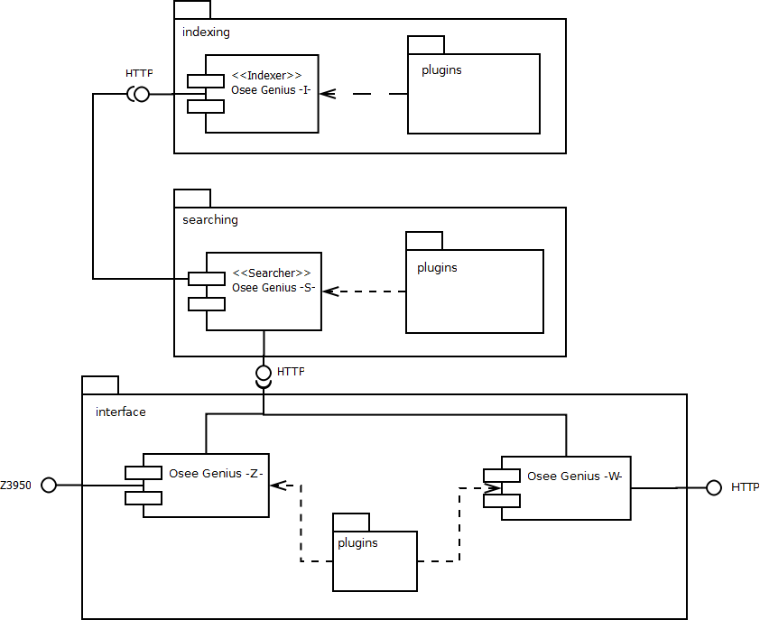
Picture 1: Osee Genius family

The next chapters show the functional modules that compose Osee Genius.

Osee Genius -I-
A module built on top of Apache SOLR that is in charge of index data of several kinds. Indexing is the first phase that needs to be executed when you want to make your data searchable through an information retrieval system. It can be considered as a standalone and decoupled module that usually sits on top of a dedicated node.

Osee Genius -I- itself comes with a set (inherited from SOLR) of generic data importers that cover a lot of file formats, including for example XML, rich documents, emails, HTML, database records.

In addition, there's a rich catalogue of plug-ins available in case of specific indexing requirements, including bibliographic records, rich documents with keyword indexing, SKOS and RDF data.

This module is not part of the community edition of Osee Genius. For those scenarios that don't require Osee Genius -I- capabilities, we strongly suggest the latest version of Apache SOLR.

Osee Genius -S-
After indexing your data, it's time to search: Osee Genius -S- is the module of the Osee Genius family that provides search capabilities. That includes a base SOLR distribution with a lot of additional text analysis plug-ins for improving the user search experience.

This module is not part of the community edition of Osee Genius. For those scenarios that don't require Osee Genius -W- capabilities, we strongly suggest the latest version of Apache SOLR.

Osee Genius -Z-
Osee Genius -Z- is a module that acts as a Z3950 endpoint fully compliant with BATH 2.0 specification, extending Osee Genius -S- connectivity by providing that additional protocol so popular in library domains.
Keep in mind that It is just a proxy so It doesn't have any search capability: that means It is not supposed to be isolated from an Osee Genius -S- instance.

This module is not part of the community edition of Osee Genius. For those scenarios that don't require Osee Genius -Z- capabilities, we suggest products like YazProxy, from Knowledge Integration or JZKit from IndexData.

Osee Genius -W-
The latest module of Osee Genius is a very nice and attractive end user interface with a lot of features like faceting search, auto-completion, browsing, simple and advanced search.

Following the same implementation strategy of previous module, Osee Genius -W- is a web application entirely written in Java and therefore able to run on top of most popular web and application servers like Apache Tomcat, JBoss, Oracle WebLogic or IBM WebSphere.

This module is part of the community edition of Osee Genius, and therefore is freely downloadable. The application comes with a predefined set of extension points that delivers a high level of extensibility, letting you or your development team to extend the functionalities of the user interfaces by providing, for example, connection with your Library Management System.

The application uses internally Java Management Extensions to manage cross-cutting configuration concerns like for example

- what attributes have to be shown while displaying items;
- what are the available sort attributes;
- how many results have to be displayed for each page;
- enable / disable features like export in PDF, MARC21, MARCXML (those latters for libraries only)
- which component has to be enabled / disabled;

Although they are not part of the downloadable bundle, also for Osee Genius -W- there is a catalogue of plug-ins that enables account management, circulation data viewers (for libraries), auto-completion based on controlled vocabulary, Google cover gathering and so on.
For more information about those extensions please refer to

http://oseegennius.atcult.it/ogw/addon_catalogue

Functional Area

Functional Area 1: text analysis components
This chapter illustrates all text analysis capabilities offered by Osee Genius modules.
When a document is indexed, its individual fields are subject to several analyzing and tokenizing filters that can transform and normalize the data in the source fields.
Specifically, these kind of components are widely used both in index and search layer (i.e. Osee Genius -I- and -S-); most of them are already shipped with the Apache SOLR distribution. The Osee Genius framework enrich those set of components by providing additional plug-ins (that are not part of the community edition).

Stop-words
For indexes with lots of text, common uninteresting words like "the", "a", and so on, could make the index large and therefore could slow down phrase queries. To deal with this problem, it is usually better to remove them from indexed fields.

Stop words are basically words which are usually filtered out prior to processing of text. That because

- they are not relevant from a search point of view;
- they are frequently used in natural language data so that means if we consider them during the index phase, the index could become very large;

As consequence of that, a common strategy is to define a set of terms, that will be ignored both at index and query time.
That's the reason why this kind of “filtering” is used both in Osee Genius -I- and -S- side.

Why both index and query time? Effectively, that doesn't make sense to remove those terms only while indexing or searching because the difference between what you index and what you search could lead to a wrong search result.

The stop-words component that is shipped with Apache SOLR uses a file as data source. Osee Genius has an additional filter that is able to gather those words from a generic URL (e.g. HTTP, FTP)

Synonyms
Synonyms are a widely used form of “normalization” of source documents that can be applied both at index and query time.
Basically, each term / phrase found within the original document can be indexed together with one or more synonyms found in a predefined source (e.g. file, thesaurus).
In this way, users will be able, during the phase search, to retrieve documents using the original terms but also its added synonyms.
This kind of analysis can be applied using two different strategies:

- at index time: source terms are indexed together with their synonyms;
- at query time: source terms are indexed alone, and later at query time, user entered search terms are expanded with their synonyms;

How to get synonyms for a given term / phrase? Apache SOLR comes with a built-in synonym filter that is able to get those data from a file and of course, Osee Genius inherits that. In addition, Osee Genius provides a special plug-in that is able to gather synonyms data from

- a local thesaurus, available in SKOS format;
- a remote thesaurus, available as a SPARQL endpoint.

Stemming
Stemming can be defined the process for reducing inflected (or derived) words to their stem, base or root form.
The stem need not be identical to the morphological root of the word; it is usually sufficient that related words map to the same stem, even if this stem is not in itself a valid root.
The most important thing while using stemming is that the algorithm can change depending on the language of indexed documents. That's because languages have different grammatical rules and from this point of view a wrong algorithm could lead to a wrong data analysis.

Article Elision
As a special case of stopwords, this component filters out the trailing articles (and their abbreviated form) from a given sentence. Articles are words such as “la principessa”, but they can be abbreviated, such as “l'etimologia”, when certain conditions occurs.
The same consideration of Stemming algorithm is valid: the elision procedure needs to be localized because depends on the language of source documents.

Ngramming
An n-gram is a subsequence of n items from a given sequence. Items can be phonemes, syllables, letters, words or base pairs according to the application.
This kind of analysis component is extremely useful when you want to provide an “incomplete phrase or word” search feature.
So for example if you have a document with written by

“Contessa Servelloni Mazzanti Vien Dal Mare”

applying the ngram component user will be able to search that document by author using one of the following Contessa,Cont, Servelloni Mazz and so on.
That because the original author has been split by ngramming analysis in several derived tokens like: Co,Con,Conte,on,onte,ontes and so on.

Lower casing
Usually the first form of normalization that is applied to source documents. When indexed, fields are lower-cased in order to create a lowercase normalized index and therefore be able to execute a case insensitive searches.
Obviously, lower-casing must be applied both at index of query time.

Diacritics
A diacritic is an ancillary glyph added to a letter, or basic glyph. The main use of diacritics in the Latin alphabet is to change the sound value of the letter to which they are added.
Some languages (like for example Romanian) have a lot of those special characters; it's generally useful, while indexing your data, to remove diacritics from characters because users should be able to use “plain” form (without diacritics) in their query strings.
Just to give an example, suppose that you have a document with “pòtàtùqètì” as title; the diacritics filter will index that term as “potatuqeti”.
After that, a foreign user comes to your information retrieval system in order to search that document; He doesn't know / remember how exactly is written that term, specifically where are diacritics, because He is italian (and in italian language they aren't very frequently used), but he remember that term without diacritic marks “potatuqeti”.
At this point the goal of such text analysis should be clear...if the italian user searches “potatuqeti” he will find (the system will find) the indexed document.

Phonemes
A phoneme is the smallest segmental unit of sound employed to form meaningful contrasts between utterances.
Thus a phoneme is a group of slightly different sounds which are all perceived to have the same function by speakers of the language or dialect in question.
Phonemes are widely used in information retrieval systems for sounds-like algorithms, where the user is able to match documents using query terms that “sounds like” the indexed terms.

Stemming with language auto-detection
The stemming algorithm is language-sensitive because of differences between grammatical rules. That means an English stemming algorithm applied to an Italian document could result in a wrong data indexed in your engine.
Osee Genius has a special component that is able to determine the language of a document. Once the language has been determined, the appropriate stemming algorithm can be applied.

Functional Area 2: indexing
The main purpose of indexing phase is to create an index. That will optimize speed and performance in finding relevant documents for a search query entered by a user.
Without indexing, an information retrieval system would have to scan every document, and this would require considerable time and computing power.
That's the main reason why this phase is so important. A good index will be able to improve the user search experience, delivering documents in an intelligent way and therefore helping as much as possible the end user to find what he needs with few input information.

Datasources
In information retrieval systems, data is indexed and then searched.
From that point of view, things seem to be easy but going a little bit deep inside the first process (indexing), we will find that data that needs to be indexed is found “in nature” in several forms / formats: emails, web sites, XML, HTML, PDF, Microsoft Word, database records and so on.
So, there's a strong challenge from that point of view that requires to be flexible as much as possible, in order to minimize the effort required to index your data.

Osee Genius comes with a predefined set of components that are able to gather data from several kind of sources. In addition, in case of very specific requirements, the indexing module can be easily extended in order to implement custom logic.
This section will briefly describe all those indexing capabilities.

Bibliographic records (Marc21 / MarcXml)
Marc21 and MarcXML are two standard formats for expressing bibliographic data.
Libraries that have their catalogue in such those formats (or that can be exported in those formats) can benefit of Osee Genius MARC indexer which is a powerful indexing components with a lot of pre-processing capabilities.
Basically, it is an extremely configurable and extensible framework that enables MARC record pre-processing, transformation, normalization and substitution at different level of granularity (field / sub-field). So, just to give some example:

- the “title” attribute (in Osee Genius index) will be composed by concatenating all alphanumeric sub-fields of 245 field;
- in case the uniform title is absent, manipulate the content of the 245 field in order to individuate and delete the article;
- remove unnecessary characters (e.g. trailing punctuation, symbols);
- substitute some codes with their verbal expression (e.g. a value of 300 for Dewey Decimal Classification scheme will indexed as “Social Sciences” and / or “Scienze Sociali”)
- retain, in a special field, the whole raw MARC data. This can be useful later (for example) for exporting data in such format. Applied both to binary and XML source data.
- associate a full-text (e.g. rich document) with a MARC record. The association can be implicit (control number based association) or explicit (using 856 tag);
- keyword indexing: automatically extracts and associates keywords and key phrases;

Osee Genius Marc Indexer (and in general Osee Genius -I-) is an additional component that is not part of the community distribution. If you want to index your MARC records without having a professional edition, we recommend SOLRMARC project, which is an opensource and free-of-charge project.

Digital documents
Rich documents can be indexed in Osee Genius by using two different approaches. The first one relies on a built-in SOLR capability it is not supposed to be used for a massive submission. The alternative is an enhanced digital document indexer that can

- automatically populate the Osee Genius index; this is done by placing documents in a given (configured) folder; at predefined and configured intervals, Osee Genius will scan that folder (and sub-folders) and will start the indexing process;

- enable specific (i.e. customized) text pre-processing; this is useful is for example you are working with domain-specific data and you want to operate with some transformation before the indexing phase happens; as an example, you can determine a set of words, symbols and so on, that mustn't be extracted because are not relevant in your domain specific language;

- keyword indexing: that means, as described above, enriching the documents with semantic data, by providing automatic keywords and key phrases extraction. This feature is better described later;

- publish indexed documents under a predefined and configured directory. In this way, when the user will search for those documents, it will be able to see their (automatically extracted and added) meta-data and at the same time to open / download the underlying document.

This process can be applied to a lots of file types including:

- Portable Document Format (PDF);
- Microsoft Office documents (e.g. Word, Power point, Excel);
- Open Office documents (e.g. Calc, Writer, Impress, Draw);
- Plain Text document (txt and in general documents with text/plain mime type);
- Text-based structured documents (HTML, XML and in general *ML);
- Images (e.g. png, jpg, gif, raw);
- Audio;
- Video;

SKOS Thesaurus
A controlled vocabulary in SKOS format can be submitted to OseeGenius -I- for indexing. In this way, SKOS concepts and their semantic relationships will be indexed using several (configurable) text analyzers.

This kind of indexing can be useful in several scenarios: first of all a special extension of OseeGenius -W- called ThGenius will let users browse graphically concepts and relations in order to subsequently execute a "controlled" search (i.e. starting from one or more controlled terms). ThGenius component is illustrated later.

Next, we can use those controlled data as datasource for the autocompletion feature.

In general, a controlled vocabulary is a precious and important source of data that can improve in several ways the user search experience.

OseeGenius provides SKOS indexing and navigating capabilities, but if there are other (probably most complex) requirements the extensible nature of the underlying framework helps you to meet your needs.

Database
While the MARC format is widely used in libraries, there are a lot of scenarios where customers have their data in relational databases, which are a de facto standard for organizing and storing unstructured records.

But a search index is something different from a relational (or object oriented) database; it can be compared to a database with just one table.

For that reason, there's a strong “normalization” requirement, when importing such data, in order to ensure that things are working properly once the relational data is indexed in a “raw” structure like that.

The underlying engine of Osee Genius, Apache SOLR, comes with a built-in component for dealing with such database scenarios. That component is highly extensible and configurable and comes with a set of so-called entity processors that are able to apply different kind of pre-trasformation to relational data.

Osee Genius provides a set of additional entity processors that have been implemented as a consequence of our concrete experience.
Osee Genius also provides an extensible and configurable framework that
make easy and fast to build database connectors for gathering such data.

While a framework instead of a ready-to-use set of components? The reason is that database schema is different from customer to customer so it's simply impossible to predict the future and build something that fits all world needs.

The right approach is instead to provide a set of tools that, properly configured, are able to gather data from any relational data source.

In addition, in case of very domain-specific requirements, it is always possible to extend that framework by implementing custom routines (see below).

Emails
Another (really speaking not very usual) data-source for gathering data is the SMTP protocol. Using this kind of data-source your search engine will be able to index and search among a set of emails, by providing different relevance to body, subject, recipient and so on.

Custom
For all customers with requirements that are not satisfied using functional modules described above, the Osee Genius indexing framework can be extended by implementing components able to gather data from legacy data sources.

Obviously, those components aren't part of the core distribution because they are customer-specific and are implemented / configured individually.

According with customer agreement, customized connectors are retained in a special repository as a core potential candidates. That means if one of them is widely requested by different customers, it will be gradually moved within the core distribution.

Keyword indexing
Keywords and key phrases provide a brief summary of document contents. They are particularly useful in information retrieval as description of the document returned by a query, helping the end-users to get a quick idea about the content of a given document.

Key phrases are an important means of document summarization and topic search. Especially for digital documents, only a small minority of them have author-assigned key phrases, simply because manually assigning key phrases to existing documents can be very laborious and tedious. Therefore it is highly desirable to automate the key phrase extraction and assignment process.

That process, in conjunction with the usage of a controlled vocabulary (e.g. thesaurus) could lead to a very powerful semantic indexing model, providing automatic assignment of controlled keywords and key phrases (e.g. preferred terms and / and not preferred terms) by enriching documents that for some reason are “poor” from a meta-data perspective.

As natural consequence of that, this has a strong impact on the information retrieval phase (i.e. the user search) which is the subsequent and concrete “usage” of the indexing process: the user will be able to search documents using the previously assigned semantic meta-data.

The usage of a controlled vocabulary can also be useful when you want to assign to a given document a set of keywords / key phrases that are not considered preferred or usual terms.

Let's say for example that you're working on a specific domain like medical domain. Your organization has a lot of documents that talk about medicine and wants to publish them, wants to make them searchable by end users through a corporate portal.
In medical domain the reference vocabulary is known as Medical Subject Heading (MESH). The following is an extract (in SKOS format)

<Concept rdf:about="http://www.nlm.nih.gov/mesh/2006#D000045">
<skos:broader rdf:resource="http://www.nlm.nih.gov/mesh/2006#D019736"/>
<skos:related rdf:resource="http://www.nlm.nih.gov/mesh/2006#D007887"/>
<skos:prefLabel>Acacia</prefLabel>
<skos:altLabel>Locust Tree</altLabel>
<skos:altLabel>Wattle Tree</altLabel>
</Concept>

So what does it mean the above XML fragment? It's easy, there's a (medical) entity that is labelled with a preferred term “Acacia” and two not preferred terms (Locust Tree and Wattle Tree).
Now, suppose that you're indexing a document that is talking about Acacia. Probably the immediate thing that comes in our mind is: I want “Acacia” to be a keyword of my document...and that's obviously right! But what if some user does a search using “Locust Tree”? This will lead to an empty search result....and this is where the controlled keyword indexing comes to help us.

Depending on what is configured, Osee Genius is able to enrich the documents with only the preferred terms or with preferred and not preferred terms, letting (in the first case) the end-users make searches using “uncommon” (not preferred) terms.

Functional Area 2: searching
While the indexing could be considered as a pre-conditional phase, the main goal of an Information Retrieval System is to provide a fast and efficient search among a set of documents. This chapters will describe Osee Genius search capabilities (and therefore is mainly focused on the Osee Genius -S- module).

“Simple” search
The most popular form of search, erroneously labelled as “simple”, is a search procedure, that executes complex text analysis against what user entered in a simple text field.
In this kind of search users don't have to specify target attribute(s) (e.g. title=History); instead only the value that needs to be searched is given. In this way the underlying engine automatically makes its assumptions about target fields (first search terms in title, after that in author, after that in subject and so on), relevance (a document with that term in the attribute title it's more important than another document with a match in the subject), boosting, phrase and word query (if user enters Charlie Brown then give priority to documents that have in the title exactly those two terms, after that searc for documents that have at least one of them).
The corresponding graphical user component is a simple text field (that eventually can be enhanced with an auto-completion feature).

“Advanced” search
With “advanced search” we mean, here, the capability of executing complex queries using target attributes and boolean operators. From that point of view this kind of search is qualified as advanced because usually requires more time (than the simple search) to “compile” the request (the user must enter “where”, “what” and boolean operators) before submit.
It allows a fine level of granularity on the search that will be executed, especially if is compared to its “simple” counterpart.
Just to give you an example, an advanced search allows the user to execute a query like this:

(author=Manzoni AND title=”I Promessi Sposi”)
OR
(bibliographic_level=monograph AND language=italian)
AND NOT
format=hard_cover

Faceted search
Faceted search, (AKA faceted navigation or faceted browsing), is a technique for accessing a collection of information represented using aggregations, allowing users to explore by filtering.
Faceted aggregation enables the assignment of multiple classifications to a document, enabling the classifications to be ordered in multiple ways, rather than in a single, pre-determined, taxonomic order.
Each resulting “facet” corresponds to the possible values of a given attribute or can be determined at runtime as a result of a query (e.g. alphabetical range of title, publication date range).

More Like This
More Like This search component provides “similar” or related content to a given search result; this is usually a nice way to provide additional content to end users.
The similarity is calculated using one or more attributes of indexed documents; usually the candidates are those attributes that represent some kind of classification (e.g. CDD, Call Number, subject).

Spell checking
End users often misspell search terms for a lot of reasons (wrong / fast typing, keyboard problems, international names). Spellchecker component provides a feature better known as "Did you mean?", which provides alternative suggestions in case of misspelling.

There are more than one underlying algorithm available (mainly based on n-gram analysis) that are able to determine the opportune distance between a term and the corresponding suggestions.

A very common approach is to execute this component only when a search gives no result; anyway, the list of similar terms can be returned also in case of successful searches, in order to provide a meaningful set of alternative suggestions.

Highlighting
Highlighting is a feature that display search terms found in matching documents (specifically in attributes of matching documents) in different way (colors and / or fonts).
In this way, user can immediately see why a given document has been returned as result of a search.
The highlighting can be used, for example, when matching documents of searches are rich documents (e.g. PDF); that provides an immediate view of entered search terms directly within the full-text, helping users to improve the understanding and the relevance of returned documents.

Auto-completion
Auto completion / suggestion is a very attractive features that can tremendously improve end user search experience by providing real-time suggestions while they are typing search terms.
In order to accomplish that, Osee Genius provides several ways to retrieve suggested terms.
- indexed data: specifically one or more attributes of indexed documents. This is the usual approach because indexed data contains proper nouns;
- text file (see for example http://wordlist.sourceforge.net);
- controlled vocabulary: suggested terms are taken in this case from a controlled structure available as SPARQL endpoint;

Search Enhancement Plug-ins
This section shows a set of optional plug-ins that equip Osee Genius with additional capabilities, providing for example real-time data or query transformation services that can (transparently) enhance the end-user search experience.

Holding Data (for bibliographic records)
For bibliographic records information retrieval, holding data can be plugged in for supplying information about item availability, location, signature, shelf an so on.
This is usually needed in case if the underlying institution is a library and is doing circulation with its own bibliographic material.
At the moment, for each bibliographic records, for each copy held by the library, the following set of information can be returned:

- holds count;
- a flag indicating if the copy is on order;
- shelf list;
- location;
- due date (in case the copy is charged out);
- institution identifier;
- institution name;
- institution symbol;
- sub-institution identifier;
- sub-institution name;
- sub-institution symbol;

Translation
Using this extension, user entered search terms will be translated in several (predefined and configured) languages, enabling a multilingual search.
In this way, an italian user will be able to search among a foreign catalogue by entering search terms in his native language.

This kind of plug-in doesn't have an its own translator but instead relies on external services like Google translator. Depending on which service you want to connect, check its (commercial?) license and make sure you can use that.

Controlled vocabulary
We already saw what role can be played by a controlled vocabulary in Osee Genius -I-. In search phase this can be used in two ways.
The first one is a “controlled” search where user entered terms are replaced with their corresponding preferred forms.
The second one is the capability of directly search within the thesaurus, by searching and navigating among its semantic relations.

This latter one is known as ThGenius and is technically a whole thesaurus browser. We can consider it as a full working Osee Genius -S- but with one important difference: instead of documents, the index contains thesaurus concepts and their relations.
Obviously, this can be seen as a general case of the controlled search mentioned before: you can start navigating thesaurus structure and once identified a term you can tell Osee Genius “search this terms within the full-text of my documents”.

Spatial Search
In case indexed entities (e.g. documents) have one or more attributes that represent location data, is possible to enhance searches by providing geo-spatial information.

For example, in library domain, could be useful to see where is the closest library that holds a copy of a given bibliographic record;

Using this component, is possible to do things like these:

- automatically adding geo-spatial data to documents;
- ordering search results by distance from a given address;
- scoring / boosting results by distance;
- filtering results that are too distant from a given address;

Functional Area 3: interfaces
Osee Genius -I- and -S- are two very powerful modules that do a great work in indexing and searching but without interfaces they are not useful because nobody and nothing can use them.
This chapter illustrates the last set of components that enables communication between Osee Genius and the rest of the world.

HTTP
The first things that comes in mind when talking about interfaces are web applications. That's exactly what is Osee Genius -W-.
It is a web application that acts as client of Osee Genius -S- and at the same time provides interaction with end users.
The following sections show a list of graphical components available in Osee Genius -W-, without focusing on their functional aspect (already discussed in previous chapter).

Search
Searching is the main goal of the whole Osee Genius family so the first components that needs to be listed are search graphical components.

Simple search
Most probably it doesn't need any explanation. We are all Google users: a simple text field where is possible to enter one or more words (e.g. Contessa Serbelloni Mazzanti Vien Dal Mare) and / or one or more phrases (e.g. “Contessa Serbelloni“ “Mazzanti Vien Dal Mare”).

Advanced search
An interface that allows end users to compose an advanced search query in a usable way.
Users can specificity a variable number of fields with target attribute, search value (both words and phrases) and a set of boolean operator (AND, OR, AND NOT, OR NOT) that concatenate fields in order to form a query expression.
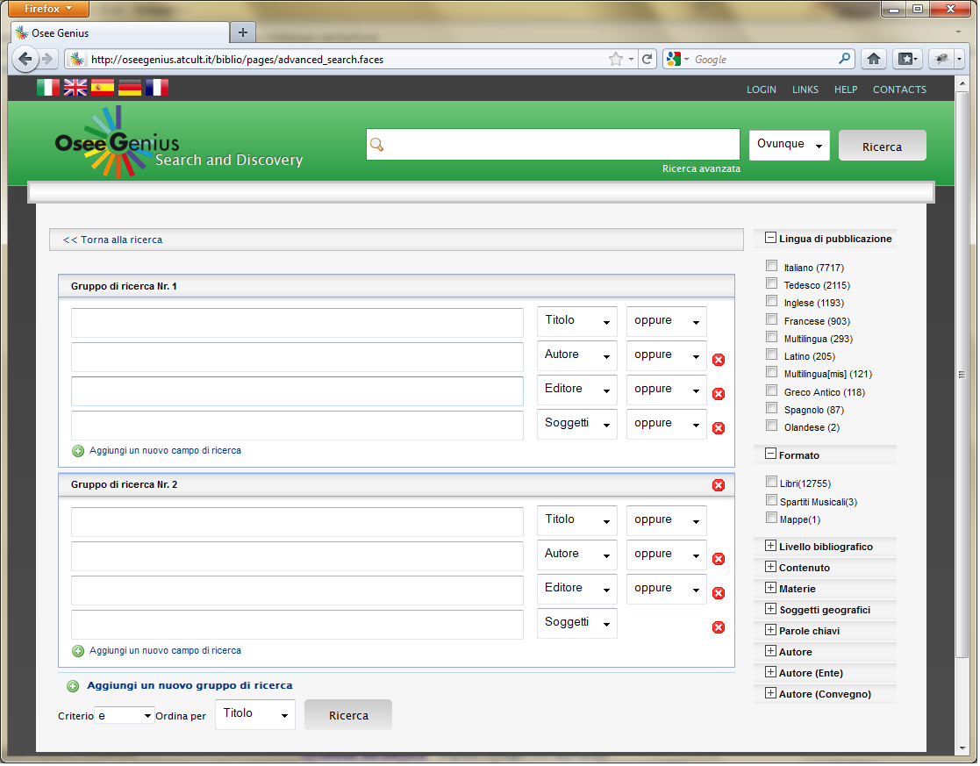
Picture 2: Osee Genius advanced search GUI component

Configurable view
When a search is made, Osee Genius -W- display the first page of matching documents in a web page. In that view, the only attributes that are fixed and always displayed are title and author.
Other attributes like publisher, url, id, other authors, subjects are hidden by default but they can be enabled using configuration. In this way you can customize the interface depending on your needs.

The same consideration is valid for the detail page (the page that focuses on the details of a selected document).

Perspectives
Documents returned after a search can be viewed in several perspectives:

- List mode (default): this is the default view of Osee Genius;
- Tabular mode: documents are disposed within a table;
- Marc21 mode (only for bibliographic record)

Users can switch between perspectives using the web interface toolbar component.

Skinning
Osee Genius -W- is a web application and uses, for graphical look and feel, several cascading style sheets (CSS). By manipulating those CSS is possible to completely change the skin of the application, by moving component disposition, applying different colors, different fonts and so on.

In addition, a feature called automatic skinning is provided. If your application uses virtual hosts, Osee Genius is able to associate a skin with each of them. Doing that, the same application will look completely different depending on how is called. For example, if the application responds to these URLs:

- http://www.xyz.com
- http://biblio.xyz.com
- http://archives.xyz.com

The automatic skinning feature can associated three different skins with the same Osee Genius -W- instance.

Here are some examples of different skins applied to Osee Genius.

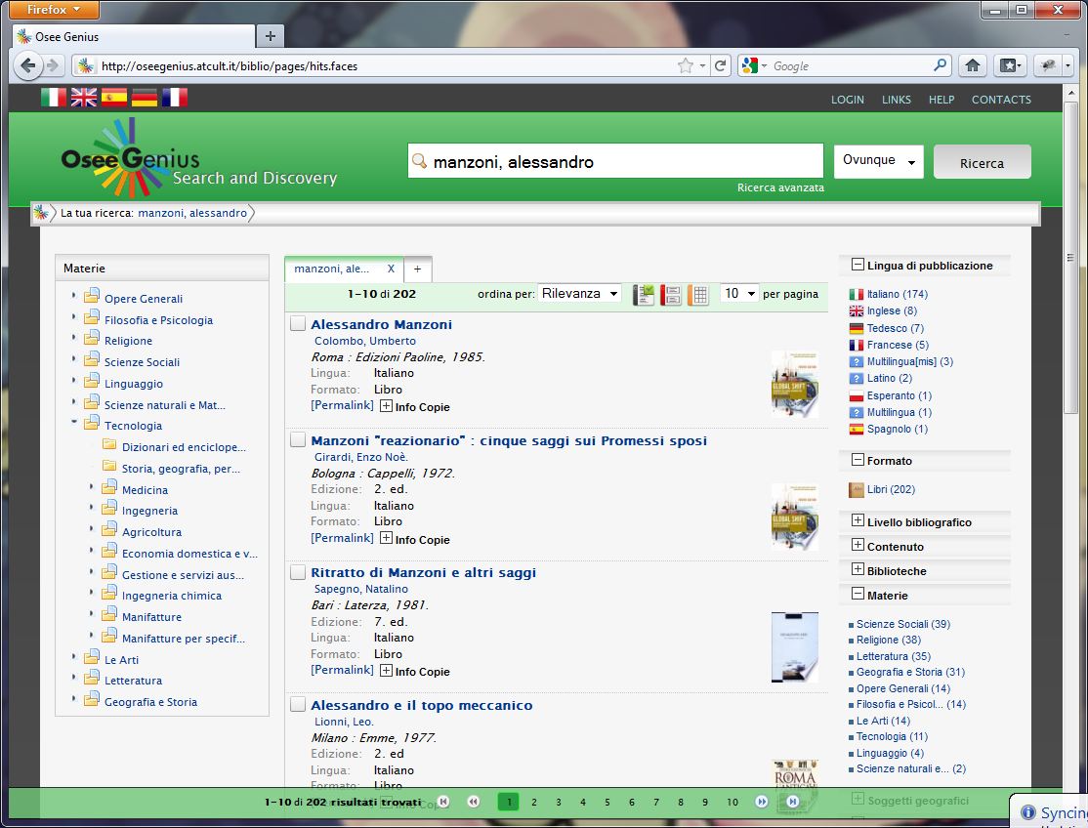
Picture 3: Osee Genius -W- graphical user interface
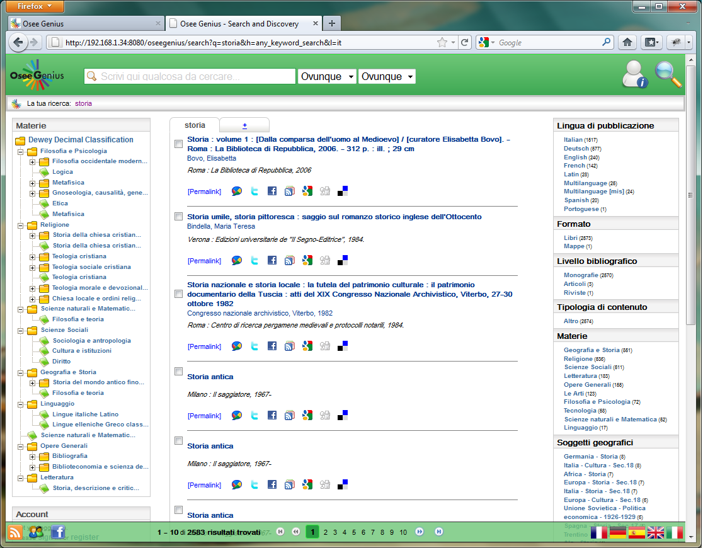
Picture 4: Osee Genius -W- graphical user interface (internal use)
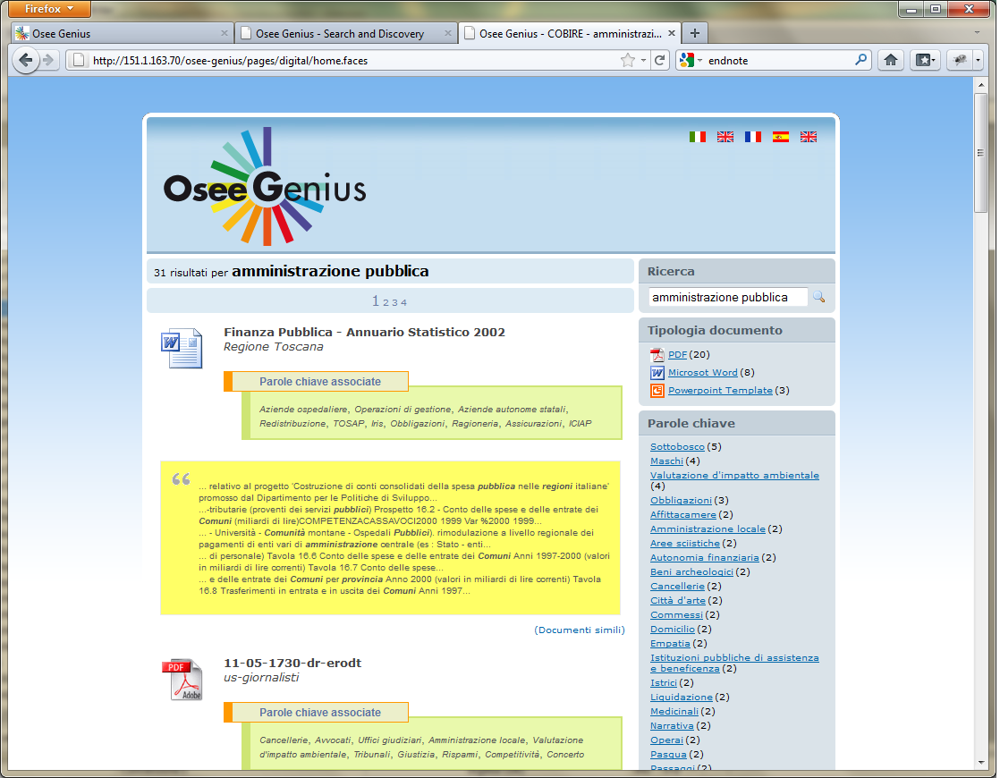
Picture 5: Osee Genius -W- graphical user interface (COBIRE)

Tabbed search
A component that is able to maintain several searches at the same time using tabs. This kind of graphical facility has been adopted by all internet browser (e.g. Internet Explorer, Mozilla Firefox, Google Chrome, Opera) and represents a very simple and powerful help for end user who is able to “leave open” several search results coming from different searches.
The following picture illustrates an instance of Osee Genius -W- where three tabs (corresponding to three different searches).
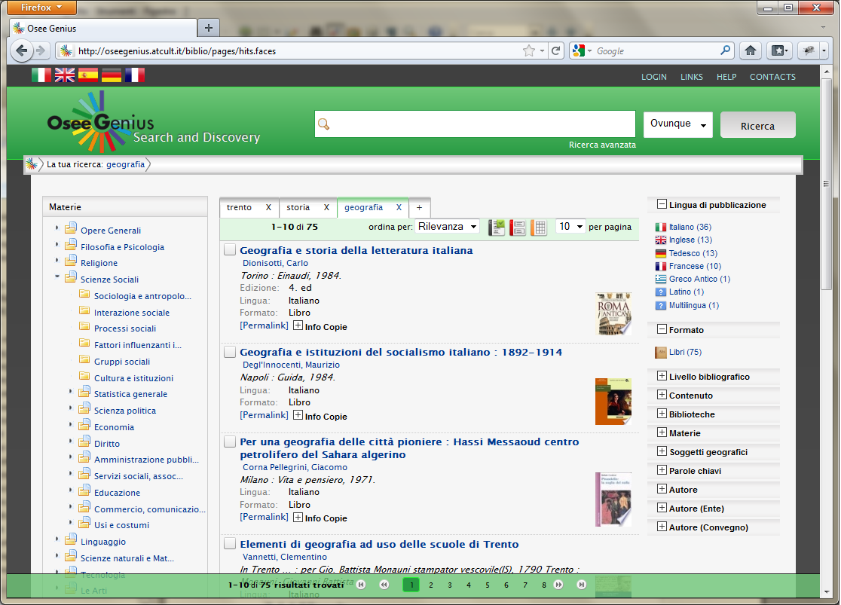
Picture 6: Osee Genius tabbed search GUI component

Facets
What is faceting and faceted search has been explained before. Here we will simply illustrates how things behave from a graphical point of view.
Facets are usually positioned on the right or left side of the application. Osee Genius -W- facets components have an header section (displaying the facet attribute) and a body (with facet values and counts). Each component can be opened or closed by clicking on the corrisponding header.
Picture 7: Osee Genius facets GUI component (on the right side)

Breadcrumb
A breadcrumb is a special component positioned on top of the page (just below the search toolbar) and contains all logical "steps" that compose the current displayed search.
That includes the query that originates the search results and all currently applied filters.

The component provides some interaction so users can easily remove filters changing the search results with just few clicks (instead of repeating the whole search).

Auto-completion
Auto-completion graphical component is a kind of “comics“ that appears under the search text-field showing up terms / phrases starting with entered characters.

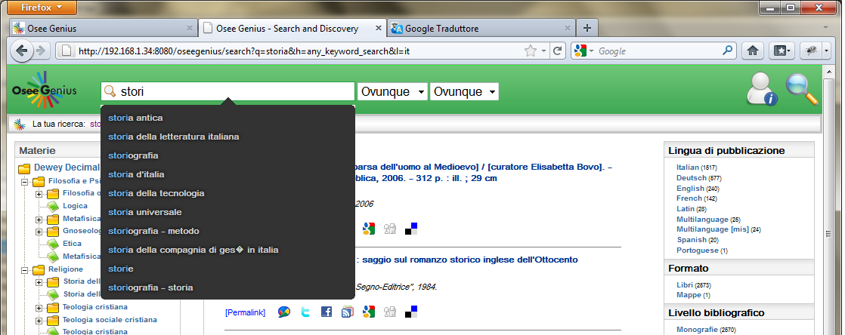
Picture 8: Osee Genius auto-completion GUI component
Matching characters are highlighted in a different color (blu in the sample screenshot)

I18n (Internationalization)
The Osee Genius interface is fully internationalized in several languages. Although at the moment Italian and English are the only two available languages, the underlying i18n framework makes very easy to add languages.
All application labels are centralized in few files ending with the correspondent language code.
So for example, Dewey labels can be found in a file named deweys_it.properties (Italian) and deweys_en.properties (Engligh).
If you want to add spanish translation, just create the deweys_es.properties and copy it into the application folder.

User can control the current language by using the apposite toolbar (see below)

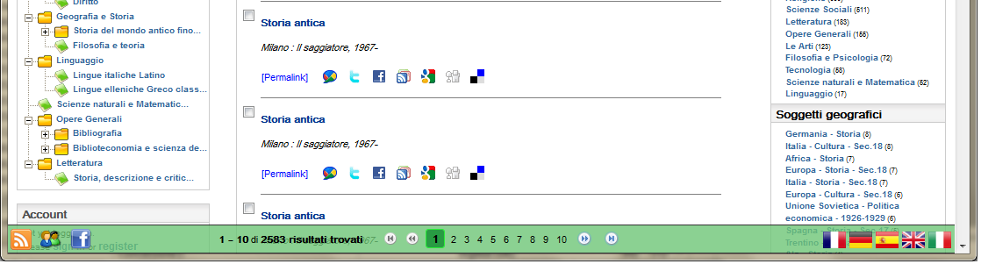
Picture 9: Osee Genius i18n GUI component (on the bottom right)

Export
Search results can be exported in several formats for different usages. The following are the export format / target available at the moment.

Refworks
RefWorks is an online research management, writing and collaboration tool that is designed to help researchers easily gather, manage, store and share all types of information, as well as generate citations and bibliographies.
Osee Genius can export search result towards your RefWorks account.

EndNote
Thomson Reuters EndNote is the industry standard software tools for publishing and managing bibliographies on the Windows and Macintosh desktop.
Osee Genius can export search result towards your RefWorks account.

MARC 21 / MARC XML
MARC21 and MARCXML are two popular formats used in libraries for representing bibliographic data. This kind of export can be disabled by Osee Genius Administrator because not all libraries want to make publicy available data in such formats.

PDF
Search results can be exported in PDF format (for printing or sending via email). That kind of export can be applied to one or more items by making a pre-emptive selection.

Send by e-mail
Search results can be sent by email by selecting them and choosing the appropriate control on the web interface.

Browsing
Browsing components can display various number of records which have the same data structure. Thus, it can be used as a basis for document browsers, product catalogues, classification schemes, or any kind of informational resources that have a hierarchical relation.

Dewey Decimal Classification
The Dewey Decimal Classification (DDC) is a proprietary system of library classification developed by Melvil Dewey in 1876.
The DDC attempts to organize all knowledge into ten main classes. The ten main classes are each further subdivided into ten divisions, and each division into ten sections, giving ten main classes, 100 divisions and 1000 sections.
DDC's advantage in using decimals for its categories allows it to be both purely numerical and infinitely hierarchical.

Library of Congress Call Number
The Library of Congress Classification (LCC) is a system of library classification developed by the Library of Congress. It is used by most research and academic libraries.

Universal Decimal Classification
The Universal Decimal Classification is a system of library classification developed by the Belgian bibliographers Paul Otlet and Henri La Fontaine at the end of the 19th century. It is based on the Dewey Decimal Classification, but uses auxiliary signs to indicate various special aspects of a subject and relationships between subjects.

Custom browsing
Sometimes there are specific situations where is possible to determine a hierarchy relations between indexed documents but at the same time those kind of relations cannot be determined using “standard” attributes.

This is the scenario where custom browsing comes to help us: It is always possible to extend the browsing component in order to reflect the hierarchy relationship of a given (custom) attribute found in a set of documents.

ThGenius: the thesaururs explorer
In case your installation of OseeGenius -I- includes SKOS indexing capabilities, the most eligible usage of such data is a special extension of OseeGenius called ThGenius.

What is ThGenius? Basically it is a thesaurus explorer, that shows data coming from an OseeGenius -S- with a SKOS-based index.

A first important note about ThGenius is that although it should be considered as an OseeGenius -W- extension, it can run in standalone mode, without requiring an instance of OseeGenius -W-. As consequence of that it can be considered as a self-consistent web application.

Instead, when combined with OseeGenius, provides additional search capabilities letting users transparently switch back and fourth from (for example) bibliographic,digital documents to SKOS concepts.

In the following sections we will illustrate what it can do.

Integration with OseeGenius and other OPAC / IR
Regardless the concrete ThGenius running mode (integrated with OseeGenius or standalone), it's possible to configure a set of "external" search providers. In this way, you will activate what is called "controlled search", that is, a search towards a given external provider using the selected thesaururs term as search string.

The only precondition that an external providers must have in order to be eligible for that feature, is that it must support a REST-like interface; in other words, it should be queried using HTTP GET method, appending parameters in the query string section.

Using OseeGenius / ThGenius configuration, it's easy to add several providers; for each of them the administrator must define a label and the HTTP query string (excluding the search terms that will be appended at runtime by the application).

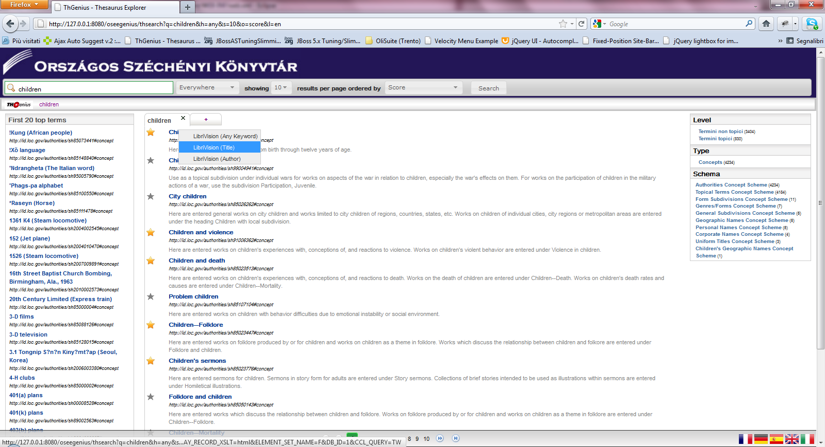
Picture 10: ThGenius with LibriVision as external search provider
Obviously, OseeGenius -W- can be configured as an external provider.

Search
Search capabilities are inherithed from OseeGenius -W- so basically we have a simple search (the text field on the top toolbar) with autocompletion feature (described in the next section). Searches can use the following available meta-attributes:

Meta-Attribute | Composition | SKOS attribute
Everywhere | - Preferred labels  - Alternate labels  - Notes  - History notes  - Editorial notes  - Scope notes | - skos:prefLabel  - skos:altLabel  - skos:note  - skos:historyNote  - skos:editorialNote  - skos:scopeNote
Preferred labels | - Preferred labels; | - skos:prefLabel
Alternate labels | - Alternate labels; | - skos:altLabel
All notes | - Notes  - History notes  - Editorial notes  - Scope notes | - skos:note  - skos:historyNote  - skos:editorialNote  - skos:scopeNote
Notes | - Notes | - skos:note
History notes | - History notes | - skos:historyNote
Editorial notes | - Editorial notes | - skos:editorialNote
Scope notes | - Scope notes | - skos:scopeNote
Table 1: ThGenius meta-attributes
Those general-purpose set are basically defined in SKOS specification and therefore are widely used and shared on controlled vocabulary. We are always looking for additional attributes that can be useful for search and therefore can be added to the previous list, so if you see something interesting from this point of view (your thesaurus or a public one) feel free to send us your suggestions (info@atcult.it)

Meta-attribute context sensitive autocompletion
The simple search text field positioned on the left side of the top toolbar has a useful feature that starts automatically when the user types something. The complex title "Meta-attribute context sensitive autocompletion" means a simple things: when the user types one or more characters in the search field, ThGenius (really speaking is OseeGenius but that's another story), suggests several terms that starts with those charaters.

"Context sensitive" means that the suggestion list is populated differently depeding on the selected meta-attribute. So, just to give you an example, if the selected attribute is "Preferred labels" the suggested terms will be only preferred labels, while if the selected meta-attribute is "All notes" suggestion terms will be text tokens that have been indexed as part of one kind of note (e.g. general, scope, history or editorial).

Autocompletion is useful in general because users are able to make sure that, before pressing the "search" button, what is written inside the text field does make sense from a search perspective.

Facets
Faceted search has been discussed as part of OseeGEnius section so here we must just specify that working with thesaurus data we can't have the same richness for faceting that can have, as an example, a bibliographic set of records.

As consequence of that, we introduced in ThGenius (at the moment) three kind of facets:

- A "Level" that provides two categories: top terms and children terms;
- A "Type" that does faceting using the skos:type property of a given RDF Resource. Note that at the moment only skos:Concept are supported so this facet has just one entry.
- A schema that does faceting using the skos:inScheme property and therefore classifies entities depending on the owning schemas.

First n top terms viewer
The component on the left side of the search page shows the first "n" top terms. Displayed terms can be clicked, as any other, to go to corresponding details page or can be used as a "controlled search" terms towards a predefined external search provider.
The exact number of the top terms that the viewer will show is configurable by the system administrator.

Results page
The main component of the result page is obviouslt the list of results. For each hit the result page shows the preferred label, the URI and (if exists) the first indexed note (this can be a history, scope, general or editorial note).

Preferred labels (this is valid in general for ThGenius) have a double behaviour: they can be used (left click of the mouse) to go to the corresponding details page, or can be used as a "controlled search" terms towards a predefined external search provider (right click of the mouse).

ThGenius inherits the REST behaviour from its parent OseeGenius: that means, in this specific context, that you can copy and paste among your favorites, the HTTP URL of the browser that is displaying the search results and later, without passing through the home page, you can reopen the browser and return directly to that page simply pasting the copied address.

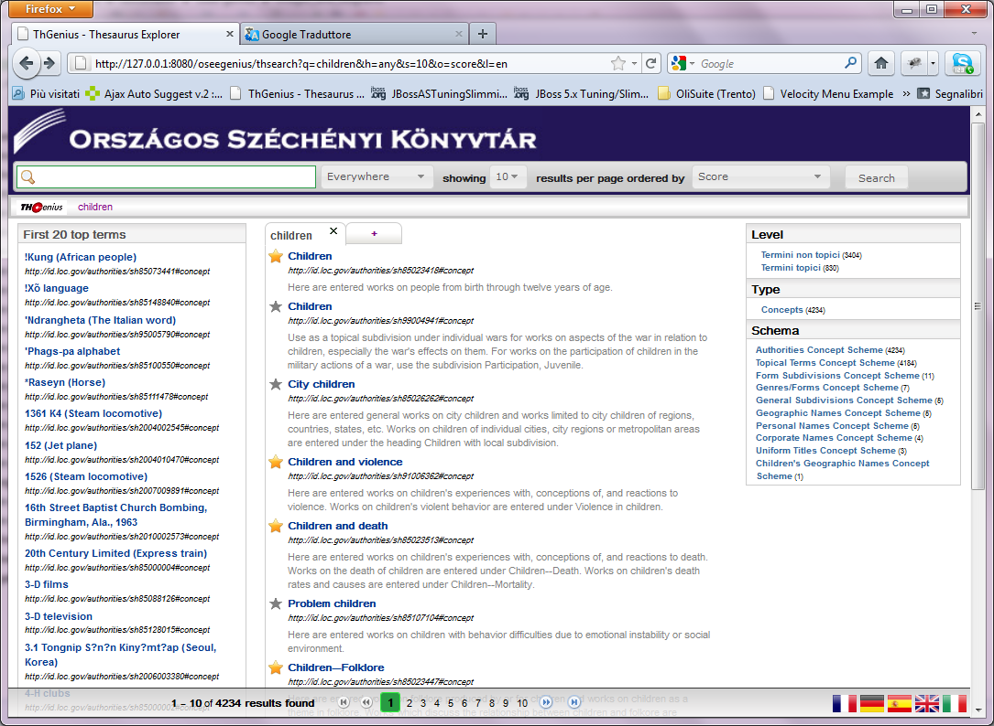
Picture 11: ThGenius results page

Details page
The details page shows all the available data of a given concept. In order to make easy the understanding of a page that could be very full of information, ThGenius organizes those data in several logical section that can be reached using the corresponding buttons in the bottom toolbar.


Picture 12: ThGenius bottom detail toolbar
Of course, the buttons are there only if the concept has the corresponding sections; the toolbar in the picture is associated with a concept that, for example, doesn't have Editorial notes or alternate labels.

This toolbar is extremely useful in case the concept data doesn't fit in one page and therefore to jump back and fourth from one section to another user should use the vertical toolbar.

Concept data is organized in the following sections:

- General: shows the preferred labels and the concept URI. The concept URI is an (external) hyperlink that open a new page using the URI itself as address; the preferred label can be used for controlled search.

- Schema: shows the owning schema(s) of the selected concept.

- Alternate labels: shows the alternate label of the selected concept. Each of them can be used for controlled search.

- Scope notes: a list of all scope notes;

- History notes: a list of all history notes;

- Editorial notes: a list of all editorial notes;

- General notes: a list of all general notes;

- Relationships: three columns that report respectively broader terms, narrower terms and related terms. If a column is empty (e.g. a concept doesn't have broader terms) it won't be displayed. Each term can be used in dual mode (left click goes to the details page, right click for controlled search).

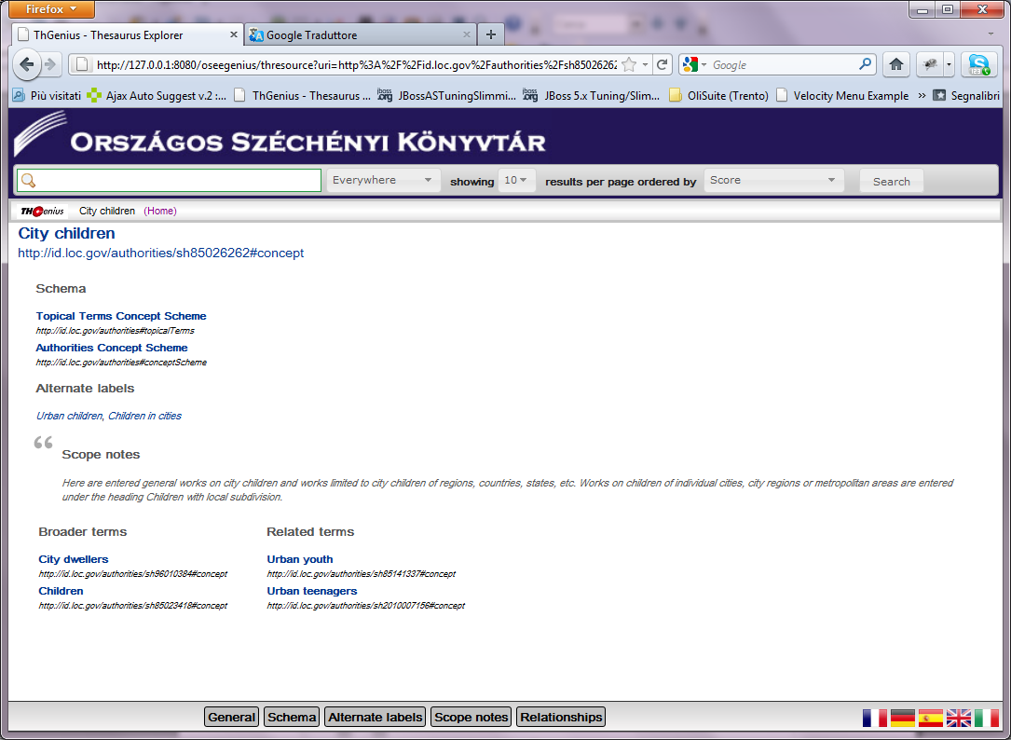
Picture 13: ThGenius details page

Controlled search
This feature has been briefly described in previous sections. Basically it works in this way: the system administrator can configure one or more external search providers by specifying a label and a HTTP query URL.

Once did that, ThGenius will enable a right-mouse-click context menu on each displayed preferred and alternate labels that allows to search using the selected label as search terms; the context menu will contain one entry for each configured external provider.

Of course, in case ThGenius is not running in standalone mode, OseeGenius can be used itself as a external search provider.

Account
Account management can be enabled on Osee Genius -W- in order to let users creates a personal “space” on the application.
On top of that, account profile can be further extended with several components like

- circulation plug-ins (for libraries): in this way users can have a dedicated real-time workspaces with loans, holds and fines;
- community plug-ins: for tagging, reviewing, wish list and sharing;

Login
The login module of Osee Genius is fully compliant with Java Authorization and Authentication Service (JAAS); that basically means easy of integration with an existing AAA infrastructure, in case for example of a corporate LDAP.

That's the main reason why Osee Genius usually doesn't come with an account database: most times customers already have a security infrastructure and they don't want absolutely to migrate existing data.

Indeed, there are cases where those kind of storage are not available and therefore an account database is needed in order to set up a minimal environment: the downloadable bundle contains a set of ddl scripts that creates such schema; most popular databases are supported (specifically those that provide a JDBC driver).

Last, this functionality can be completely hidden in case you don't need user account management.

Registration
The logical counterpart of the previous module is the registration capability. Obviously, a user can log into the application only if he already has an account...
First of all, in the same way of the login module it can be enabled or disabled so you can have a login module without registration...why?
Well, there are some situation that requires this scenario, especially when the underlying organization want to maintain some kind of control on new accounts.
For example, a library network requires that each (registered) user has an RFID card: in order to do that users have to go to the library for registering, giving their personal data and taking such card. Only after that, they will be able to log in within the OPAC.
As you can see this is a usual scenario where login is enabled while registration doesn't.
Registration requires a storage where user information can be inserted. For that point of view the same considerations of the login module are valid: Osee Genius can be extended to interact with an existing storage or can rely on a its own relational database. The choice depends on the concrete deployment context.

Circulation data
Once the account plug-in has been enabled, a lot of several features can be enabled or not, depending on your needs.

Subscriptions
In case of libraries, and specifically a network of libraries, users are usually shared, avoiding duplication of the same data between institutions. That is what usually referred as subscriptions. A subscription is the state of a given user on a given library. That includes activation, deactivation date and some other local information.

Loans
In their personal workspace, users can always have an up-to-date resume of their loans, including loan date, due date, a renewal count, a recall notification date and so on.
Obviously, in case a library is not doing circulation this feature can be disabled.

Holds
If this module is enabled, users will be able to place holds on items and, of course, to get a resume of placed holds in their personal workspace.
In case a library is not doing circulation this feature can be disabled.

Fines
An last concerning circulation data, is possible to enable a specific area in personal workspaces, where users can see their fines.

Community
Once a user is authenticated, if the social / community plugin has been activated, he can open several sections where is possible to manage / view his tags, reviews, rating and wish list.

Tagging
Authenticated users can tag records, that is, can associate a set of keywords or terms to a given document that is part of a search result.
Tagging became very popular with the advent of Web 2.0 and is considered as an important feature of many Web 2.0 services.

The tagging feature can be disabled even if the community plug-in has been activated.

Reviews
Authenticated users can leave a comment, a review on a given document that is part of a search result. This feature is very popular in e-commerce search engines, where users, before choosing an item can see what other users think about it.

This feature can be disabled even if the community plug-in has been activated.

Wish list
A special repository where user can create his own personal bibliography while browsing search results.

Administration
The authenticated user mentioned above is an end user, someone who wants to use search services. There's another important role in Osee Genius which is the administrator.
He is in charge to configure the overall behaviour of the application. Note that with application here we mean the Osee Genius -W- module. Other modules doesn't have a graphical user interfaces and therefore require a low-level system administrator.

General settings
There are different level of configuration control that you can achieve with an Osee Genius instance.

- License: settings cannot be changed at this level; for example you're using a professional edition and you didn't buy the xyz component which therefore is deactivated by the underlying license;

- System administration: this kind of configuration is handled by several configuration files. Usually a change is allowed but requires an application restart;

- Console administration: administrator can use the graphical interface in order to activate / deactivate features. Those kind of changes doesn't require an application restart. As an example, if you have the community plugin activated (license level), the administrator (console administration level) can enable or disable tagging or reviewing.

Statistics
A special area where administrators can monitor the Osee Genius instance by analysing collected usage data and some other useful statistics.
Data can be exported in several formats (Microsoft Excel, Open office Calc, PDF, images).

Z3950
Z39.50 is a popular client–server protocol for searching and retrieving information from remote computer databases.
It is covered by ANSI/NISO standard Z39.50, and ISO standard 23950. The standard's maintenance agency is the Library of Congress.

Conformance with BATH profile 2.0
The Bath Profile is an ISO Internationally Registered Profile of the Z39.50 Information Retrieval Protocol, intended as a basis for effective interoperability between library and cross-domain applications.
It is widely implemented, and generally seen as the best basis for interoperability between independently built bibliographic Z39.50 clients and servers.
This chapter illustrates the conformance of Osee Genius towards BATH profile specifications that can be found here

http://www.nlc-bnc.ca/bath/tp-bath2-e.htm

Functional Area A: Level 0 Basic Bibliographic Search and Retrieval

Attribute Type | Attribute Value | Attribute Name
Use (1) | 1003 | Author
Relation (2) | 3 | Equal
Position (3) | 3 | Any position in field
Structure (4) | 2 | Word
Truncation (5) | 100 | Do not truncate
Completeness (6) | 1 | Incomplete sub-field
Table 2: Author Search – Keyword

Attribute Type | Attribute Value | Attribute Name
Use (1) | 4 | Title
Relation (2) | 3 | Equal
Position (3) | 3 | Any position in field
Structure (4) | 2 | Word
Truncation (5) | 100 | Do not truncate
Completeness (6) | 1 | Incomplete sub-field
Table 3: Title Search – Keyword

Attribute Type | Attribute Value | Attribute Name
Use (1) | 21 | Subject
Relation (2) | 3 | Equal
Position (3) | 3 | Any position in field
Structure (4) | 2 | Word
Truncation (5) | 100 | Do not truncate
Completeness (6) | 1 | Incomplete sub-field
Table 4: Subject Search -- Keyword

Attribute Type | Attribute Value | Attribute Name
Use (1) | 1016 | Any
Relation (2) | 3 | Equal
Position (3) | 3 | Any position in field
Structure (4) | 2 | Word
Truncation (5) | 100 | Do not truncate
Completeness (6) | 1 | Incomplete sub-field
Table 5: Any Search -- Keyword

Functional Area A: Level 1 Bibliographic Search and Retrieval

Attribute Type | Attribute Value | Attribute Name
Use (1) | 1003 | Author
Relation (2) | 3 | Equal
Position (3) | 3 | Any position in field
Structure (4) | 2 | Word
Truncation (5) | 1 | Right truncation
Completeness (6) | 1 | Incomplete sub-field
Table 6: Author Search -- Keyword with right truncation

Attribute Type | Attribute Value | Attribute Name
Use (1) | 1003 | Author
Relation (2) | 3 | Equal
Position (3) | 1 | First in field
Structure (4) | 1 | Phrase
Truncation (5) | 100 | Do not truncate
Completeness (6) | 3 | Complete field
Table 7: Author Search -- Exact Match

Attribute Type | Attribute Value | Attribute Name
Use (1) | 1003 | Author
Relation (2) | 3 | Equal
Position (3) | 1 | First in field
Structure (4) | 1 | Phrase
Truncation (5) | 100 | Do not truncate
Completeness (6) | 1 | Incomplete sub-field
Table 8: Author Search -- First words in field

Attribute Type | Attribute Value | Attribute Name
Use (1) | 1003 | Author
Relation (2) | 3 | Equal
Position (3) | 1 | First in field
Structure (4) | 1 | Phrase
Truncation (5) | 1 | Right truncation
Completeness (6) | 1 | Incomplete sub-field
Table 9: Author Search -- First characters in field

Attribute Type | Attribute Value | Attribute Name
Use (1) | 4 | Title
Relation (2) | 3 | Equal
Position (3) | 3 | Any position in field
Structure (4) | 2 | Word
Truncation (5) | 1 | Right truncation
Completeness (6) | 1 | Incomplete sub-field
Table 10: Title Search -- Keyword and right truncation

Attribute Type | Attribute Value | Attribute Name
Use (1) | 4 | Title
Relation (2) | 3 | Equal
Position (3) | 1 | First in field
Structure (4) | 1 | Phrase
Truncation (5) | 100 | Do not truncate
Completeness (6) | 3 | Complete field
Table 11: Title Search -- Exact Match

Attribute Type | Attribute Value | Attribute Name
Use (1) | 4 | Title
Relation (2) | 3 | Equal
Position (3) | 1 | First in field
Structure (4) | 1 | Phrase
Truncation (5) | 100 | Do not truncate
Completeness (6) | 1 | Incomplete sub-field
Table 12: Title Search -- First words in field

Attribute Type | Attribute Value | Attribute Name
Use (1) | 4 | Title
Relation (2) | 3 | Equal
Position (3) | 1 | First in field
Structure (4) | 1 | Phrase
Truncation (5) | 1 | Right truncation
Completeness (6) | 1 | Incomplete sub-field
Table 13: Title Search – First characters in field

Attribute Type | Attribute Value | Attribute Name
Use (1) | 21 | Subject heading
Relation (2) | 3 | Equal
Position (3) | 3 | Any position in field
Structure (4) | 2 | Word
Truncation (5) | 1 | Right truncation
Completeness (6) | 1 | Incomplete sub-field
Table 14: Subject Search -- Keyword and right truncation

Attribute Type | Attribute Value | Attribute Name
Use (1) | 21 | Subject heading
Relation (2) | 3 | Equal
Position (3) | 1 | First in field
Structure (4) | 1 | Phrase
Truncation (5) | 100 | Do not truncate
Completeness (6) | 3 | Complete field
Table 15: Subject Search -- Exact Match

Attribute Type | Attribute Value | Attribute Name
Use (1) | 21 | Subject heading
Relation (2) | 3 | Equal
Position (3) | 1 | First in field
Structure (4) | 1 | Phrase
Truncation (5) | 100 | Do not truncate
Completeness (6) | 1 | Incomplete sub-field
Table 16: Subject Search -- First words in field

Attribute Type | Attribute Value | Attribute Name
Use (1) | 21 | Subject heading
Relation (2) | 3 | Equal
Position (3) | 1 | First in field
Structure (4) | 1 | Phrase
Truncation (5) | 1 | Right truncation
Completeness (6) | 1 | Incomplete sub-field
Table 17: Subject Search – First characters in field

Attribute Type | Attribute Value | Attribute Name
Use (1) | 1016 | Any
Relation (2) | 3 | Equal
Position (3) | 3 | Any position in field
Structure (4) | 2 | Word
Truncation (5) | 1 | Right truncation
Completeness (6) | 1 | Incomplete sub-field
Table 18: Any Search -- Keyword and right truncation

Attribute Type | Attribute Value | Attribute Name
Use (1) | 1007 | Identifier-standard
Relation (2) | 3 | Equal
Position (3) | 1 | First in field
Structure (4) | 1 | Phrase
Truncation (5) | 100 | Do not truncate
Completeness (6) | 1 | Incomplete sub-field
Table 19: Standard Identifier Search

Attribute Type | Attribute Value | Attribute Name
Use (1) | 31 | Date of publication
Relation (2) | - 1  - 2  - 3  - 4  - 5 | - Less than  - Less than or equal  - equal  - greater than or equal  - greater than
Position (3) | 1 | First in field
Structure (4) | 4 | year
Truncation (5) | 100 | Do not truncate
Completeness (6) | 1 | Incomplete sub-field
Table 20: Date of publication Search

Functional Area A: Level 1 Use of SCAN
Not yet implemented.

Functional Area A: Level 2 Bibliographic Search and Retrieval

Attribute Type | Attribute Value | Attribute Name
Use (1) | 33 | Title key
Relation (2) | 3 | Equal
Position (3) | 3 | Any position in field
Structure (4) | 2 | Word
Truncation (5) | 100 | Do not truncate
Completeness (6) | 1 | Incomplete sub-field
Table 21: Key Title Search – Keyword

Attribute Type | Attribute Value | Attribute Name
Use (1) | 33 | Title key
Relation (2) | 3 | Equal
Position (3) | 3 | Any position in field
Structure (4) | 2 | Word
Truncation (5) | 1 | Right truncation
Completeness (6) | 1 | Incomplete sub-field
Table 22: Key Title Search -- Keyword and right truncation

Attribute Type | Attribute Value | Attribute Name
Use (1) | 33 | Title key
Relation (2) | 3 | Equal
Position (3) | 1 | First in field
Structure (4) | 1 | Phrase
Truncation (5) | 100 | Do not truncate
Completeness (6) | 3 | Complete field
Table 23: Key Title Search -- Exact Match

Attribute Type | Attribute Value | Attribute Name
Use (1) | 33 | Title key
Relation (2) | 3 | Equal
Position (3) | 1 | First in field
Structure (4) | 1 | Phrase
Truncation (5) | 100 | Do not truncate
Completeness (6) | 1 | Incomplete sub-field
Table 24: Key Title Search -- First words in field

Attribute Type | Attribute Value | Attribute Name
Use (1) | 33 | Title key
Relation (2) | 3 | Equal
Position (3) | 1 | First in field
Structure (4) | 1 | Phrase
Truncation (5) | 1 | Right truncation
Completeness (6) | 1 | Incomplete sub-field
Table 25: Key Title Search – First characters in field

Attribute Type | Attribute Value | Attribute Name
Use (1) | 1031 | Material-type
Relation (2) | 3 | Equal
Position (3) | 3 | Any position in field
Structure (4) | 2 | Word
Truncation (5) | 100 | Do not truncate
Completeness (6) | 1 | Incomplete sub-field
Table 26: Format / Type of material Search – Keyword

Attribute Type | Attribute Value | Attribute Name
Use (1) | 1031 | Material-type
Relation (2) | 3 | Equal
Position (3) | 1 | First in field
Structure (4) | 1 | Phrase
Truncation (5) | 100 | Do not truncate
Completeness (6) | 1 | Incomplete sub-field
Table 27: Format / Type of material Search – Phrase

Attribute Type | Attribute Value | Attribute Name
Use (1) | 54 | Code-language
Relation (2) | 3 | Equal
Position (3) | 3 | Any position in field
Structure (4) | 2 | Word
Truncation (5) | 100 | Do not truncate
Completeness (6) | 1 | Incomplete sub-field
Table 28: Language Search – Keyword

Attribute Type | Attribute Value | Attribute Name
Use (1) | 31 | Date of publication
Relation (2) | 104 | Within
Position (3) | 3 | Any position in field
Structure (4) | 4 | Year
Truncation (5) | 100 | Do not truncate
Completeness (6) | 1 | Incomplete sub-field
Table 29: Date of publication – Range Search

Attribute Type | Attribute Value | Attribute Name
Use (1) | 1044 | Possessing institution
Relation (2) | 3 | Equal
Position (3) | 3 | Any position in field
Structure (4) | 1 | Phrase
Truncation (5) | 100 | Do not truncate
Completeness (6) | 1 | Incomplete sub-field
Table 30: Possessing institution Search

Functional Area C: Cross-Domain Search and Retrieval

Attribute Type | Attribute Value | Attribute Name
Use (1) | 1003 | Author
Relation (2) | 3 | Equal
Position (3) | 3 | Any position in field
Structure (4) | 2 | Word
Truncation (5) | 100 | Do not truncate
Completeness (6) | 1 | Incomplete sub-field
Table 31: Creator Search – Keyword

Attribute Type | Attribute Value | Attribute Name
Use (1) | 4 | Title
Relation (2) | 3 | Equal
Position (3) | 3 | Any position in field
Structure (4) | 2 | Word
Truncation (5) | 100 | Do not truncate
Completeness (6) | 1 | Incomplete sub-field
Table 32: Title Search – Keyword

Attribute Type | Attribute Value | Attribute Name
Use (1) | 21 | Subject heading
Relation (2) | 3 | Equal
Position (3) | 3 | Any position in field
Structure (4) | 2 | Word
Truncation (5) | 100 | Do not truncate
Completeness (6) | 1 | Incomplete sub-field
Table 33: Subject Search – Keyword

Attribute Type | Attribute Value | Attribute Name
Use (1) | 1016 | Any
Relation (2) | 3 | Equal
Position (3) | 3 | Any position in field
Structure (4) | 2 | Word
Truncation (5) | 100 | Do not truncate
Completeness (6) | 1 | Incomplete sub-field
Table 34: Any Search – Keyword

Functional Area C: Level 1 Cross-Domain Search and Retrieval

Attribute Type | Attribute Value | Attribute Name
Use (1) | 1003 | Author
Relation (2) | 3 | Equal
Position (3) | 3 | Any position in field
Structure (4) | 2 | Word
Truncation (5) | 1 | Right truncation
Completeness (6) | 1 | Incomplete sub-field
Table 35: Creator Search -- Keyword and right truncation

Attribute Type | Attribute Value | Attribute Name
Use (1) | 4 | Title
Relation (2) | 3 | Equal
Position (3) | 3 | Any position in field
Structure (4) | 2 | Word
Truncation (5) | 1 | Right truncation
Completeness (6) | 1 | Incomplete sub-field
Table 36: Title Search -- Keyword and right truncation

Attribute Type | Attribute Value | Attribute Name
Use (1) | 4 | Title
Relation (2) | 3 | Equal
Position (3) | 3 | Any position in field
Structure (4) | 1 | Phrase
Truncation (5) | 100 | Do not truncate
Completeness (6) | 1 | Incomplete sub-field
Table 37: Title Search – Unanchored phrase

Attribute Type | Attribute Value | Attribute Name
Use (1) | 21 | Subject heading
Relation (2) | 3 | Equal
Position (3) | 3 | Any position in field
Structure (4) | 2 | Word
Truncation (5) | 1 | Right truncation
Completeness (6) | 1 | Incomplete sub-field
Table 38: Subject Search -- Keyword and right truncation

Attribute Type | Attribute Value | Attribute Name
Use (1) | 21 | Subject heading
Relation (2) | 3 | Equal
Position (3) | 3 | Any position in field
Structure (4) | 1 | Phrase
Truncation (5) | 100 | Do not truncate
Completeness (6) | 1 | Incomplete sub-field
Table 39: Subject Search – Unanchored phrase

Attribute Type | Attribute Value | Attribute Name
Use (1) | 1016 | Any
Relation (2) | 3 | Equal
Position (3) | 3 | Any position in field
Structure (4) | 2 | Word
Truncation (5) | 1 | Right truncation
Completeness (6) | 1 | Incomplete sub-field
Table 40: Any Search -- Keyword and right truncation

Attribute Type | Attribute Value | Attribute Name
Use (1) | 1016 | Any
Relation (2) | 3 | Equal
Position (3) | 3 | Any position in field
Structure (4) | 1 | Phrase
Truncation (5) | 100 | Do not truncate
Completeness (6) | 1 | Incomplete sub-field
Table 41: Any Search – Unanchored phrase

Attribute Type | Attribute Value | Attribute Name
Use (1) | 1007 | Identifier-standard
Relation (2) | 3 | Equal
Position (3) | 1 | First in field
Structure (4) | 1 | Phrase
Truncation (5) | 100 | Do not truncate
Completeness (6) | 1 | Incomplete sub-field
Table 42: Standard Identifier Search

Attribute Type | Attribute Value | Attribute Name
Use (1) | 31 | Date of publication
Relation (2) | - 1  - 2  - 3  - 4  - 5 | - Less than  - Less than or equal  - equal  - greater than or equal  - greater than
Position (3) | 1 | First in field
Structure (4) | 4 | year
Truncation (5) | 100 | Do not truncate
Completeness (6) | 1 | Incomplete sub-field
Table 43: Date of publication Search

Functional Area D: Level 1 Authority Record Search and Retrieval

Attribute Type | Attribute Value | Attribute Name
Use (1) | 1002 | Name
Relation (2) | 3 | Equal
Position (3) | 3 | Any position in field
Structure (4) | 2 | Word
Truncation (5) | 100 | Do not truncate
Completeness (6) | 1 | Incomplete sub-field
Table 44: Name Search – Keyword

Attribute Type | Attribute Value | Attribute Name
Use (1) | 1002 | Name
Relation (2) | 3 | Equal
Position (3) | 3 | Any position in field
Structure (4) | 2 | Word
Truncation (5) | 1 | Right truncation
Completeness (6) | 1 | Incomplete sub-field
Table 45: Name Search -- Keyword with right truncation

Attribute Type | Attribute Value | Attribute Name
Use (1) | 1002 | Name
Relation (2) | 3 | Equal
Position (3) | 1 | First in field
Structure (4) | 1 | Phrase
Truncation (5) | 100 | Do not truncate
Completeness (6) | 3 | Complete field
Table 46: Name Search -- Exact Match

Attribute Type | Attribute Value | Attribute Name
Use (1) | 1002 | Name
Relation (2) | 3 | Equal
Position (3) | 1 | First in field
Structure (4) | 1 | Phrase
Truncation (5) | 1 | Right truncation
Completeness (6) | 1 | Incomplete sub-field
Table 47: Name Search -- First characters in field

Attribute Type | Attribute Value | Attribute Name
Use (1) | 4 | Title
Relation (2) | 3 | Equal
Position (3) | 3 | Any position in field
Structure (4) | 2 | Word
Truncation (5) | 100 | Do not truncate
Completeness (6) | 1 | Incomplete sub-field
Table 48: Title Search – Keyword

Attribute Type | Attribute Value | Attribute Name
Use (1) | 4 | Title
Relation (2) | 3 | Equal
Position (3) | 3 | Any position in field
Structure (4) | 2 | Word
Truncation (5) | 1 | Right truncation
Completeness (6) | 1 | Incomplete sub-field
Table 49: Title Search -- Keyword with right truncation

Attribute Type | Attribute Value | Attribute Name
Use (1) | 4 | Title
Relation (2) | 3 | Equal
Position (3) | 1 | First in field
Structure (4) | 1 | Phrase
Truncation (5) | 100 | Do not truncate
Completeness (6) | 3 | Complete field
Table 50: Title Search -- Exact Match

Attribute Type | Attribute Value | Attribute Name
Use (1) | 4 | Title
Relation (2) | 3 | Equal
Position (3) | 1 | First in field
Structure (4) | 1 | Phrase
Truncation (5) | 100 | Do not truncate
Completeness (6) | 1 | Incomplete sub-field
Table 51: Title Search -- First words in field

Attribute Type | Attribute Value | Attribute Name
Use (1) | 4 | Title
Relation (2) | 3 | Equal
Position (3) | 1 | First in field
Structure (4) | 1 | Phrase
Truncation (5) | 1 | Right truncation
Completeness (6) | 1 | Incomplete sub-field
Table 52: Title Search -- First characters in field

Attribute Type | Attribute Value | Attribute Name
Use (1) | 21 | Subject heading
Relation (2) | 3 | Equal
Position (3) | 3 | Any position in field
Structure (4) | 2 | Word
Truncation (5) | 100 | Do not truncate
Completeness (6) | 1 | Incomplete sub-field
Table 53: Subject Search – Keyword

Attribute Type | Attribute Value | Attribute Name
Use (1) | 21 | Subject heading
Relation (2) | 3 | Equal
Position (3) | 3 | Any position in field
Structure (4) | 2 | Word
Truncation (5) | 1 | Right truncation
Completeness (6) | 1 | Incomplete sub-field
Table 54: Subject Search -- Keyword with right truncation

Attribute Type | Attribute Value | Attribute Name
Use (1) | 21 | Subject heading
Relation (2) | 3 | Equal
Position (3) | 1 | First in field
Structure (4) | 1 | Phrase
Truncation (5) | 100 | Do not truncate
Completeness (6) | 3 | Complete field
Table 55: Subject Search -- Exact Match

Attribute Type | Attribute Value | Attribute Name
Use (1) | 21 | Subject heading
Relation (2) | 3 | Equal
Position (3) | 1 | First in field
Structure (4) | 1 | Phrase
Truncation (5) | 100 | Do not truncate
Completeness (6) | 1 | Incomplete sub-field
Table 56: Subject Search -- First words in field

Attribute Type | Attribute Value | Attribute Name
Use (1) | 21 | Subject heading
Relation (2) | 3 | Equal
Position (3) | 1 | First in field
Structure (4) | 1 | Phrase
Truncation (5) | 1 | Right truncation
Completeness (6) | 1 | Incomplete sub-field
Table 57: Subject Search -- First characters in field

Functional Area D: Level 1 Use of SCAN
Not yet implemented.

Functional Area D: Level 2 Authority Record Search and Retrieval

Attribute Type | Attribute Value | Attribute Name
Use (1) | 1 | Personal name
Relation (2) | 3 | Equal
Position (3) | 3 | Any position in field
Structure (4) | 2 | Word
Truncation (5) | 100 | Do not truncate
Completeness (6) | 1 | Incomplete sub-field
Table 58: Personal Name Search – Keyword

Attribute Type | Attribute Value | Attribute Name
Use (1) | 1 | Personal name
Relation (2) | 3 | Equal
Position (3) | 3 | Any position in field
Structure (4) | 2 | Word
Truncation (5) | 1 | Right truncation
Completeness (6) | 1 | Incomplete sub-field
Table 59: Personal Name Search -- Keyword with right truncation

Attribute Type | Attribute Value | Attribute Name
Use (1) | 1 | Personal name
Relation (2) | 3 | Equal
Position (3) | 1 | First in field
Structure (4) | 1 | Phrase
Truncation (5) | 100 | Do not truncate
Completeness (6) | 3 | Complete field
Table 60: Personal Name Search -- Exact Match

Attribute Type | Attribute Value | Attribute Name
Use (1) | 1 | Personal name
Relation (2) | 3 | Equal
Position (3) | 1 | First in field
Structure (4) | 1 | Phrase
Truncation (5) | 1 | Right truncation
Completeness (6) | 1 | Incomplete sub-field
Table 61: Personal Name Search -- First characters in field

Attribute Type | Attribute Value | Attribute Name
Use (1) | 2 | Corporate name
Relation (2) | 3 | Equal
Position (3) | 3 | Any position in field
Structure (4) | 2 | Word
Truncation (5) | 100 | Do not truncate
Completeness (6) | 1 | Incomplete sub-field
Table 62: Corporate Name Search – Keyword

Attribute Type | Attribute Value | Attribute Name
Use (1) | 2 | Corporate name
Relation (2) | 3 | Equal
Position (3) | 3 | Any position in field
Structure (4) | 2 | Word
Truncation (5) | 1 | Right truncation
Completeness (6) | 1 | Incomplete sub-field
Table 63: Corporate Name Search -- Keyword with right truncation

Attribute Type | Attribute Value | Attribute Name
Use (1) | 2 | Corporate name
Relation (2) | 3 | Equal
Position (3) | 1 | First in field
Structure (4) | 1 | Phrase
Truncation (5) | 100 | Do not truncate
Completeness (6) | 3 | Complete field
Table 64: Corporate Name Search -- Exact Match

Attribute Type | Attribute Value | Attribute Name
Use (1) | 2 | Corporate name
Relation (2) | 3 | Equal
Position (3) | 1 | First in field
Structure (4) | 1 | Phrase
Truncation (5) | 1 | Right truncation
Completeness (6) | 1 | Incomplete sub-field
Table 65: Corporate Name Search -- First characters in field

Attribute Type | Attribute Value | Attribute Name
Use (1) | 3 | Conference name
Relation (2) | 3 | Equal
Position (3) | 3 | Any position in field
Structure (4) | 2 | Word
Truncation (5) | 100 | Do not truncate
Completeness (6) | 1 | Incomplete sub-field
Table 66: Conference Name Search – Keyword

Attribute Type | Attribute Value | Attribute Name
Use (1) | 3 | Conference name
Relation (2) | 3 | Equal
Position (3) | 3 | Any position in field
Structure (4) | 2 | Word
Truncation (5) | 1 | Right truncation
Completeness (6) | 1 | Incomplete sub-field
Table 67: Conference Name Search -- Keyword with right truncation

Attribute Type | Attribute Value | Attribute Name
Use (1) | 3 | Conference name
Relation (2) | 3 | Equal
Position (3) | 1 | First in field
Structure (4) | 1 | Phrase
Truncation (5) | 100 | Do not truncate
Completeness (6) | 3 | Complete field
Table 68: Conference Name Search -- Exact Match

Attribute Type | Attribute Value | Attribute Name
Use (1) | 3 | Conference name
Relation (2) | 3 | Equal
Position (3) | 1 | First in field
Structure (4) | 1 | Phrase
Truncation (5) | 1 | Right truncation
Completeness (6) | 1 | Incomplete sub-field
Table 69: Conference Name Search -- First characters in field

Attribute Type | Attribute Value | Attribute Name
Use (1) | 6 | Uniform title
Relation (2) | 3 | Equal
Position (3) | 3 | Any position in field
Structure (4) | 2 | Word
Truncation (5) | 100 | Do not truncate
Completeness (6) | 1 | Incomplete sub-field
Table 70: Uniform Title Search – Keyword

Attribute Type | Attribute Value | Attribute Name
Use (1) | 6 | Uniform title
Relation (2) | 3 | Equal
Position (3) | 3 | Any position in field
Structure (4) | 2 | Word
Truncation (5) | 1 | Right truncation
Completeness (6) | 1 | Incomplete sub-field
Table 71: Uniform Title Search -- Keyword with right truncation

Attribute Type | Attribute Value | Attribute Name
Use (1) | 6 | Uniform title
Relation (2) | 3 | Equal
Position (3) | 1 | First in field
Structure (4) | 1 | Phrase
Truncation (5) | 100 | Do not truncate
Completeness (6) | 3 | Complete field
Table 72: Uniform Title Search -- Exact Match

Attribute Type | Attribute Value | Attribute Name
Use (1) | 6 | Uniform title
Relation (2) | 3 | Equal
Position (3) | 1 | First in field
Structure (4) | 1 | Phrase
Truncation (5) | 100 | Do not truncate
Completeness (6) | 1 | Incomplete sub-field
Table 73: Uniform Title Search -- First words in field

Attribute Type | Attribute Value | Attribute Name
Use (1) | 6 | Uniform title
Relation (2) | 3 | Equal
Position (3) | 1 | First in field
Structure (4) | 1 | Phrase
Truncation (5) | 1 | Right truncation
Completeness (6) | 1 | Incomplete sub-field
Table 74: Uniform Title Search -- First characters in field

Attribute Type | Attribute Value | Attribute Name
Use (1) | 8 | ISSN
Relation (2) | 3 | Equal
Position (3) | 1 | First in field
Structure (4) | 1 | Phrase
Truncation (5) | 100 | Do not truncate
Completeness (6) | 1 | Incomplete sub-field
Table 75: ISSN Search

Attribute Type | Attribute Value | Attribute Name
Use (1) | 12 | Local control number
Relation (2) | 3 | Equal
Position (3) | 1 | First in field
Structure (4) | 1 | Phrase
Truncation (5) | 100 | Do not truncate
Completeness (6) | 1 | Incomplete sub-field
Table 76: Remote System Record Number Search

Attribute Type | Attribute Value | Attribute Name
Use (1) | 58 | Geographic name
Relation (2) | 3 | Equal
Position (3) | 3 | Any position in field
Structure (4) | 2 | Word
Truncation (5) | 100 | Do not truncate
Completeness (6) | 1 | Incomplete sub-field
Table 77: Geographic Name Search – Keyword

Attribute Type | Attribute Value | Attribute Name
Use (1) | 58 | Geographic name
Relation (2) | 3 | Equal
Position (3) | 3 | Any position in field
Structure (4) | 2 | Word
Truncation (5) | 1 | Right truncation
Completeness (6) | 1 | Incomplete sub-field
Table 78: Geographic Name Search -- Keyword with right truncation

Attribute Type | Attribute Value | Attribute Name
Use (1) | 58 | Geographic name
Relation (2) | 3 | Equal
Position (3) | 1 | First in field
Structure (4) | 1 | Phrase
Truncation (5) | 100 | Do not truncate
Completeness (6) | 3 | Complete field
Table 79: Geographic Name Search -- Exact Match

Attribute Type | Attribute Value | Attribute Name
Use (1) | 58 | Geographic name
Relation (2) | 3 | Equal
Position (3) | 1 | First in field
Structure (4) | 1 | Phrase
Truncation (5) | 1 | Right truncation
Completeness (6) | 1 | Incomplete sub-field
Table 80: Geographic Name Search -- First characters in field

Attribute Type | Attribute Value | Attribute Name
Use (1) | 4 | Title
Relation (2) | 3 | Equal
Position (3) | 3 | Any position in field
Structure (4) | 1 | Phrase
Truncation (5) | 100 | Do not truncate
Completeness (6) | 1 | Incomplete sub-field
Table 81: Title Search – Unanchored phrase

Attribute Type | Attribute Value | Attribute Name
Use (1) | 21 | Subject heading
Relation (2) | 3 | Equal
Position (3) | 3 | Any position in field
Structure (4) | 1 | Phrase
Truncation (5) | 100 | Do not truncate
Completeness (6) | 1 | Incomplete sub-field
Table 82: Subject Search – Unanchored phrase

Attribute Type | Attribute Value | Attribute Name
Use (1) | 1002 | Name
Relation (2) | 3 | Equal
Position (3) | 3 | Any position in field
Structure (4) | 1 | Phrase
Truncation (5) | 100 | Do not truncate
Completeness (6) | 1 | Incomplete sub-field
Table 83: Name Search – Unanchored phrase

Attribute Type | Attribute Value | Attribute Name
Use (1) | 63 | Note
Relation (2) | 3 | Equal
Position (3) | 3 | Any position in field
Structure (4) | 2 | Word
Truncation (5) | 100 | Do not truncate
Completeness (6) | 1 | Incomplete sub-field
Table 84: Note Search – Keyword

Attribute Type | Attribute Value | Attribute Name
Use (1) | 63 | Note
Relation (2) | 3 | Equal
Position (3) | 3 | Any position in field
Structure (4) | 2 | Word
Truncation (5) | 1 | Right truncation
Completeness (6) | 1 | Incomplete sub-field
Table 85: Note Search -- Keyword with right truncation

Attribute Type | Attribute Value | Attribute Name
Use (1) | 1016 | Any
Relation (2) | 3 | Equal
Position (3) | 3 | Any position in field
Structure (4) | 2 | Word
Truncation (5) | 100 | Do not truncate
Completeness (6) | 1 | Incomplete sub-field
Table 86: Any Search – Keyword

Attribute Type | Attribute Value | Attribute Name
Use (1) | 1016 | Any
Relation (2) | 3 | Equal
Position (3) | 3 | Any position in field
Structure (4) | 2 | Word
Truncation (5) | 1 | Right truncation
Completeness (6) | 1 | Incomplete sub-field
Table 87: Any Search -- Keyword with right truncation

Attribute Type | Attribute Value | Attribute Name
Use (1) | 1079 | Topical subject heading
Relation (2) | 3 | Equal
Position (3) | 3 | Any position in field
Structure (4) | 2 | Word
Truncation (5) | 100 | Do not truncate
Completeness (6) | 1 | Incomplete sub-field
Table 88: Topical Subject Search – Keyword

Attribute Type | Attribute Value | Attribute Name
Use (1) | 1079 | Topical subject heading
Relation (2) | 3 | Equal
Position (3) | 3 | Any position in field
Structure (4) | 2 | Word
Truncation (5) | 1 | Right truncation
Completeness (6) | 1 | Incomplete sub-field
Table 89: Topical Subject Search -- Keyword with right truncation

Attribute Type | Attribute Value | Attribute Name
Use (1) | 1079 | Topical subject heading
Relation (2) | 3 | Equal
Position (3) | 1 | First in field
Structure (4) | 1 | Phrase
Truncation (5) | 100 | Do not truncate
Completeness (6) | 3 | Complete field
Table 90: Topical Subject Search -- Exact Match

Attribute Type | Attribute Value | Attribute Name
Use (1) | 1079 | Topical subject heading
Relation (2) | 3 | Equal
Position (3) | 1 | First in field
Structure (4) | 1 | Phrase
Truncation (5) | 100 | Do not truncate
Completeness (6) | 1 | Incomplete sub-field
Table 91: Topical Subject Search -- First words in field

Attribute Type | Attribute Value | Attribute Name
Use (1) | 1079 | Topical subject heading
Relation (2) | 3 | Equal
Position (3) | 1 | First in field
Structure (4) | 1 | Phrase
Truncation (5) | 1 | Right truncation
Completeness (6) | 1 | Incomplete sub-field
Table 92: Topical Subject Search -- First characters in field

Attribute Type | Attribute Value | Attribute Name
Use (1) | 1075 | Genre/Form subject heading
Relation (2) | 3 | Equal
Position (3) | 3 | Any position in field
Structure (4) | 2 | Word
Truncation (5) | 100 | Do not truncate
Completeness (6) | 1 | Incomplete sub-field
Table 93: Genre / Form Search – Keyword

Attribute Type | Attribute Value | Attribute Name
Use (1) | 1075 | Genre/Form subject heading
Relation (2) | 3 | Equal
Position (3) | 3 | Any position in field
Structure (4) | 2 | Word
Truncation (5) | 1 | Right truncation
Completeness (6) | 1 | Incomplete sub-field
Table 94: Genre / Form Search -- Keyword with right truncation

Attribute Type | Attribute Value | Attribute Name
Use (1) | 1075 | Genre/Form subject heading
Relation (2) | 3 | Equal
Position (3) | 1 | First in field
Structure (4) | 1 | Phrase
Truncation (5) | 100 | Do not truncate
Completeness (6) | 3 | Complete field
Table 95: Genre / Form Search -- Exact Match

Attribute Type | Attribute Value | Attribute Name
Use (1) | 1075 | Genre/Form subject heading
Relation (2) | 3 | Equal
Position (3) | 1 | First in field
Structure (4) | 1 | Phrase
Truncation (5) | 100 | Do not truncate
Completeness (6) | 1 | Incomplete sub-field
Table 96: Genre / Form Search -- First words in field

Attribute Type | Attribute Value | Attribute Name
Use (1) | 1075 | Genre/Form subject heading
Relation (2) | 3 | Equal
Position (3) | 1 | First in field
Structure (4) | 1 | Phrase
Truncation (5) | 1 | Right truncation
Completeness (6) | 1 | Incomplete sub-field
Table 97: Genre / Form Search -- First characters in field

Functional Area D: Level 2 Use of SCAN
Not yet implemented.

Technical Area

Architecture
From a technology point of view, Osee Genius is a three layered JEE application and therefore developed on top of Java Platform. This ensures all the benefits of what is defined a de-facto standard for delivering enterprise applications.

Thanks to its micro kernel based architecture (described earlier), optional / additional components (one of those illustrated in the previous sections or implemented from scratch) can be easily added or removed.

Osee Genius is not just a complete product, but an extensible framework that can be used (by technical people, of course) in order to add domain-specific features or implement customer-specific requirements.

What is possible to “extends”, and the way to do that, depends on the functional module you are looking for. Just to give you an example, Osee Genius -I- (the indexing module) is based on popular Apache SOLR, so most times extending Osee Genius -I- means extending SOLR.

The following is a big picture of Osee Genius components architecture.

Diagram 1: Osee Genius Components Overview
As you can see, there are three decoupled logical areas that participate together in order to build a complete solution for indexing and searching data.

Osee Genius -I-
The indexer component is a module built on top of Apache SOLR. As its name suggests, it is in charge to manage all indexing operations and therefore it's not supposed for this module to be exposed to external clients.

The micro-kernel architecture depicted below shows how is possible to plug-in a lot of different components in order to give to Osee Genius -I- several indexing capabilities.

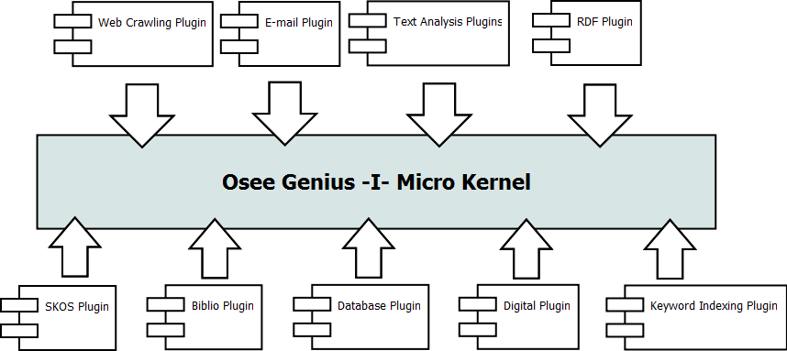
Diagram 2: Osee Genius -I- Micro Kernel architecture
All those components have been described (from functional point of view) in previous chapters. What is important here is to underline the high level of extensibility that this architecture allows, enabling a fast and easy development and integration of new components.

Osee Genius -S-
From an architecture and technology perspective, Osee Genius -S-, the search component, is basically equal to Osee Genius -I-, being built on top of Apache SOLR.
What is different is the role and the responsibility of this component, strictly dedicated to search data that have been previously indexed (by Osee Genius -I-).

Osee Genius -S-, in the same way of its brother, has a Micro Kernel architecture (depicted below) where is possible to plug-in several (search) components. Note that some of them could be found on indexing layer too because there are text analysis that have to be executed both at index and search time.

The list of components depicted on the diagram below is non exhaustive (the same consideration is valid for Osee Genius -I- diagram) simply because the plug-in catalogue is continuously growing. For detailed information about those components please refer to previous sections.

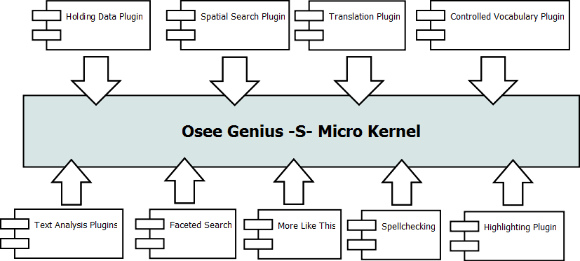
Diagram 3: Osee Genius -S- Micro Kernel Architecture

Osee Genius -Z-
As part of the interface layer, Osee Genius -Z- is a proxy that enables Z3950 connectivity.
It is a configurable module that includes only the protocol adapter logic, leaving all “search” responsibilities to Osee Genius -S-, which remains the real information retriever.

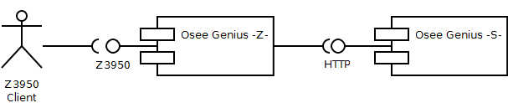
Diagram 4: Osee Genius -Z- context diagram

Osee Genius -W-
Last but not least, Osee Genius has a very nice web interface that lets you appreciate all the benefits and the power of the previously described components (that are working behind the scenes).

That interface is a web application implemented using Java Platform (specifically JEE web components).

Using the underlying JMX configuration module you can plug in / out several features like community, account management, library and social features.
While the web application itself is part of community edition and therefore is freely downloadable as an open source project, it's possible that some of those mentioned features are not included because part of the professional edition.
Osee Genius -W-, in the say way of the other sibling modules, has several extension points that let you extend the application with additional capabilities. An example: in order to display holding data Osee Genius -W- needs to lookup the database of your Library Management System (LMS). As LMS aren't usually free-ware we cannot know in advance how to retrieve such data. If you (or your team) are confident with Java coding Osee Genius -W- provides an extension point that lets you write a connector that reads holding data in your database

Deployment perspective
In this chapter we will show how Osee Genius can be deployed in a concrete scenario.

That depends on the concrete context where the application has to be deployed. That means RAM, Operating system, hardware in general, storage and of course on top of that, money.
With this precondition in mind, we will illustrate four deployment scenarios. For each of them we'll describe advantages and disadvantages.

Deployment scenario #1: four nodes
The following diagram illustrates this deployment strategy:

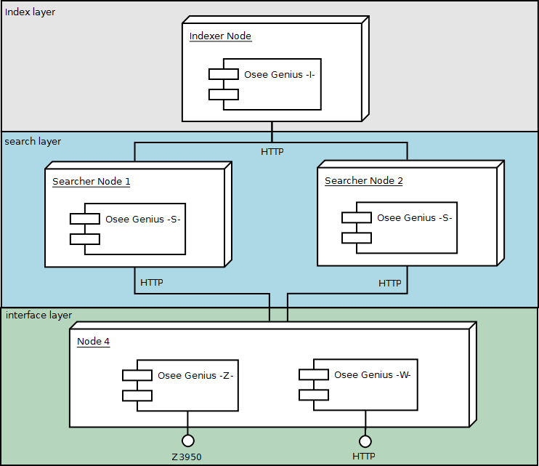
Diagram 5: Osee Genius deployment scenario #1 (four nodes)
This kind of deployment is strongly recommended in high load scenarios, because it provides a high level of scalability both in search and interface layer. Specifically, the search layer comes already with two searches -S- which are basically clones; that means requests coming from interface layer can be distributed among the two nodes in order to ensure load balancing and fail over handling.
The basic routing algorithm is a simple round-robin but, for example, we could insert a dedicated load-balancing hardware between layers in order to optimize the load distribution.

The interface layer is not depicted in a cluster because usually is not what you need. Interface layer is in charge to handle incoming client requests and, in case of Osee Genius -W-, render the appropriate web page.
Of course, although not depicted, is possible to split both Osee Genius -W- and -Z- in a clustered environment, duplicating instances and providing load balancing and fail over also in this layer. Keep in mind that in this case most probably you'll need to put a load balancer in front of those module.

The index layer is the only decoupled node from the rest of system. It is the maintainer and the manager of the index and that means non functional requirements are different for this node; specifically, (usually) there's no need to worry about fail over or load balancing. Instead we have to take care about RAM, storage and processor because the indexing phase needs a lot of resources.

Deployment scenario #2: three nodes
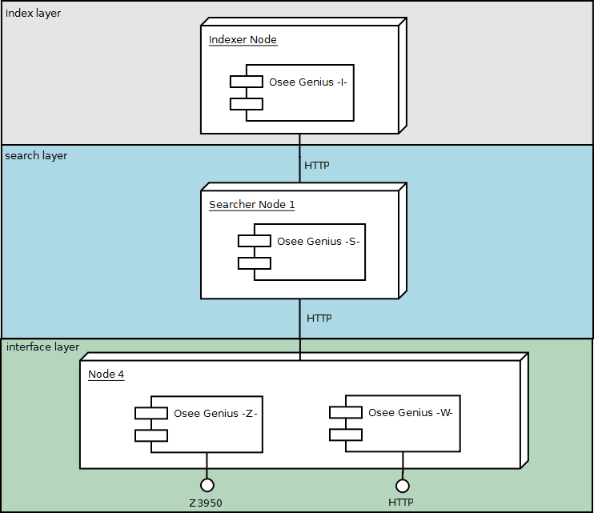
Diagram 6: Osee Genius deployment scenario #2 (three nodes)
In this scenario we have three nodes because there's one single searcher node. That means we 3 nodes instead of 4 but we don't have load balancing and fail-over on that layer.
No difference instead within the other layers.

Deployment scenario #3: two nodes
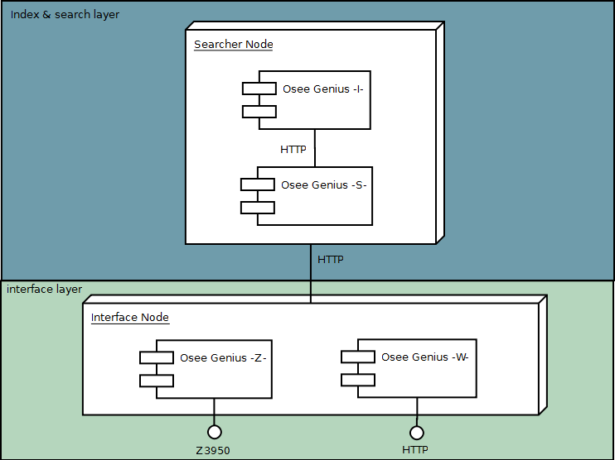
Diagram 7: Osee Genius deployment scenario #3 (two nodes)
If you got the point about difference between scenario #1 and #2, this scenario doesn't require much information.
Index and search layer are put together in a single node. From one point of view this configuration is obviously less expensive but with one disadvantage: index and search are two very different roles and each of them requires (in case of medium / big indexes) a consistent amount of resources in terms of memory, storage and processor.
So this scenario is usually recommended in cases where the size of indexed data (i.e. the size of the index) is small.

Deployment scenario #4: one node

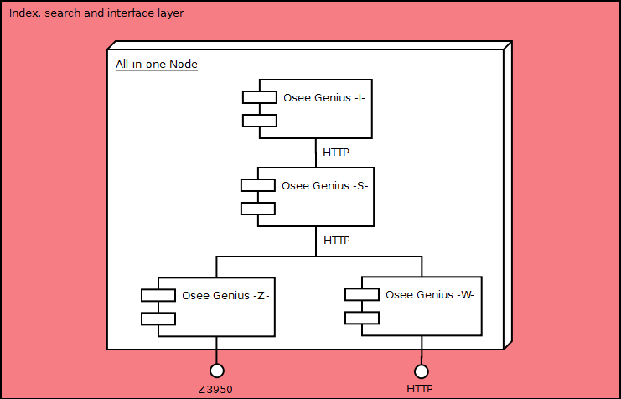
Diagram 8: Osee Genius deployment scenario #4 (one node)

Technology perspective

JEE Web components
These set of components include, strictly speaking, Java Servlets, Java Server Pages and Tag libraries. Usually a web application is not build using directly those components but instead relying on a proven existing framework like Apache Struts or Java Server Pages that leverages low details and speed up the development work, improving the level of modularity and extensibility of the overall application.

Java Server Faces
Java Server Faces is a model-view-controller set of specifications that allows developers to build web application using a component-oriented approach.
The most benefit of using JSF is the big availability of ready-to-use components

Rich Faces
The RichFaces project is an advanced user interface component framework for easily integrating Ajax capabilities into business applications implemented with Java Server Faces components.

Apache Velocity
The Apache Velocity project is basically a free open-source templating engine. Velocity is used in Osee Genius to generate web pages in applications, usually as a direct replacement for JSP.

Enterprise Java Beans (EJB)
Part of JEE specification, Enterprise Java Beans offer a fully integrated component-based model for developing enterprise application built on top of Enterprise Java Platform.

Apache log4j
Log4j is a Java based tool-kit for logging. It allows a fine control over the overall logging system, enabling modularity and hot reloading.

Apache SOLR
Solr is the popular, fast open source enterprise search platform built on top of Lucene. It is often defined as the “serverization” of Lucene, providing powerful features like full-text search, highlighting, faceted search, clustering, database integration, rich document and geospatial search.

Apache Nutch
Apache Nutch is defined as an open source web-search software. It is built on top of Lucene and SOLR, adding web-specifics, such as a crawler, a link-graph database, a parsers for HTML and several other document formats.
Osee Genius uses Nucth mainly behind the scenes, in its -I- module.

Apache Tika
Apache Tika is a set of tools for detecting, analysing and extracting both meta-data and structured text content from rich documents.

Jena
Jena is a framework for building Semantic Web applications. It provides a programmatic environment for dealing with RDF, RDFS, OWL, SPARQL.
Osee Genius uses Jena in controlled keyword indexing extensions, by providing the capability of navigating semantic relationships of a controlled vocabulary.

KEA & MAUI
KEA is an algorithm for extracting keyphrases from rich documents. MAUI extends the capabilities of KEA by implementing an additional keyword indexing algorithm that uses Wikipedia.
They are both used on Osee Genius -I- side for indexing with a controlled vocabulary.

Marc4j
MARC4J is an easy to use java-based library for working with MARC records. As you can imagine, this library is widely used in several parts of Osee Genius (indexing, searching and user interface components).

References
Java Platform
http://www.oracle.com/us/technologies/java/index.html

Java Enterprise Edition
http://www.oracle.com/technetwork/java/javaee/tech/index.html

Java Server Faces
http://www.oracle.com/technetwork/java/javaee/javaserverfaces-139869.html

Rich Faces
http://www.jboss.org/richfaces

Apache Velocity
http://velocity.apache.org/

Enterprise Java Beans
http://www.oracle.com/technetwork/java/javaee/ejb/index.html

Apache Log4j
http://logging.apache.org/log4j/1.2/

Apache SOLR
http://lucene.apache.org/solr/

Apache Lucene
http://lucene.apache.org

Apache Nutch
http://nutch.apache.org/

Apache Tika
http://tika.apache.org/

Jena
http://jena.sourceforge.net/

KEA
http://www.nzdl.org/Kea/

MAUI
http://code.google.com/p/maui-indexer/

Marc4j
http://marc4j.tigris.org/doc/

SOLRMARC
http://code.google.com/p/solrmarc/

