Requirements and Design
PR Multimediale Systeme
SS 2016 – Gruppe K5

Document Control

Contributors
Person | Role | Company | Contribution
Atdhe Kurteshi | Use Case Lead | UNIVIE | Template draft and Architecture
Joajane Montalban | Project Management Lead | UNIVIE | Design Architecture, Documentation and Milestone

Revision History
Issue | Author | Date | Description
VD.1 | Atdhe Kurteshi | 05-April-2016 | 1st Use cases revision
V0.1 | Joajane Montalban | 07-April-2016 | 1st version written

Table of Contents
1 Application Overview and Objectives 3
1.1 Application Overview 4
1.2 Objectives 4
2 Use Cases 5
2.1 Roles and Actors 5
2.2 Use Case Diagrams 6
2.3 Textual Use Case Descriptions 6
3 Architecture 7
3.1 Overview 7
3.2 Architecture for Application's Component 8
4 Project Management 10
4.1 Milestones and Schedules 11
4.2 Planned Effort per Person 13

Application Overview and Objectives
Wikipedia is considered as one of the most useful tool for Internet Users and everyone. It is free, open content encyclopedia created through the collaborative effort of a community of users known as Wikipedians. According to techtarget.com, since anyone registered on the site can create an article for publication and registration is not required to edit articles, Wikipedia faces criticisms include assertions that its openness makes it unreliable and unauthoritative. Because articles don't include bylines, authors aren't publicly accountable for what they write. Similarly, because anyone can edit any article, the site's entries are vulnerable to unscrupulous edits.

As of April 2016 there are 292 Wikipedias of which 281 are active. As of 5th of April 2016 there are 39,213,648 articles distributed in different language editions, namely: see graphic below:
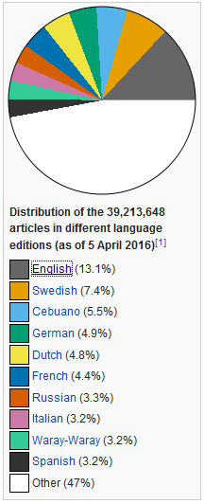

There are major problems of Wikipedia, one of which is the inconsistency of Information between language versions. e.g. population of Berlin: DE: 3,562,166, ES: 3,421,829, NL: 3.437.916, SV: 3,375,222, IT: 3,562 166

Application Overview

WikiDataReport is a Wikipedia Browser application that provide report of data differences between three different language versions. This is use to detect data inconsistency of different language versions and generate summary report. The three languages that meant to compare are among the 4 official languages in the world; namely: English, French, Spanish and German.
This application will be specifically design for the data information particularly the numeric data of a City/country. The Report is in different language versions inside a pop up window which contains the population data of a city/country in info boxes.
All results are displayed in a small window overlaying the browser.
WikiDataReport does not come with many bells and whistles. It simply serves a summary report of data inconsistency between 3 different language versions. It enables the users to know and realize the inconsistency of information provided.

The main purpose of the application is to provide information awareness to the user. The target audiences are the users who seek reliable information.

The principal functionality of WikiDataReport is to produce the summary of the found inconsistencies in three different language versions of a searched city/country. However, it will not provide which has the accurate and correct data.

Objectives
Our application objectives are to create a helping tool application and a user-friendly browser plugin application.
The following is the list of Application’s functional high-level requirements:
- search city/country in any languages
- WikiDataReport will analyse the data inside the info box of a searched city.
- Once data inconsistencies found, WikiDatareport will ask to show summary report of data found inconsistencies in three different language versions.
- Shows result in a small window overlaying the browser and the different languages are arranged in columns.
- User can select continue or exit to go back to the current page or click “see more” to any specific language version that leads to a page of a specific language.

Use Cases
In this application we only have one main actor – the user. User is identified as students, Internet savvy users, Researchers, Teachers/Professors, parents, travellers, writers, journalists and many more.
The Use cases in our application are our project goals. The identification of Use Cases are based on what does the actor-user want to accomplish with the system. The user would do the following use cases:
- Open Wikipedia Page
- Type City on Wikipedia search panel
- Show report of data found inconsistencies in three other different language versions.

Roles and Actors
The user as the main actor has the following roles:
- Who will use the system
- Who is interested in a certain feature or service provided by the system

Use Case Diagrams
Please find below our Project’s Use case diagram that determines our Project goals.
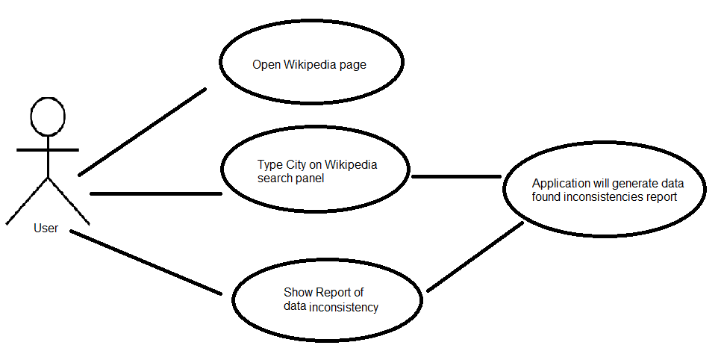

Textual Use Case Descriptions

Category | Entry
Use Case ID | 1
Title | Open Wikipedia page
Description | Open the website Wikipedia in any browser
Actor | User
Preconditions | In order for the application to work, Wikipedia page must be opened.
Success Guarantees | The application will run properly

Category | Entry
Use Case ID | 2
Title | Type City on Wikipedia Search Panel
Description | The search panel serves as the trigger of the application
Actor | User
Preconditions | The user must type a city to generate data
Success Guarantees | The application will analyse and show results if data found inconsistent or not.

Category | Entry
Use Case ID | 3
Title | Show result page of data report
Description | It enables the complete summary report in three different language versions.
Actor | User
Preconditions | User has to click the button where to show the report summary.
Success Guarantees | The summary report of data inconsistencies in three other different language version. .

Architecture

Overview
The application components are the following with description:
- Web Browser – serves as the entry level for the application to work.
- Wikipedia server 1– delivers the Wikipedia page and search results
- Search Result- triggers the application to start the application to analyse and verify information.
- Application Server 2 – the brain and root of application to run properly.

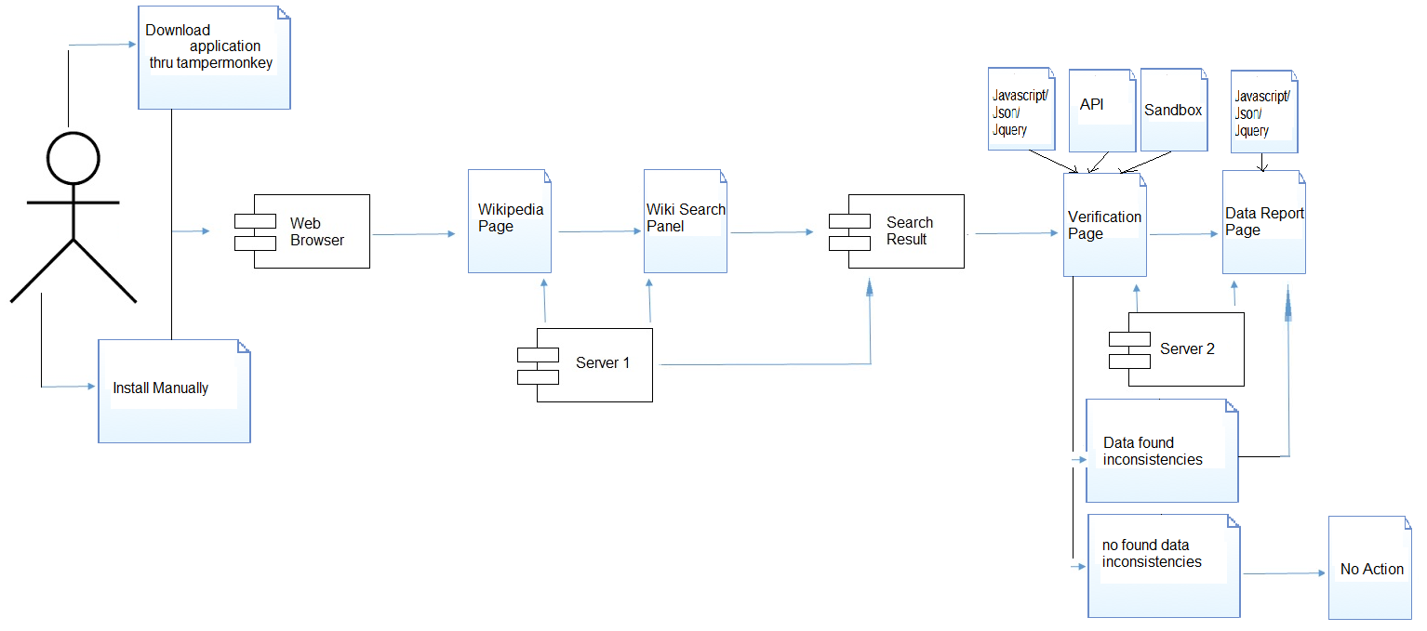

Architecture for Application’s Component

Design Considerations
There were no issues but rather a major factor that influence the designs of each component of our application. This is the operation of the application. We first had to determine the operational data that are required to ensure the efficient deployment and operation of our application. Making into consideration the application’s component and sub-systems with a clear understanding of their individual operational requirements influenced us the design of each component.

Overview of data design
The data model of our application represent the logical structure of a system. It captures the both the data requirements and the behaviour of objects within the model domain. And it defines both the data and the behaviour of a structural unit

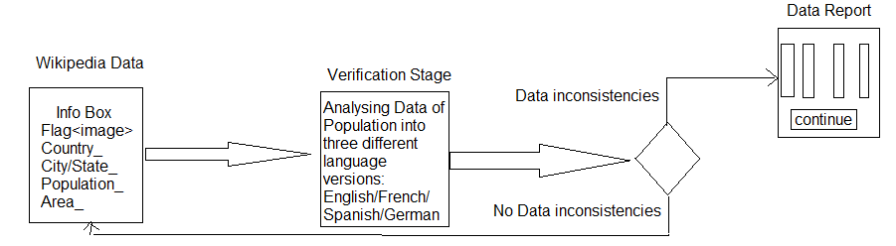

Interfaces to/from internal and external components
In our application we considered 4 components that represent the modular part our application:
- 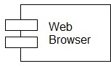 Web Browser as an application’s component serves as application’s housing stage to perform its optimal use.

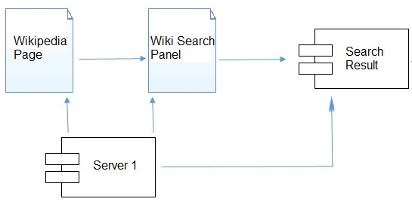

- Server 1 produces Wikipedia data of a searched city and a country.
- Search Result, triggers the application’s functionality to run. In this stage, Verification of data in three other different language is done.
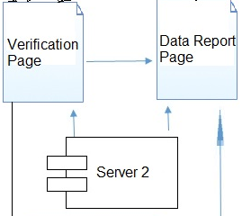
- Server 2 creates server environment that runs the application.

Project Management
We are a two man team, and we understand how important good project management is. In any project, a good project management produces good coordination and communication that are essential to a well-run project. So as managing Software Development Project.

Milestones and Schedules
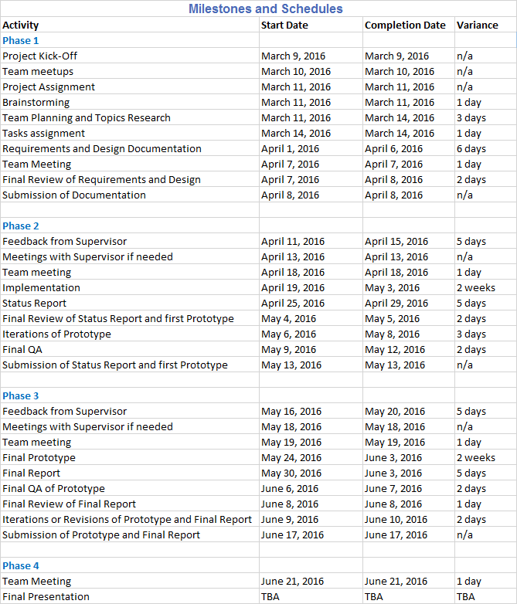
Attached is excel file, a continuation of this table which has a scheduled calendar milestone of the project.
Among the four phases of the project, the 1st phase has the most important role of the delivery of the project. The planning and understanding of the requirements and designs are the most crucial part of this project. While on the 2nd Phase, is the feedback from Supervisor. We may have common grounds as engineers but definitely has different interpretation of each case. Supervisor’s feedback is our prove and evaluation if we are on right track or not.
On the 3rd phase, the final working prototype is what we all aim for. Without this, the whole planning and project would be a failure. On the other hand, the 4th phase is an oral presentation that evaluates our performance individually and as a team.

Planned Effort per Person
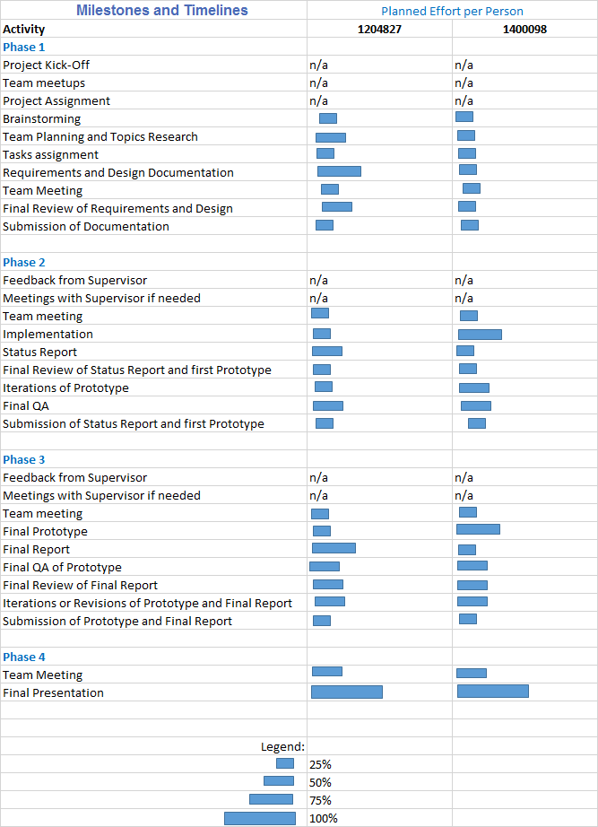
In order to meet the deadline realistically and work efficiency as a team, we delegate tasks to ourselves. This process is part of our 1st phase – Tasks Assignment/Delegation. Delegation improves efficiency when it allows work to be transferred to people whose skills are a better match for the work. And since this is a team, there is no individual decision as an alternative we communicate each other from time to time and meet common decision.
The table shows of each task that both of us contributed for both of our approval needed before this is marked complete.

