DEVIXO SOLUTIONS

TASK 02 – DATA CLEANING & FEATURE ENGINEERING
Submitted By: Ateeb Mustapha Bhatti
Organization: Devixo Solutions
Technology Used: Python, Pandas, NumPy, Scikit-learn
Dataset: Hotel Booking Demand Dataset (Kaggle)

1. Objective
The objective of this task is to transform a raw dataset into a clean and analysis-ready dataset while creating meaningful features that improve data quality and usability.

2. Dataset Description
The Hotel Booking Demand dataset was obtained from Kaggle.
Dataset Link: https://www.kaggle.com/datasets/jessemostipak/hotel-booking-demand
The dataset contains approximately 119,390 booking records and 32 columns. It includes information about City Hotels and Resort Hotels.
The dataset contains information such as:
- Hotel type
- Booking dates
- Customer information
- Number of guests
- Room types
- Booking prices
- Cancellation status
- Special requests
This dataset was selected because it contains numerical and categorical variables, missing values, duplicate records and outliers, making it suitable for data cleaning and feature engineering.

3. Data Cleaning

3.1 Handling Missing Values
Missing values were identified using Pandas isnull() function.
The following operations were performed:
- The Company column was removed because it contained a very high percentage of missing values.
- Missing values in the Agent column were replaced with 0.
- Missing values in the Country column were replaced with "Unknown".
- Missing values in the Children column were replaced using the median.
This ensures that missing values do not interfere with further processing.

3.2 Removing Duplicate Records
Duplicate records were identified using the duplicated() function and removed using drop_duplicates().
This prevents repeated records from affecting the accuracy of descriptive statistics and analysis.

3.3 Detecting and Handling Outliers
The Interquartile Range (IQR) method was used to detect outliers.
The formulas used were:
IQR = Q3 - Q1
Lower Bound = Q1 - 1.5 × IQR
Upper Bound = Q3 + 1.5 × IQR
Outliers were detected in the ADR and Lead Time columns.
The clipping method was used to limit extreme values while preserving the remaining records.

3.4 Data Type Conversion
Data types were corrected to ensure that each column could be processed appropriately.
The Reservation Status Date column was converted into datetime format.
The Agent column was converted into a categorical identifier.
These changes improve data consistency and usability.

4. Categorical Encoding
Categorical variables were converted into numerical representations using One-Hot Encoding.
This allows machine learning preprocessing algorithms to work with categorical data without assigning artificial numerical rankings to categories.

5. Numerical Standardization
StandardScaler was used to standardize numerical features.
Standardization transforms numerical values to have a mean of approximately zero and a standard deviation of one.
This ensures that numerical features with different scales can be processed more consistently.

6. Feature Engineering
Eleven new meaningful features were created.
Feature | Description
Total Nights | Calculates the total number of nights booked.
Total Guests | Calculates the total number of guests.
Is Family | Identifies bookings containing children or babies.
Is Weekend Stay | Identifies bookings containing weekend nights.
Previous Booking Total | Calculates the total number of previous bookings.
Has Previous Cancellations | Identifies customers with previous cancellations.
Has Special Requests | Identifies bookings with special requests.
Booking Value Estimate | Estimates booking value using ADR and total nights.
Arrival Season | Categorizes bookings according to the arrival season.
Lead Time Category | Groups bookings according to how early they were made.
Stay Type | Categorizes bookings into weekday and weekend stays.
These features provide additional information and make the dataset more useful for analysis.

7. Descriptive Statistics
Descriptive statistics were generated before and after preprocessing using Pandas.
The following information was examined:
- Mean
- Standard deviation
- Minimum and maximum values
- Quartiles
- Frequency of categorical values
- Missing-value counts
- Dataset dimensions
The before-and-after results were used to examine the effects of the preprocessing operations.

8. Automated Preprocessing Pipeline
An automated preprocessing pipeline was developed using Scikit-learn.
The pipeline contains two separate processing stages.
Numerical Pipeline:
- SimpleImputer using median.
- StandardScaler.
Categorical Pipeline:
- SimpleImputer using most frequent values.
- OneHotEncoder.
A ColumnTransformer was used to combine both pipelines.
The dataset was divided into:
- 80% Training Data
- 20% Testing Data
The preprocessing pipeline was fitted on the training data and then applied to the testing data to prevent data leakage.

9. Generated Output Files
The program generates the following files:
- hotel_bookings_cleaned.csv
- hotel_train_preprocessed.npz
- hotel_test_preprocessed.npz
- hotel_preprocessing_pipeline.pkl
- feature_names.csv
- y_train.csv
- y_test.csv
These files contain the cleaned dataset, preprocessed features, saved pipeline and corresponding target values.

9. Outputs
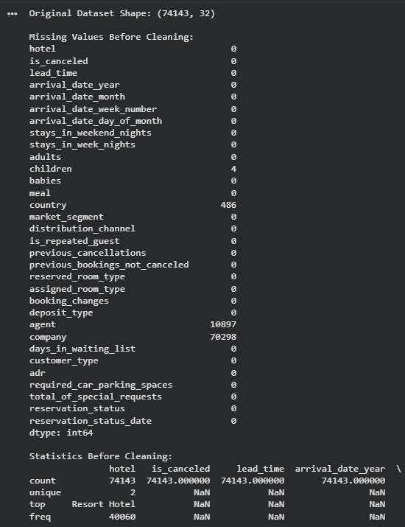
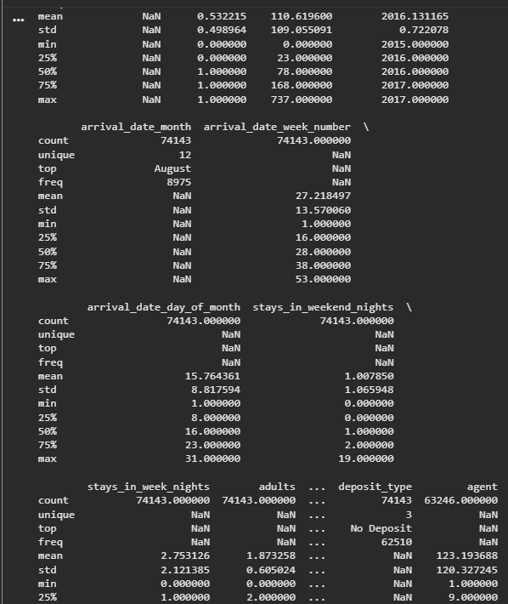
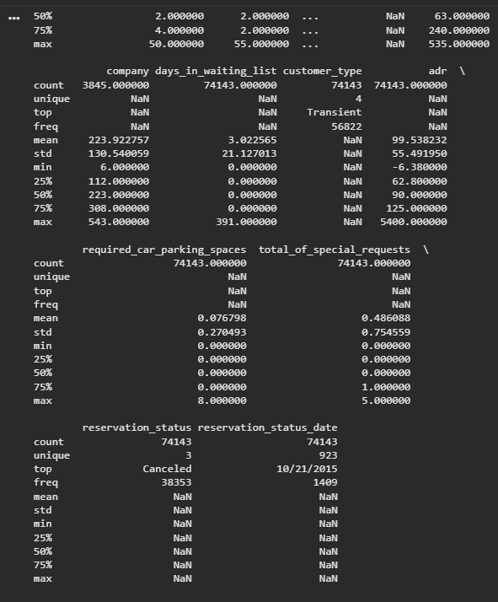
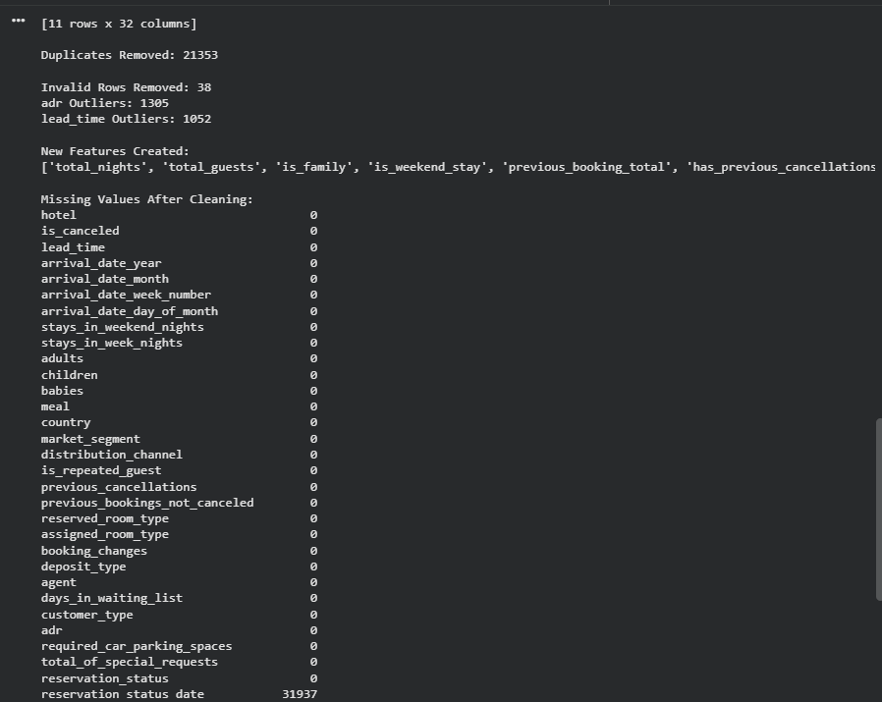
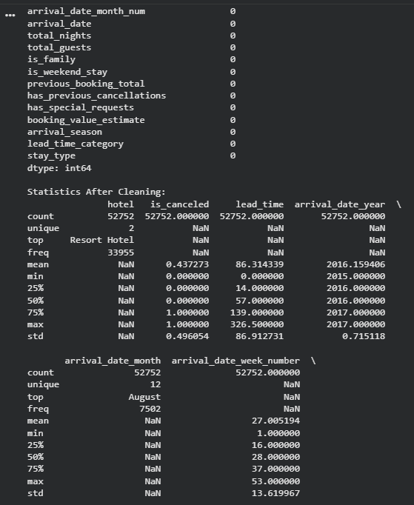
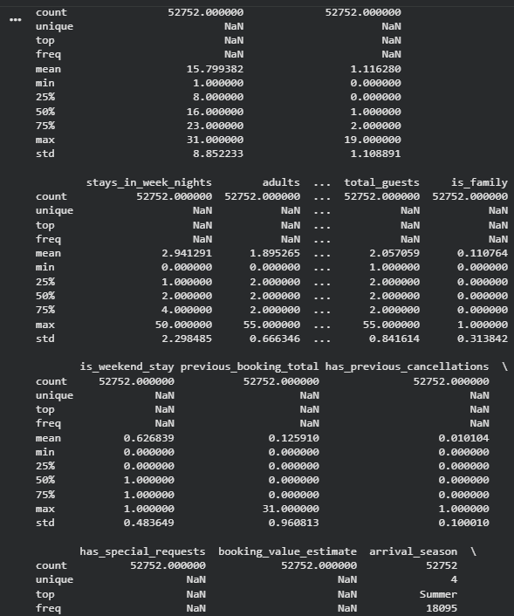
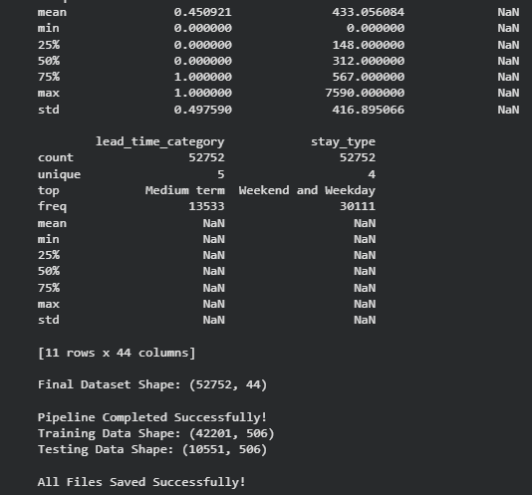

10. Conclusion
This task demonstrates the complete process of data cleaning and feature engineering using Python.
Missing values were handled, duplicate records were removed, outliers were detected and treated, and incorrect data types were corrected.
Categorical variables were encoded, numerical features were standardized, and eleven new meaningful features were created.
An automated preprocessing pipeline was also implemented using Scikit-learn, making the preprocessing process reusable and efficient.
The final dataset is cleaner, more structured and suitable for further data analysis and machine learning applications.

