Logo DJ AT



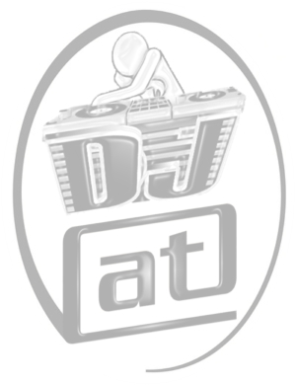

**www.**dj-at-osnabrueck**.de**

tebben**@**gmx.de

**0171**-7451535