**Keep Track of your Running with a PowerBI template**

**Track Your Miles PowerBI Dashboards** running was created to track Resting heart beat based on your Fitbit app, Miles that you ran, and the time it took to complete your distance.

The objective to have charts that you can visually see to track your running workouts,  
to improve your overall workout routine and health.

For example, you can see over a period of time whether your distance running is increasing   
or decreasing, heart rate is decreasing or increasing, or time that you are running a specific distance (For example 2 miles) has been improving or not.

Dashboards created for you:

* **Totals-** Table showing miles run and distance and heart rate
* **Resting Heart Rate** (from FitBit app)
* **Peak Heart Rate** (from FitBit app)
* **Miles run by date**
* **Pie chart** displaying Miles run on a date
* **All Heart rates**
* **Times**- bar Chart showing Times run per day

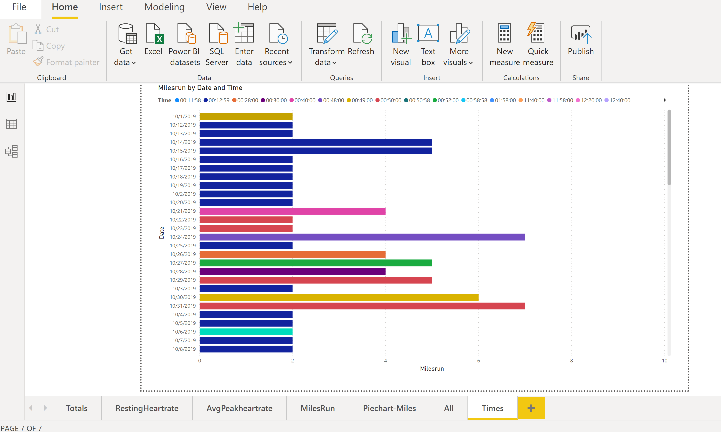

1. **Download and install PowerBI desktop and point to the Times.csv file (text file) provided with sample data as your data source.**

Power BI Desktop:

<https://powerbi.microsoft.com/en-us/downloads/>

|  |
| --- |
|  |
|  |  |  |
|  |  | Download the TrackRunning.pbix file and times.tsv files |
|  |  |  |
|  |  | Download and install newer PowerBI client from https://powerbi.microsoft.com/en-us/desktop/ |
|  |  |  |
|  |  | Open the TrackRunning.pbix file |
|  |  |  |
|  |  | Point to the times.tsv file |

1. **Go to Data**

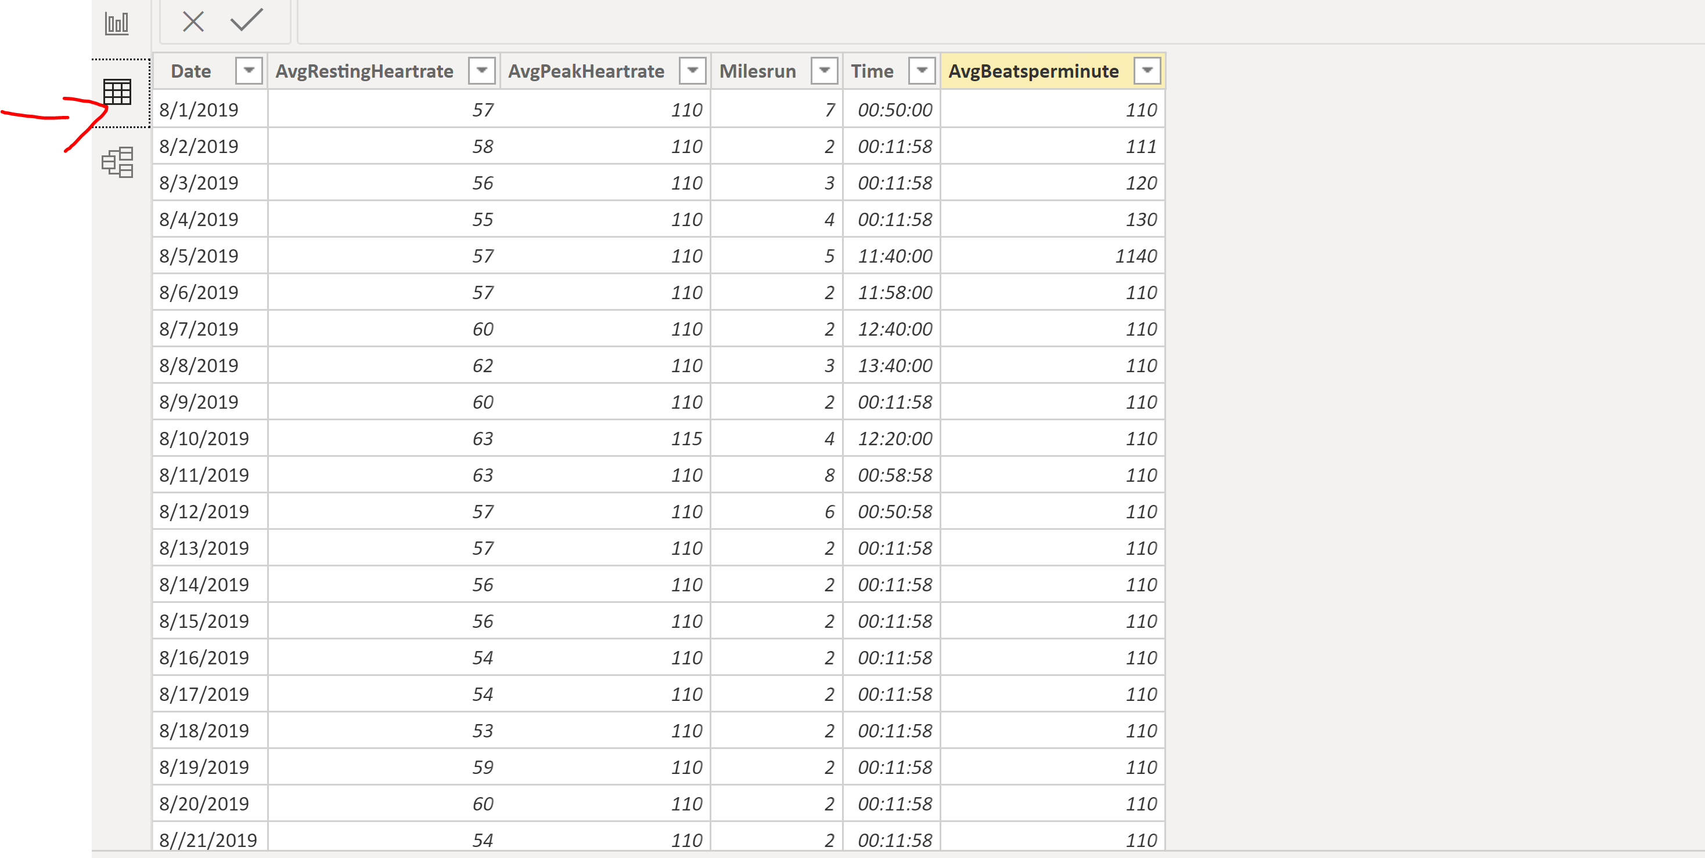

1. Right Click on the Times Table, and select **Edit Query**

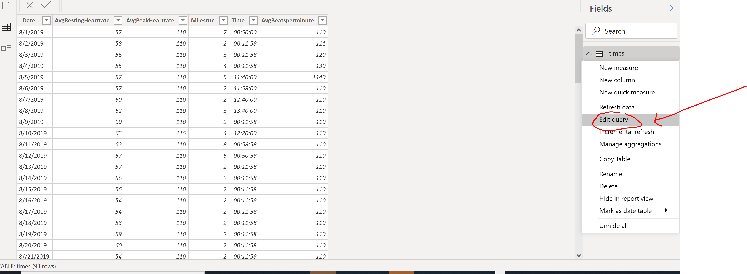

1. **Point to the location of the Times.csv file**

- Doubleclick on Source at the right of the screen.

- **Point to the location of the Times.csv file** (sample Times.csv file included for you)

- **You need to edit the Times.csv file with your own data.**

**For example, enter the date, miles and the time of your runs.**

- Check that the delimiter is Comma

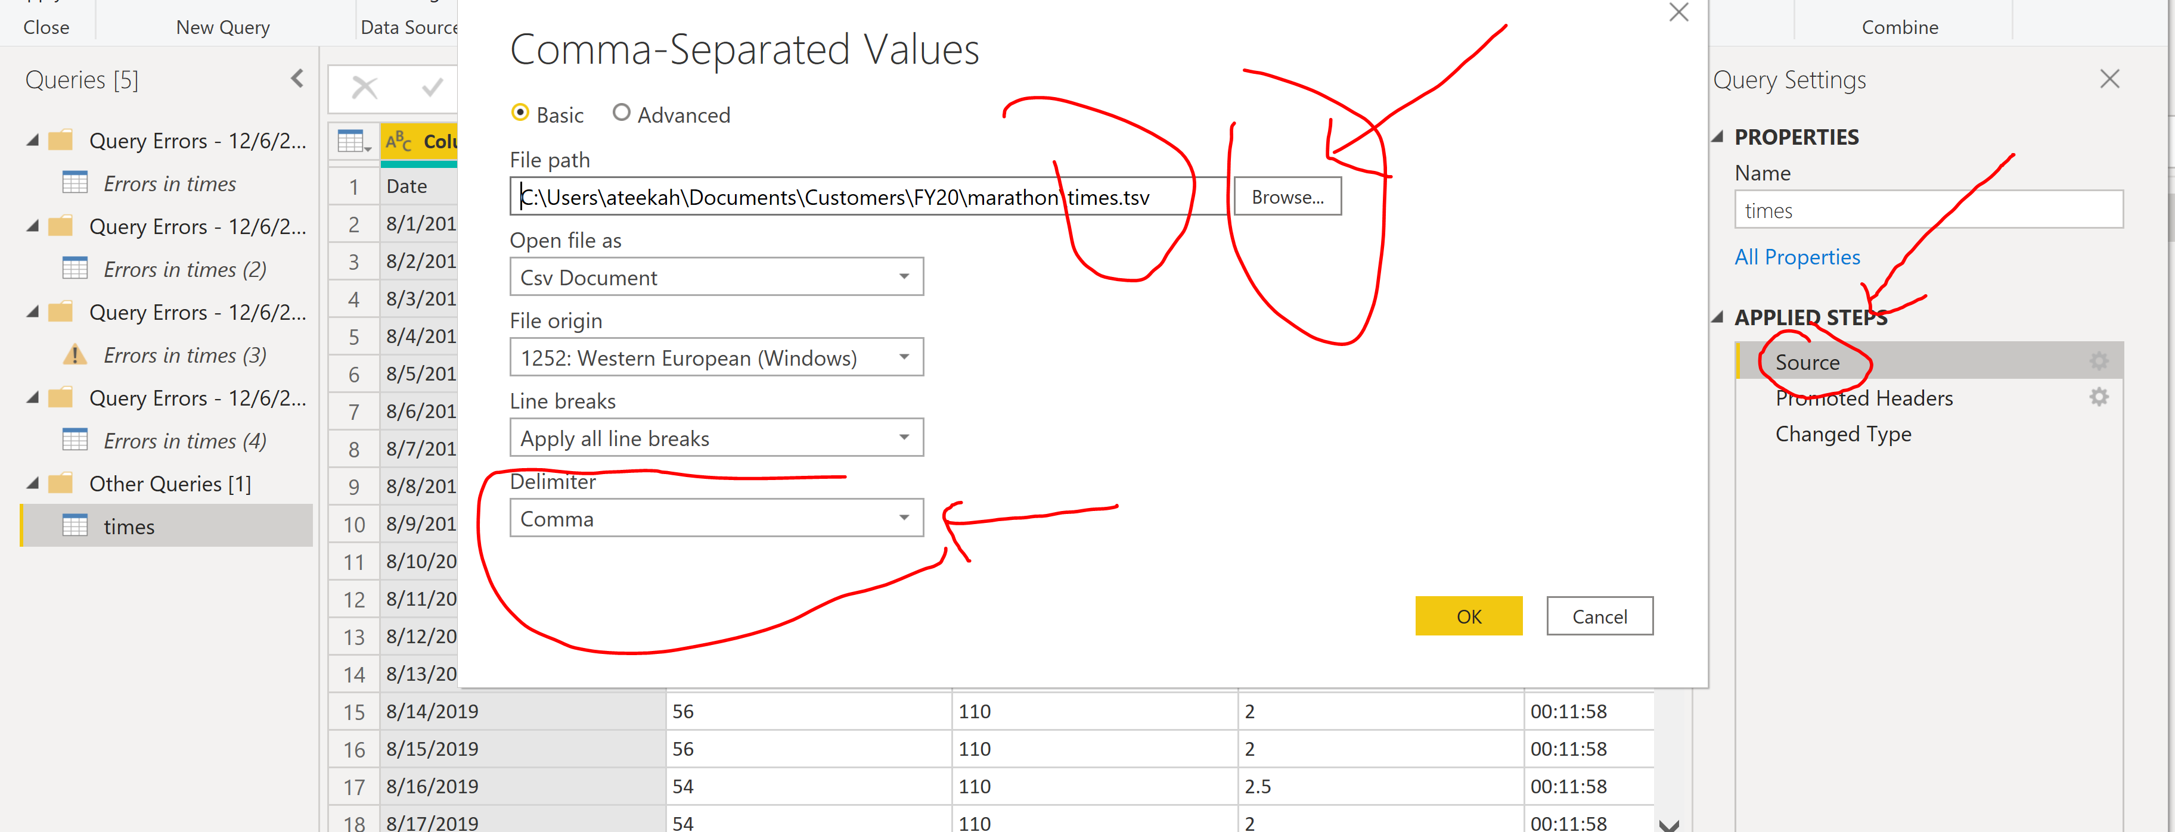

1. **Close and Apply**

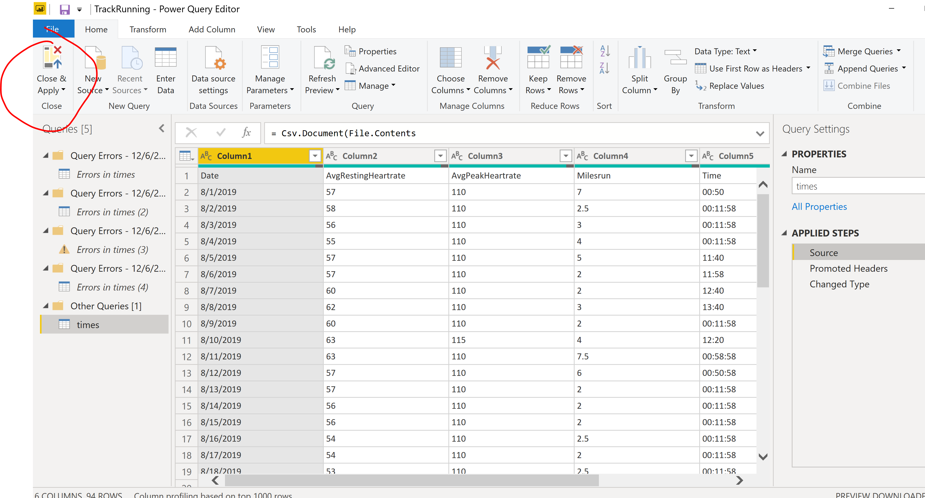

1. **Time Format** – If you see Time errors or the time displayed is incorrect, check that the Following Time Format is correct (13:30:55 **(hh:mm:ss)**

**-Select the time Column**

**- Go to Column Tools tab at the Top and select the correct Time Format**

