**5.0 Abstract and Snapshots:**

This is to highlight the key feature of the project with snapshots for each activities are shown along with discussion of each activity describing its working.Each snapshot describes every single step of alarm clock mobile Application. The project is devide into many Activities which are further divide into Sub Activities which

is discussed below.Each activity has its own functioning which we will see as we move ahead with project.Some elements are still to be included in the project so we are goin to discuess them in brief and we will also try to improvise in each section,so might notice some changes in the final project then what is discussed here.

**ALARM CLOCK MOBILE APPLICATION**

**5.1 STARTING WITH MOBILE APPLICATION DEVELOPMENT  
  
5.1.1 CREATING NEW ANDROID APPLICATION PROJECT  
  
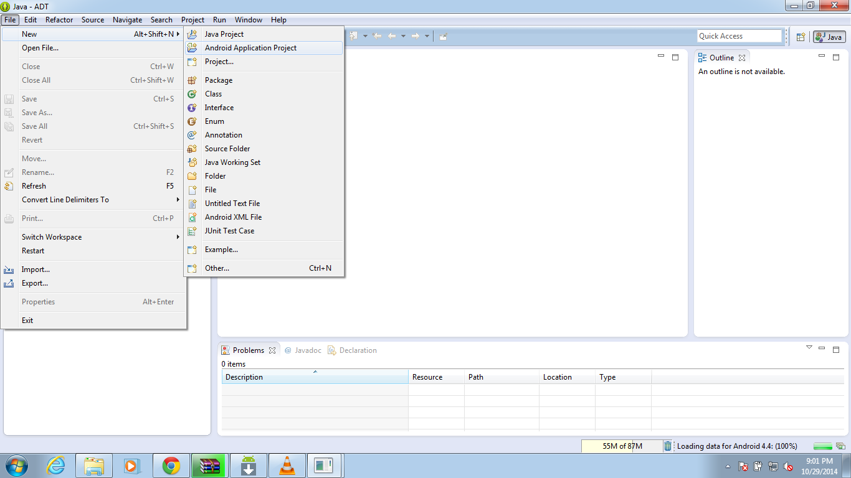**

**FIGURE 5.1**  New Android Application Project

**5.1.2 NAMING ANDROID APPLICATION**

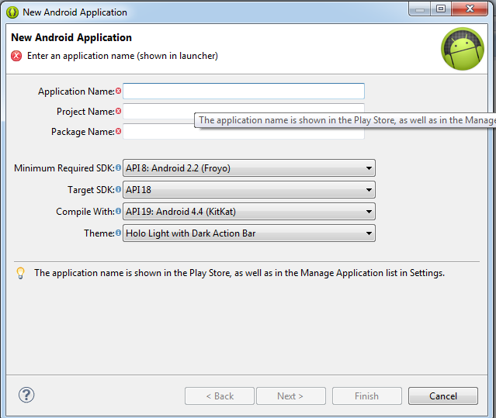

**Figure 5.2** Application Name

**5.1.3 PACKAGE EXPLORER  
  
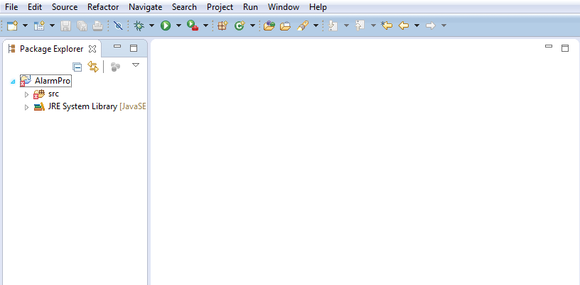**

**Figure 5.3** Package Explorer

**5.1.4 SCREEN SHOTS OF THE PROJECT**

**5.1.4.1 MAIN ACTIVITY**

