class04.R
black
2026-01-16
x <- 1:50
plot(x)
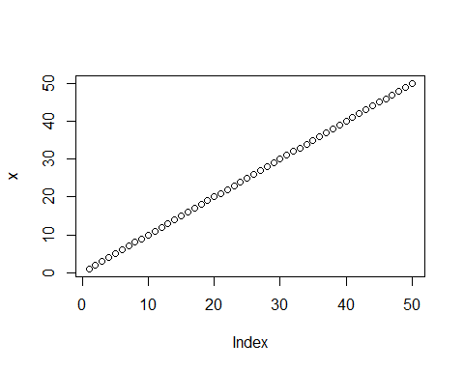
plot(x,sin(x),typ="l", col="orange", lwd=5, xlab="it is lunch time")
