Name – Ateen Rai
Rollno – 202401100200099
Branch- CSE/B
Subject - DevOps

GitHub repository URL
ateenrai/github-skills-challenge

Pull request URL used to validate the workflows
https://github.com/ateenrai/github-skills-challenge/pull/1

Screenshot showing the GitHub Actions workflows
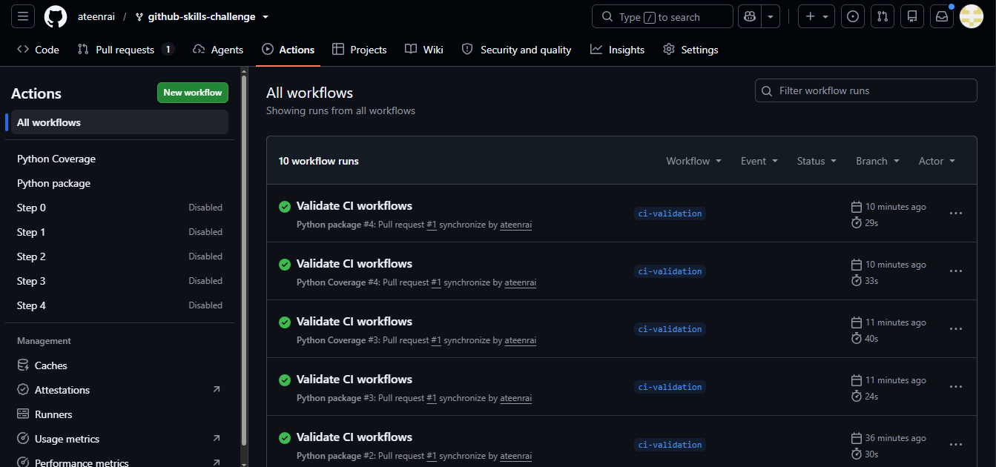

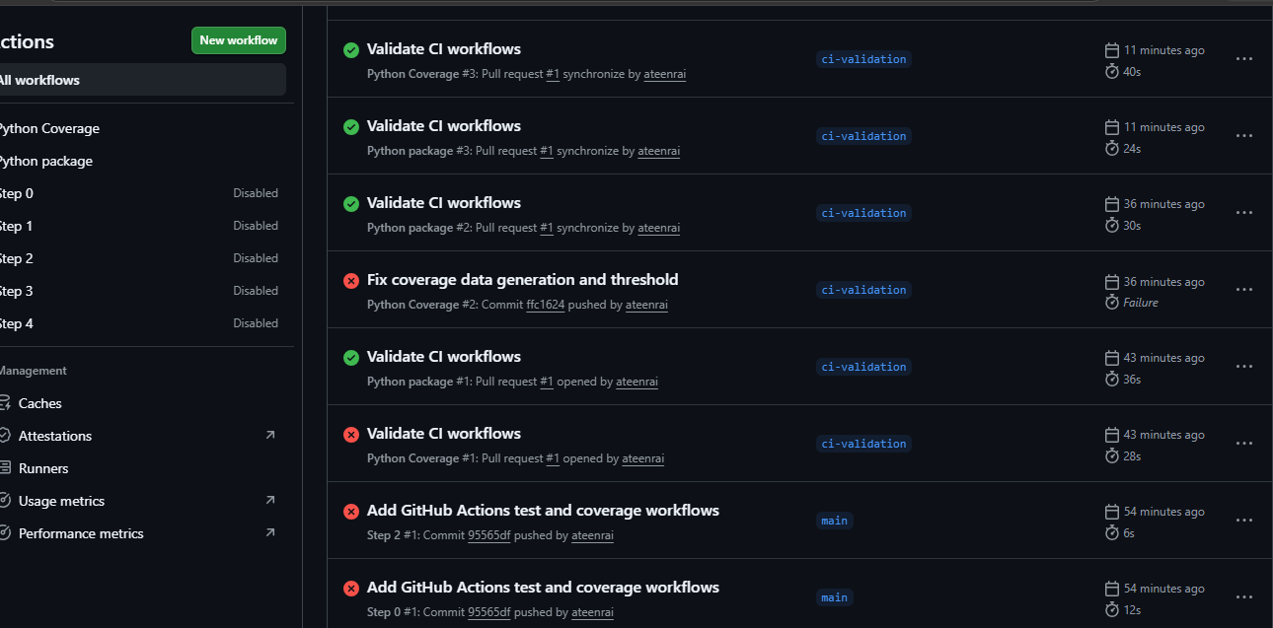

Screenshot showing the coverage result/comment on the pull request

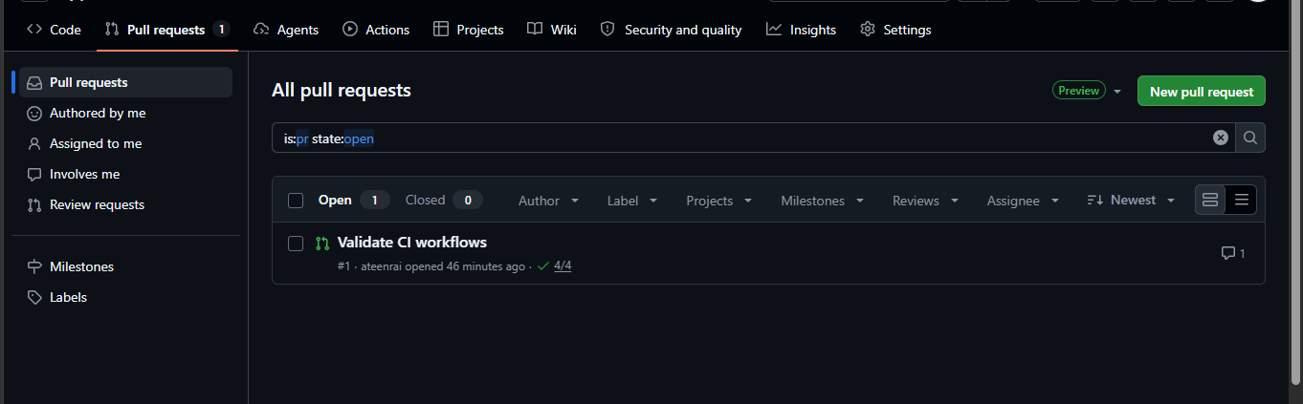

Screenshot showing the final repository/workflow files
