Software Requirements Specification

Version 1.0

<<Annotated Version>>

May 27, 2021

Atef AL-Madane Teamleader

Yara AL-Hassan

Submitted in partial fulfillment Of the requirements of CS 310 Software Engineering

<<Any comments inside double brackets such as these are not part of this SRS but are

comments upon this SRS example to help the reader understand the point being made.

Refer to the SRS Template for details on the purpose and rules for each section of this

document.

This work is based upon the submissions of the Spring 2004 CS 310. The students who

submitted these team projects were Atef AL-Madane , Yara AL-Hassan >>

**Table of Contents**

Table of Contents .................................................................................................... 3 **1.0. Introduction**

1.1.Purpose.............................................................................................................. 5 1.2. Scope of Project ............................................................................................... 5 1.3. Glossary .......................................................................................................... 6 1.4. References ....................................................................................................... 6 1.5. Overview of Document .................................................................................... 7

**2.0 Overall Description**

2.1 System Environment ……………………………………………………………………………………. 8

2.2 Functional Requirements Specification

2.2.1 Empolyee Use Case …………………………………………………………………..……. 9

Use Case : Registering a beneficiary in the system ………………….……. 11

2.2.2 Manager Use Case …………………………………………………………….…………… 11

Use Case : Evaluation of a beneficiary request by the manager ……. 12

2.3 User Characteristics …………………………………………………………………………………… 13

2.4 Non-Functional Requirement ……………………………………………………………………… 13

**3.0 Requirements Specification**

3.1 External Interface Requirements ………………………………………………………………… 14

3.2 Functional Requirements

3.2.1 Registering a beneficiary in the system ………………………………………… 14

3.2.2 Evaluation of a beneficiary request by the manager ……………………… 15

3.3 Detailed Non-Functional Requirements

3.3.1 Logical Structure of the Data ………………………………………………………………… 16

3.3.2 Security ………………………………………………………………………………………………… 16

3.3.3 Network ………………………………………………………………………………………………. 17

**1.0. Introduction**

***1.1. Purpose***

The purpose of this document is to present a detailed description of the Management Automation System . It will explain the purpose and features of the system, the interfaces of the system, what the system will do, the constraints under which it must operate and how the system will react to external stimuli. This document is intended for both the stakeholders and the developers of the system and will be proposed to the Management of Umm Al-Zinar Center for Relief and Development for its approval.

***1.2 Scope of Project***

This software system will be Management Automation System for a local establishment of Umm Al-Zinar Center for Relief and Development . The Umm Al-Zinar Center for Relief and Development is considered one of the important humanitarian organizations as it had a great role in providing various assistance in 14 regions distributed over 3 governorates (Homs - Hama - Tartous), where its main center is located in Homs, where there are data for all beneficiaries, and from this point it appeared The importance of developing a flexible management system that reduces the burden on employees and facilitates the beneficiaries' affairs easily and quickly The system also contains

a relational database containing a list Beneficiaries and their families .

***1.3 Glossary***

|  |  |
| --- | --- |
| Term | Definition |
| Beneficiary | The person who will come to the center to apply for aid from the center. |
| Employee | The person who is present in the center and is the one who will communicate with the beneficiary directly to take the information from him and add it to the system and send the request to the manager . |
| Manager | The person who manages the center and his mission is to evaluate the application submitted by the beneficiary, which is pending until the manager approves or rejects it. |
| Application / Request | It is a form in which there are many questions related to the applicant and through it the beneficiary information is entered into the system if he is accepted as a beneficiary . |
| Pending Request | The request that was sent to the manager through the system and the manager has not yet evaluated it . |
| Points Program | A program designed by the center to give each person applying to the system points according to his personal information . |

***1.4 References***

IEEE. IEEE Std 830-1998 IEEE Recommended Practice for Software Requirements Specifications. IEEE Computer Society, 1998.

***1.5 Overview of Document***

The next chapter, the Overall Description section, of this document gives an overview of the functionality of the product. It describes the informal requirements and is used to establish a context for the technical requirements specification in the next chapter.

The third chapter, Requirements Specification section, of this document is written primarily for the developers and describes in technical terms the details of the

functionality of the product.

Both sections of the document describe the same software product in its entirety,

but are intended for different audiences and thus use different language.

**2.0 Overall Description**

***2.1 System Environment***

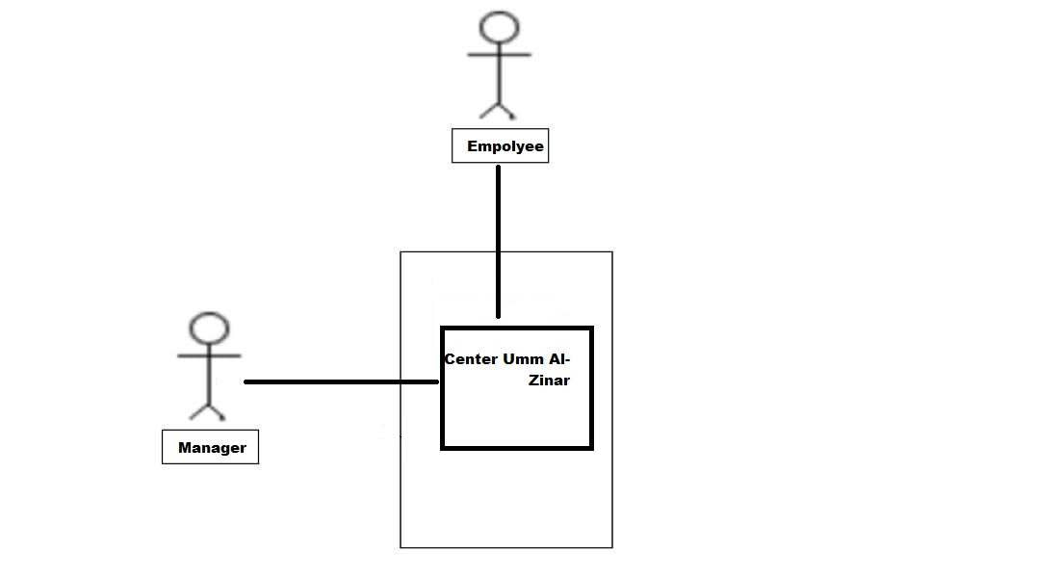

The system has two actors Where the employee accesses the system and determines the type of request to be submitted through his communication with the beneficiary .

The employee fills in the beneficiary information and sends the request through the system to the manager responsible for evaluating the request and giving the final decision for the request .

***2.2 Functional Requirements Specification***

This section outlines the use cases for each of the employee submits the beneficiary's request evaluation of the application by the director of the institution .

***2.2.1 Employee Use Case***

***Use Case :* Registering a beneficiary in the system**

**Brief Description :**

Beneficiary data management :

Here it is intended to add a new beneficiary with adding his own number and adding his information that includes:

1- His parish

2- His serial number within the center

3- Is he a resident or displaced person?

4- The father's name with his children, his mother's name and his national number (and the mother also)

5- The family book number

6- Telephone numbers for communication

7- His work and monthly income (and for the mother as well)

8- His health condition (and for the mother as well)

9 - The status of the house is it owned or rented

10- Is there a martyr or missing person in this family, and if any, his full name must be mentioned along with the date of the incident (martyrdom / loss)

11- Does he own a car, is it private or for work?

12 - The number of family members

13- The area of ​​displacement if he was displaced and the date of displacement in addition to his current residence

**Initial Step-By-Step Description :**

1 The employee logs into the system with his account and password .

2 The employee enters the application or the form he wants to work on, after asking the beneficiary what he wants .

3 The system saves the beneficiaries' information in the database .

4 The employee sends the application after filling it out and sending it to the manager .

5 The system transfers the request to the manager and remains pending until the manager responds to it .

**Diagram :**

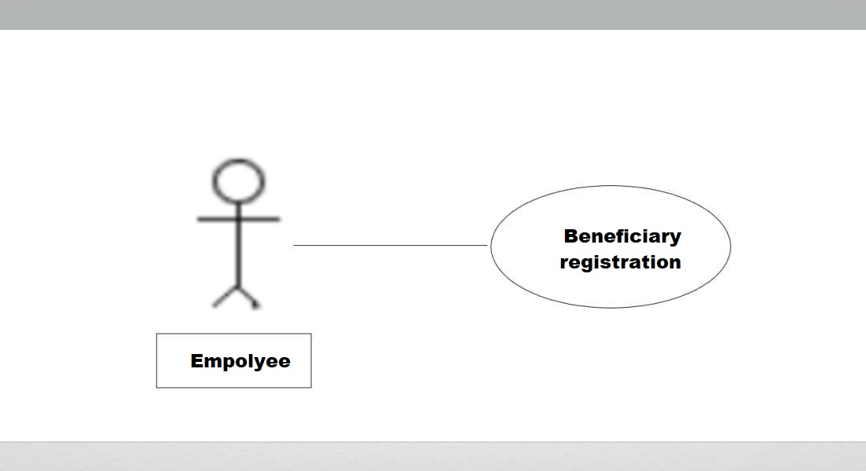

***2.2.2 Manager Use Case***

***Use Case :* Evaluation of a beneficiary request by the manager**

The manager opens the pending application and evaluates the beneficiary's request through the points program .

**Diagram :**

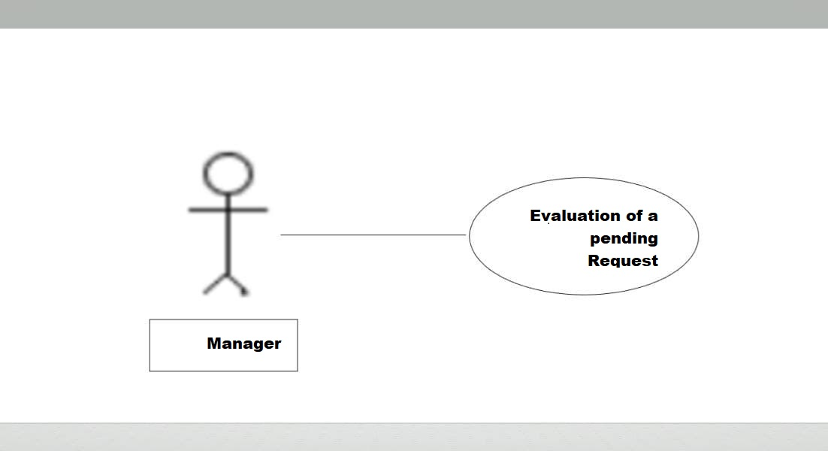

**Initial Step-By-Step Description :**

1 The administrator logs into the system .

2 He opens pending orders and logs into one of them .

3 The application is evaluated through a special program of the organization called the points program .

4 After the evaluation, the director will issue a final decision to say whether or not the request will be rejected .

***2.3 User Characteristics***

It is expected that both the manager and the employee will be able to use the computer and interact with it

As there will be a main interface through which the employee will log in to the system and deal with requests and beneficiaries' data .

***2.4 Non-Functional Requirements***

There is a network between devices within the center that work can be achieved quickly.

Print the card for the recipient in color.

Securing the confidentiality of the data within the program through a fingerprint .

The Manager will run on the Manager’ s PC and will contain an Access database. Access is already installed on this computer and is a Windows operating

system.

***3.0 Requirements Specification***

**3.1 External Interface Requirements**

The only link to an external system is the link to the Umm Al-Zinar Center Database to add a beneficiary or verify its existence and amend pre-existing information .

The Umm Al-Zinar Database fields of interest to the manage Umm Al-Zinar systems are many of the fields previously mentioned are data related to the beneficiary, such as his name, residence, number of children, and to which church he belongs etc….

**3.2 Functional Requirements**

**3.2.1 Registering a beneficiary in the system**

|  |  |
| --- | --- |
| Use Case Name | Registering a beneficiary in the system |
| XRef | Section 2.2.1 |
| Trigger | The employee registers a request for an applicant |
| Precondition | The applicant should not have registered an application before |
| Basic Path | 1- The applicant comes to the center .  2- The employee submits a request to the applicant after filling it out with the necessary information .  3- The employee sends the request to the manager for evaluation . |
| Alternative Paths | None |
| Postcondition | The request was registered and sent to the manager |
| Exception Paths | The beneficiary may abandon the request at any time. |
| Other | none |

**3.2.2 Evaluation of a beneficiary request by the manager**

|  |  |
| --- | --- |
| Use Case Name | Evaluation of a beneficiary request by the manager |
| XRef | Section 2.2.1 |
| Trigger | The principal evaluated the pending application according to the points program |
| Precondition | There should be a pending request |
| Basic Path | 1- The administrator logs into the system  2- He finds some request pending  3- The application is evaluated according to the points program |
| Alternative Paths | None |
| Postcondition | The application was evaluated and the response came either by accepting or rejecting the request |
| Exception Paths | none |
| Other | none |

**3.3 Detailed Non-Functional Requirements**

**3.3.1 Logical Structure of the Data**

The logical structure of the data to be stored in the internal Center Umm Al-Zinar Manager database is given below .

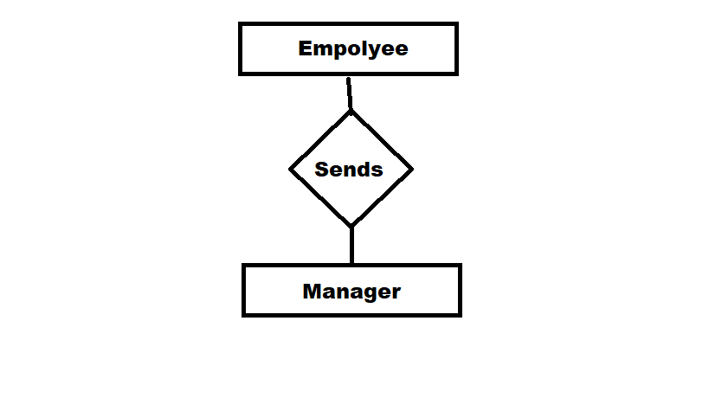

**3.3.2 Security**

There will be a local network in the center that will be fast and protected with appropriate protocols to protect it from penetration, and there will be contact with a nationwide network in order to send information between centers in the governorates .

**3.3.3 Network**

The PC on which the Manager resides will have its own security. Only the

Manager will have physical access to the machine and the program on it .