<Title of the Project>

# Introduction

Using predictive analytics on the income of immigrants to Ontario by sex, landing age, immigrant admission category & family status to determine trend and pattern. The analysis is to determine if there is a correlation between the Admission category, Family Status, sex and age with income. To be able to predict what category of yields highest income. The data set is published by Statistics Canada. The data is packaged in a CSV file. The data can be converted to a cube with 8 dimensions. The quantitative data is under Value and is classified by categorical data found under Statistics. Python is used to explore the data in and for Outlier detection and then time-series analysis is performed to see the rate of income growth year over year. Ideally, this data can be used to train a model to predict the best category to immigrate to Ontario and the potential income based on the user profile.

# Literature Review

The number of immigrants coming to Canada has seen a massive increase. In 2016, there was almost 321,000 new landed immigrant which 33% higher than the previous year. [1] While the massive increase in immigration impact on the economy in a macroeconomic level. The studies show that immigration has a positive impact on the Canadian Labor market. The issue lies in the fact that even though it is positively stimulating the economy the new landed immigrants are fall into poverty. [2]

As new immigrants land then need to be able to integrate into the economy smoothly. While there are multiple ways to integrate the immigrants, who come via Skilled labor class contribute to the innovative capacity and inherently contrite to their wage increments. [3]

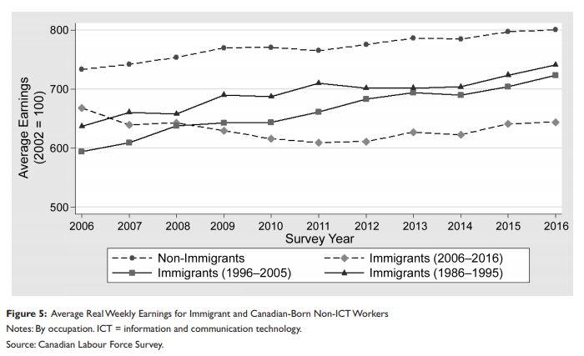For example, in the Information and Communication Technology (ICT) labor market there is an increasing need for skilled and experienced people. In the last few decades number of immigrates who have come in through the Federal programs and the skilled labor programs has the shortage less but there is still a demand. As new immigrates came and joined it has dampened the increase of wages in the ICT group, see graph below:

This has also resulted in a lack of interest for Canadians to pursue training in the ICT careers. [4]

There are also other factors which contribute the income of immigrates. Immigrates in a region can be categorized in two types:

1. International Immigrates
2. Interprovincial migrates.

While the international immigrates measure lower compare to the Canadian-born counter parts, whereas interprovincial migrants are more skilled than the non-migrants. [5]

Some programs which have brought immigrates to Canada see a significate gap in the earning compare to Canadian counter parts. “According to the study, the average Canadian-born man earned $33,887 in 1996, while male immigrants earned an average of $20,603 over their first five years in the country.” While Canadian employers favor more Canadian workers it significantly impacts the settlement efforts of the new immigrates. [6]

# Dataset

The Data set used for this project is a cube from Statistics Canada.

Cube Title: Immigrant income by period of immigration, Ontario, inactive

URL: https://www150.statcan.gc.ca/t1/tbl1/en/tv.action?pid=4310005501

|  |  |
| --- | --- |
| Attribute | Description |
| Year | Year |
| Sex | Gender, Male, Female, or Both |
| Landing.age.group | Age group of the people. It is captured as a range, example 2 to 24 |
| Immigrant.admission.category | Category in which they became immigrants |
| Family.status | Family Status, single or Family |
| VALUE | Total Income |

The dataset was analyzed to see if it was equally distributed and each of the features were well represented.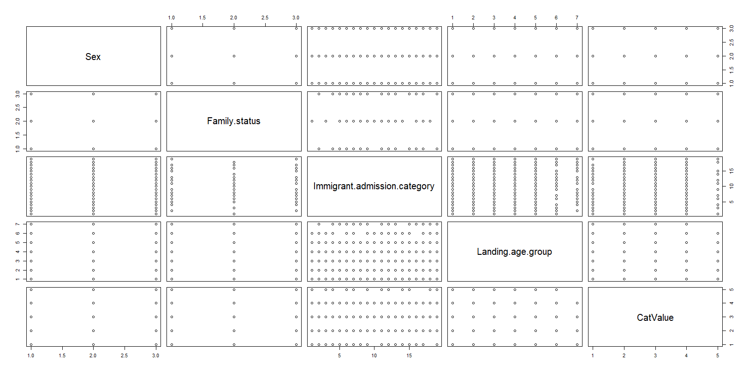

# Approach

## Step 1: Data Collection & Cleaning up

### Data Collection

The dataset was created by stats Canada. It was a archived in a cube format.

The data can be found in <https://github.com/atefalvi/Ryerson_Capstone>

Data/flattendata.csv

## Step 2: <Name of the step>

Write details of the step 2. If there is any source code that you’d like to share then provide the link of the Github.

………………………………………………………………………………………………………………………..

………………………………………………………………………………………………………………………..

## Step N: <Name of the step>

Write details of the step N. If there is any source code that you’d like to share then provide the link of the Github.

# References:

[1]"Government Advisory Group Recommends Massive Increase to Canadian Immigration Numbers Over Next Five Years." *Canadian Government News*, 20 Oct. 2016*. Canadian Periodicals Index Quarterly*, https://link-galegroup-com.ezproxy.lib.ryerson.ca/apps/doc/A467543991/CPI?u=rpu_main&sid=CPI&xid=54874c1e. Accessed 30 June 2019.

[2] Dungan, Peter, Fang, Tony, and Gunderson, Morley. 2013. “ Macroeconomic Impacts of Canadian Immigration: Results from a Macro Model.” *British Journal of Industrial Relations* **51**

[3] Asadul Islam, Faridul Islam and Chau Nguyen, Skilled Immigration, Innovation, and the Wages of Native‐Born Americans, *Industrial Relations: A Journal of Economy and Society*, **56**, 3, (459-488), (2017).

[4] Thomson, Alexander & Veall, Michael & Sweetman, Arthur. "Is There Evidence of an Information and Communication Technology Labour Shortage in the Canadian Labour Force Survey?" *Canadian Public Policy*, vol. 44 no. 1, 2018, pp. S1-S12. *Project MUSE*, muse.jhu.edu/article/711476.

[5] Coulombe, Serge, and Jean-François Tremblay. "Migration and Skills Disparities Across the Canadian Provinces." *Regional Studies* 43.1 (2009): 5-18. Web. 30 June 2019  
Coulombe S. and Tremblay J.-F. Migration and skills disparities across the Canadian provinces, Regional Studies.

[6] Jimenez, Marina. "Earnings Study shows Immigration Not Boosting Economy: Income Gap between Newcomers and Canadians has Widened since '70s: National Edition]."*National Post*, Apr 27, 2000, pp. A4*. ProQuest*, http://ezproxy.lib.ryerson.ca/login?url=https://search-proquest-com.ezproxy.lib.ryerson.ca/docview/329611417?accountid=13631.

[7] Moore, Eric G., and Michael A. Pacey. “Changing Income Inequality and Immigration in Canada, 1980-1995.” *Canadian Public Policy / Analyse De Politiques*, vol. 29, no. 1, 2003, pp. 33–52. *JSTOR*, [www.jstor.org/stable/3552487](http://www.jstor.org/stable/3552487).