I have ctreated a flow like

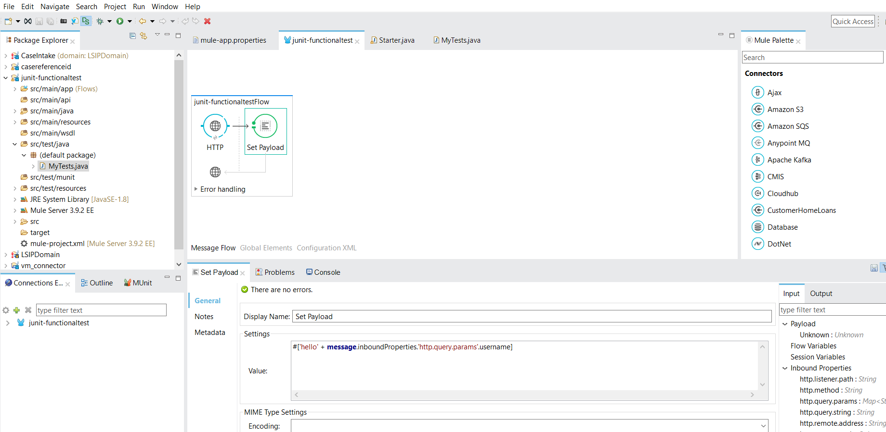

And a javaclass like

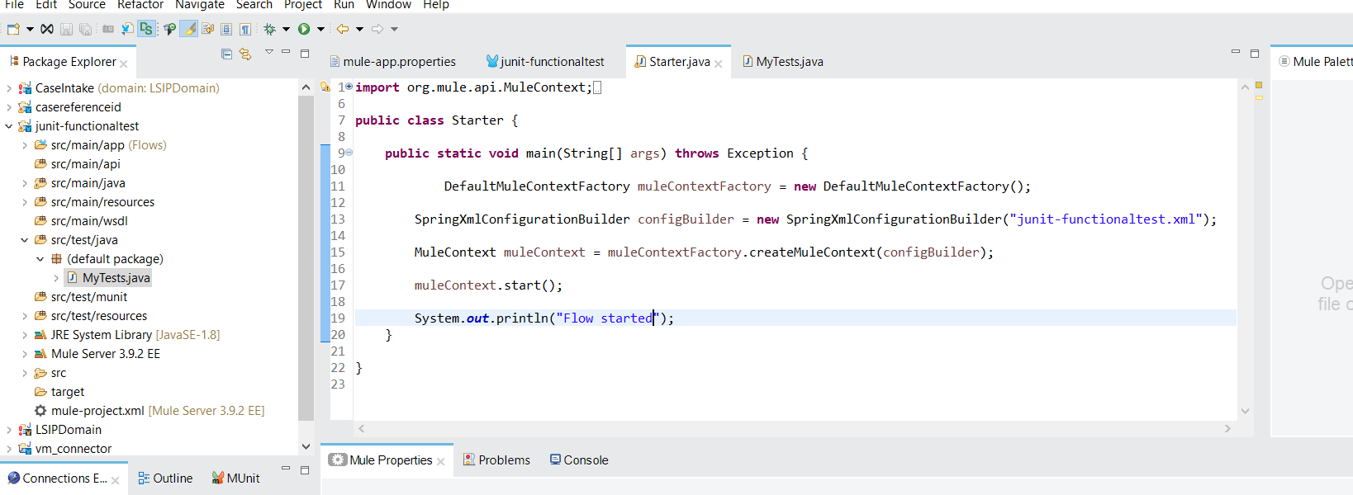

And called the flow from the browser like

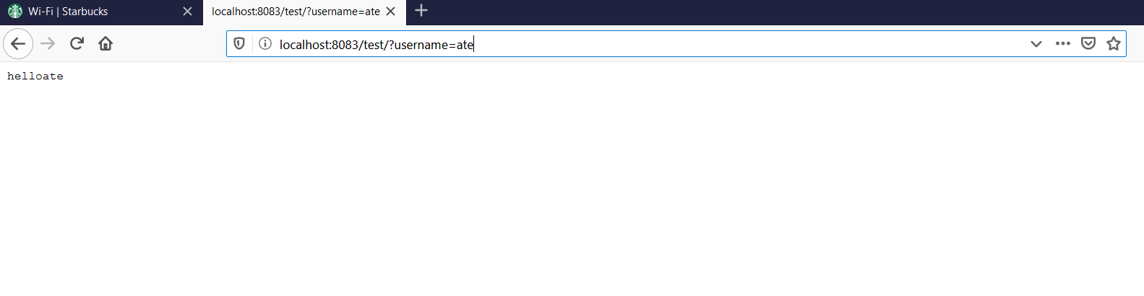

Thus the mule flow is invoked from javaside

Now I want to do Junit functional testing:

1. Create a java class under src/test/java = **MyTests**

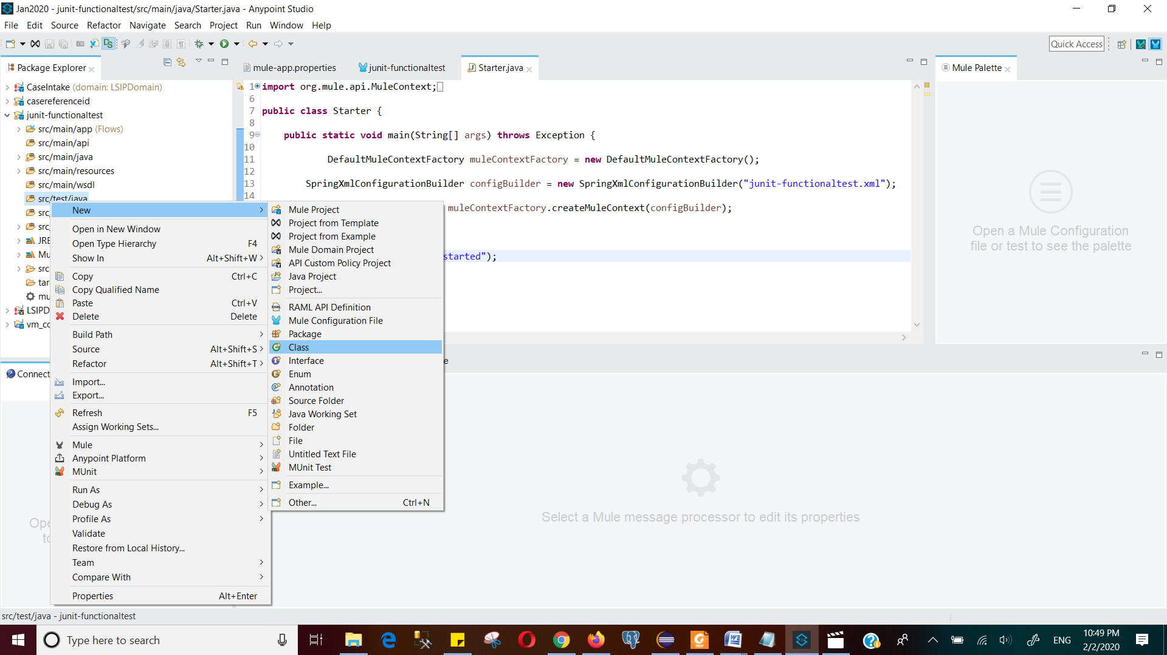

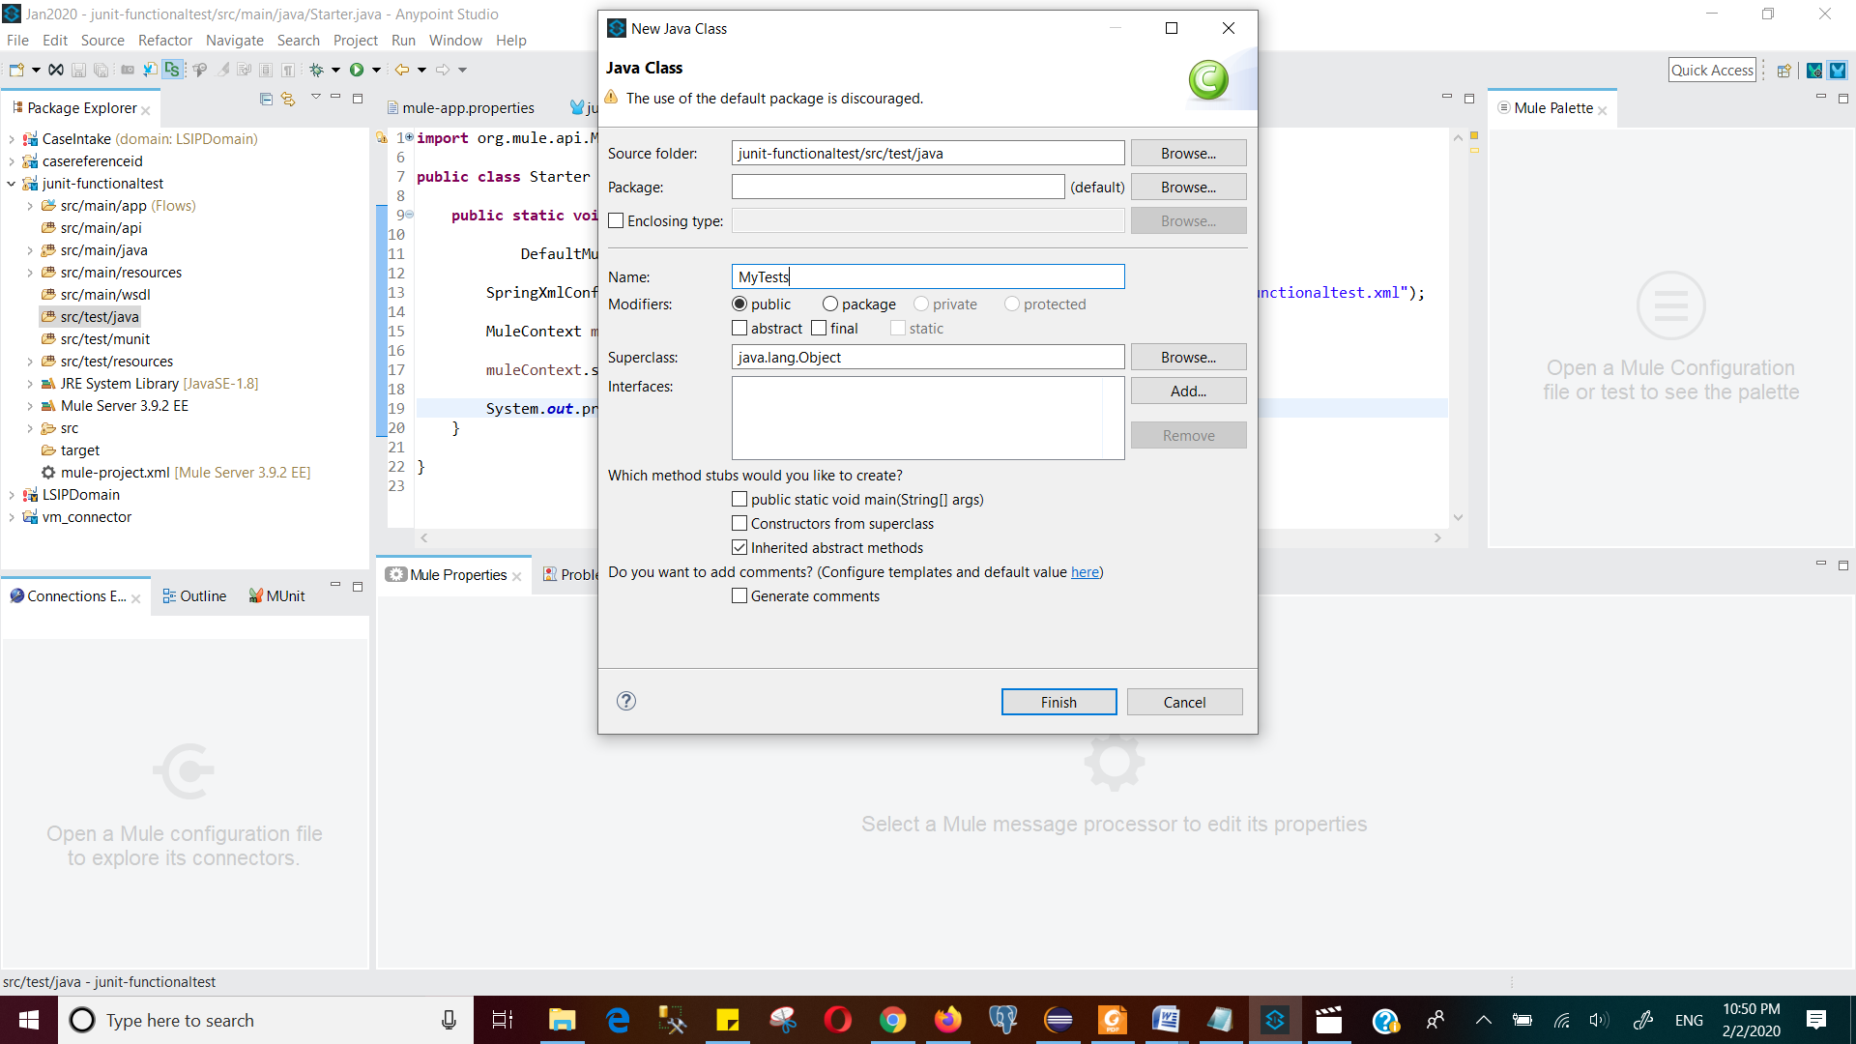

The junit is written below

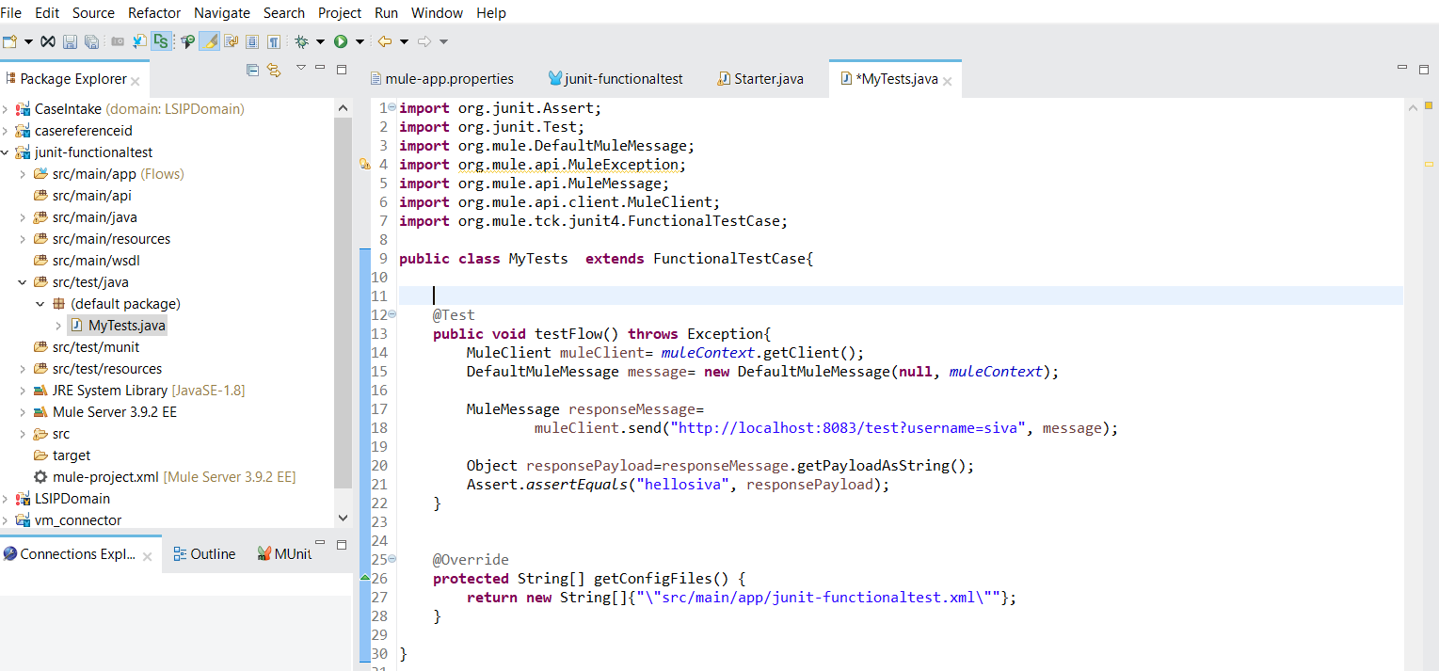

Then run as junit

