I have a flow like the following

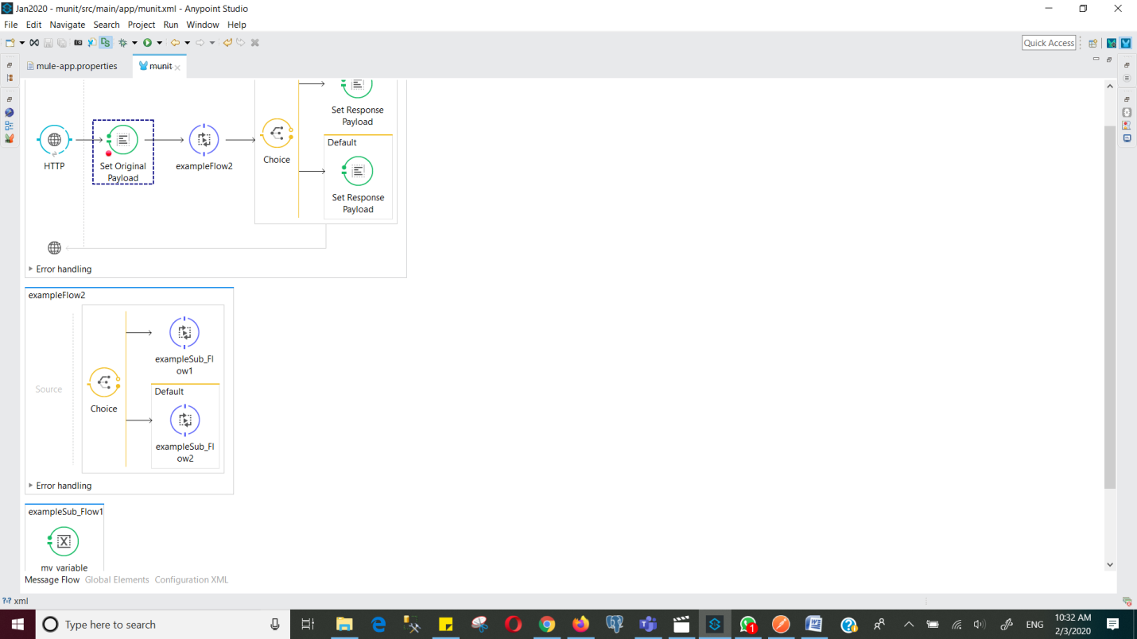

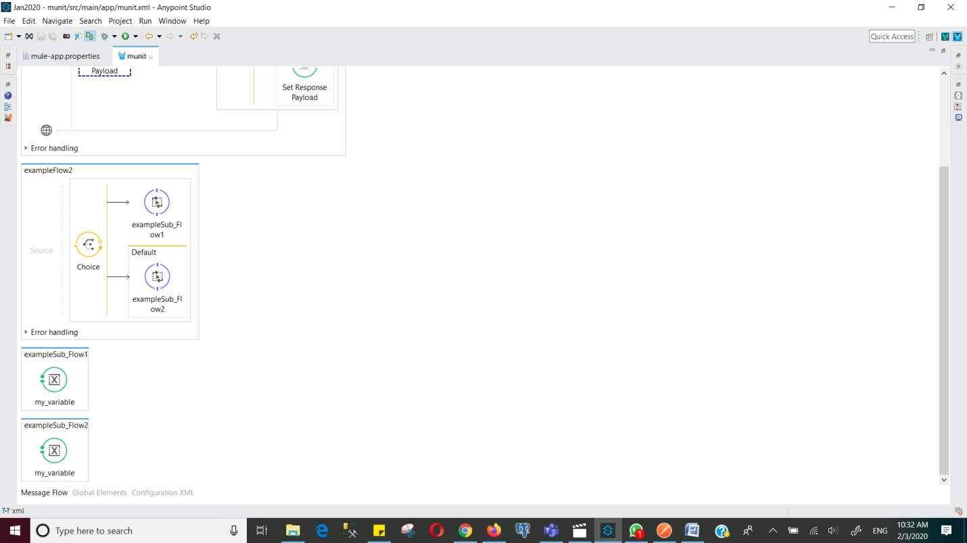

**Setpayload=** #[**message**.inboundProperties.'http.query.params'.url_key]

Start debugging

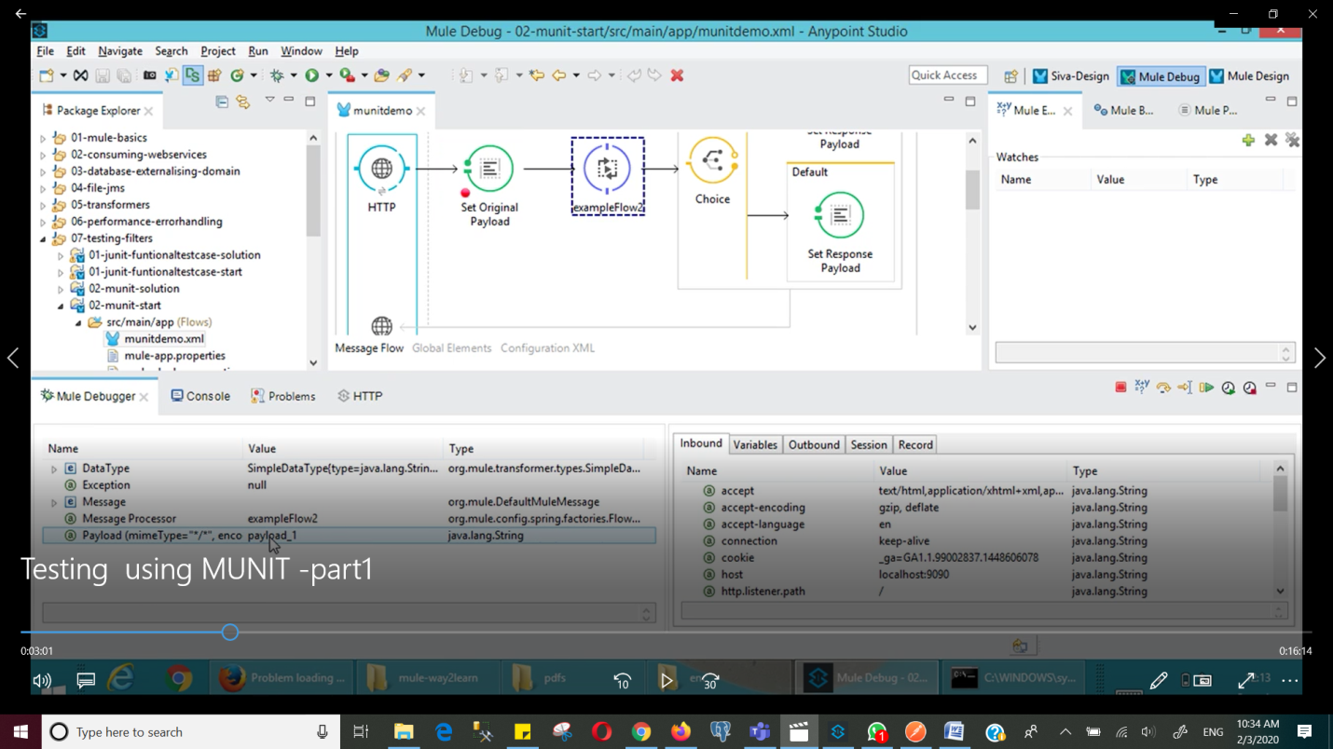

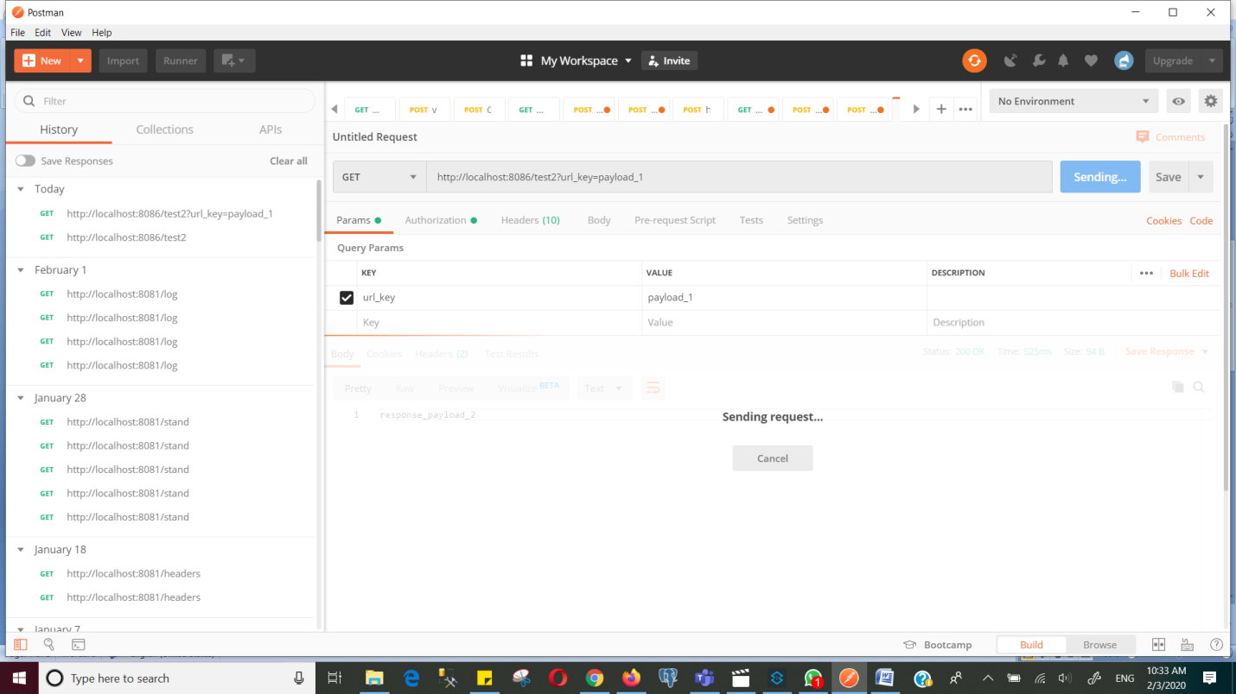

Initially the payload is null as shown

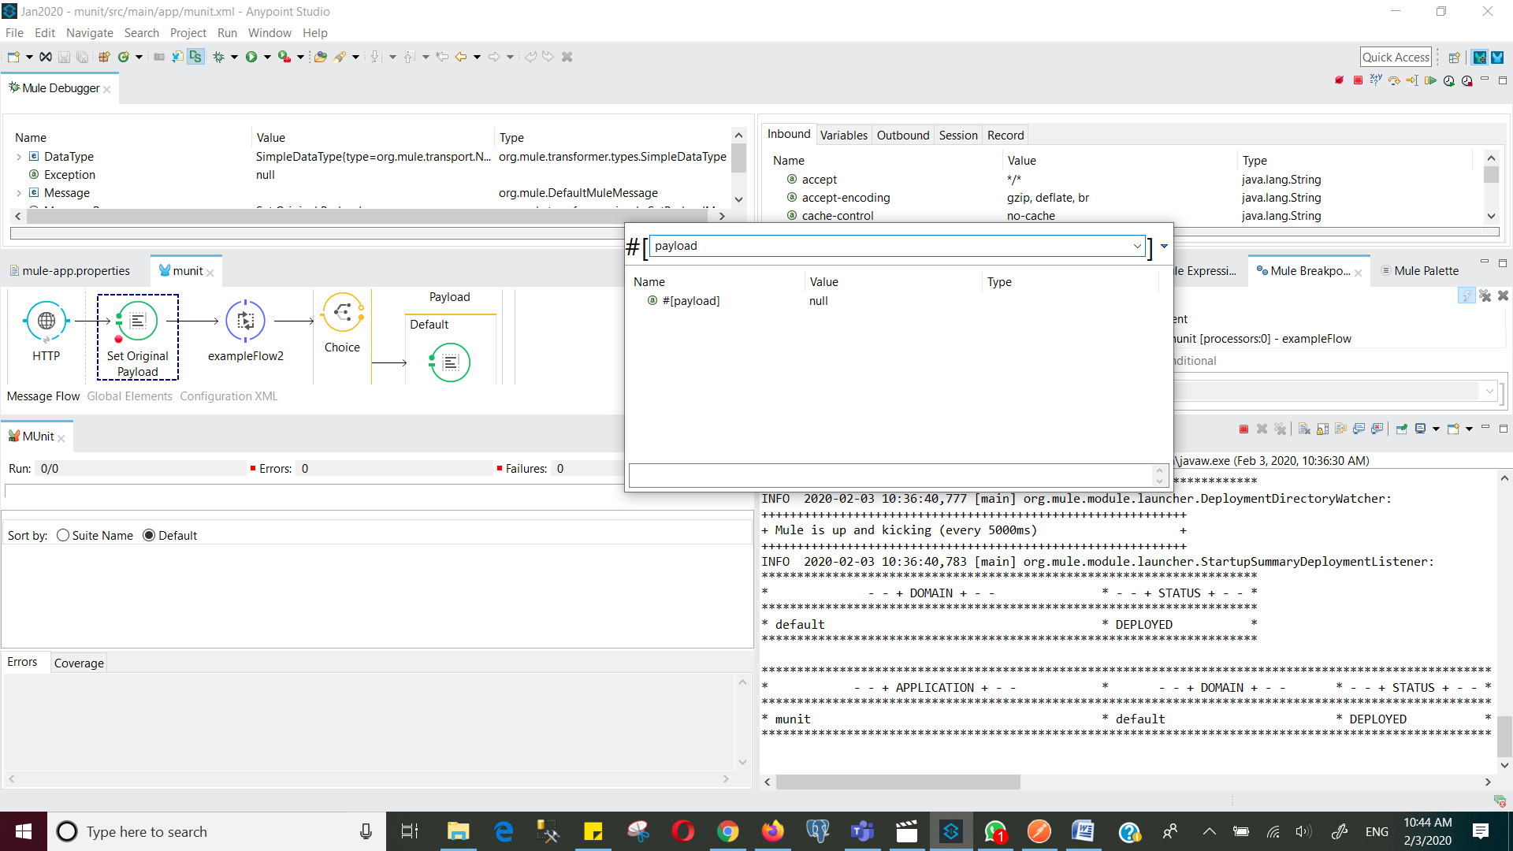

Now go next and see, here (below) the payload is shown

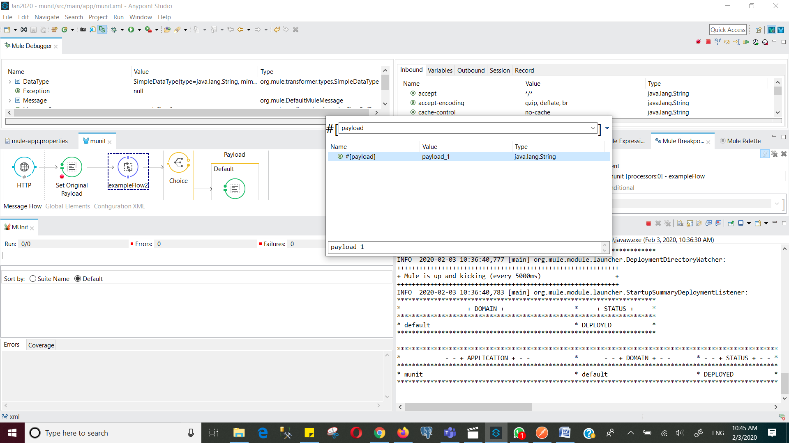

The flow goes to flowexample2 and put a break point on that choice and hit next and still the payload is payload_1

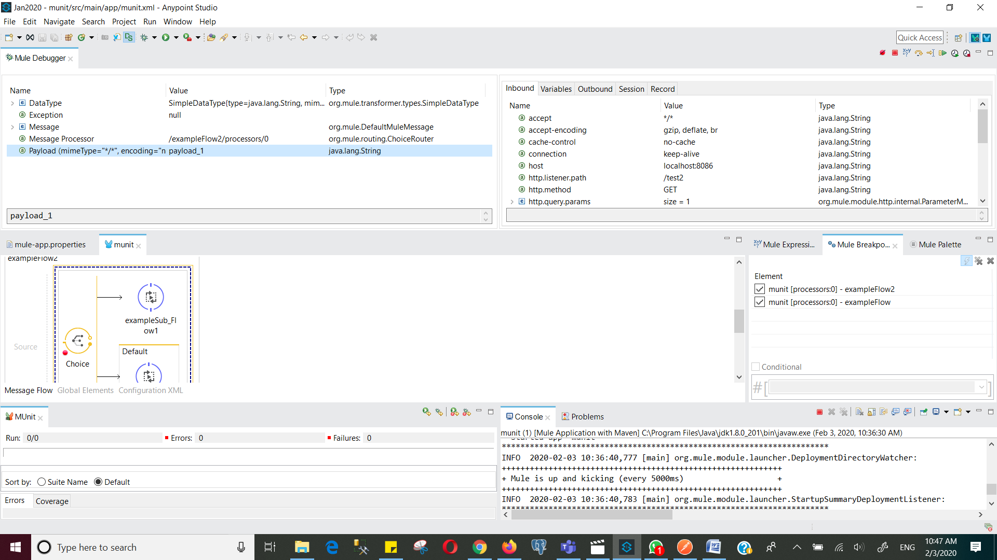

The flow goes to variable and put a breakpoint

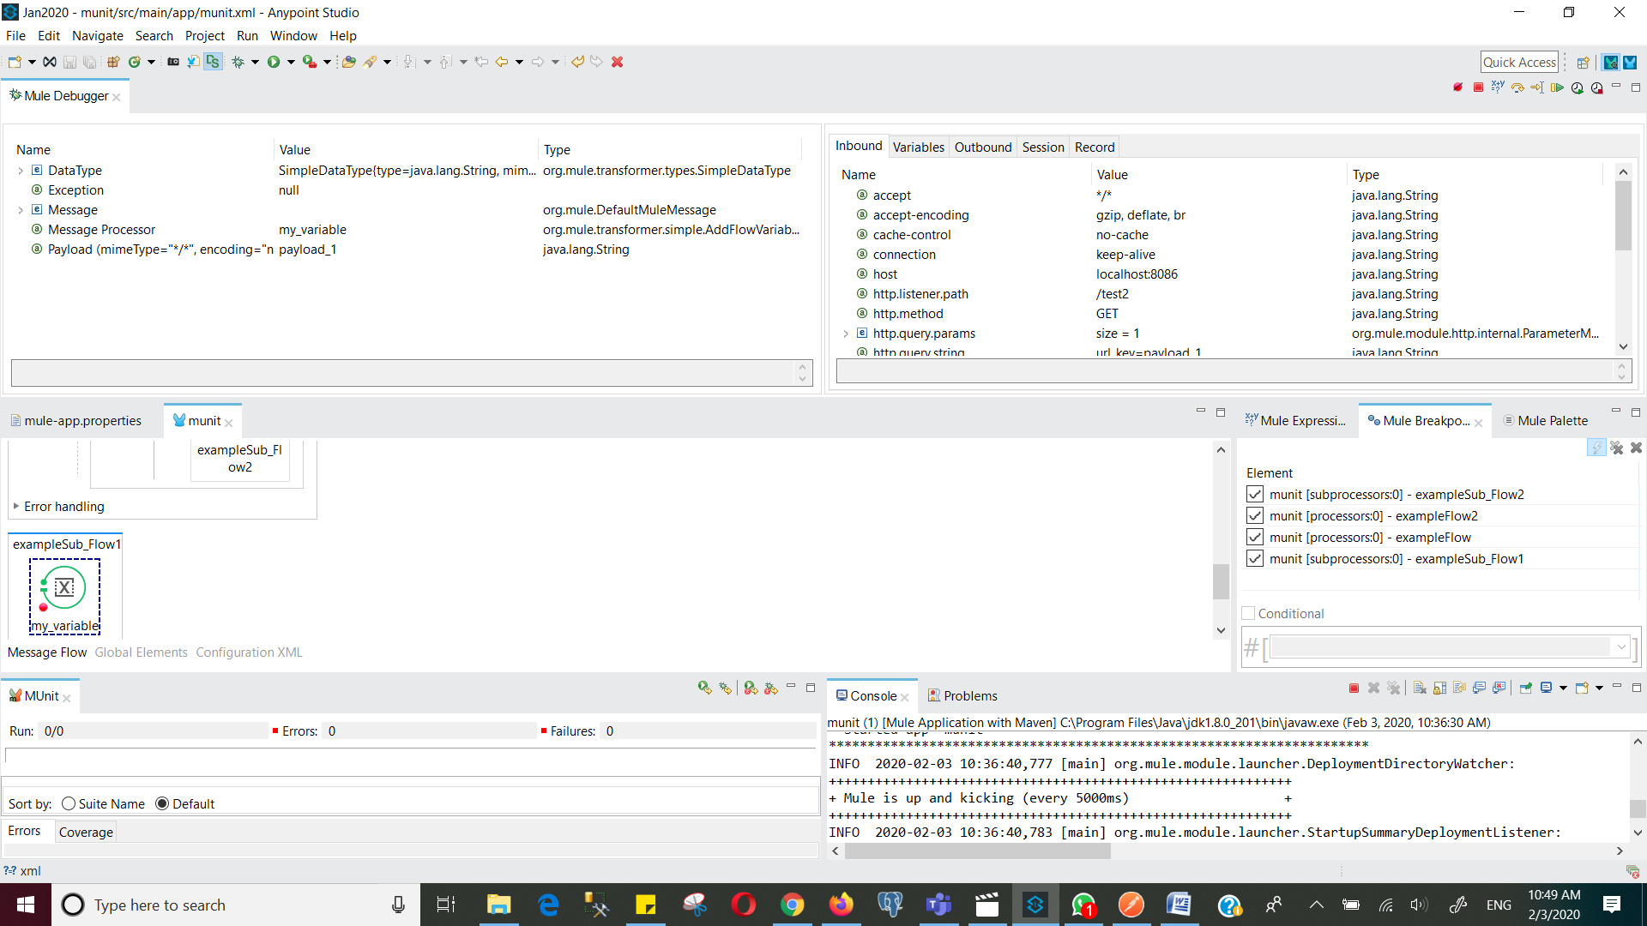

Now create a munit test suite for the first flow, put set message and verify if the the flow_reference is calling the exampleFlow2

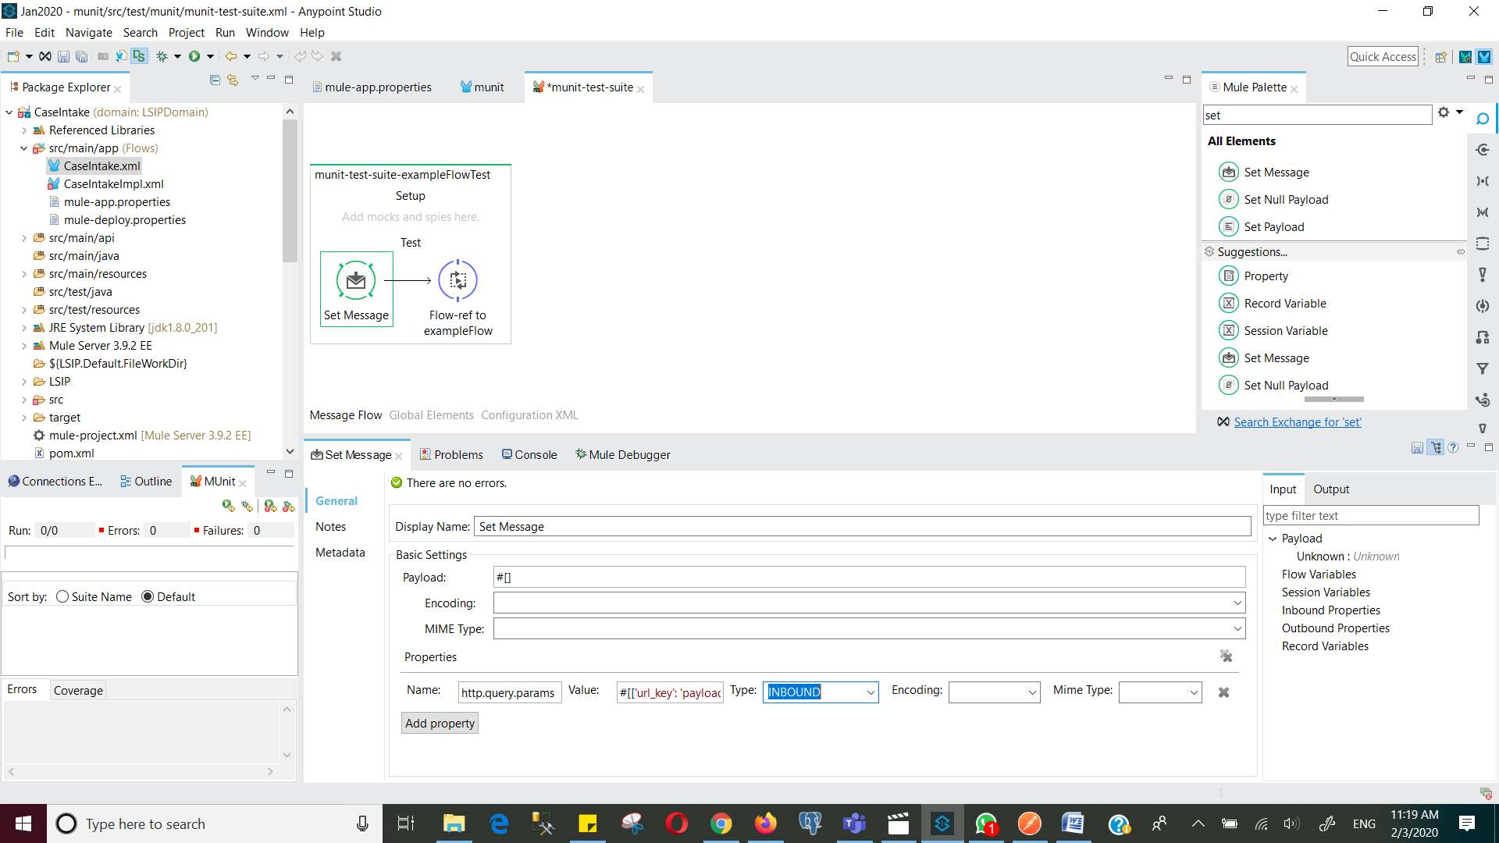

verify if the the flow_reference is calling the exampleFlow2

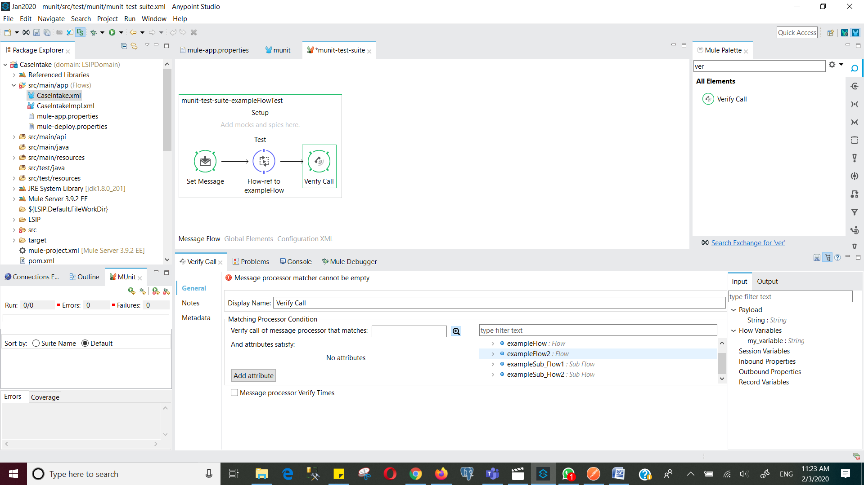

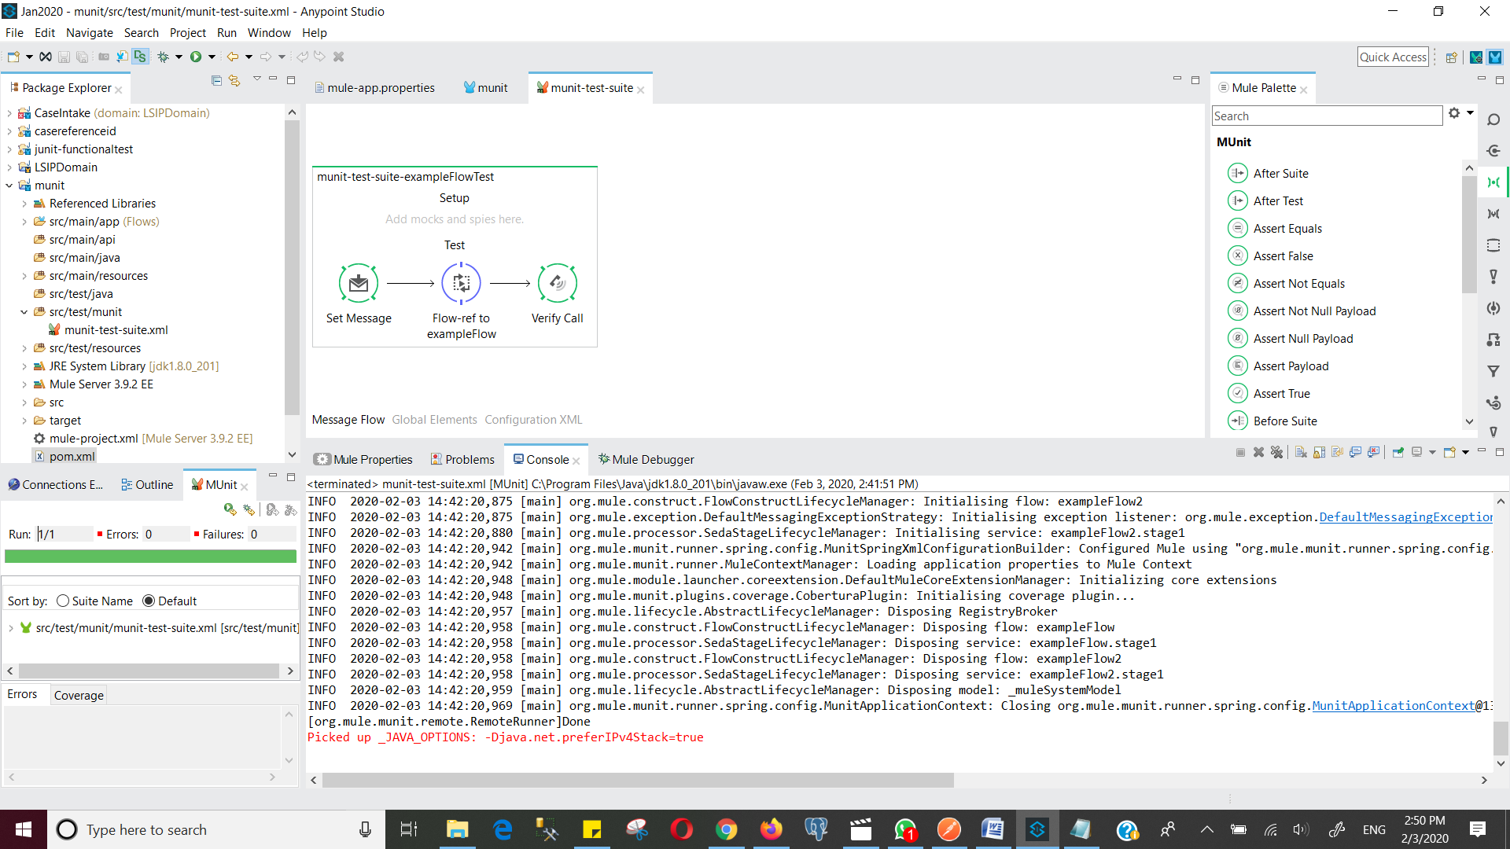

Next, we want to see the assert payload by providing an expected payload

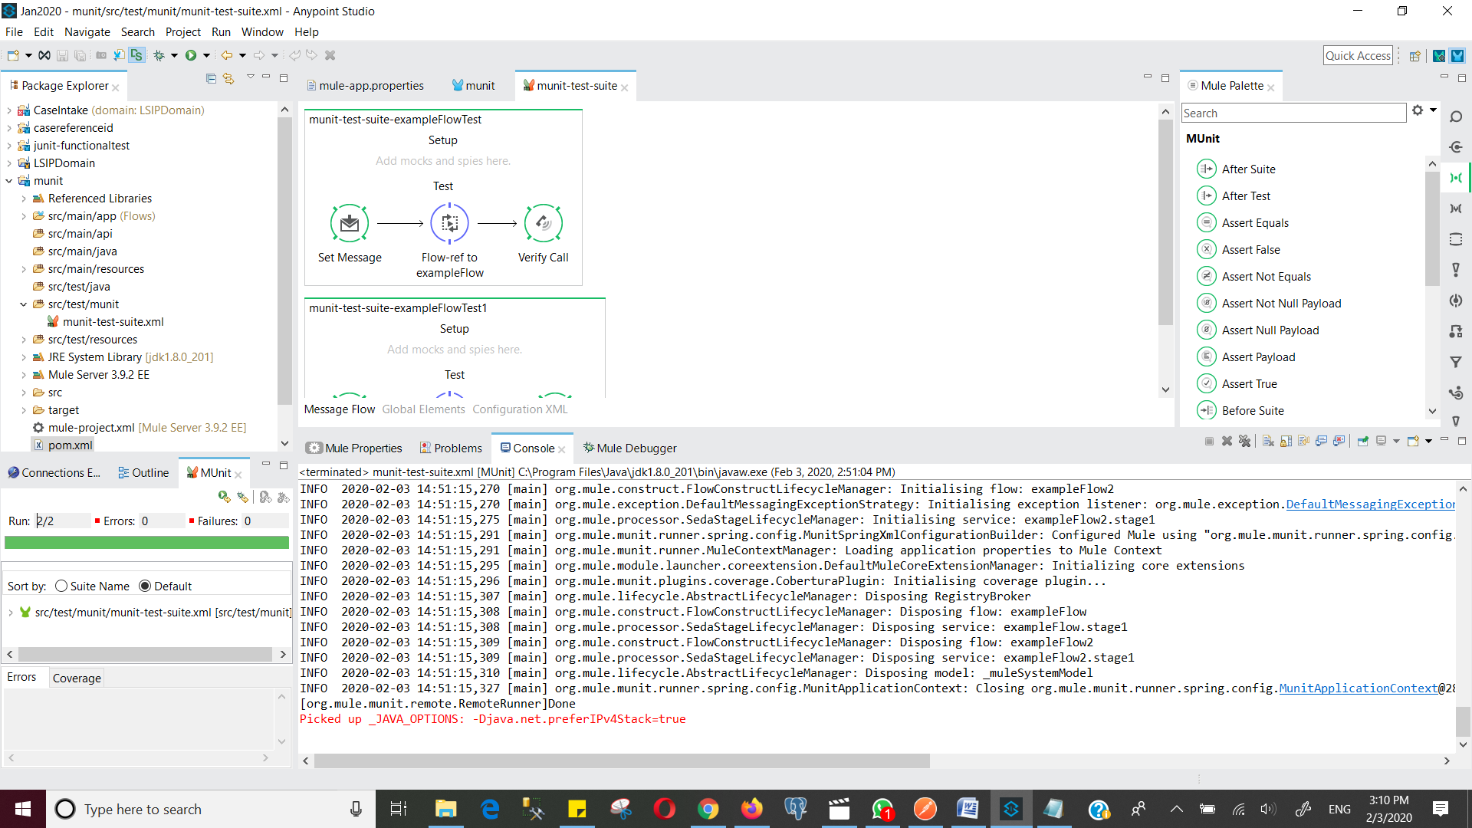

Next, let me apply Before Test and run the following with payload_1

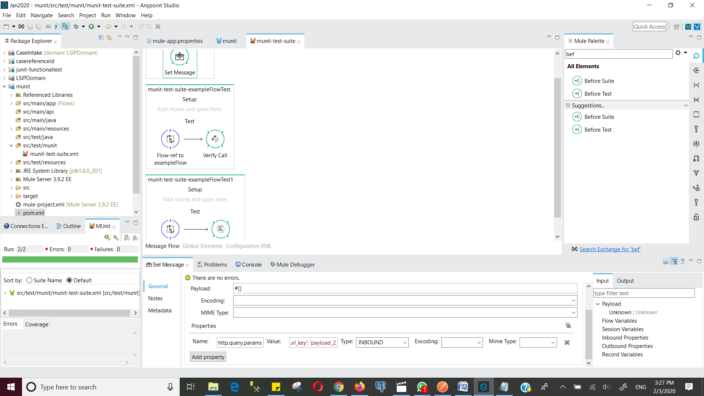

The following also throws an error payload_2

