Name: Ateh Precious
Track: Computer Networking and Cyber security
BLIND / TIME-BASED SQL INJECTION AND DATABASE EXTRACTION
1. Introduction
Blind SQL Injection is a web application vulnerability where an attacker can manipulate database queries without directly seeing database errors or results. This practical was performed in a controlled DVWA environment.
2. Objective
The objective was to identify and demonstrate blind SQL injection, perform database enumeration and extraction, and test the security of the extracted password hashes.
3. Lab Environment
Component | Used
Operating System | Kali Linux
Application | DVWA
Database | MariaDB/MySQL
Testing Tool | SQLMap
Hash Tool | John the Ripper

4. Vulnerability Identification
The SQL Injection (Blind) section of DVWA was tested using Boolean conditions:
- 1' AND 1=1 #
- 1' AND 1=2 #
The different responses demonstrated Boolean-based blind SQL injection.

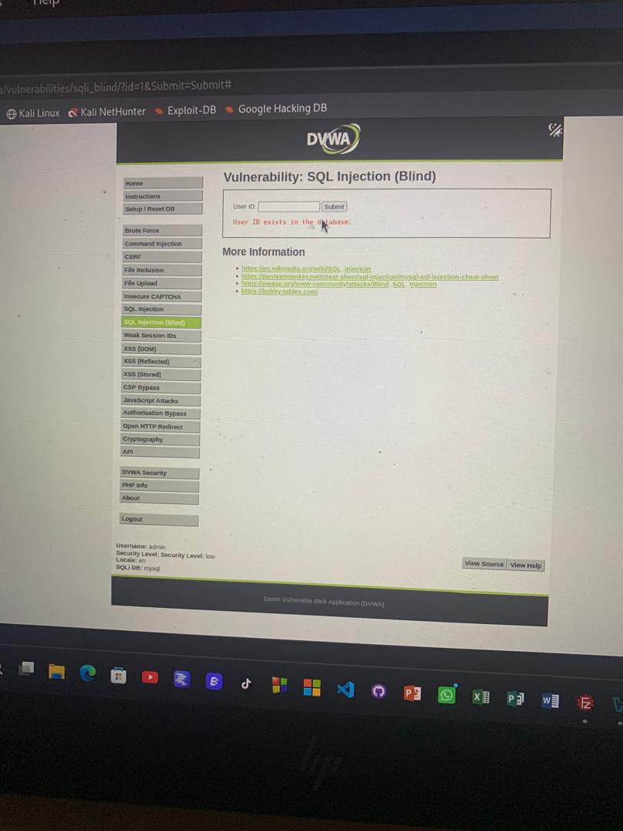
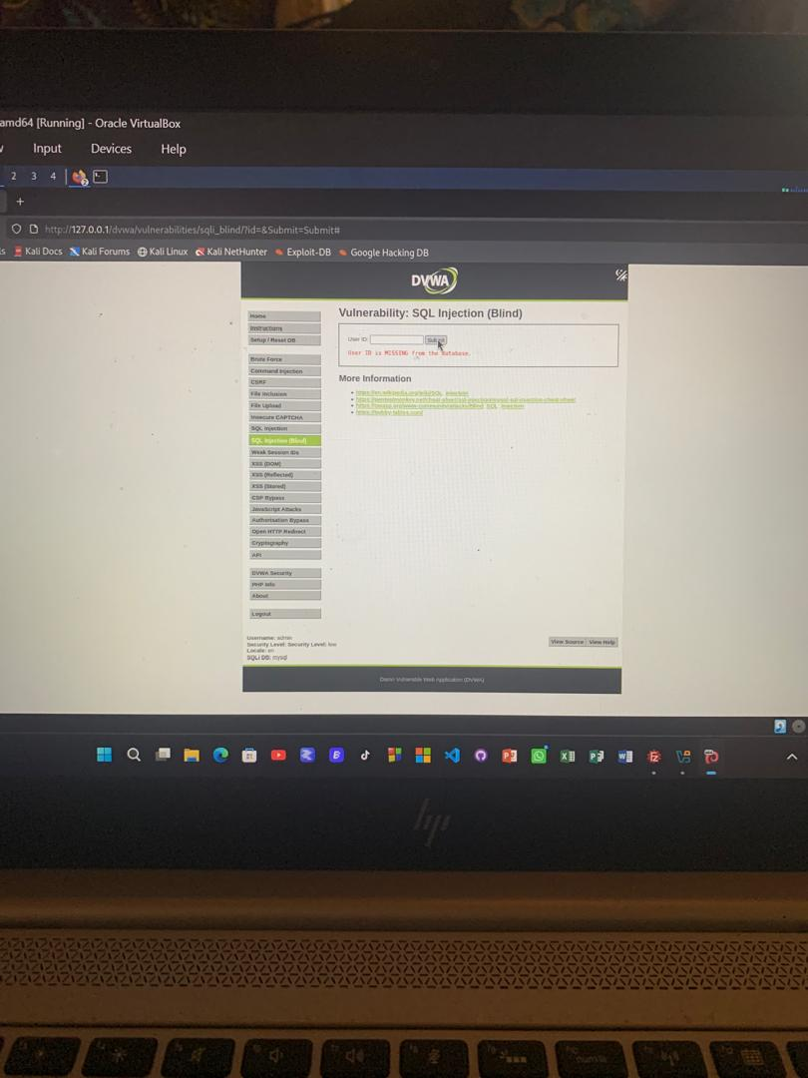
5. Time-Based Testing
SQLMap was used to test for time-based blind SQL injection. The technique determines whether a condition is true based on a delay in the application's response.
sqlmap -u "DVWA_URL" -p id --technique=T --time-sec=5
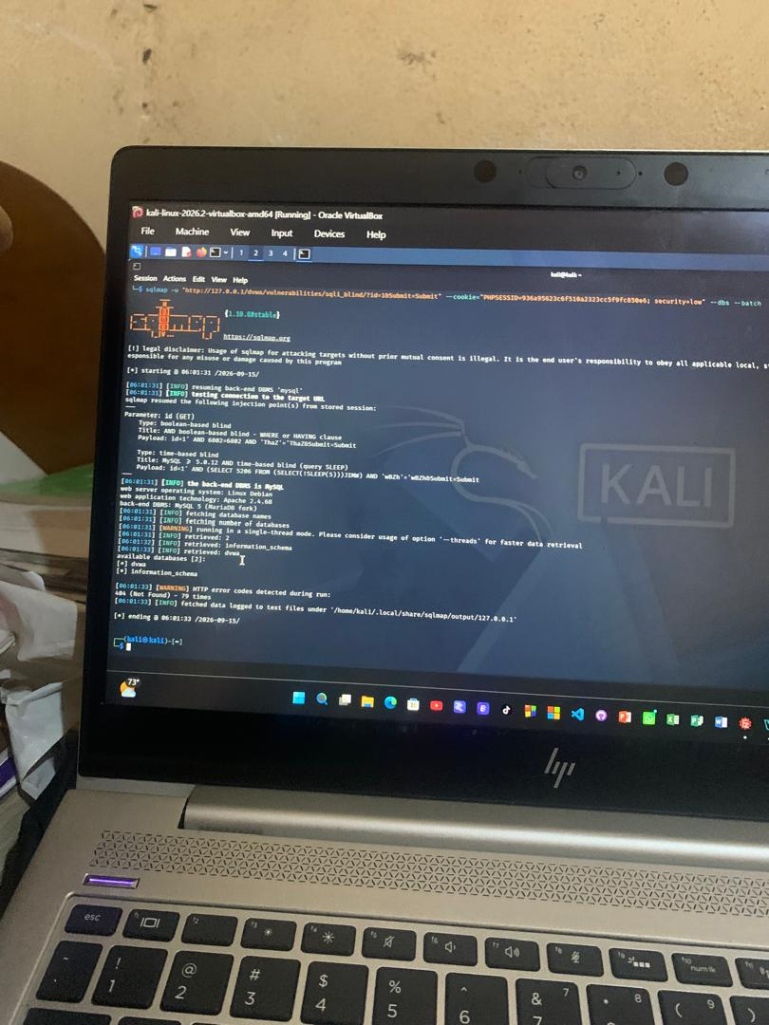
6. Database Enumeration and Extraction
SQLMap was used to enumerate the database and its structure:
sqlmap -u "DVWA_URL" -p id --dbs
sqlmap -u "DVWA_URL" -p id -D dvwa --tables
sqlmap -u "DVWA_URL" -p id -D dvwa -T users --columns
The users table was then used to retrieve the username and password-hash fields.

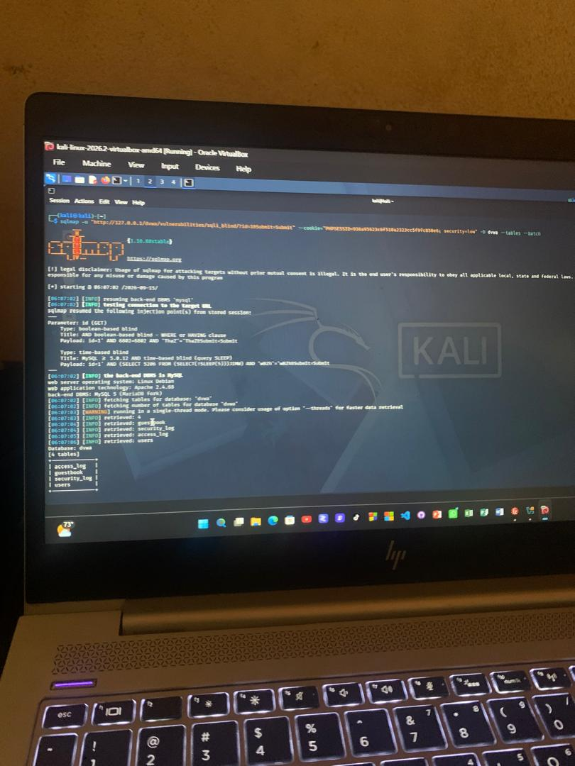
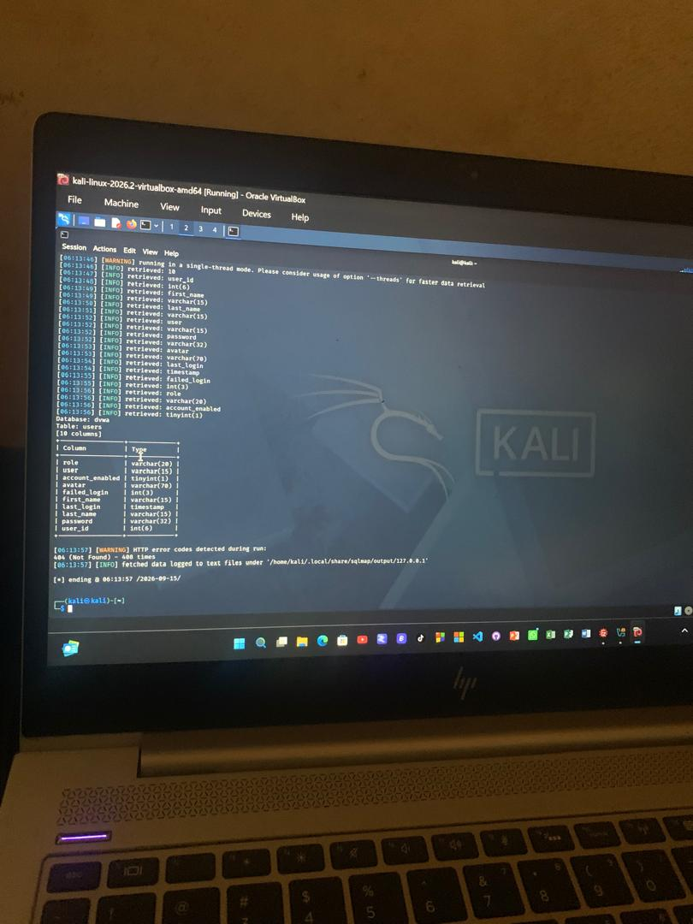
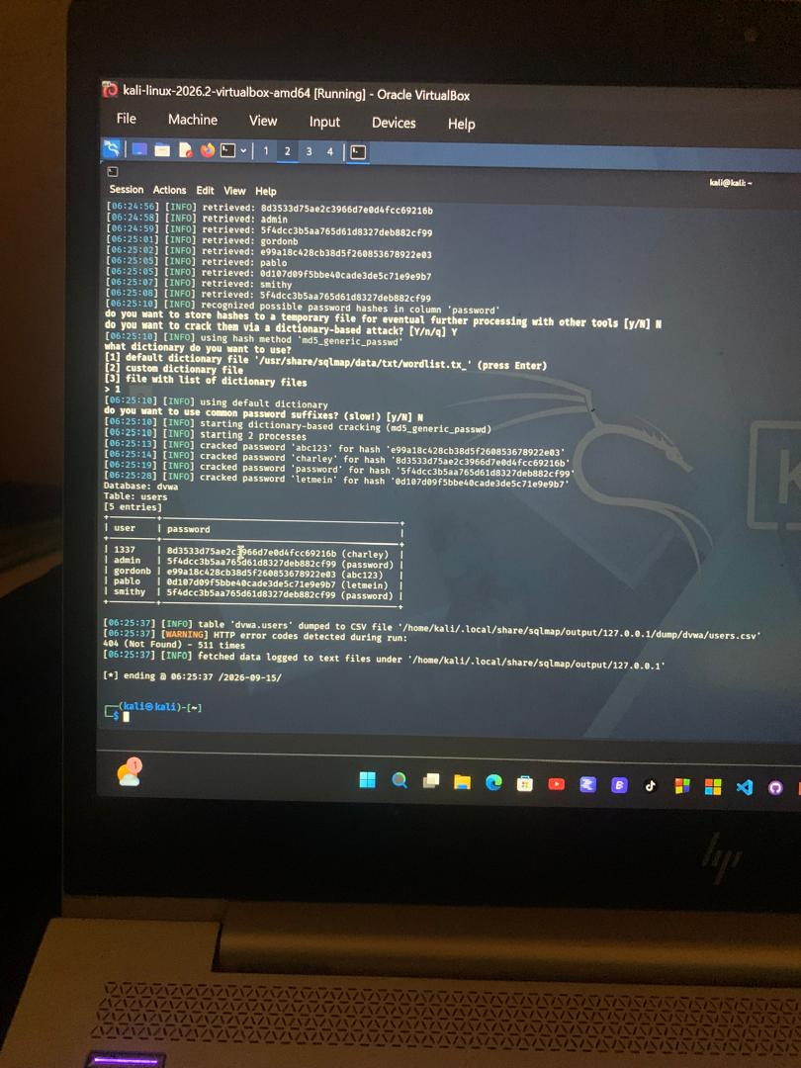

7. Password Hash Testing
The extracted hash was tested using John the Ripper:
john --format=raw-md5 hash.txt
The result showed: 1 password hash cracked, 0 left. This demonstrated that the weak hash could be recovered through offline password cracking.

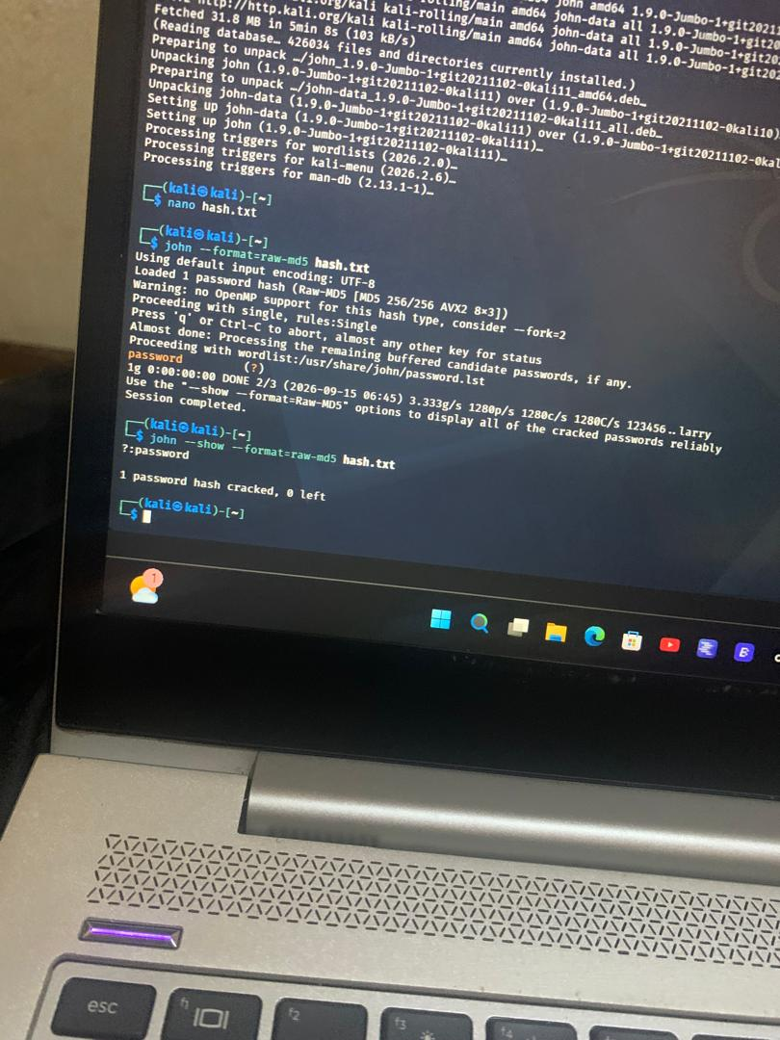
8. SQL Injection Types
Type | Description
Error-based | Uses database error messages to obtain information.
Boolean-based | Uses TRUE/FALSE responses to infer information.
Time-based | Uses response delays to infer information.
9. Impact
Blind SQL injection can allow attackers to access database information such as usernames, password hashes and other sensitive data.
10. Recommendations
• Use prepared statements/parameterized queries.
• Validate and sanitize user input.
• Use strong password hashing such as Argon2id or bcrypt instead of MD5.
• Apply least-privilege database accounts.
• Avoid displaying database errors to users.
11. Conclusion
The practical successfully demonstrated blind SQL injection, database enumeration, extraction of training data, and offline password-hash cracking in DVWA. The exercise showed the importance of secure SQL queries and strong password protection.

