Name: Ateh Precious
Track: Computer networking and cyber security
Stored Cross-Site Scripting (XSS) Vulnerability
- Introduction
Stored Cross-Site Scripting (XSS) is a web vulnerability where malicious JavaScript is permanently stored in an application, such as a guestbook, comment, or profile field. The script executes whenever a user views the affected page.
- Vulnerability Identification
I tested the DVWA (Damn Vulnerable Web Application) stored XSS page using the guestbook fields. A harmless JavaScript payload was entered into the input field and submitted.
- Tools used;
- Kali Linux
- DVWA (Damn vulnerable Web Application)
- Web browser (e.g. Firefox they one l used)
- Burp suite (for observing HTTP Request)
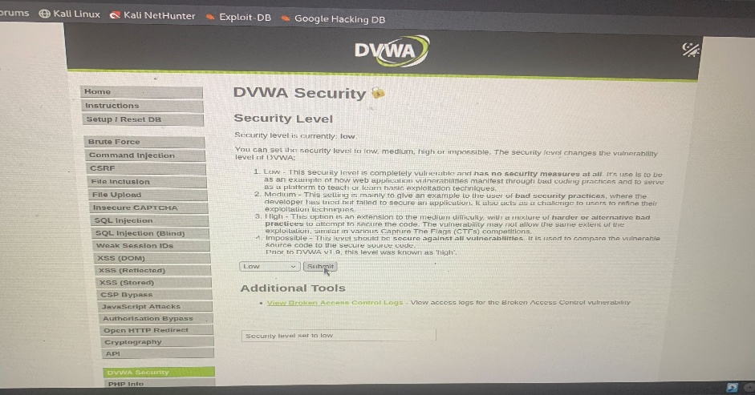
Example test payload
<script>alert ( ‘XSS’ )</script>
The payload was saved in the guestbook which was the location and executed again when the page was refreshed, confirming that the input was stored and not properly sanitized.
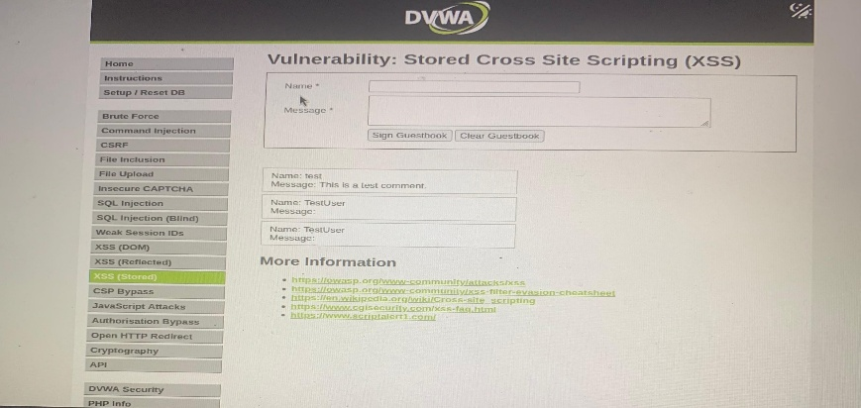
- Simulated Cookie Exfiltration
For demonstration purposes, a simulated session cookie was used instead of a real user’s credentials. The test demonstrated that JavaScript running through an XSS vulnerability could access accessible session information and send it to a controlled listener. This shows how an attacker could potentially use stolen session information to impersonate another use and I used Burp suit to observe the HTTP request from the user
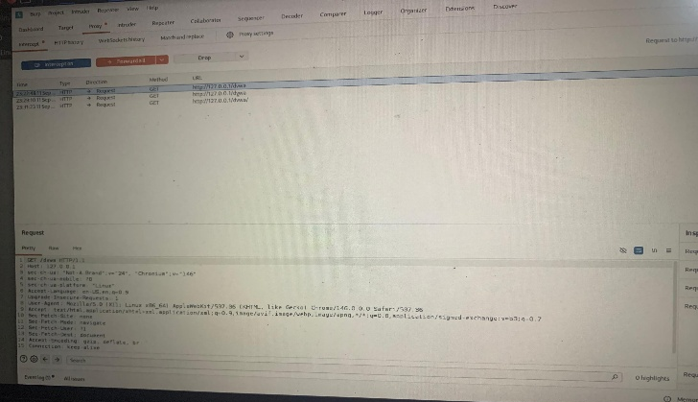
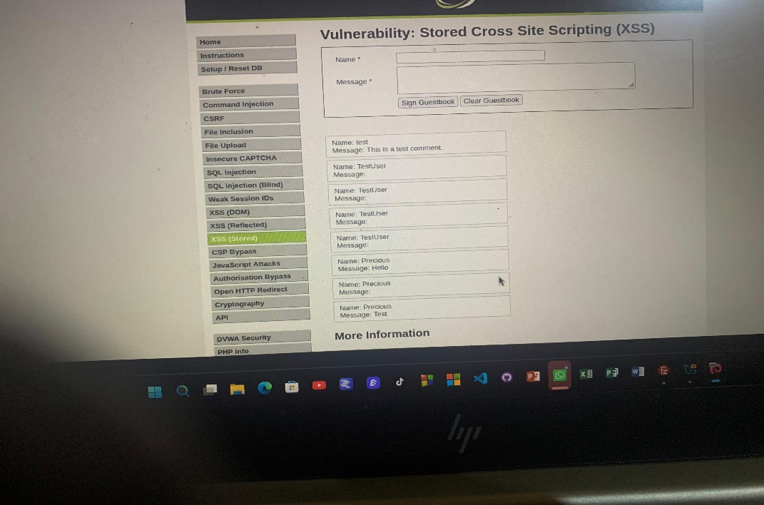
- Impact
Stored XSS can allow an attacker to execute JavaScript in another user’s browser, steal accessible session information, modify page content, perform actions as the victim, or redirect the victim to malicious content.
- Recommend
The following measures should be implemented:
- Input validation: Reject or restrict dangerous input where appropriate.
- Output encoding: Encode user-controlled data before displaying it in HTML, attributes, JavaScript, or other contexts.
- Content Security Policy (CSP): Use a strong CSP to reduce the impact of injected scripts. Use secure cookie settings such as Http Only and Secure where appropriate.
Conclusion
The test successfully demonstrated a stored XSS vulnerability in the deliberately vulnerable application. The malicious input persisted in the guestbook and executed when the page was viewed again. Proper input handling, output encoding, CSP, and secure cookie configuration can significantly reduce the risk of stored XSS attacks.

