Part 1

* Prerequisite  
  use the windows + R  
  type msinfo32 to check system information  
  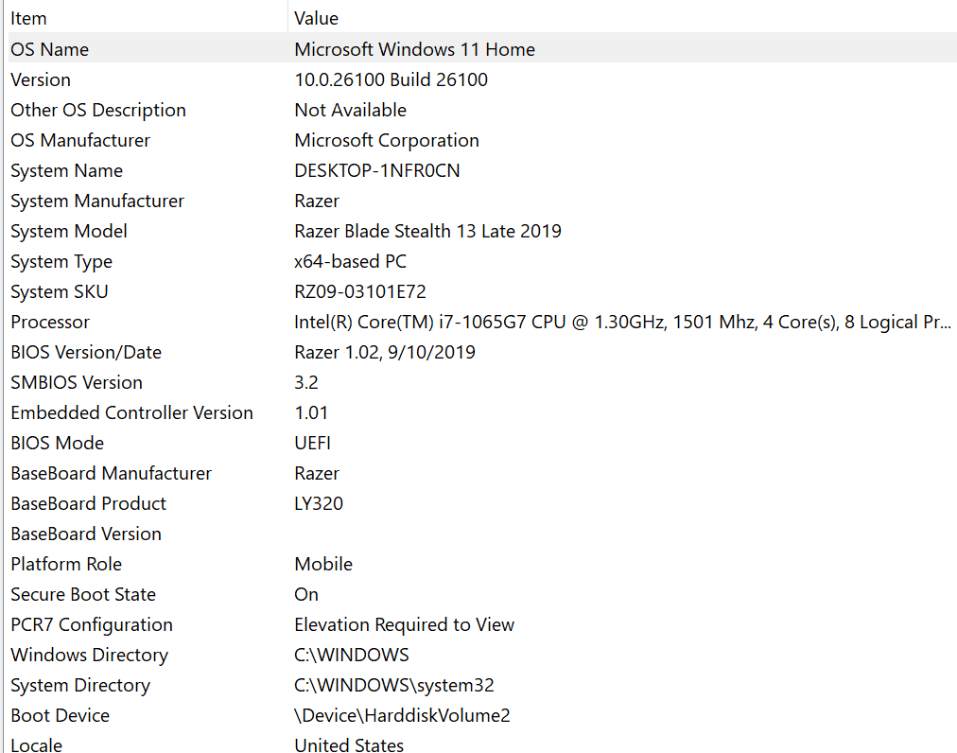

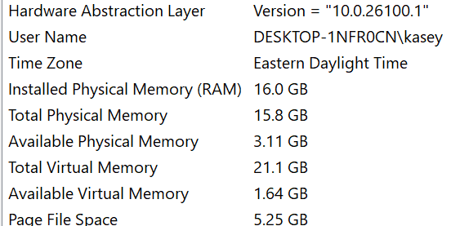

* Installation  
  Step 1: Downloaded MySQL Installer
  + Went to dev.mysql.com/downloads
  + Downloaded MySQL Installer for Windows
  + File size and version you downloaded

Step 2: Ran the Installer

* + Ran as administrator
  + Any security warnings that appeared

Step 3: Setup Type Selection

* + Which setup type you chose (Developer Default, Server Only, Custom, etc.)

Step 4: Product Configuration

* + Server configuration choices you made
  + Port number 3306
  + Authentication method selected
  + Whether you set up MySQL as Windows service

Step 5: Root Password Setup

* + That you created a root password (don't include actual password)
  + Any additional user accounts you created

Step 6: Installation Completion

* + Final configuration applied
  + Services started successfully
* Post installation

Look for mysql in program files

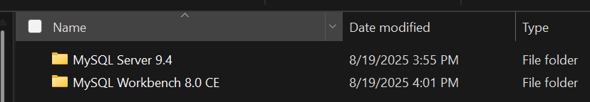  
check mysql version  
  
check sql path  
connect to mysql

Part 2

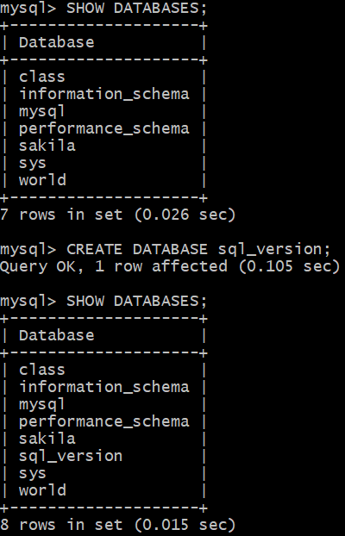

Part 3

1. Used secure password entry without saving credentials in plain text files.
2. Used only read-only SELECT VERSION() command that cannot modify database data.
3. Worked in dedicated test database sql_version instead of production databases.
4. Double checked SQL syntax and script content before executing commands.
5. Used appropriate root user account with verified access permissions.