**Question 1: Run scripts in MySQL commandline**

1d.)

1e.)

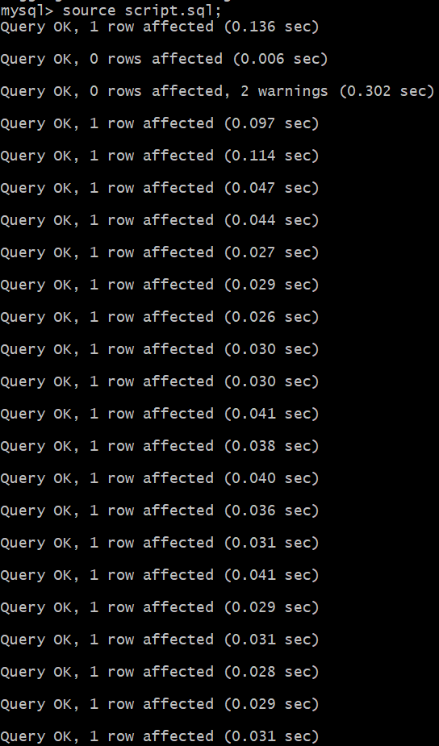

1f.) Before running a script from the MySQL command line, always review the file for destructive commands and make sure you are connected to the correct database. Back up your data, test the script in a safe environment first, and ensure you have the right file path and permissions.

**Question 2: Using MySQL commandline, write querries to answer the following questions.** 1a.)

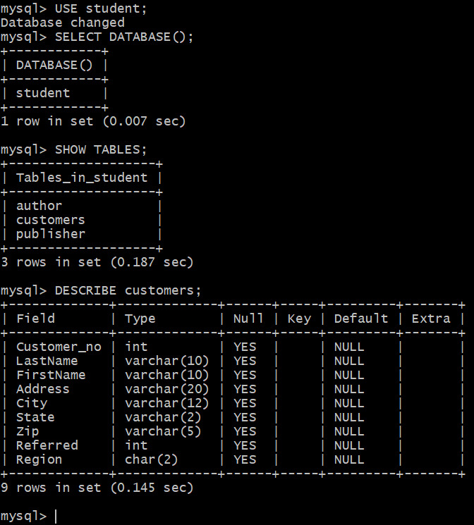

1b.)

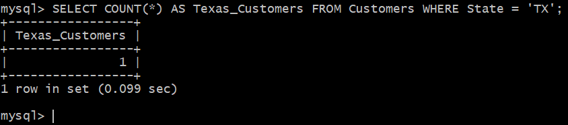

1c.)

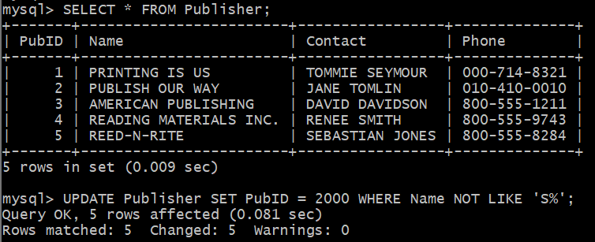

1d.)

1e.)

1f.)

1g.)

**Question 3: Working with Tables.**

1a.)

You can duplicate a table to safely test changes without affecting the original data or to create a backup for experiments and reporting.

1b.)

TRUNCATE clears all data but keeps the table, while DROP removes the table entirely.

1c.)

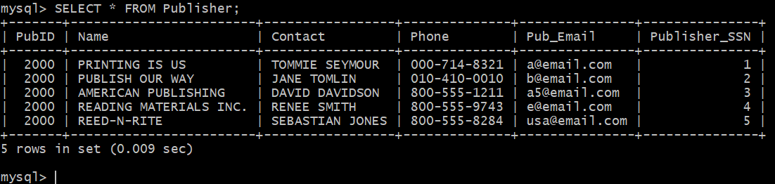

AUTO_INCREMENT automatically generates unique numbers for a column, helping a DBA maintain unique IDs and simplify data management.