**ABA Design Requirements**

**ProdReady**

***v0.1***

|  |  |
| --- | --- |
| Author: | Ashley Templeman |
| Document Status: | DRAFT |

**Revision History**

|  |  |  |  |
| --- | --- | --- | --- |
| **Revision Date** | **Version No.** | **Author** | **Description of Change/Revision** |
| 2831/08/2020 | 0.1 | Ashley Templeman | Creation of Requirements document |
|  |  |  |  |
|  |  |  |  |

**Table of Contents**

1. Summary 2

2. Expectations 2

3. Site Overview 3

3.1 Description of Site 3

4. Site Pages 3

4.2 Navigation Bar 3

4.3 Footer 3

4.4 Home Page 4

4.4.1 Welcome Content 4

4.4.2 Login Component 4

4.4.3 Register Component 4

4.4.4 Contact Us component 4

4.4.5 Wireframe Mockups & current implementation 5

5. Estimations 6

# Summary

The current ABA basketball simulation website is functioning correctly. The site has been built focusing on functionality and is requiring a design overhaul to improve the use of the site to make it easier to use and more visually appealing to end users. The end goal of this requirement document is to outline what is to be designed and then create in a HTML & CSS setup. All functions are NOT to be implemented as this is already existing in an Angular TS code base.

Note: Many more pages will be re-themed after the initial home page and again, all logic exists on our end, we are just after layouts and theming for the pages.

# Expectations

The expectations of this piece of work is to produce two outcomes:

* A design which captures all current features of the current ABA website
* HTML and CSS code to implement the new page designs which can be plugged into the existing Angular TS project. The design of the pages will need to be compatible with mobile devices. This would mean that the designs are made in a responsive manner

# Site Overview

The following is an overview of the site, including details of what the site is. In Section 4, each page of the site will be broken down and provides details of each feature of the site.

## 3.1 Description of Site

The ABA site is a fantasy basketball simulation. Using our own custom built simulation engine, the site allows users to play in competition with other users and control their own basketball franchise. Users can review results, watch live text based games, view statistics and most importantly, manage their own team via signing, trades and drafts.

# Site Pages

The following will outline each page, what each page contains and what is required in the new design.

## 4.2 Navigation Bar

The navigation bar will be on every page. It is a main way for a user to navigate through the site with menu links displayed.





Current Navigation Bar – desktop computer

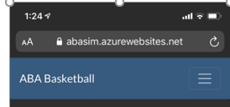 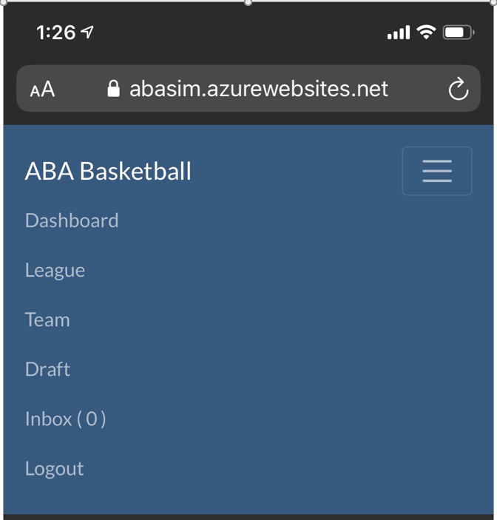

Current Navigation Bar - phone

This will be ideally having a logo before the title of the website (ABA Basketball).

This component will require minimal work with the following being required:

* Logo Design (without text title)
* Any theme colour changes for the rest of the site

## 4.3 Footer

The footer will be on every page. It simply contains basic copyright and versioning details. However, an about link may be added depending on costs and ideas.



Current Footer – desktop computer



Current Footer – phone

This component will require minimal work with the following being required:

* Any theme colour changes for the rest of the site

## 4.4 Home Page

The Home page is the landing page for the website. This page will contain the following features:

* Navigation bar – this will be fixed across all pages – see section 3.2
* Welcome content and general site information
* Login
* Register
* Contact Us
* Footer – this will be fixed across all pages – see section 3.3

### 4.4.1 Welcome Content

The welcome component will contain a background image with a clear text overlay.

The Text overlay will contain a title and an introduction paragraph about what the site is along with some points of information. A possible arrangement is available in the wireframe mockups in section 4.4.5.

### 4.4.2 Login Component

The login component contains a simple login form consisting of:

* Username
* Password
* Login button

### 4.4.3 Register Component

The register component contains a form consisting of:

* Username
* Password
* Confirm Password
* Email
* Team Name
* Mascot Name
* Register button

The register form can be replaced with a Registration unavailable heading and text description. This can occur when there are no available spots for user registration. This will require a 2 components to be done – one for when a registration is available and one when registration is not available.

### 4.4.4 Contact Us component

The contact us component contains a form with the following:

* Title
* Text description
* Name text field with label
* Email text field with label
* Your message text area with label
* Send message button

### 4.4.5 Wireframe Mockups & current implementation

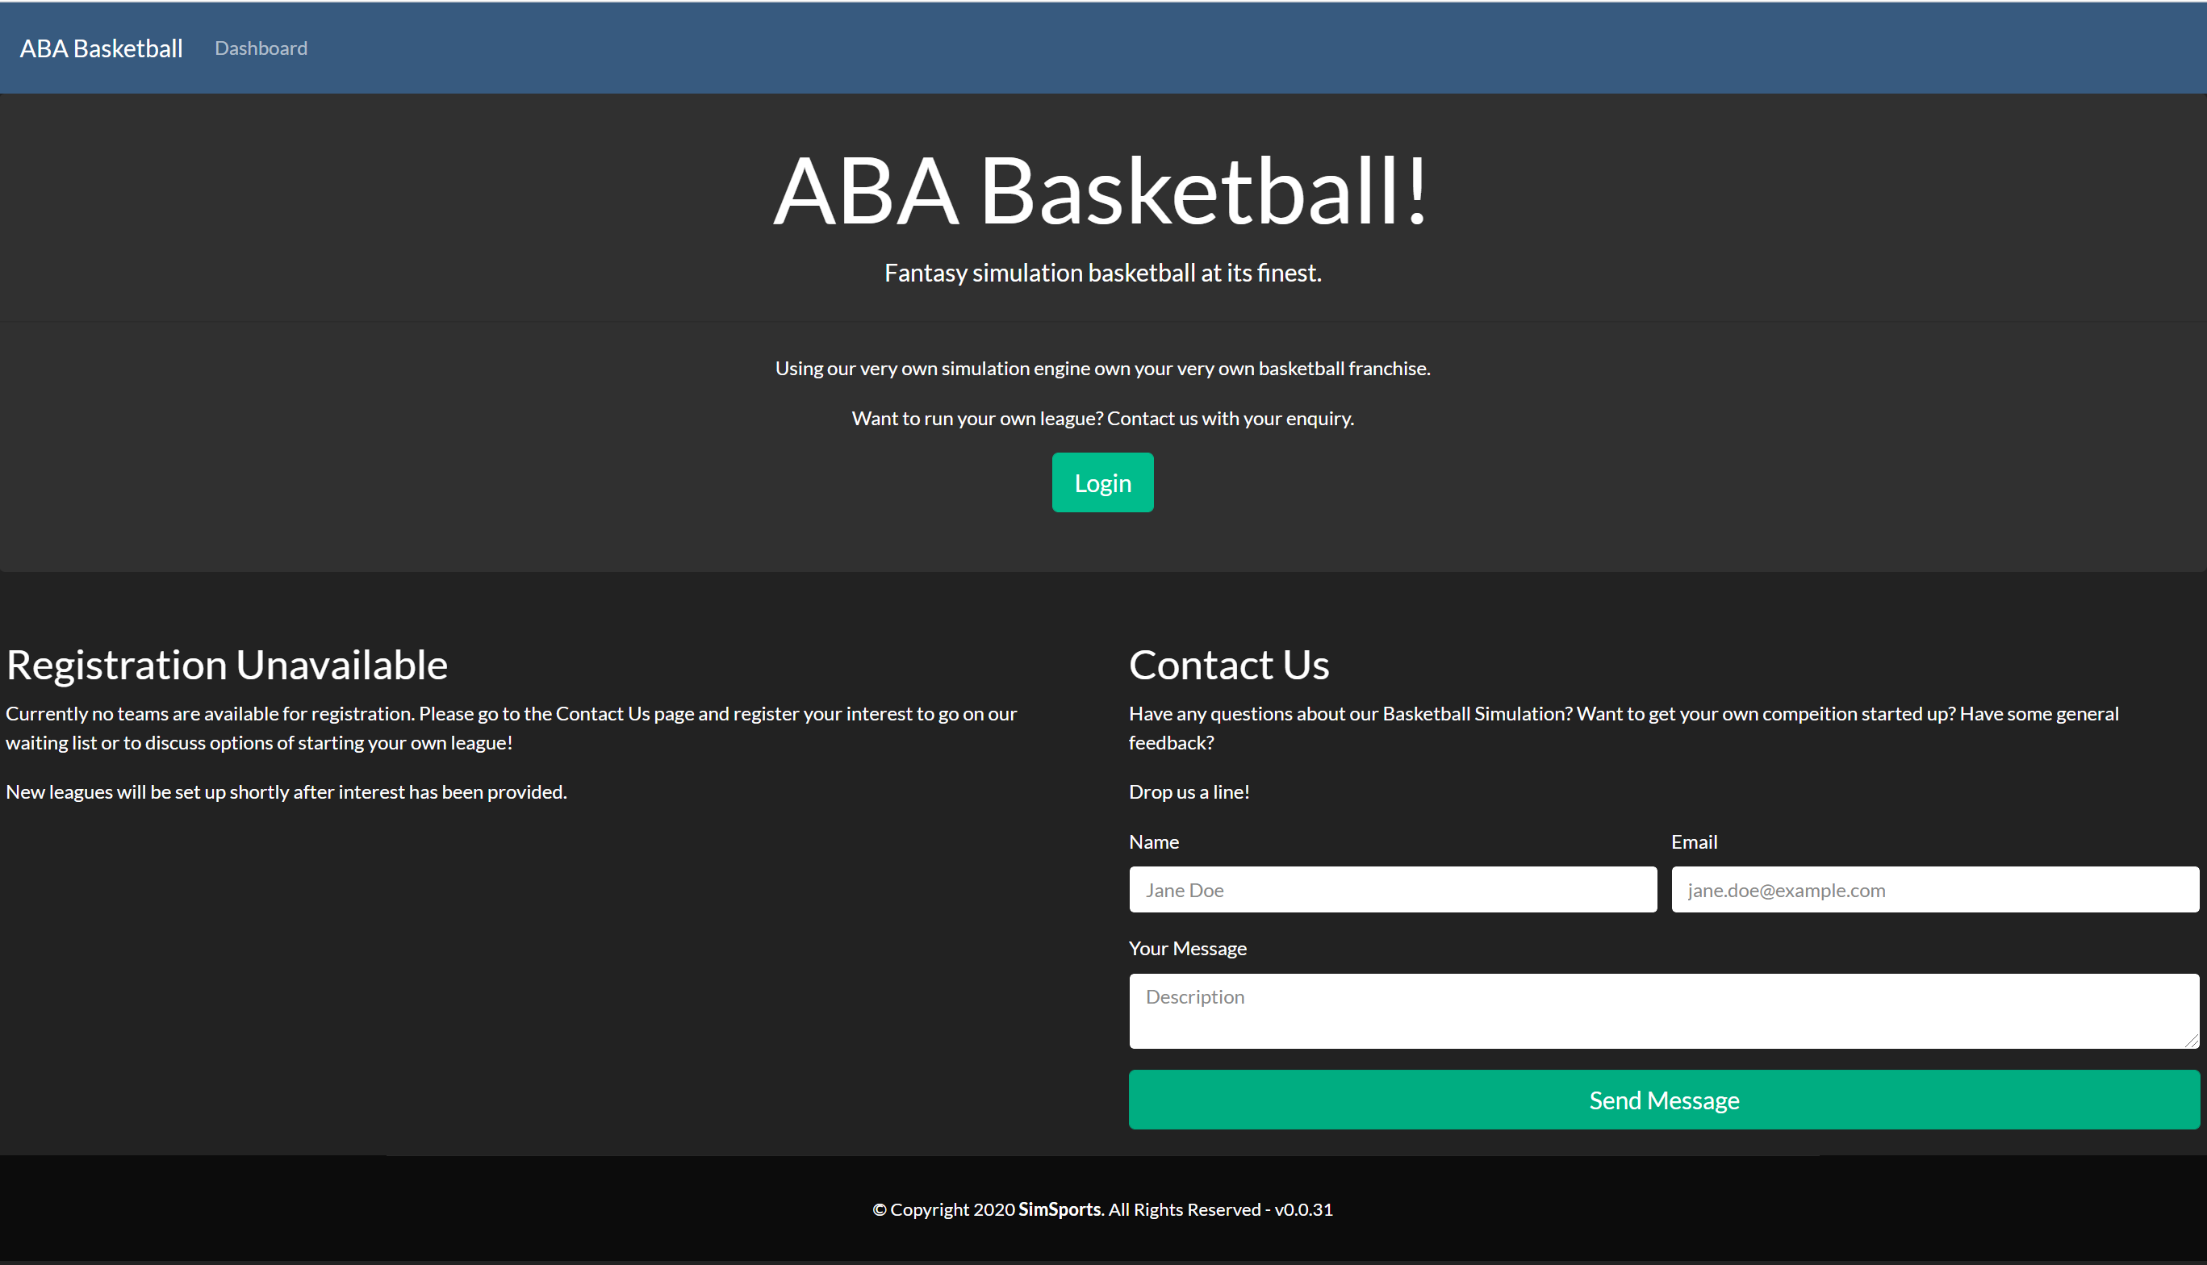

Current home page on desktop PC

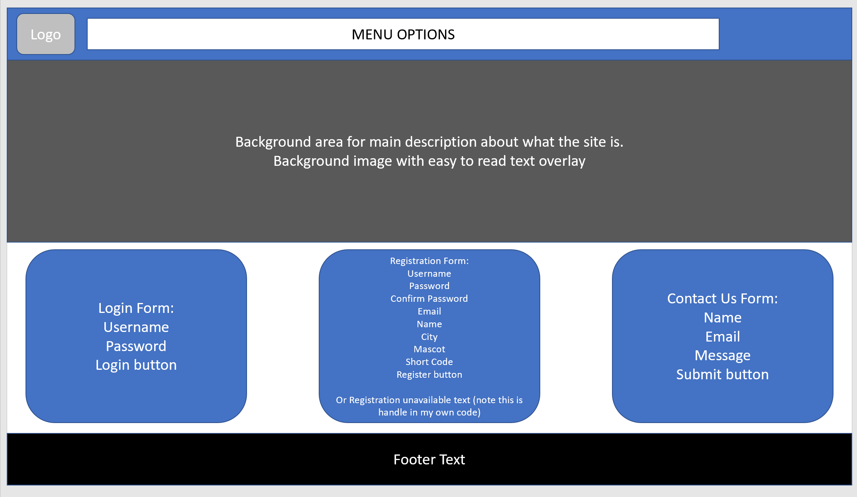

Proposed Wireframe design/mockup

# Estimations

|  |  |  |  |
| --- | --- | --- | --- |
| **Page** | **Sub-Component** | **Estimate (hours)** | **Cost** |
| Navigation Bar | Logo Design |  |  |
|  | Theming |  |  |
| Footer | Theming |  |  |
| Home Page | Page design |  |  |
|  | Welcome compontent HTML & CSS markup |  |  |
|  | Login Component HTML & CSS markup |  |  |
|  | Register Component HTML & CSS markup |  |  |
|  | Contact Us component HTML & CSS markup |  |  |
| **TOTALS** |  |  |  |