Klutch Fantasy Basketball

Functional Specification

Version history

|  |  |  |  |
| --- | --- | --- | --- |
| Version no. | Date | Changed by | Nature of amendment |
| 1.0 | 25/05/2021 | A.Templeman | Initial draft |
|  |  |  |  |
|  |  |  |  |
|  |  |  |  |
|  |  |  |  |

Contents

1 Background Introduction 5

1.1 Document Purpose 5

1.2 Document Structure 5

2 Business Rules 5

2.1 Applied business rules 5

2.2 Part of Day Codes 5

2.3 Absence Reason Codes 6

4 Page 1 Report Layout - detail visulisation requirements 9

4.1 User Navigation Filters 9

4.2 Year-to-date Attendance rate 10

4.3 Year-to-date students with <85% attendance 11

4.4 Year-to-date students with chronic absenteeism 12

4.5 Average attendance for Mondays 13

4.6 Average attendance for Tuesdays 14

4.7 Average attendance for Wednesday 15

4.8 Average attendance for Thursday 16

4.9 Average attendance for Friday 17

4.10 Proportion of students by attendance rate range 18

4.11 Average attendance rate by school type 19

4.12 Average attendance rate by student attributes 20

4.13 Days not in school by reason 21

4.14 Region 22

4.15 School results table 23

5 Page 2 Report Layout - detail visulisation requirements 24

5.1 User Navigation Filters 24

5.2 Year-to-date Attendance rate 25

5.3 Average full day absence count 26

5.4 Average part day absence count 27

5.5 Percenetage of part day absences by time of day 28

5.6 Chronic absenteeism 29

5.7 Average attendance for Mondays 30

5.8 Average attendance for Tuesdays 31

5.9 Average attendance for Wednesday 32

5.10 Average attendance for Thursday 33

5.11 Average attendance for Friday 34

5.12 Daily attendance rate and YTD attendance rate trend 35

5.13 Proportion of students by attendance rate range 36

5.14 YTD attendance rate QSS school type comparison 37

5.15 YTD attendance rate Region school type comparison 38

6 Page 3 Report Layout - detail visulisation requirements 39

6.1 User Navigation Filters 39

6.2 Year-to-date full day absence day count 40

6.3 Year-to-date part day absence count 41

6.4 Percentage of part day absences by time of day 42

6.5 Count of absences by reason type 43

6.6 Daily absence count by type 44

6.7 Proportion of students by attendance rate range 45

6.8 Count of absences by reason type 46

6.9 Student table 47

7 Page 4 Report Layout - detail visulisation requirements*** 48

7.1 User Navigation Filters 48

7.2 Year-to-date full day absence day count 49

7.3 Year-to-date full day absence day count 50

7.4 Year-to-date part day AM absence count 51

7.5 Year-to-date part day AM absence count 52

7.6 Count of absences by reason type 53

7.7 Daily attendance rate and YTD attendance rate trend 54

7.8 Student calendar 55

APPENDIX A: Current Report Layout – Daily Attendance 56

APPENDIX B: Wire Frame – Page 1 57

APPENDIX C: Wire Frame – Page 2 58

APPENDIX D: Wire Frame – Page 3 59

APPENDIX E: Wire Frame – Page 4 60

# Background Introduction

The School Online Reporting Dashboard (SORD) project was intiated to provide a replacement reporting system for the existing school data profile information, school headline indicators and elements of the existing OneSchool performance dashboards. The project was established to deliver a platform that enables users to access the existing School Data and corresponding information within an online and interactive environment.

## Document Purpose

The purpose of this document is to present a clear definition of the functional requirements of each SORD report developed.

## Document Structure

This document is a living document and is intended to evolve over the life of the SORD project.

As the SORD project progresses through its Product Roadmap, each new version delivers additional dashboard reports using different data sets. With each new report, a functional specification should be completed. If any reports need to be modified due to report maturity and/or design changes, this document should be adjusted with justfication placed in the ‘visualisation context and design considerations’.

Any additional Business Glossary items should also be added as required.

# Business Rules

## Applied business rules

The current source of attendance information is OSCR which is a warehouse designed to support reporting from OneSchool. However, the daily attendance data for this dashboard will be sourced from OSLP transactional database. The existing daily attendance cube was reversed engineered to list all the tables and business rules as it would have been applied in OSLP. Student attendance is not stored in OneSchool. Instead, it is derived from a school day calendar and student absences. It’s assumed a student has attended if it’s a school day, is enrolled and is not absent.

* Attendance/Absence count only on school days
* Students with future enrolments are excluded from the results
* Student who have changed schools must retain their attendance at their previous schools
* Only students with enrolment status of ‘full-time’ are included in attendance rate calculation
* Attendance rates are calculated only when a student’s enrolment date has lapsed
* Year 10, 11 and 12 students have a different term 4 end date and is calculated differently
* Hospital schools are excluded from corporate attendance reporting
* Students at youth engagement hubs are excluded from corporate attendance reporting

## Part of Day Codes

Students can be absent for full (1.0) or part (0.5) of the day. Below outlines the Absence types, codes and descriptions.

|  |  |  |  |
| --- | --- | --- | --- |
| Type of Absence | Code | Day Penalty | Explanatory notes |
| Entire day | A | 1 | Student was absent the entire day. |
| Early (no penalty) | E | 0 | Student left early, but within the final 2 hours of scheduled schooling. This will not count as an afternoon/half day absence. If the student left earlier than 2 hours prior to end of school day, this will count as an afternoon day absence (see “P” code) |
| Late (no penalty) | L | 0 | Student arrived late, but within 2 hours of scheduled schooling. This will not count as a morning/half day absence. If the student arrived after the first 2 hours of the scheduled school day, this will count as a morning/half day absence (see “M” code). |
| Morning | M | 0.5 | Student was absent for the morning. This will count as a half day absence. |
| Late | P | 0.5 | Student was absent during the afternoon. This will count as a half day absence. |

## Absence Reason Codes

Students can be ‘not in school’ but not counted as an absence penalty depending on the reason. For example, a student may be doing a school activity not at school (like Biology camp), even thought the student is not attending the school they are no classed as ‘absent’ and therefore to do not get a part-day or full-day penalty (refer 3.9.1). Below are the list of Absent reason codes with their description and if they are counted as an absence yes or no:

|  |  |  |  |
| --- | --- | --- | --- |
| Absence Reason | Code | Explanation | Count as an absence? |
| School activity | A | Student is participating in an authorised school activity for school purposes. May include participation in school choirs, youth parliament, or community service or attendance at a hospital school. | No |
| Attendance not required | B | Student was not required to attend school on this day as a it is not included in their educational program, or for a student with charge-related reasons the student has enrolled in a school of distance education or engaged in an educational program. This code also applies if the student is in a youth detention centre. | No |
| Excursion | C | Student is participating in an excursion which occurs outside the school grounds and is conducted, organised and/or approved by the school. Excursions could include part-day, full-day or multi-day class visits to venues outside the school or school camps. | No |
| Off Campus activity | F | Student is participating in an authorised activity that is away from the school campus. These activities may include flexible arrangements, attendance at a TAFE or other training provider course, participation in a VET activity or participation in a school-based apprenticeship or traineeship. These activities will be regular and ongoing. | No |
| Holiday | H | The parent, or the student if they are living independently, has informed the school that the student/family is taking a holiday. Note that holidays during the school term should be discouraged. If the absence is more than 10 consecutive days, an exemption is required. | Yes |
| Illness | I | The parent, or student if they are living independently, has informed the school that the student is sick. This includes all reference to ill health or seasons relating to the health of a student. If a medical certificate has been provided this should be noted in OneSchool and kept on file. If a child is unable to attend school for a period longer than 10 consecutive school days, an exemption is required. A child may be absent from school if the child is, or is a member of a class of persons that is, subject to a direction or order given about an infections or contagious disease or condition. | Yes |
| Natural Disaster | N | Student is unable to attend school due to an extreme weather event or other natural disaster. | No |
| Sorry Business | D | Aboriginal and Torres Strait Islander students participating in sorry business. | Yes |
| Other | O | The principal has determined that the excuse provided by the parent or student (where the student is an adult or where it would be inappropriate to ask the parent) is reasonable. Principals must use the guidelines to determine reasonable excuses and document these reasons. This code may be used for medical or dental appointments, religious observances, funerals and legal matters. | Yes |
| Short suspension | P | Student is suspended for 1 to 10 days | Yes |
| Long suspension | Q | Student is suspended for 11 to 20 days | Yes |
| Suspension – recommended exclusion | R | Student is suspended with the recommendation for exclusion | Yes |
| Sport (representative sport) | S | Student is representing their school, district, region, state or nation at a sporting event recognised by the school. If student is ot presenting school use Code O. | No |
| Work experience | W | Student is participating in an approved work experience program. | No |
| Exemptions | Z | Student has an exemption from schooling | No |
| Unexplained | U | No reason has been given for the student absence. | Yes |
| Unauthorised | J | The excuse given for a student absence is deemed as unreasonable. The reason (with any supporting evidence) as to why an explanation is considered to be unreasonable must be documented. | Yes |

# Page 1 Report Layout - detail visulisation requirements

## User Navigation Filters

The characteristics/dimensions listed below need to be available in the data model to enable further navigations on the default visualisation.

| Name / Item | Functionality | Default |
| --- | --- | --- |
|  |  |  |
|  |  |  |
|  |  |  |
|  |  |  |
|  |  |  |
|  |  |  |

No filters applied to first page – could this be done as a dashboard?

## Year-to-date Attendance rate

|  |  |
| --- | --- |
| Name / Item | Functionality |
| Description | This chart will show the Attendance Rate for the calendar year-to-date |
| Chart type | KPI Indicator |
| Default view | Result for all Queensland State Schools |
| Chart Title | YTD attendance rate |
| Indicator/Measure | Attendance Rate: Formula =  Sum(AttendanceFTE) / (Sum(AttendanceFTE) + Sum(AbsenceFTE)) * 100 |
| Trend axis | n/a |
| Target goals | n/a |
| Visualisation specific data filters | Most recent result displayed, current calendar year-to-date calculation |
| Hierarchy drill-down | n/a |
| Visual link to other page | n/a |
| Tooltip | Power Bi default view (repeat number) |
| Nice to have function | n/a |

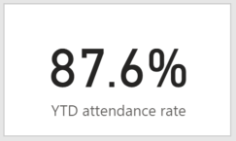

## Year-to-date students with <85% attendance

|  |  |
| --- | --- |
| Name / Item | Functionality |
| Description | This chart will show the proportion of students with less than 85% attendance rate, for the calendar year-to-date |
| Chart type | KPI Indicator |
| Default view | Result for all Queensland State Schools |
| Chart Title | YTD Students with <85% attendance |
| Indicator/Measure | % of students with less than 85% attendance rate.  Attendance Rate: Formula =  Sum(AttendanceFTE) / (Sum(AttendanceFTE) + Sum(AbsenceFTE)) * 100 |
| Trend axis | n/a |
| Target goals | n/a |
| Visualisation specific data filters | Most recent result displayed, current calendar year-to-date calculation |
| Hierarchy drill-down | n/a |
| Visual link to other page | n/a |
| Tooltip | Power Bi default view (repeat number) |
| Nice to have function | n/a |

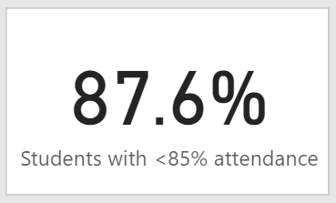

## Year-to-date students with chronic absenteeism

|  |  |
| --- | --- |
| Name / Item | Functionality |
| Description | This chart will show the proportion of students with an attendance rate of 80% or less |
| Chart type | KPI Indicator |
| Default view | Result for all Queensland State Schools |
| Chart Title | YTD Students with chronic absenteeism |
| Indicator/Measure | % of students with 80% or less attendance rate.  Attendance Rate: Formula =  Sum(AttendanceFTE) / (Sum(AttendanceFTE) + Sum(AbsenceFTE)) * 100 |
| Trend axis | n/a |
| Target goals | n/a |
| Visualisation specific data filters | Most recent result displayed, current calendar year-to-date calculation |
| Hierarchy drill-down | n/a |
| Visual link to other page | n/a |
| Tooltip | Power Bi default view (repeat number) |
| Nice to have function | n/a |

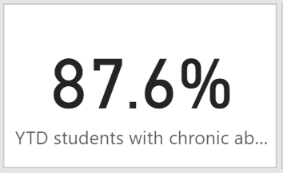

## Average attendance for Mondays

|  |  |
| --- | --- |
| Name / Item | Functionality |
| Description | This chart will show the average attendance rate for the calendar year-to-date, for Mondays only |
| Chart type | Paypal KPI donut chart |
| Default view | Result for all Queensland State Schools |
| Chart Title | Avg. Monday |
| Indicator/Measure | Average attendance rate for Mondays that have occurred YTD  Attendance Rate: Formula =  Sum(AttendanceFTE) / (Sum(AttendanceFTE) + Sum(AbsenceFTE)) * 100 |
| Trend axis | n/a |
| Target goals | n/a |
| Visualisation specific data filters | Most recent result displayed, current calendar year-to-date calculation, day = Monday |
| Hierarchy drill-down | n/a |
| Visual link to other page | n/a |
| Tooltip | Power Bi default view (repeat number) |
| Nice to have function | n/a |

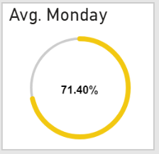

## Average attendance for Tuesdays

|  |  |
| --- | --- |
| Name / Item | Functionality |
| Description | This chart will show the average attendance rate for the calendar year-to-date, for Tuesdays only |
| Chart type | Paypal KPI donut chart |
| Default view | Result for all Queensland State Schools |
| Chart Title | Avg. Tuesday |
| Indicator/Measure | Average attendance rate for Tuesdays that have occurred YTD  Attendance Rate: Formula =  Sum(AttendanceFTE) / (Sum(AttendanceFTE) + Sum(AbsenceFTE)) * 100 |
| Trend axis | n/a |
| Target goals | n/a |
| Visualisation specific data filters | Most recent result displayed, current calendar year-to-date calculation, day = Tuesday |
| Hierarchy drill-down | n/a |
| Visual link to other page | n/a |
| Tooltip | Power Bi default view (repeat number) |
| Nice to have function | n/a |

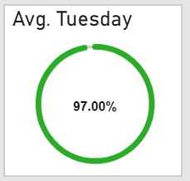

## Average attendance for Wednesday

|  |  |
| --- | --- |
| Name / Item | Functionality |
| Description | This chart will show the average attendance rate for the calendar year-to-date, for Wednesdays only |
| Chart type | Paypal KPI donut chart |
| Default view | Result for all Queensland State Schools |
| Chart Title | Avg. Wednesday |
| Indicator/Measure | Average attendance rate for Wednesdays that have occurred YTD  Attendance Rate: Formula =  Sum(AttendanceFTE) / (Sum(AttendanceFTE) + Sum(AbsenceFTE)) * 100 |
| Trend axis | n/a |
| Target goals | n/a |
| Visualisation specific data filters | Most recent result displayed, current calendar year-to-date calculation, day = Wednesday |
| Hierarchy drill-down | n/a |
| Visual link to other page | n/a |
| Tooltip | Power Bi default view (repeat number) |
| Nice to have function | n/a |

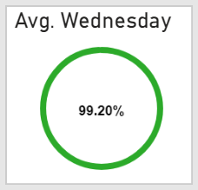

## Average attendance for Thursday

|  |  |
| --- | --- |
| Name / Item | Functionality |
| Description | This chart will show the average attendance rate for the calendar year-to-date, for Thursday only |
| Chart type | Paypal KPI donut chart |
| Default view | Result for all Queensland State Schools |
| Chart Title | Avg. Thursday |
| Indicator/Measure | Average attendance rate for Thursdays that have occurred YTD  Attendance Rate: Formula =  Sum(AttendanceFTE) / (Sum(AttendanceFTE) + Sum(AbsenceFTE)) * 100 |
| Trend axis | n/a |
| Target goals | n/a |
| Visualisation specific data filters | Most recent result displayed, current calendar year-to-date calculation, day = Thursday |
| Hierarchy drill-down | n/a |
| Visual link to other page | n/a |
| Tooltip | Power Bi default view (repeat number) |
| Nice to have function | n/a |

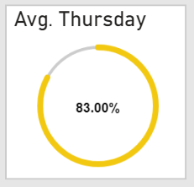

## Average attendance for Friday

|  |  |
| --- | --- |
| Name / Item | Functionality |
| Description | This chart will show the average attendance rate for the calendar year-to-date, for Friday only |
| Chart type | Paypal KPI donut chart |
| Default view | Result for all Queensland State Schools |
| Chart Title | Avg. Friday |
| Indicator/Measure | Average attendance rate for Fridays that have occurred YTD  Attendance Rate: Formula =  Sum(AttendanceFTE) / (Sum(AttendanceFTE) + Sum(AbsenceFTE)) * 100 |
| Trend axis | n/a |
| Target goals | n/a |
| Visualisation specific data filters | Most recent result displayed, current calendar year-to-date calculation, day = Friday |
| Hierarchy drill-down | n/a |
| Visual link to other page | n/a |
| Tooltip | Power Bi default view (repeat number) |
| Nice to have function | n/a |

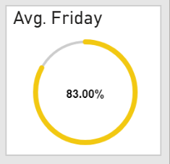

## Proportion of students by attendance rate range

|  |  |
| --- | --- |
| Name / Item | Functionality |
| Description | This chart will show the proportion of students by attendance rate range for the calendar year-to-date |
| Chart type | %100 stacked bar chart |
| Default view | Result for all Queensland State Schools |
| Chart Title | YTD students by attendance rate range |
| Indicator/Measure | Percentage of students with an Attendance rate* between the following ranges (sorted lowest to highest by attendance %):   * < 85% * 85% < 89.9% * 90% < 94.9% * 95% < 100%   Attendance Rate: Formula =  Sum(AttendanceFTE) / (Sum(AttendanceFTE) + Sum(AbsenceFTE)) * 100 |
| X axis | Value = 0%-100%  Title = off  Functionality expected = n/a |
| Y axis | Value = Year-to-date  Title = off  Functionality = n/a |
| Legend | Display = off  Title = n/a  Formatting = n/a |
| Visualisation specific data filters | Current calendar year-to-date calculation |
| Hierarchy drill-down | n/a |
| Visual link to other page | n/a |
| Tooltip | Power Bi default view (repeat number) |
| Nice to have function | n/a |

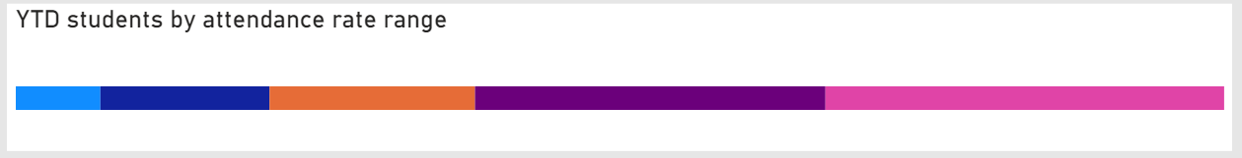

## Average attendance rate by school type

|  |  |
| --- | --- |
| Name / Item | Functionality |
| Description | This chart will show the average attendance rate by school type over time. |
| Chart type | Line chart |
| Default view | Result for all Queensland State Schools |
| Chart Title | Avg. attendance rate by school type |
| Indicator/Measure | Average attendance rate over time for the calendar year, for the following school types:   * Primary * Secondary * Combined * Special School   Attendance Rate: Formula =  Sum(AttendanceFTE) / (Sum(AttendanceFTE) + Sum(AbsenceFTE)) * 100 |
| X axis | Value = date  Title = off  Functionality expected = users is expected to be able to drill up/down to their desired date range, e.g. display the axis as months of year, or terms, or semesters etc |
| Y axis | Value = 0%-100%  Title = off  Functionality = n/a |
| Legend | Display = on  Title = School type  Formatting = bottom centre |
| Visualisation specific data filters | Current calendar displayed on x axis only |
| Hierarchy drill-down | n/a |
| Visual link to other page | n/a |
| Tooltip | Power Bi default view: date at data point, result per school type |
| Nice to have function | n/a |

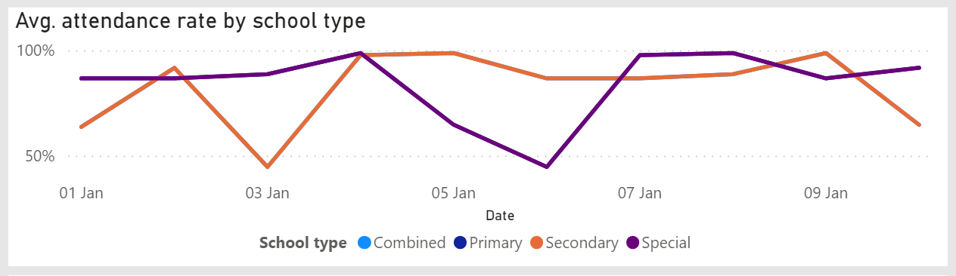

Business rule:

* It is expected that this graph act as a date range slicer for the rest of the report. If this cannot be achieved, than it is expected that a date range slider be provided for the report.
* It is expected that if a user selects a single date from line graph, that the rest of the report would adjust to show results for that particular day.

## Average attendance rate by student attributes

|  |  |
| --- | --- |
| Name / Item | Functionality |
| Description | This chart will show the average YTD attendance rate by various student attributes. This visualisation allows the user to filter by any combination of student attributes in order to adjust the report by the user selection (e.g. Year 5, indigenous, students with disability). |
| Chart type | Tree-map |
| Default view | Result for all Queensland State Schools |
| Chart Title | Avg. attendance rate by student attribute/s |
| Indicator/Measure | Average attendance rate for the calendar year-to-date (result data label to be turned on), for the following: (category then detail)   * Year level (0P-12) * Indigenous (yes, no, unknown) * Students with disability (yes, no, unknown) * Gender (male, female, undisclosed) * EAL/D (yes, no, unknown) * International/Visa holder (yes, no)   Attendance Rate: Formula =  Sum(AttendanceFTE) / (Sum(AttendanceFTE) + Sum(AbsenceFTE)) * 100 |
| Legend | Display = on  Title = off  Formatting = bottom centre |
| Visualisation specific data filters | Most recent result displayed, current calendar year-to-date calculation |
| Hierarchy drill-down | n/a |
| Visual link to other page | n/a |
| Tooltip | Power Bi default view: category, detail, avg. attendance rate |
| Nice to have function | n/a |

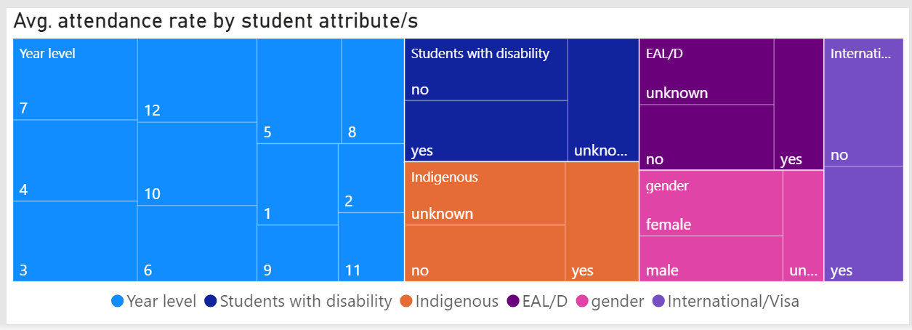

Business rule:

* It is expected that this graph acts as filter to all other graphs within the report. If a user selects a particular student attribute or combination of attributes, graphs adjust to show results for only those students.

## Days not in school by reason

|  |  |
| --- | --- |
| Name / Item | Functionality |
| Description | This chart will show the total number of absences recorded YTD by reason provided in OneSchool. The graph is expected to be colour coded to show the distinction between penalty absences and non-penalty absences. |
| Chart type | Stacked bar chart |
| Default view | Result for all Queensland State Schools |
| Chart Title | Days not in school by reason |
| Indicator/Measure | Total number of days recorded as absences for the current calendar year-to-date for each absence reason code recorded in OneSchool. (refer to SORD Overview spec 3.9.3). Yes = penalty absence codes, No = non-penalty absence codes. |
| X axis | Value = total number of days (adjusting number format)  Title = off  Functionality expected = n/a |
| Y axis | Value = Reason description  Title = off  Functionality = users is expected to be able to drill up to totals by penalty/non-penalty |
| Legend | Display = on  Title =Counted as absence?  Formatting = bottom centre |
| Visualisation specific data filters | Current calendar year-to-date calculation |
| Hierarchy drill-down | n/a |
| Visual link to other page | n/a |
| Tooltip | Power Bi default view: reason description, total days absence, penalty type |
| Nice to have function | n/a |

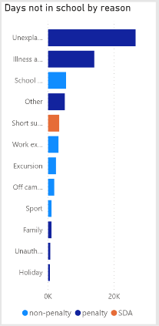

## Region

|  |  |
| --- | --- |
| Name / Item | Functionality |
| Description | This chart will show the regions of queensland, enabling users to filer by the selected region/s. |
| Chart type | Synoptic Panel by OKVIZ |
| Default view | Result for all Queensland State Schools (no particular region selected) |
| Chart Title | *No title* |
| Indicator/Measure | Attendance rate for each region of Queensland.  Attendance Rate: Formula =  Sum(AttendanceFTE) / (Sum(AttendanceFTE) + Sum(AbsenceFTE)) * 100 |
| Trend | n/a |
| Goals | n/a |
| Visualisation specific data filters | Current calendar year-to-date calculation |
| Hierarchy drill-down | n/a |
| Visual link to other page | n/a |
| Tooltip | Power Bi default view: region name, YTD attendance rate |
| Nice to have function | * It would be nice if the regions could also be a heatmap, highlighting if a region has a high or low attendance rate * It would be nice if there was some sort of zoom functionality which would satisfy the requirements covered in visualisation 3.15 (displaying attendance rate by schools), allowing us to not display the table. |

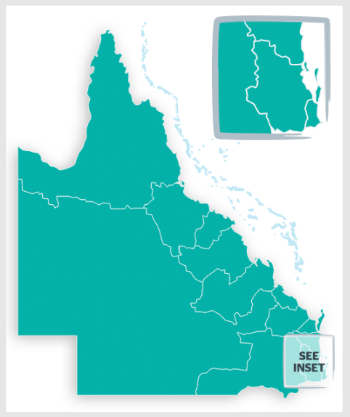

## School results table

|  |  |
| --- | --- |
| Name / Item | Functionality |
| Description | This table will show you a list of schools with their most recent YTD attendance rate. |
| Chart type | Table |
| Default view | All State Schools within Queensland |
| Chart Title | *No title* |
| Column Headings | * School * YTD attendance rate * Students enrolled |
| Values | * Centre name * YTD attendance rate: Formula =  Sum(AttendanceFTE) / (Sum(AttendanceFTE) + Sum(AbsenceFTE)) * 100 * Enrolment count |
| Visualisation specific data filters | Current calendar year-to-date calculation |
| Hierarchy drill-down | n/a |
| Visual link to other page | * It would be good if selecting the school enabled users to go to the School Attendance page, however this must need to consider RLS restricting school users from being able to only see their own school |
| Tooltip | Power Bi default view: repeat values |
| Nice to have function | * It would be nice if conditional formatting on the attendance rate column could be applied with a diverging colour from highest to lowest attendance rate value. |

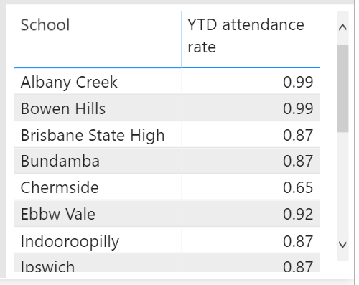

Business rules:

* It is expected that the table will adjust based on any demographic combination selected by the users from the visualisation outlined in 3.12
* It is expected that if a school has less than 5 student enrolments that those school results do not appear within this table OR results return 0 or blank.
* It is expected that if a school has less than 5 students enrolled based on criteria selected in 3.12, that those school result do not appear whithin this table OR results return 0 or blank.

# Page 2 Report Layout - detail visulisation requirements

## User Navigation Filters

The characteristics/dimensions listed below need to be available in the data model to enable further navigations on the default visualisation.

| Name / Item | Functionality | Default |
| --- | --- | --- |
| Date* | Slider  YTD calendar year date range | Beginning of the year to current date |
| School | Drop Down with Search Bar Option to select all, multiple or a single option | All** |
| Year level | Drop Down  Option to select all, multiple or single option | All |
| Students with disability | Drop Down  Option to select all, or a single option | All |
| Indigenous | Drop Down  Option to select all, or a single option | All |
| Gender | Drop Down  Option to select all, or a single option | All |
| EAL/D | Drop Down  Option to select all, or a single option | All |
| International/Visa | Drop Down  Option to select all, or a single option | All |

*may not be necessary if user can select date range via the YTD attendance rate line graph, new feature of latest power bi release

**Design challenge: how can we make the user experience better? School users ideally see only their schools selected (as they will most likely only have a few and one in most cases). Corporate users need to have access to all schools – what can we show them as default? How do users get to this page from State page?

## Year-to-date Attendance rate

|  |  |
| --- | --- |
| Name / Item | Functionality |
| Description | This chart will show the Attendance Rate for the calendar year-to-date |
| Chart type | KPI Indicator |
| Default view | Result for selected school – refer to design challenge outlined in 4.1 |
| Chart Title | YTD attendance rate |
| Indicator/Measure | Attendance Rate: Formula =  Sum(AttendanceFTE) / (Sum(AttendanceFTE) + Sum(AbsenceFTE)) * 100 |
| Trend axis | n/a |
| Target goals | n/a |
| Visualisation specific data filters | Most recent result displayed, current calendar year-to-date calculation |
| Hierarchy drill-down | n/a |
| Visual link to other page | n/a |
| Tooltip | Power Bi default view (repeat number) |
| Nice to have function | n/a |



## Average full day absence count

|  |  |
| --- | --- |
| Name / Item | Functionality |
| Description | This chart will show for the current YTD, the average number per day, of students marked as absent for a full day. |
| Chart type | KPI Indicator |
| Default view | Result for selected school – refer to design challenge outlined in 4.1 |
| Chart Title | Avg full day absence count |
| Indicator/Measure | Absent full day count: Per day of current calendar year, sum number of students who were recorded as having a full day absence (penalty absence reason).  Measure = Average of the Absent full day count |
| Trend axis | n/a |
| Target goals | n/a |
| Visualisation specific data filters | Most recent result displayed, current calendar year-to-date calculation |
| Hierarchy drill-down | n/a |
| Visual link to other page | n/a |
| Tooltip | Power Bi default view (repeat number) |
| Nice to have function | n/a |

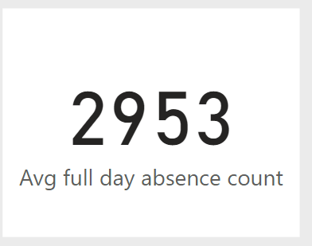

*please refer to SORD overview suite 20/141922 chapters 3.9.2 on part/full day reason codes

## Average part day absence count

|  |  |
| --- | --- |
| Name / Item | Functionality |
| Description | This chart will show for the current YTD, the average number per day, of students marked as absent for a part day. |
| Chart type | KPI Indicator |
| Default view | Result for selected school – refer to design challenge outlined in 4.1 |
| Chart Title | Avg part day absence count |
| Indicator/Measure | Absent part day count: Per day of current calendar year, sum number of students who were recorded as having a part day absence (penalty absence reason).  Measure = Average of the Absent part day count |
| Trend axis | n/a |
| Target goals | n/a |
| Visualisation specific data filters | Most recent result displayed, current calendar year-to-date calculation |
| Hierarchy drill-down | n/a |
| Visual link to other page | n/a |
| Tooltip | Power Bi default view (repeat number) |
| Nice to have function | n/a |

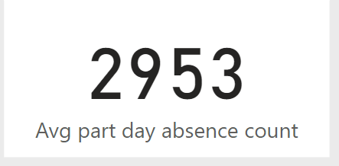

*please refer to SORD overview suite 20/141922 chapters 3.9.2 on part/full day reason codes

## Percenetage of part day absences by time of day

|  |  |
| --- | --- |
| Name / Item | Functionality |
| Description | This chart will percentage of part day absences by time of day (AM or PM) |
| Chart type | Tree-map |
| Default view | Result for selected school – refer to design challenge outlined in 4.1 |
| Chart Title | *No title* |
| Indicator/Measure | Denominator = total number of part day absences YTD for the current calendar year.  Measure = percentage of total absences by time of day:   * AM * PM |
| Legend | Display = *off*  Title = *off*  Formatting = data labels on |
| Visualisation specific data filters | Most recent result displayed, current calendar year-to-date calculation |
| Hierarchy drill-down | n/a |
| Visual link to other page | n/a |
| Tooltip | Power Bi default view: Part day type “AM” Percentage of total: “68.1%” |
| Nice to have function | n/a |

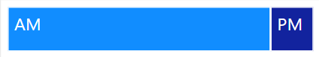

*please refer to SORD overview suite 20/141922 chapters 3.9.2 on part/full day reason codes

## Chronic absenteeism

|  |  |
| --- | --- |
| Name / Item | Functionality |
| Description | This chart will show the percentage of students who have less than 85% attendance rate for the current calendar year-to-date. |
| Chart type | KPI Indicator |
| Default view | Result for selected school – refer to design challenge outlined in 4.1 |
| Chart Title | YTD student <85% attendance |
| Indicator/Measure | Denominator: total number of students currently enrolled  Measure: percentage of students with an attendance rate of less than 85% for the current YTD  Attendance Rate: Formula =  Sum(AttendanceFTE) / (Sum(AttendanceFTE) + Sum(AbsenceFTE)) * 100 |
| Trend axis | n/a |
| Target goals | n/a |
| Visualisation specific data filters | Most recent result displayed, current calendar year-to-date calculation |
| Hierarchy drill-down | n/a |
| Visual link to other page | n/a |
| Tooltip | Power Bi default view (repeat number) |
| Nice to have function | n/a |

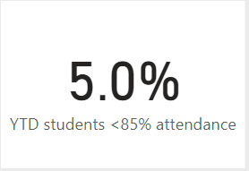

## Average attendance for Mondays

|  |  |
| --- | --- |
| Name / Item | Functionality |
| Description | This chart will show the average attendance rate for the calendar year-to-date, for Mondays only |
| Chart type | Paypal KPI donut chart |
| Default view | Result for selected school – refer to design challenge outlined in 4.1 |
| Chart Title | Avg. Monday |
| Indicator/Measure | Average attendance rate for Mondays that have occurred YTD  Attendance Rate: Formula =  Sum(AttendanceFTE) / (Sum(AttendanceFTE) + Sum(AbsenceFTE)) * 100 |
| Trend axis | n/a |
| Target goals | n/a |
| Visualisation specific data filters | Most recent result displayed, current calendar year-to-date calculation, day = Monday |
| Hierarchy drill-down | n/a |
| Visual link to other page | n/a |
| Tooltip | Power Bi default view (repeat number) |
| Nice to have function | n/a |



## Average attendance for Tuesdays

|  |  |
| --- | --- |
| Name / Item | Functionality |
| Description | This chart will show the average attendance rate for the calendar year-to-date, for Tuesdays only |
| Chart type | Paypal KPI donut chart |
| Default view | Result for selected school – refer to design challenge outlined in 4.1 |
| Chart Title | Avg. Tuesday |
| Indicator/Measure | Average attendance rate for Tuesdays that have occurred YTD  Attendance Rate: Formula =  Sum(AttendanceFTE) / (Sum(AttendanceFTE) + Sum(AbsenceFTE)) * 100 |
| Trend axis | n/a |
| Target goals | n/a |
| Visualisation specific data filters | Most recent result displayed, current calendar year-to-date calculation, day = Tuesday |
| Hierarchy drill-down | n/a |
| Visual link to other page | n/a |
| Tooltip | Power Bi default view (repeat number) |
| Nice to have function | n/a |



## Average attendance for Wednesday

|  |  |
| --- | --- |
| Name / Item | Functionality |
| Description | This chart will show the average attendance rate for the calendar year-to-date, for Wednesdays only |
| Chart type | Paypal KPI donut chart |
| Default view | Result for selected school – refer to design challenge outlined in 4.1 |
| Chart Title | Avg. Wednesday |
| Indicator/Measure | Average attendance rate for Wednesdays that have occurred YTD  Attendance Rate: Formula =  Sum(AttendanceFTE) / (Sum(AttendanceFTE) + Sum(AbsenceFTE)) * 100 |
| Trend axis | n/a |
| Target goals | n/a |
| Visualisation specific data filters | Most recent result displayed, current calendar year-to-date calculation, day = Wednesday |
| Hierarchy drill-down | n/a |
| Visual link to other page | n/a |
| Tooltip | Power Bi default view (repeat number) |
| Nice to have function | n/a |



## Average attendance for Thursday

|  |  |
| --- | --- |
| Name / Item | Functionality |
| Description | This chart will show the average attendance rate for the calendar year-to-date, for Thursday only |
| Chart type | Paypal KPI donut chart |
| Default view | Result for selected school – refer to design challenge outlined in 4.1 |
| Chart Title | Avg. Thursday |
| Indicator/Measure | Average attendance rate for Thursdays that have occurred YTD  Attendance Rate: Formula =  Sum(AttendanceFTE) / (Sum(AttendanceFTE) + Sum(AbsenceFTE)) * 100 |
| Trend axis | n/a |
| Target goals | n/a |
| Visualisation specific data filters | Most recent result displayed, current calendar year-to-date calculation, day = Thursday |
| Hierarchy drill-down | n/a |
| Visual link to other page | n/a |
| Tooltip | Power Bi default view (repeat number) |
| Nice to have function | n/a |



## Average attendance for Friday

|  |  |
| --- | --- |
| Name / Item | Functionality |
| Description | This chart will show the average attendance rate for the calendar year-to-date, for Friday only |
| Chart type | Paypal KPI donut chart |
| Default view | Result for selected school – refer to design challenge outlined in 4.1 |
| Chart Title | Avg. Friday |
| Indicator/Measure | Average attendance rate for Fridays that have occurred YTD  Attendance Rate: Formula =  Sum(AttendanceFTE) / (Sum(AttendanceFTE) + Sum(AbsenceFTE)) * 100 |
| Trend axis | n/a |
| Target goals | n/a |
| Visualisation specific data filters | Most recent result displayed, current calendar year-to-date calculation, day = Friday |
| Hierarchy drill-down | n/a |
| Visual link to other page | n/a |
| Tooltip | Power Bi default view (repeat number) |
| Nice to have function | n/a |



## Daily attendance rate and YTD attendance rate trend

|  |  |
| --- | --- |
| Name / Item | Functionality |
| Description | This chart will show the attendance rate for every individual school day (calendar YTD) combined with the YTD attendance rate trend over time. |
| Chart type | Line and clustered column chart |
| Default view | Result for selected school – refer to design challenge outlined in 4.1 |
| Chart Title | Daily attendance rate and YTD attendance rate |
| Indicator/Measure | Columns: Attendance rate for the school for each day  Line: YTD attendance rate over time  Attendance Rate: Formula =  Sum(AttendanceFTE) / (Sum(AttendanceFTE) + Sum(AbsenceFTE)) * 100 |
| X axis | Value = date  Title = off  Functionality expected = users is expected to be able to drill up/down to their desired date range, e.g. display the axis as days, or months of year, or terms, or semesters etc |
| Y axis | Value = 0%-100%  Title = off  Functionality = n/a |
| Legend | Display = *on*  Title = *off*  Formatting = bottom centre |
| Visualisation specific data filters | Current calendar displayed on x axis only |
| Hierarchy drill-down | n/a |
| Visual link to other page | n/a |
| Tooltip | Power Bi default view: date at data point, daily attendance rate for data point, YTD attendance rate at data point |
| Nice to have function | n/a |

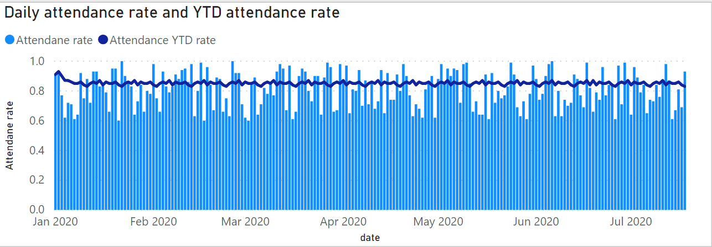

## Proportion of students by attendance rate range

|  |  |
| --- | --- |
| Name / Item | Functionality |
| Description | This chart will show the proportion of students by attendance rate range for the calendar year-to-date |
| Chart type | Clustered bar chart |
| Default view | Result for selected school – refer to design challenge outlined in 4.1 |
| Chart Title | YTD students by attendance rate range |
| Indicator/Measure | Percentage of students with an Attendance rate* between the following ranges (sorted lowest to highest by attendance %):   * 0% <20% * 20% <40% * 40%<60% * 60%<80% * 80%,100%   Attendance Rate: Formula =  Sum(AttendanceFTE) / (Sum(AttendanceFTE) + Sum(AbsenceFTE)) * 100 |
| X axis | Value = 0%-100%  Title = off  Functionality expected = n/a |
| Y axis | Value = *off*  Title = *off*  Functionality = *n/a* |
| Visualisation specific data filters | Current calendar year-to-date calculation |
| Hierarchy drill-down | n/a |
| Visual link to other page | n/a |
| Tooltip | Power Bi default view (repeat number) |
| Nice to have function | It would be nice if the user could drill-up/drill-down on the y categories to break them down further (e.g. show 10% ranges or 5% ranges) |

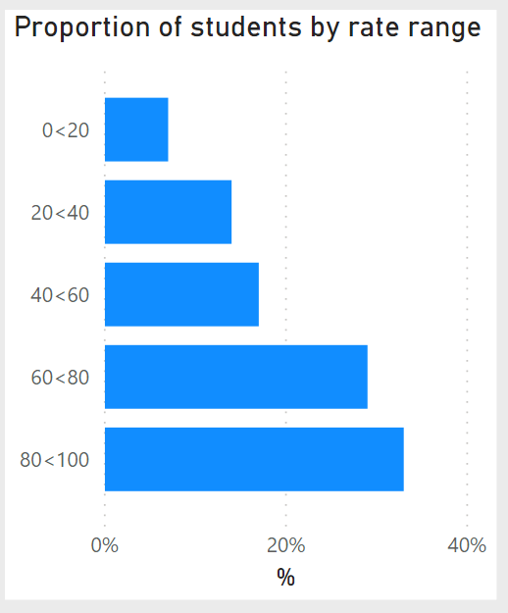

## YTD attendance rate QSS school type comparison

|  |  |
| --- | --- |
| Name / Item | Functionality |
| Description | This chart will show the difference between the attendance rate (YTD) for the selected school, vs the attendance rate for the same school type for all Queensland State Schools. |
| Chart type | KPI Indicator |
| Default view | Result for selected school – refer to design challenge outlined in 4.1 |
| Chart Title | YTD attendance rate QSS school type comparison |
| Indicator/Measure | Attendance rate for user selected school  Attendance rate for Queensland State Schools with the same school type as user selected school (e.g. Primary, Secondary, Combined)  Measure: difference between school attendance rate and QSS attendance rate  Attendance Rate: Formula =  Sum(AttendanceFTE) / (Sum(AttendanceFTE) + Sum(AbsenceFTE)) * 100 |
| Trend axis | n/a |
| Target goals | n/a |
| Visualisation specific data filters | Most recent result displayed, current calendar year-to-date calculation |
| Hierarchy drill-down | n/a |
| Visual link to other page | n/a |
| Tooltip | Power Bi default view (repeat number) |
| Nice to have function | Colour change to show better than, same or lower than QSS result |

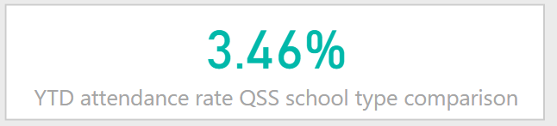

## YTD attendance rate Region school type comparison

|  |  |
| --- | --- |
| Name / Item | Functionality |
| Description | This chart will show the difference between the attendance rate (YTD) for the selected school, vs the attendance rate for the same school type for all schools within the relative region. |
| Chart type | KPI Indicator |
| Default view | Result for selected school – refer to design challenge outlined in 4.1 |
| Chart Title | YTD attendance rate Region school type comparison |
| Indicator/Measure | Attendance rate for user selected school  Attendance rate for all schools of the same type as the user selected school (e.g. primary, secondary, combined) within the same region as the user selected school  Measure: difference between school attendance rate and region attendance rate  Attendance Rate: Formula =  Sum(AttendanceFTE) / (Sum(AttendanceFTE) + Sum(AbsenceFTE)) * 100 |
| Trend axis | n/a |
| Target goals | n/a |
| Visualisation specific data filters | Most recent result displayed, current calendar year-to-date calculation |
| Hierarchy drill-down | n/a |
| Visual link to other page | n/a |
| Tooltip | Power Bi default view (repeat number) |
| Nice to have function | Colour change to show better than, same or lower than Region result |

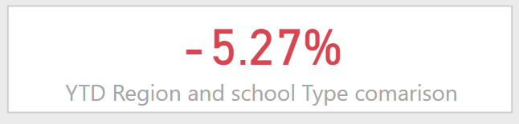

# Page 3 Report Layout - detail visulisation requirements

## User Navigation Filters

The characteristics/dimensions listed below need to be available in the data model to enable further navigations on the default visualisation.

| Name / Item | Functionality | Default |
| --- | --- | --- |
| Date* | Slider  YTD calendar year date range | Beginning of the year to current date |
| School | Drop Down with Search Bar Option to select all, multiple or a single option | All** |
| Year level | Drop Down  Option to select all, multiple or single option | All |
| Students with disability | Drop Down  Option to select all, or a single option | All |
| Indigenous | Drop Down  Option to select all, or a single option | All |
| Gender | Drop Down  Option to select all, or a single option | All |
| EAL/D | Drop Down  Option to select all, or a single option | All |
| International/Visa | Drop Down  Option to select all, or a single option | All |
| Student | Drop Down Search Bar Option to select all, multiple or single options | All |

*may not be necessary if user can select date range via the YTD attendance rate line graph, new feature of latest power bi release

**Design challenge: how can we make the user experience better? School users ideally see only their schools selected (as they will most like only have a few and one in most cases). Corporate users need to have access to all schools – what can we show them as default?

## Year-to-date full day absence day count

|  |  |
| --- | --- |
| Name / Item | Functionality |
| Description | This chart will show for the current YTD, total number of full day absences recorded. |
| Chart type | KPI Indicator |
| Default view | Result for selected school – refer to design challenge outlined in 4.1 |
| Chart Title | YTD full day absence count |
| Indicator/Measure | Absent full day count: year-to-date sum number of full day absences recorded. |
| Trend axis | n/a |
| Target goals | n/a |
| Visualisation specific data filters | Most recent result displayed, current calendar year-to-date calculation |
| Hierarchy drill-down | n/a |
| Visual link to other page | n/a |
| Tooltip | Power Bi default view (repeat number) |
| Nice to have function | n/a |

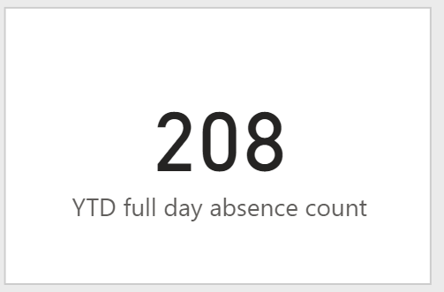

*please refer to SORD overview suite 20/141922 chapters 3.9.2 on part/full day reason codes

## Year-to-date part day absence count

|  |  |
| --- | --- |
| Name / Item | Functionality |
| Description | This chart will show for the current YTD, total number of part day absences recorded. |
| Chart type | KPI Indicator |
| Default view | Result for selected school – refer to design challenge outlined in 4.1 |
| Chart Title | YTD part day absence count |
| Indicator/Measure | Absent part day count: year-to-date sum number of part day absences recorded. |
| Trend axis | n/a |
| Target goals | n/a |
| Visualisation specific data filters | Most recent result displayed, current calendar year-to-date calculation |
| Hierarchy drill-down | n/a |
| Visual link to other page | n/a |
| Tooltip | Power Bi default view (repeat number) |
| Nice to have function | n/a |

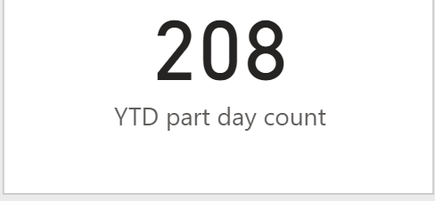

*please refer to SORD overview suite 20/141922 chapters 3.9.2 on part/full day reason codes

## Percentage of part day absences by time of day

|  |  |
| --- | --- |
| Name / Item | Functionality |
| Description | This chart will percentage of part day absences by time of day (AM or PM) |
| Chart type | Tree-map |
| Default view | Result for selected school – refer to design challenge outlined in 4.1 |
| Chart Title | *No title* |
| Indicator/Measure | Denominator = total number of part day absences YTD for the current calendar year.  Measure = percentage of total absences by time of day:   * AM * PM |
| Legend | Display = *off*  Title = *off*  Formatting = data labels on |
| Visualisation specific data filters | Most recent result displayed, current calendar year-to-date calculation |
| Hierarchy drill-down | n/a |
| Visual link to other page | n/a |
| Tooltip | Power Bi default view: Part day type “AM” Percentage of total: “68.1%” |
| Nice to have function | n/a |



*please refer to SORD overview suite 20/141922 chapters 3.9.2 on part/full day reason codes

## Count of absences by reason type

|  |  |
| --- | --- |
| Name / Item | Functionality |
| Description | This chart will show the count of absences by reason type. Users can use this graph to investigate non-penalty and penalty reasons. User is expected to be able to either select a reason type or reason description and all other graphs on the report are to adjust highlighting on what the user has selected. |
| Chart type | Clustered column chart |
| Default view | Result for selected school – refer to design challenge outlined in 4.1 |
| Chart Title | Reason type |
| Indicator/Measure | Count of absences by penalty and non-penalty reasons. User is expected to be able to drill down/up into reason description. |
| X axis | Value = Reason type -> reason description  Title = *off*  Functionality expected = *n/a* |
| Y axis | Value = auto-adjusting number format  Title = *off*  Functionality = *n/a* |
| Visualisation specific data filters | Current calendar year-to-date calculation |
| Hierarchy drill-down | n/a |
| Visual link to other page | n/a |
| Tooltip | Power Bi default view (repeat number) |
| Nice to have function | n/a |

*please refer to SORD overview suite 20/141922 chapters 3.9.3 on reason description and penalty non-penalty rules

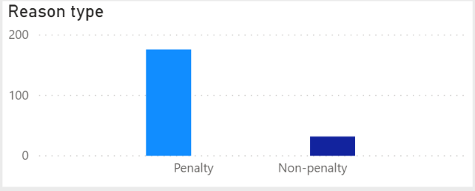

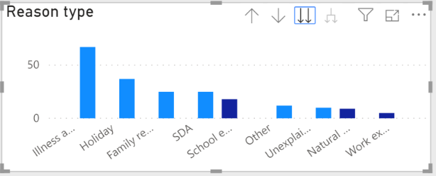

Business rule:

* It is expected that users can select a reason type and the rest of the report will adjust to show results for those reasons specifically. It is expected that the student table adjust to show you results for students who have at least one of the absence from the reason selected or the year-to-date.

## Daily absence count by type

|  |  |
| --- | --- |
| Name / Item | Functionality |
| Description | This chart will show the absence count for both penalty and non-penalty types for every individual school day (calendar YTD). |
| Chart type | Stacked column chart |
| Default view | Result for selected school – refer to design challenge outlined in 4.1 |
| Chart Title | Absences |
| Indicator/Measure | Column: count of penalty absences on day & count of non-penalty absences on day |
| X axis | Value = date  Title = off  Functionality expected = users is expected to be able to drill up/down to their desired date range, e.g. display the axis as days, or months of year, or terms, or semesters etc |
| Y axis | Value = auto-adjusting number  Title = *off*  Functionality = *n/a* |
| Legend | Display = *on*  Title = *off*  Formatting = bottom centre |
| Visualisation specific data filters | Current calendar displayed on x axis only |
| Hierarchy drill-down | n/a |
| Visual link to other page | n/a |
| Tooltip | Power Bi default view: date at data point, non-penalty absence count, penalty absence count |
| Nice to have function | n/a |

*please refer to SORD overview suite 20/141922 chapters 3.9.3 on reason description and penalty non-penalty rules

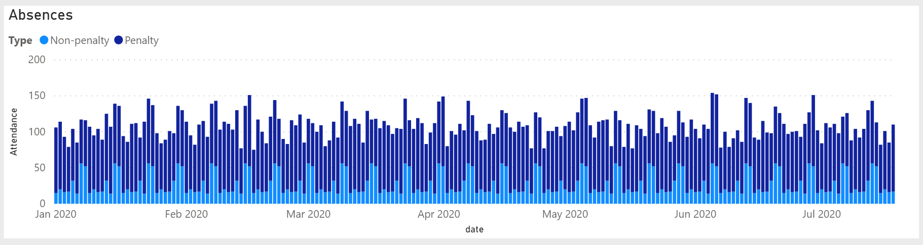

## Proportion of students by attendance rate range

|  |  |
| --- | --- |
| Name / Item | Functionality |
| Description | This chart will show the proportion of students by attendance rate range for the calendar year-to-date |
| Chart type | Clustered bar chart |
| Default view | Result for selected school – refer to design challenge outlined in 4.1 |
| Chart Title | YTD students by attendance rate range |
| Indicator/Measure | Percentage of students with an Attendance rate* between the following ranges (sorted lowest to highest by attendance %):   * 0% <20% * 20% <40% * 40%<60% * 60%<80% * 80%,100%   Attendance Rate: Formula =  Sum(AttendanceFTE) / (Sum(AttendanceFTE) + Sum(AbsenceFTE)) * 100 |
| X axis | Value = 0%-100%  Title = off  Functionality expected = n/a |
| Y axis | Value = *off*  Title = *off*  Functionality = *n/a* |
| Visualisation specific data filters | Current calendar year-to-date calculation |
| Hierarchy drill-down | n/a |
| Visual link to other page | n/a |
| Tooltip | Power Bi default view (repeat number) |
| Nice to have function | It would be nice if the user could drill-up/drill-down on the y categories to break them down further (e.g. show 10% ranges or 5% ranges) |



Business rule:

* It is expected when a user selects a bar from the rate range, that all the graphs on this page adjust to show result for students with that result.

## Count of absences by reason type

|  |  |
| --- | --- |
| Name / Item | Functionality |
| Description | This chart will show the count of absences by reason type and day of week. Users can use this graph to identify absence type trends. It is expected all reason types be on display (penalty and non-penalty) however users can filter the list down by using graph 5.5 |
| Chart type | Matrix |
| Default view | Result for selected school – refer to design challenge outlined in 4.1 |
| Chart Title | Absences by day of week |
| Indicator/Measure | Column horizontal heading = day of week  Column vertical heading = absence reason description  Value = total calendar YTD count of absences for reason description on day of week. |
| Conditional formatting | Totals = turned on  Heatmap = turned on, is expected that the user can identify higher numbers (or hot-spots) based on colour gradient applied to matrix |
| Visualisation specific data filters | Current calendar year-to-date calculation |
| Hierarchy drill-down | n/a |
| Visual link to other page | n/a |
| Tooltip | Power Bi default view (repeat number) |
| Nice to have function | n/a |

*please refer to SORD overview suite 20/141922 chapters 3.9.3 on reason description and penalty non-penalty rules

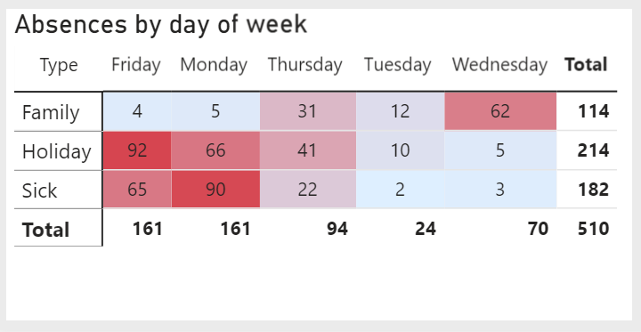

## Student table

|  |  |
| --- | --- |
| Name / Item | Functionality |
| Description | This chart will show aggregated absence counts and attendance rate for each individual student. |
| Chart type | Table |
| Default view | Result for selected school – refer to design challenge outlined in 4.1 |
| Chart Title | *No title* |
| Headings – values | Student name = student name or anonymous student number based on security  Attendance rate = current YTD attendance rate for student  Full days absent = total number of full days absent for the student for the YTD  AM part days absent = total number of part AM days absent for the student for YTD  PM part days absent = total number of part PM days absent for the student for YTD |
| Visualisation specific data filters | Current calendar year-to-date calculations |
| Hierarchy drill-down | n/a |
| Visual link to other page | n/a |
| Tooltip | Power Bi default view (repeat number) |
| Nice to have function | It would be nice if this table could act as a navigation point to the student profile report e.g click on Donald duck and get taken to the student profile for Donald |

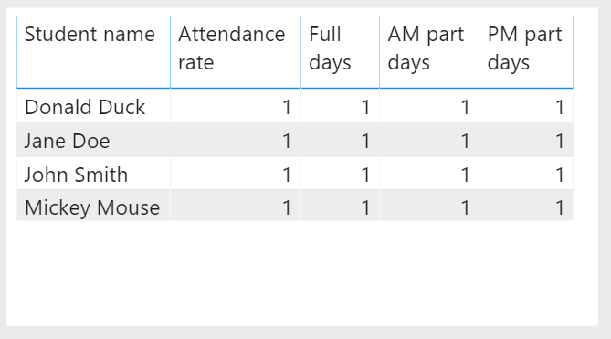

# Page 4 Report Layout - detail visulisation requirements***

## User Navigation Filters

The characteristics/dimensions listed below need to be available in the data model to enable further navigations on the default visualisation.

| Name / Item | Functionality | Default |
| --- | --- | --- |
| Date* | Slider  YTD calendar year date range | **OPTION TO GO BACK 3 YEARS** |
| Student** | Drop Down  Option to select one at a time | Top option? |

*may not be necessary if user can select date range via the YTD attendance rate line graph, new feature of latest power bi release

**Design challenge: how can we make the user experience better? Can we navigate to this student by any other means than providing a drop-down?

***Not decided if these graphs belong in the attendance daily report OR the student profile – more likely the student profile however we need to ensure we have the data to support providing these images

## Year-to-date full day absence day count

|  |  |
| --- | --- |
| Name / Item | Functionality |
| Description | This chart will show for the current date range selected by user, attendance rate for the user selected student. |
| Chart type | Gauge |
| Default view | Result for selected student– refer to design challenge outlined in 6.1 |
| Chart Title | Attendance rate |
| Indicator/Measure | Attendance Rate: Formula =  Sum(AttendanceFTE) / (Sum(AttendanceFTE) + Sum(AbsenceFTE)) * 100 |
| Colour threshold | <85% red  >85% |
| Target goals | n/a |
| Visualisation specific data filters | Most recent YTD results displayed by default, option to expand based on user date selection |
| Hierarchy drill-down | n/a |
| Visual link to other page | n/a |
| Tooltip | Power Bi default view (repeat number) |
| Nice to have function | n/a |

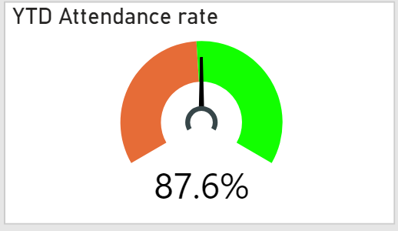

## Year-to-date full day absence day count

|  |  |
| --- | --- |
| Name / Item | Functionality |
| Description | This chart will show for the current YTD, total number of full day absences recorded. |
| Chart type | KPI Indicator |
| Default view | Result for selected student – refer to design challenge outlined in 6.1 |
| Chart Title | Full day absence count |
| Indicator/Measure | Sum of absent full days |
| Trend axis | n/a |
| Target goals | n/a |
| Visualisation specific data filters | Most recent YTD results displayed by default, option to expand based on user date selection |
| Hierarchy drill-down | n/a |
| Visual link to other page | n/a |
| Tooltip | Power Bi default view (repeat number) |
| Nice to have function | n/a |

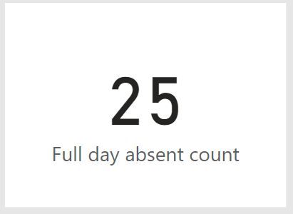

*please refer to SORD overview suite 20/141922 chapters 3.9.2 on part/full day reason codes

## Year-to-date part day AM absence count

|  |  |
| --- | --- |
| Name / Item | Functionality |
| Description | This chart will show for the current date range selected by user, total number of part day AM absences recorded. |
| Chart type | KPI Indicator |
| Default view | Result for selected student – refer to design challenge outlined in 6.1 |
| Chart Title | YTD AM part day absences |
| Indicator/Measure | Absent part day AM count: year-to-date sum number of part day absences recorded for late arrivals in the morning. |
| Trend axis | n/a |
| Target goals | n/a |
| Visualisation specific data filters | Most recent YTD results displayed by default, option to expand based on user date selection |
| Hierarchy drill-down | n/a |
| Visual link to other page | n/a |
| Tooltip | Power Bi default view (repeat number) |
| Nice to have function | n/a |

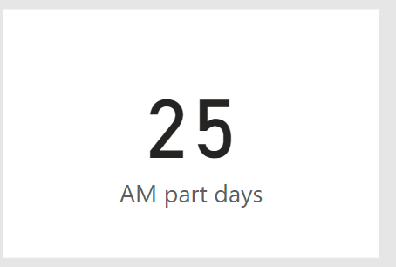

*please refer to SORD overview suite 20/141922 chapters 3.9.2 on part/full day reason codes

## Year-to-date part day AM absence count

|  |  |
| --- | --- |
| Name / Item | Functionality |
| Description | This chart will show for the current date range selected by user, total number of part day PM absences recorded. |
| Chart type | KPI Indicator |
| Default view | Result for selected student – refer to design challenge outlined in 6.1 |
| Chart Title | YTD PM part day absences |
| Indicator/Measure | Absent part day PM count: year-to-date sum number of part day absences recorded for early departures in the afternoon. |
| Trend axis | n/a |
| Target goals | n/a |
| Visualisation specific data filters | Most recent YTD results displayed by default, option to expand based on user date selection |
| Hierarchy drill-down | n/a |
| Visual link to other page | n/a |
| Tooltip | Power Bi default view (repeat number) |
| Nice to have function | n/a |

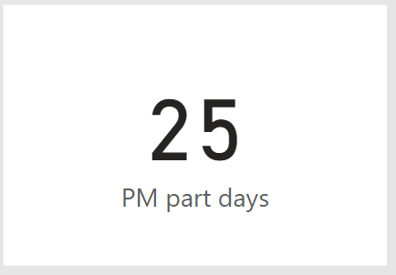

*please refer to SORD overview suite 20/141922 chapters 3.9.2 on part/full day reason codes

## Count of absences by reason type

|  |  |
| --- | --- |
| Name / Item | Functionality |
| Description | This chart will show the count of absences by reason type. Users can use this graph to investigate non-penalty and penalty reasons. User is expected to be able to either select a reason type or reason description and all other graphs on the report are to adjust highlighting on what the user has selected. |
| Chart type | Clustered column chart |
| Default view | Result for selected student – refer to design challenge outlined in 6.1 |
| Chart Title | Reason type |
| Indicator/Measure | Count of absences by penalty and non-penalty reasons. User is expected to be able to drill down/up into reason description. |
| X axis | Value = Reason type -> reason description  Title = *off*  Functionality expected = *n/a* |
| Y axis | Value = auto-adjusting number format  Title = *off*  Functionality = *n/a* |
| Visualisation specific data filters | Most recent YTD results displayed by default, option to expand based on user date selection |
| Hierarchy drill-down | n/a |
| Visual link to other page | n/a |
| Tooltip | Power Bi default view (repeat number) |
| Nice to have function | n/a |

*please refer to SORD overview suite 20/141922 chapters 3.9.3 on reason description and penalty non-penalty rules

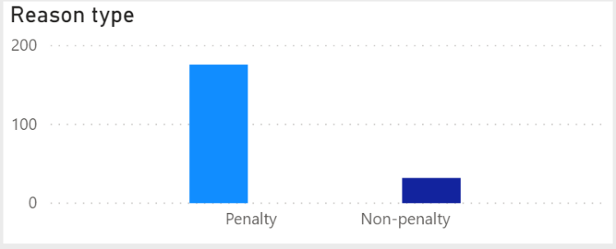

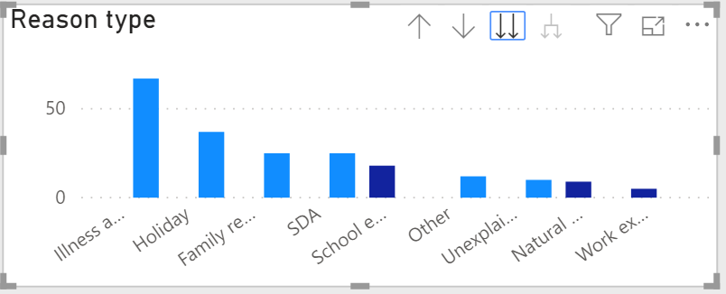

## Daily attendance rate and YTD attendance rate trend

|  |  |
| --- | --- |
| Name / Item | Functionality |
| Description | This chart will show the attendance rate over time for the user selected student. |
| Chart type | Line chart |
| Default view | Result for selected student – refer to design challenge outlined in 6.1 |
| Chart Title | Attendance rate over time |
| Indicator/Measure | Line: Attendance rate over time  Attendance Rate: Formula =  Sum(AttendanceFTE) / (Sum(AttendanceFTE) + Sum(AbsenceFTE)) * 100 |
| X axis | Value = date  Title = off  Functionality expected = users is expected to be able to drill up/down to their desired date range, e.g. display the axis as days, or months of year, or terms, or semesters etc |
| Y axis | Value = 0%-100%  Title = off  Functionality = n/a |
| Legend | Display = *on*  Title = *off*  Formatting = bottom centre |
| Visualisation specific data filters | Most recent YTD results displayed by default, option to expand based on user date selection |
| Hierarchy drill-down | n/a |
| Visual link to other page | n/a |
| Tooltip | Power Bi default view: date at data point, daily attendance rate for data point, YTD attendance rate at data point |
| Nice to have function | n/a |

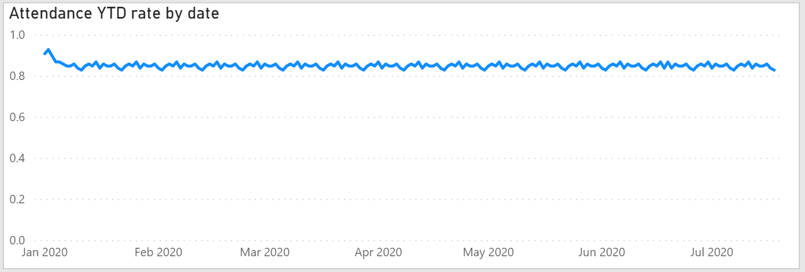

## Student calendar

|  |  |
| --- | --- |
| Name / Item | Functionality |
| Description | This chart will show the current user date selection, displayed in a calendar format, with the student absences highlighted. |
| Chart type | Calendar |
| Default view | Result for selected student – refer to design challenge outlined in 6.1 |
| Chart Title | Calendar of attendance |
| Indicator/Measure | Highlight day if absence has been recorded for student. |
| Functionality | It is expected that users can distinguish between full day or part day absences (e.g. shade of colour).  It is expected that if a user selects a penalty type and or reason description that only absences relating to the users selection are highlighted |
| Visualisation specific data filters | Most recent YTD results displayed by default, option to expand based on user date selection |
| Hierarchy drill-down | n/a |
| Visual link to other page | n/a |
| Tooltip | Power Bi default view: date at data point, absence type (e.g. full day, part day, pm/am, reason for absence) |
| Nice to have function | It would be good if the calendar could filter out non-school days such as weekends and holidays. |

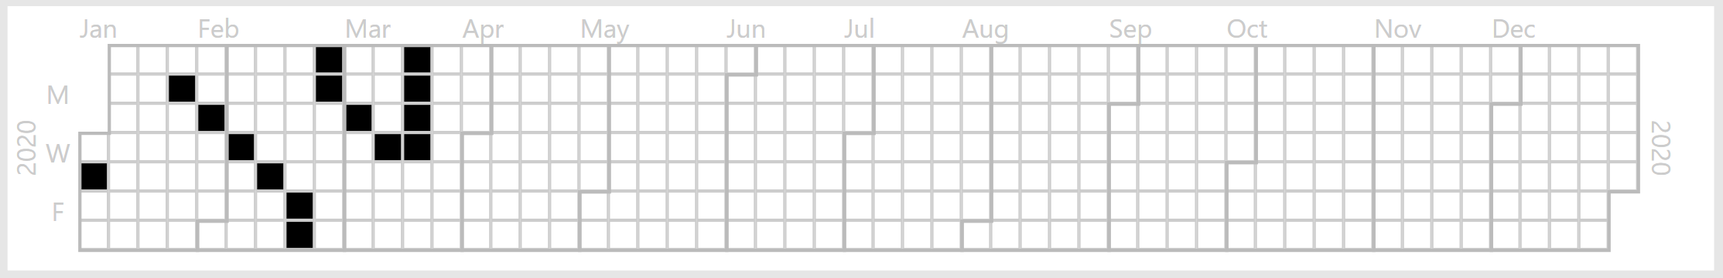

# APPENDIX A: Current Report Layout – Daily Attendance

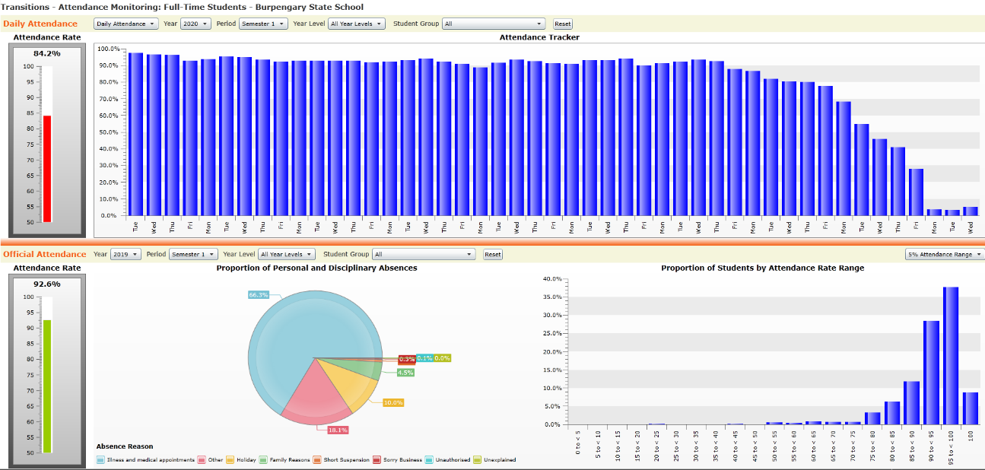The below screen shots represents the layout of the existing solution as currently delivered via Silverlight within OneSchool.

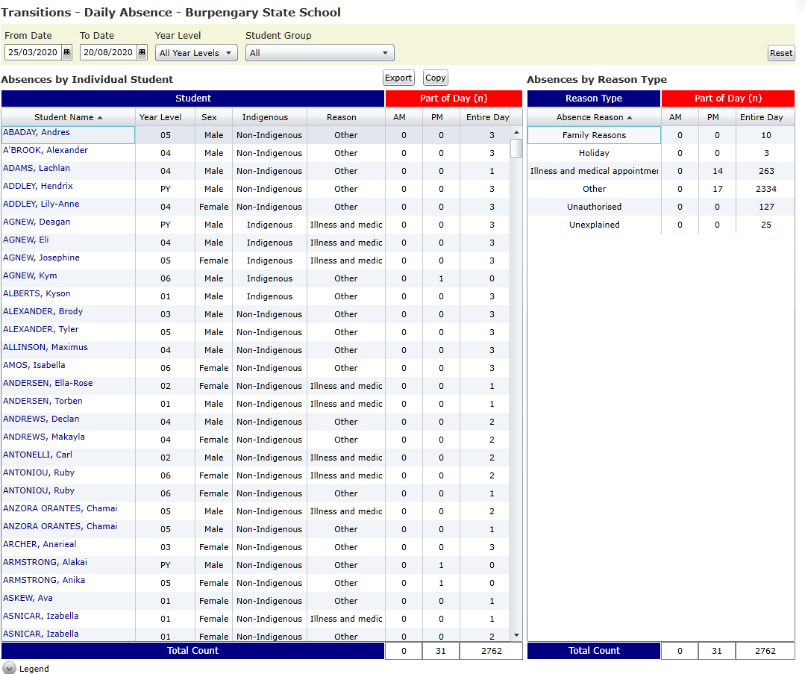



# APPENDIX B: Wire Frame – Page 1

The below screen shot is a draft proposed Power BI report layout, refer to Section 3 for specific details (such as titles, functionality, calculations etc.):

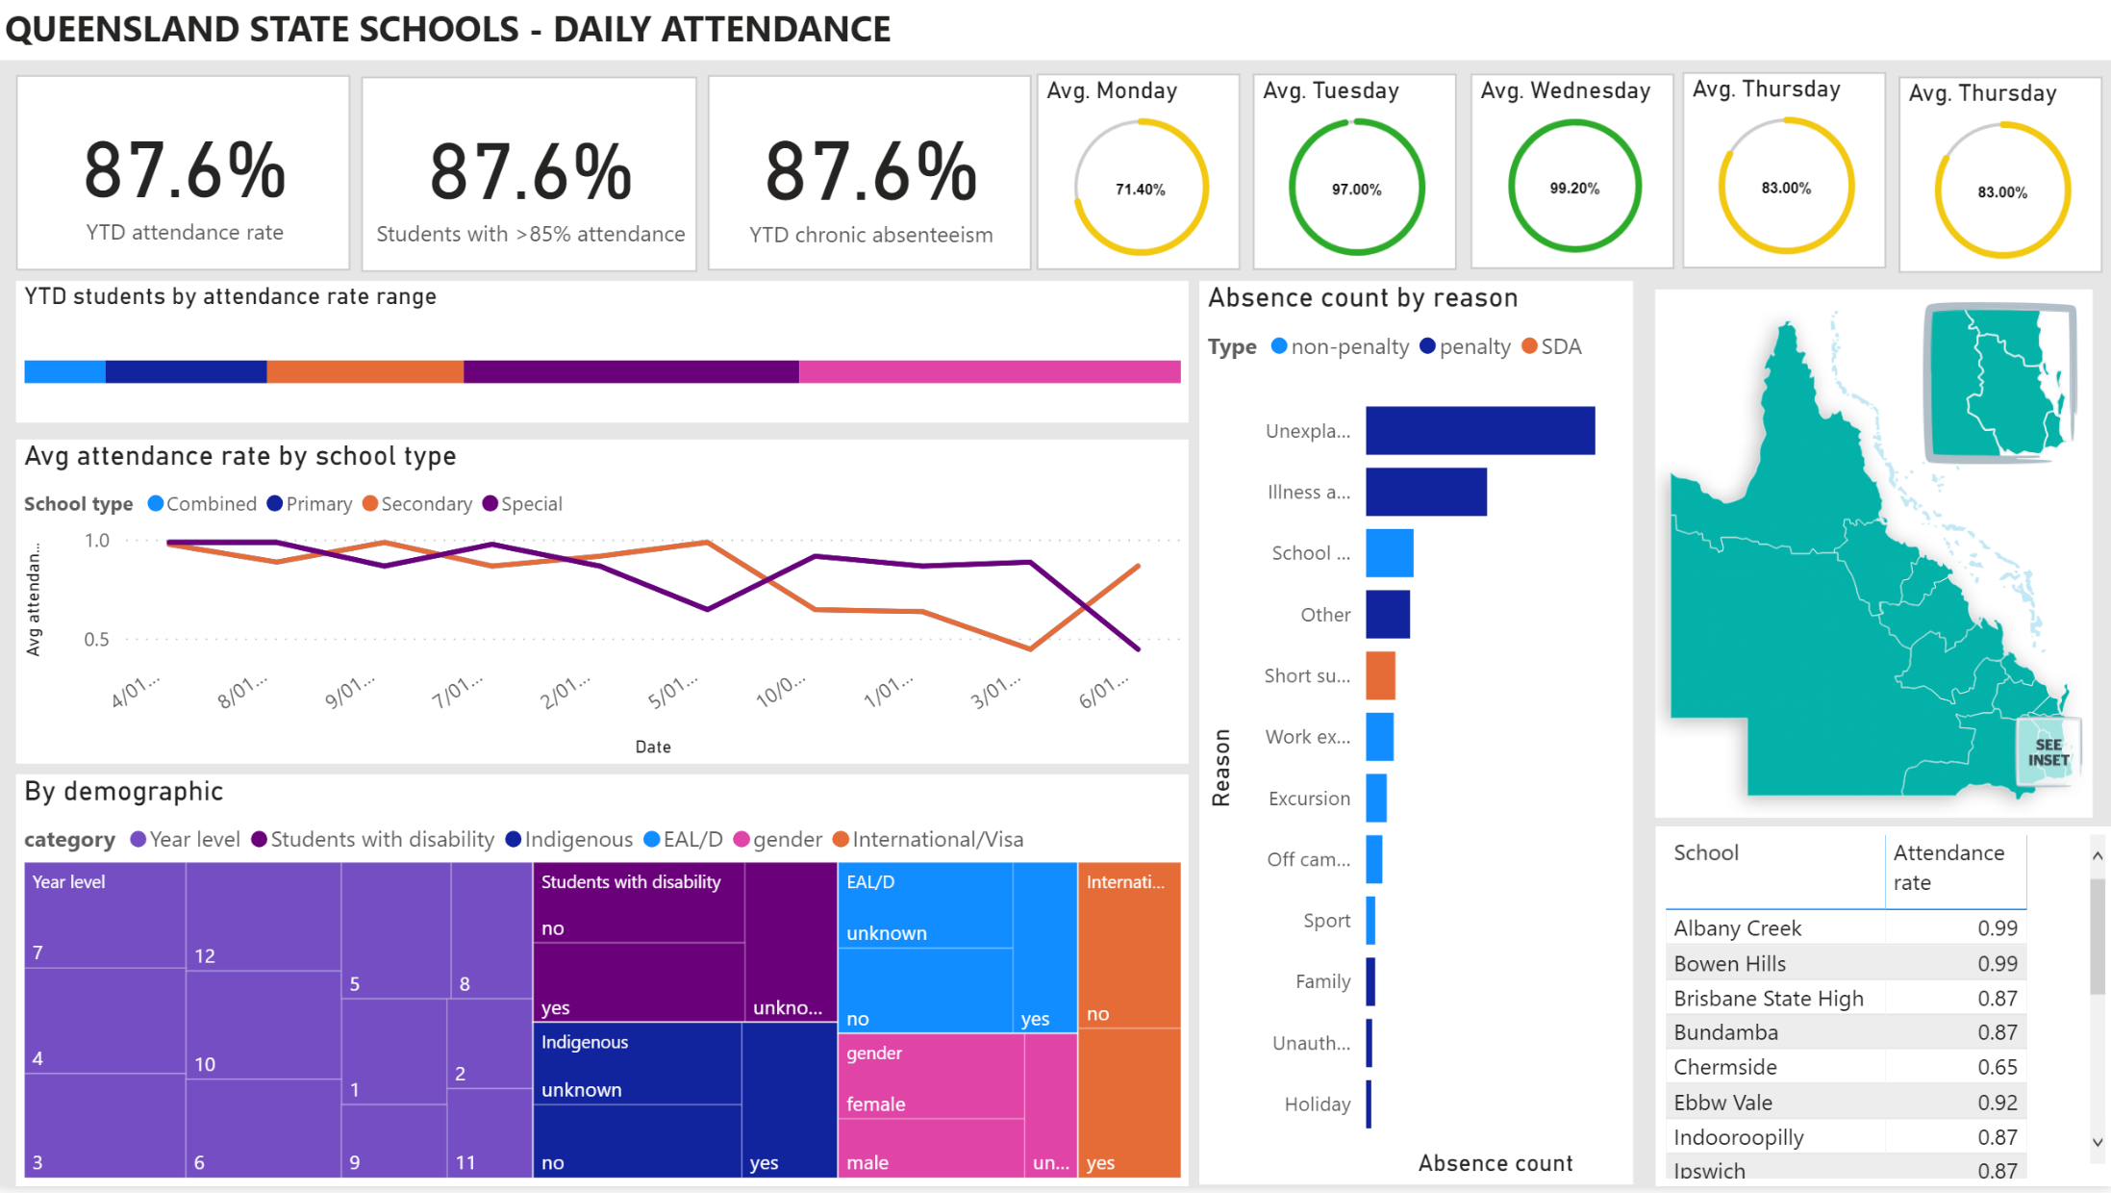

# APPENDIX C: Wire Frame – Page 2

The below screen shot is a draft proposed Power BI report layout, refer to Section 4 for specific details (such as titles, functionality, calculations etc.):

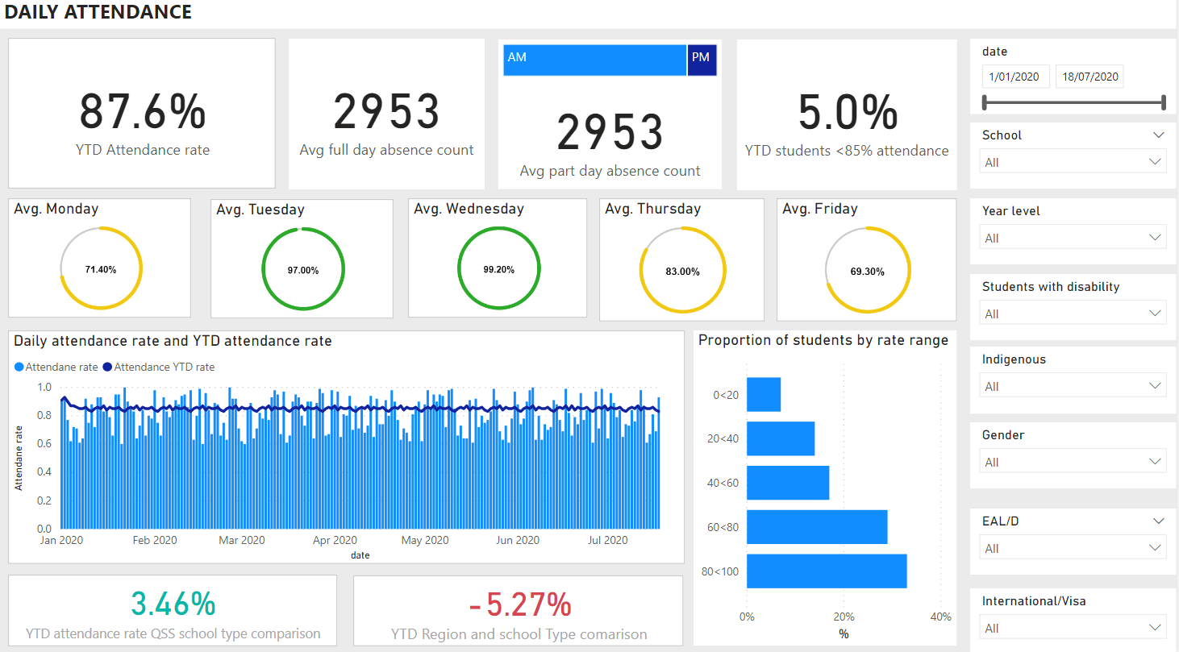

# APPENDIX D: Wire Frame – Page 3

The below screen shot is a draft proposed Power BI report layout, refer to Section 5 for specific details (such as titles, functionality, calculations etc.):

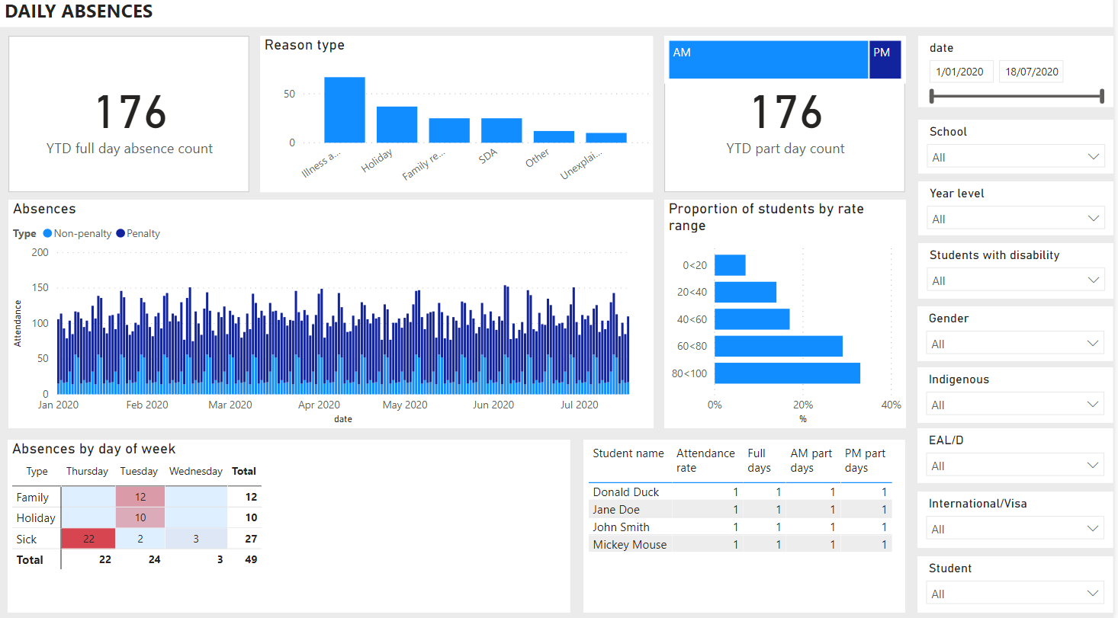

# APPENDIX E: Wire Frame – Page 4

The below screen shot is a draft proposed Power BI report layout, refer to Section 6 for specific details (such as titles, functionality, calculations etc.):

