Problem Set 4: Motion Detection

**Due: October 15th, 2017 23:59 AoE**

## **Description**

Problem Set 4 introduces optic flow as the problem of computing a dense flow field where a flow field is a vector field <u(x,y), v(x,y)>. We discussed a standard method — Hierarchical Lucas and Kanade — for computing these vectors. This assignment will have you implement methods from simpler operations in order to understand more about array manipulation and the math behind them. We would like you to focus on movement in images, and frame interpolation, using concepts that you will learn from modules 6A-6B: Optic Flow.

## **Learning Objectives**

* Implement the Lucas-Kanade algorithm based on the concepts learned from the lectures.
* Learn how pixel movement can be seen as flow vectors.
* Create image resizing functions with interpolation.
* Implement the Hierarchical Lucas-Kanade algorithm.
* Understand the benefits of using a Pyramidal approach.
* Understand the theory of action recognition.

## **Problem Overview**

**Methods to be used:** In this assignment you will be implementing the Lucas-Kanade method to compute dense flow fields. Unlike previous problem sets, you will be coding them without using OpenCV functions dedicated to solve this problem.

Consider implementing a GUI (i.e. cv2.createTrackbar) to help you in finding the right parameters for each section.

**RULES**: You may use image processing functions to find color channels, load images, find edges (such as with Canny). Don’t forget that those have a variety of parameters and you may need to experiment with them. There are certain functions that may not be allowed and are specified in the assignment’s autograder Piazza post. Do not use OpenCV functions for finding optic flow or resizing images.

Refer to this problem set’s autograder post for a list of banned function calls.

**Please do not use absolute paths in your submission code. All paths should be relative to the submission directory. Any submissions with absolute paths are in danger of receiving a penalty!**

## **Obtaining the Starter Files:**

|  |
| --- |
| Clone the problem set files:  git clone <https://github.gatech.edu/omscs6476/ps04.git> |

## **Programming Instructions**

Your main programming task is to complete the api described in the file **ps4.py**. The driver program **experiment.py** helps to illustrate the intended use and will output the files needed for the writeup. Additionally there is a file **ps4_test.py** that you can use to test your implementation.

## **Write-up Instructions**

Create **ps4_report.pdf** - a PDF file that shows all your output for the problem set, including images labeled appropriately (by filename, e.g. ps4-1-a-1.png) so it is clear which section they are for and the small number of written responses necessary to answer some of the questions (as indicated). For a guide as to how to showcase your results, please refer to the powerpoint template for PS4 here: [PS4 Template](https://docs.google.com/presentation/d/1aPNy8tH-GKk-lngWPHUPlXP2QBd3mDyNt0VbNioJcRs/edit?usp=sharing)

## **How to submit**

To submit your code, in the terminal window run the following command:

python submit.py ps04

To submit the report, input images (if any), and experiment.py, in the terminal window run the following command:

python submit.py ps04_report

**YOU MUST SUBMIT your report separately, i.e., two submissions for the code and the report, respectively. Only your last submission before the deadline will be counted for each of the code and the report.**

The following lines will appear:

GT Login required.

Username : <GT username (same as T-square)>

Password: <GT password>

Save the jwt?[y,N] <either y or N if you want to save your credentials>

You should see the autograder’s feedback in the terminal window. Additionally, you can look at a history of all your submissions at <https://bonnie.udacity.com/>

## **Grading**

The assignment will be graded out of 100 points. The last submission before the time limit will only be considered. The code portion (autograder) represents **60**% of the grade and the report the remaining **40**%.

The images included in your report must be generated using experiment.py. This file should be set to be run as is to verify your results. **Your report grade will be affected if we cannot reproduce your output images.**

The report grade breakdown is shown in the question heading. As for the code grade, you will be able to see it in the console message you receive when submitting.

### 1. Optical Flow [25 Points]

In this part you need to implement the basic Lucas Kanade step. You need to create gradient images and implement the Lucas and Kanade optic flow algorithm. Compute the gradients $I_{x }$ and $I_{y}$ using the Sobel operator (see cv2.Sobel). Set the scale parameter to one eighth, ksize to 3 and use the default border type.

Recall that the this method solves the following:

Screen Shot 2015-03-08 at 12.02.14 PM.png

The last component we need is $I_{t}$ which is just the temporal derivative - the difference between the image at time $t+1$ and $t$: $I_{t}=I(x, y, t+1) - I(x, y, t)$.

A weighted sum could be computed by just filtering the gradient image (or the gradient squared or product of the two gradients) by a function like a 5x5 or bigger (or smaller!) box filter or smoothing filter (e.g. Gaussian) instead of actually looping. Convolution is just a normalized sum. Additionally, think about what it means to solve for u and v in the equation above. Treat each sum as a component in a 2x2 matrix, and what it means when inverting that matrix. This will be very helpful in order to optimize your code.

* 1. Write a function optic_flow_lk() to perform the optic flow estimation. Essentially, you solve the equation above for each pixel, producing two displacement images $U$ and $V$ that are the X-axis and Y-axis displacements respectively ($u(x,y)$ and $v(x,y)$).   
       
     Show these displacements using a vector or *quiver* plot, though you may have to scale the values to see the dashes/arrows. An implementation of this function is provided in the utility code section of experiment.py.  
       
     For a pair of images that have a static background and a block that presents a movement of 2 pixels to the right at the center, the ideal result would be vector of zero-magnitude in the background and vectors of magnitude = 2 in the center area:  
       
      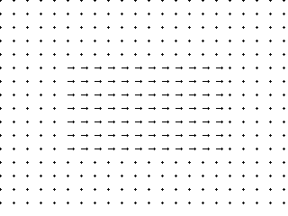  
       
     Use the base image labeled as Shift0.png and find the motion that the center block presents in the images ShiftR2.png,and ShiftR5U5.png.   
       
     **Code:** Complete optic_flow_lk()  
       
     **Report:** Show the quiver plot for the motion between:  
     - Input: **Shift0.png** **and** **ShiftR2.png**. Output: **ps4-1-a-1.png  
     -** Input: **Shift0.png** **and** **ShiftR5U5.png**. Output: **ps4-1-a-2.png**
  2. Now try the code comparing the base image Shift0 with the remaining images of ShiftR10, ShiftR20, and ShiftR40, respectively. Remember LK only works for small displacements with respect to the gradients. Try blurring your images in order to get better results.   
       
     **Report:** Show the quiver plot for the motion between:  
     - Input: **Shift0.png** **and** **ShiftR10.png**. Output: **ps4-1-b-1.png  
     -** Input: **Shift0.png** **and** **ShiftR20.png**. Output: **ps4-1-b-2.png  
     -** Input: **Shift0.png** **and** **ShiftR40.png**. Output: **ps4-1-b-3.png**- **Text answer:** Does LK still work? Does it fall apart on any of the pairs? Try using different parameters to get results closer to the ones above. Describe your results and what you tried.

### 2. Gaussian and Laplacian Pyramids [20 Points]

Recall how a Gaussian pyramid is constructed using the REDUCE operator. Here is the original paper that defines the REDUCE and EXPAND operators:  
[Burt, P. J., and Adelson, E. H. (1983). The Laplacian Pyramid as a Compact Image Code](https://s3.amazonaws.com/content.udacity-data.com/courses/ud810/readings/Burt-Adelson1983Laplacian-Pyramid.pdf)  
Here you will also find convolution to help you optimize your code to interpolate the missing pixels.

* 1. Write a function to implement REDUCE, and one that uses it to create a Gaussian pyramid. Use this to produce a pyramid of 4 levels (0-3), applying it to the first frame of DataSeq1 sequence. Here you will also complete the function create_combined_img(...) which will output an image that looks like the example below. Normalize each subimage to [0, 255] before copying it in the output array, use the utility function normalize_and_scale(...).  
       
       
     **Code**:  
     - reduce_image(image)  
     - gaussian_pyramid(image, levels)  
     - create_combined_image(img_list)  
       
     **Report**:  
     - Input: **yos_img_01.png.** Output:the four images that make up the Gaussian pyramid, side-by-side, large to small as **ps4-2-a-1.png**; the combined image should look like:  
     
  2. Although the Lucas-Kanade method does not use the Laplacian Pyramid, you do need to expand the warped coarser levels (more on this in a minute). Therefore you will need to implement the EXPAND operator. Once you have that, the Laplacian Pyramid is just some subtractions.  
       
     Write a function to implement EXPAND. Using it, write a function to compute the Laplacian pyramid from a given Gaussian pyramid. Apply it to create the 4 level Laplacian pyramid for the first frame of DataSeq1 *(your output will have 3 Laplacian images and 1 Gaussian image)*.   
       
     **Code**:  
     - expand_image(image)  
     - laplacian_pyramid(g_pyr)  
       
     **Output**:  
     - Input: **yos_img_01.png**. Output: the Laplacian pyramid images, side-by-side, large to small (*3 Laplacian images and 1 Gaussian image*), created from the first image of DataSeq1 as **ps4-2-b-1.png**

### 3. Warping by flow [15 points]

The next task is is to create a warp function that uses flow vectors to try to revert the apparent motion. This is going to be somewhat tricky. We suggest using the test sequence or some simple motion sequence you create where it’s clear that a block is moving in a specific direction. Consider the case where an object in an image $A$ moves 2 pixels to the right shown in image $B$. This means that a pixel in $B(5,7)=A(3,7)$ here the indexing uses x,y and not row, column. To warp $B$ back to $A$ create a new image $C$, set $C(x,y)$ to the value of $B(x+2,y)$. $C$ would then align with $A$.

Write a function warp() that takes as input an image (e.g. $B$) and the $U$ and $V$ displacements, and returns a warped image $C$ such that $C(x,y)=B(x+U(x,y),y+V(x,y))$. Ideally, $C$ should be identical to the original image ($A$). Note: When writing code, be careful about x, y and rows, columns.  
  
*Implementation hints:*  
- The NumPy function [meshgrid](http://docs.scipy.org/doc/numpy/reference/generated/numpy.meshgrid.html)() might be helpful in creating a matrix of coordinate values, e.g.:  
 A = np.zeros((4, 3))  
 M, N = A.shape  
 X, Y = np.meshgrid(xrange(N), xrange(M))  
This produces X and Y such that $(X(x,y),Y(x,y))=(x,y)$. Try printing X and Y to verify this. Now you can add displacements matrices $(U,V)$ directly with $(X,Y)$ to get the resulting locations.  
- Also, OpenCV has a handy [remap](http://docs.opencv.org/modules/imgproc/doc/geometric_transformations.html#remap)() function that can be used to map image values from one location to another. You simply need to provide the image, an X map, a Y map and an interpolation method.

1. Apply your single-level LK code to the DataSeq1 sequence (from 1 to 2 and 2 to 3). Because LK only works for small displacements, find a Gaussian pyramid level that works the best for these. You will show the output flow fields similar to what you did above and a warped version of image 2 to the coordinate system of image 1. That is, Image 2 is warped back into alignment with image 1. Do the same for images 2 and 3. Create a GIF (<http://gifmaker.me/>) with these three images to verify your results, you don’t need to submit this. You will likely need to use a coarser level in the pyramid (more blurring) to work for this one**.** If you did this correctly, there should be no apparent motion. **Note: For this question you are only comparing between images at some chosen level of the pyramid. In the next section you’ll do the hierarchy.**Once you have warped these images, you will subtract it from the original. After normalizing and scaling the resulting array, ideal results should be gray image with no visible edges. However with just the single-level LK this may not be the case. Here is a sample output:  
    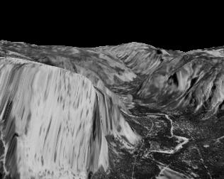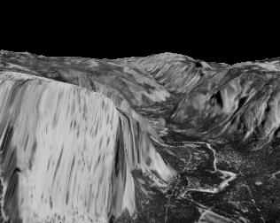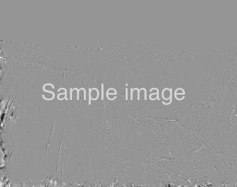  
     
   **Code:** warp(image, U, V, interpolation, border_mode)  
     
   **Report:**- Input: **yos_img_01.png** **and** **yos_img_02.png**. Output: **ps4-3-a-1.png  
   -** Input: **yos_img_02.png** **and** **yos_img_03.png**. Output: **ps4-3-a-2.png**

### 4. Optical Flow with LARGE shifts [25 Points]

You may notice that for larger shifts, the Lucas-Kanade by itself fails to record the movement values accurately. Implement the Hierarchical Lucas-Kanade method to overcome this limitation. Complete this code in the hierarchical_lk() function.

1. Compare this method with the single-level LK. Use the base image labeled as Shift0.png and find the motion that the center block presents in the images ShiftR10.png, ShiftR20.png, and ShiftR40.png. You should be able to get better results with this method.  
     
   **Code:   
   -** hierarchical_lk()  
     
   **Report:** Show the quiver plot for the motion between:  
   - Input: **Shift0.png** **and** **ShiftR10.png**. Output: **ps4-4-a-1.png  
   -** Input: **Shift0.png** **and** **ShiftR20.png**. Output: **ps4-4-a-2.png  
   -** Input: **Shift0.png** **and** **ShiftR40.png**. Output: **ps4-4-a-3.png**
2. Use the Urban2 images to calculate the optic flow between two images. Warp the second image like you did in part 3. Show the flow image and the difference between the original and the warped one. Reminder: the difference image should have almost no visible edges.   
     
   **Report:  
   -** Input: **urban01.png and urban02.png.** Output: **ps4-4-b-1.png** (quiver plot) **ps4-4-b-2.png** (difference image)

### 5. Frame Interpolation [10 Points]

Optic flow can be used in Frame Interpolation (See Szelinski 2010 Section 8.5.1). With Optic Flow principles, we are able to (or at least attempt to) create missing frames. Given that new images are created, you need to obtain the dense optical flow, one vector per pixel. Consider two frames $I_{0}$ and $I_{1}$, if the same motion estimate $u_{0}$ is obtained at location $x_{0}$ in image $I_{0}$ and is also obtained at location $x_{0}+u_{0}$ in image $I_{1}$, the flow vectors are said to be consistent. You will assume the initial flow is the same as the resulting flow. We can generate a third image $I_{t}$ where $t ∈(0, 1)$ which will contain a pixel value for the motion vector in question:

$I_{t}(x_{0}+tu_{0}) = (1-t)I_{0}(x_{0}) + tI_{1}(x_{0}+u_{0})$

$I_{t}(x_{0}) = I_{0}(x_{0} + tu_{0})$

1. You will test this method using two simple images:  
     
    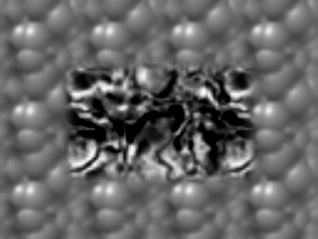 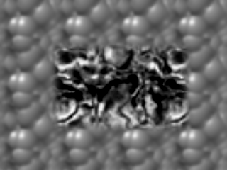  
     
   Now you will insert 4 new images uniformly distributed in between $I_{0}$ and $I_{1}$. This means your resulting sequence of images are: $I_{0}, I_{0.2}, I_{0.4}, I_{0.6}, I_{0.8}, I_{1}$. Verify your results creating a GIF from these six images.  
     
   Create an image that contains all the images in the sequence. Organize them in 2 rows and 3 columns. The first row will show $I_{0}, I_{0.2}, I_{0.4}$ and the second one $I_{0.6}, I_{0.8}, I_{1}$.  
     
   **Report:**  
   - Input: **Shift0.png ${(I}_{0})$**  **and Shift10.png $(I_{1})$** . Output: **ps4-5-1-a-1.png**
2. The next step is to try this method with real images. For this section, use the files in MiniCooper, insert 4 new images (similar to part a) for each pair of images.   
     
   Include all images organized using the same layout as before (2 rows and 3 columns) for each image pair, i.e. ${(I}_{0}, I_{1}), (I_{1}, I_{2})$, etc.   
     
   Notice this method produces a great amount of artifacts in the resulting images. Use what you have learned so far to reduce them in order to create a smoother sequence of frames.  
     
   **Report:**- Input: **mc01.png ${(I}_{0})$**  **and mc02.png $(I_{1})$** . Output: **ps4-5-1-b-1.png**- Input: **mc02.png ${(I}_{1})$**  **and mc03.png $(I_{2})$** . Output: **ps4-5-1-b-2.png**

### 6. Challenge Problem [5 points]

Another optic flow application is to calculate the flow between frames in order to measure the camera’s movement. Usually these results are shown merging the quiver plot images with the original frames. Find or film a video, name it **ps5-my-video.mp4** place it in the input_videos folder. Calculate the optic flow between each pair of frames. Add the quiver plot to the original frames and create a new video. Here is an example of what these should look like:

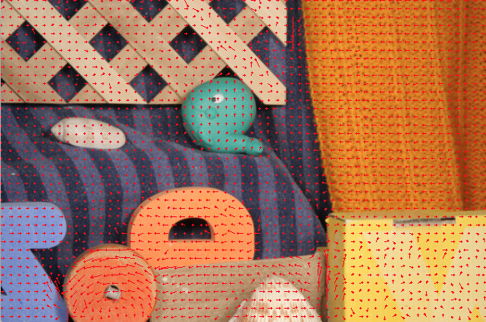

Upload this video to a site where you can share it using a private / unlisted link. Add two sample frames from the output video to your slides.

**Report:**

- Input: **ps4-my-video.mp4**. Output: **ps4-6-a-1.png** (sample frame 1), **ps4-6-a-2.png** (sample frame 2) and **link to your shared video.**