Q 4.1

Clustering models 5 examples.

Q4.2

I used kmeans function to fit the data. The parameters for kmeas are iter.max = 15 , and nstart = 20. I plot elbow curve as below.

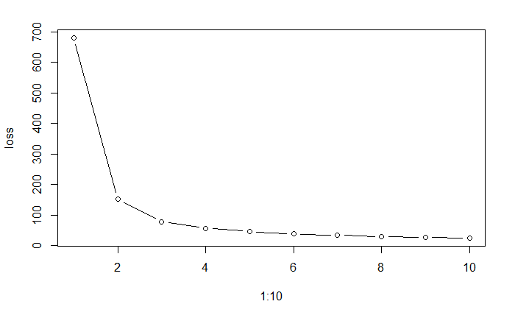

I chose k = 3. The accuracy of clustering is 0.893.

Q5.1

highest value 1993 is an outlier.

Q6.1

Q6.2