MC3-P3

# Technical Indicators

## Bollinger Bands

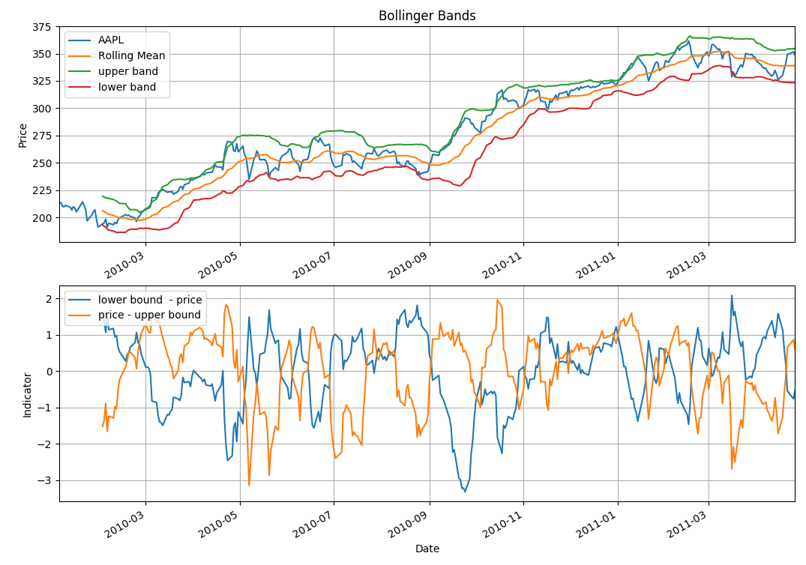

Steps to calculate the Bollinger Band and technical indicators using Bollinger Band:

1. Calculate the moving average of the stock price using 20 day window
2. Calculate the standard deviation of the stock price using 20 day window
3. Create the upper bound by adding 2 * standard deviation of the prices to the moving averages
4. Create the lower bound by subtracting 2 * standard deviation of the prices to the moving averages
5. Calculate the lower indicator = lower_bound – stock_price
   1. if this value is positive, it means stock price has went below the lower bound so it is a **signal to buy**
   2. Additionally you can normalize the values by “z-score” the indicator values
6. Calculate the upper indicator = stock_price – upper_band
   1. if this value is positive, it means that stock price has went above the upper bound so it is a **signal to sell**
   2. Additionally you can normalize the values by “z-score” the indicator values
7. Hence
   1. if upper_indicator > 0, SELL
   2. if lower_indicator > 0, BUY

## MACD (12,26,9)

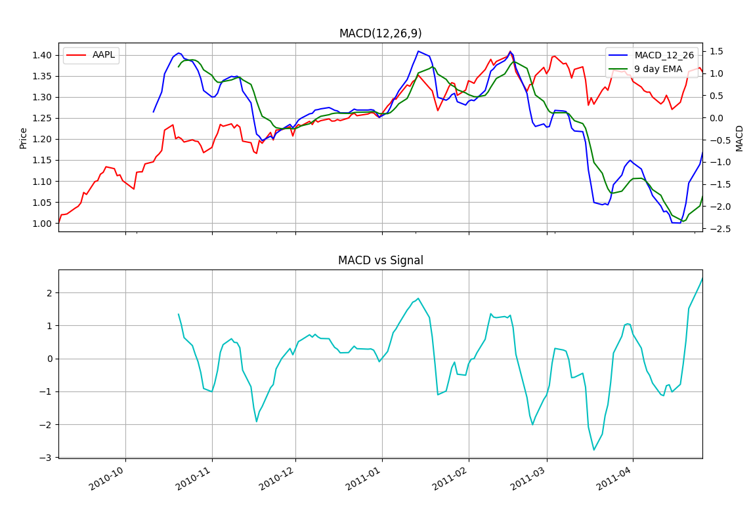

Steps to calculate the MACD(12,26,9):

1. Calculate EMA(12):
   1. Calculate the 12 day Exponential Moving Average using the Panda’s EWMA function and standardize it using z-score
2. Calculate EMA(26):
   1. Calculate the 26 day Exponential Moving Average and standardize it using z-score
3. Calculate MACD(12,26):
   1. Calculate the difference between the two using EMA(12) – EMA(26) as a formula and standardize it using z-score
4. Calculate EMA(9):
   1. Calculate the signal line which is the Exponential Moving Average of 9 days and standardize it using z-score
5. Calculate the MACD vs Signal:
   1. Calculate the technical indicator by using the below formula:
      1. MACD(12,26) – EMA(9) and normalize it using z-score
      2. If the value is positive or negative, it means there is a divergence
      3. If the value is zero or close to zero, it means MACD is about to converge with EMA(9), hence:
         1. If the previous difference was positive, then it signals the SELL
         2. If the previous difference was negative, then it signals the BUY

## Momentum vs Volatility

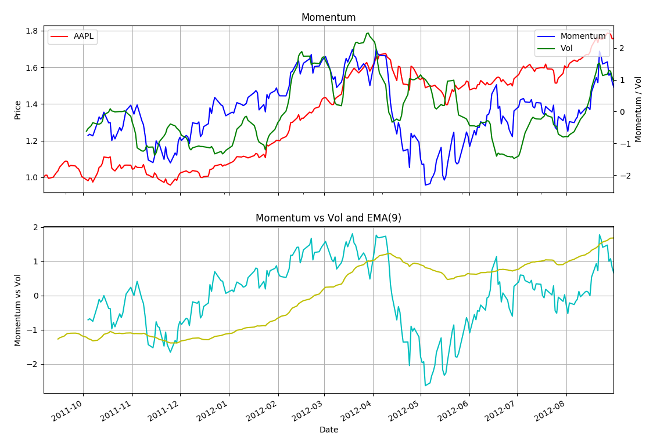

Steps to calculate Momentum vs Vol indicators:

1. Calculate the Momentum(20) and normalize them:
   1. Momentum(20) = Close(T) / Close(T-20) * 100
2. Calculate the Volatility of the stock history and normalize them
3. Calculate the Diff and normalize it:
   1. Diff = Momentum / Volatility
4. If diff > 2, it indicates that there is lots of momentum and very small volatility (risk) and it can indicates the turning points, SELL
5. If Diff < -2, it indicates that there is very little momentum and high volatility, SELL