Salary and Salbegin:
r = 0.861 ، p < 0.0001
A very strong positive correlation was found between current salary and starting salary, implying that employees who started with higher salaries tend to maintain higher salary levels over time.

Salary and Education:
r = 0.642, p < .001
The results revealed a significant positive correlation between education and current salary, indicating that employees with higher educational attainment tend to receive higher current salaries.

Salbegin and Education:
r = 0.625, p < .001
Education was also positively correlated with starting salary, suggesting that more educated employees generally began their employment with higher salaries.

Education, prevexp and age:
Education showed weak negative correlations with previous work experience (r = −0.271, p < .001) and age (r = −0.290, p < .001). These findings indicate that employees with higher educational levels tend to be younger and have less prior work experience.

Salary, Prevexp and age:
Current salary was negatively weak correlated with previous work experience (r = −0.127, p = .010) and age (r = −0.168, p = .001). Although these relationships were statistically significant, their magnitudes were relatively weak.

Salary and Gender:
The results showed a significant negative biserial correlation between gender and current salary (r = −0.445, p < .001).
Since the p-value was lower than the significance level (α = 0.05), the null hypothesis (H₀: salary and gender are not associated) was rejected, and the alternative hypothesis (Hₐ: salary and gender are associated) was accepted.
Specifically, the results suggest that there is a statistically significant difference in current salary between male and female employees. The magnitude of the correlation indicates a moderate relationship between gender and current salary.

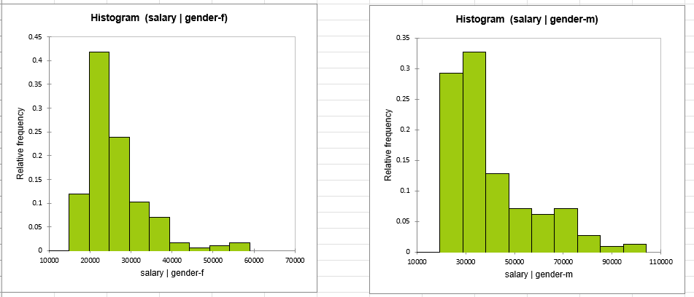

Salbegin and Gender:
A biserial correlation analysis revealed a significant negative biserial correlation between gender and starting salary (r = −0.460, p < .001).
Because the p-value was below 0.05, the null hypothesis (H₀: starting salary and gender are not associated) was rejected. Therefore, gender and starting salary are significantly related.
The negative correlation suggests that starting salary differs significantly between male and female employees. The strength of the correlation indicates a moderate association, meaning that gender explains a meaningful proportion of the variation in initial salary levels.

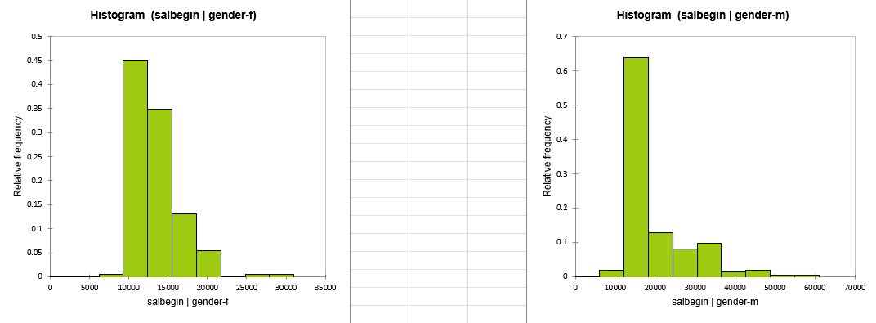

Salary and Minority:
The results showed a significant positive biserial correlation between minority status and current salary (r = 0.150, p = .004).
Since the p-value was lower than the significance level (α = 0.05), the null hypothesis (H₀: salary and minority status are not associated) was rejected, and the alternative hypothesis (Hₐ: salary and minority status are associated) was accepted.
The positive correlation indicates that minority status is statistically associated with differences in current salary. Because minority status was coded as 0 (non-minority) and 1 (minority), the positive coefficient suggests that employees classified as minorities tend to have higher salaries compared with non-minority employees in this sample.
However, the correlation coefficient is relatively small (r = 0.150), indicating a weak relationship between minority status and salary. Although the association is statistically significant, its practical effect appears limited.
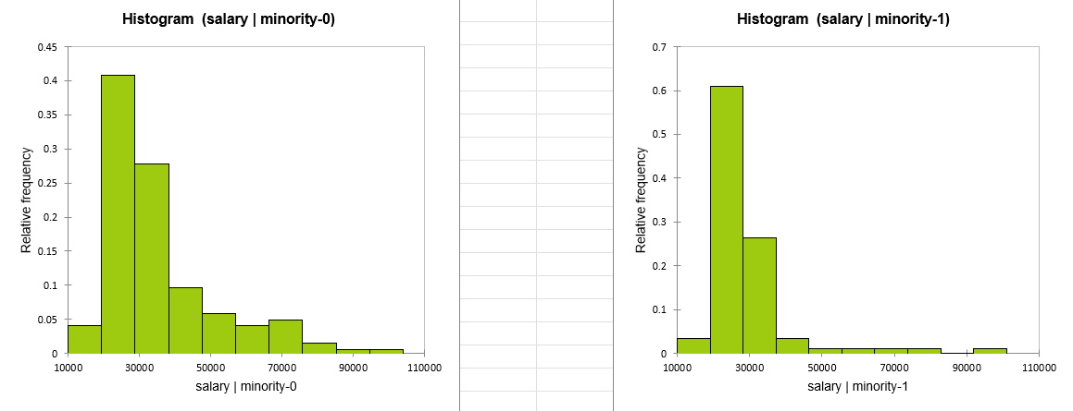

Are the average salaries for women and men the same?
The ANOVA test showed a statistically significant difference in salaries between genders (F = 100.925, p < 0.0001). Therefore, the null hypothesis was rejected, indicating that the average salaries of males and females are significantly different.
R² Value
The model produced an R² value of 0.198, meaning that gender explains approximately 19.8% of the variation in salaries. The remaining variation may be related to other factors.

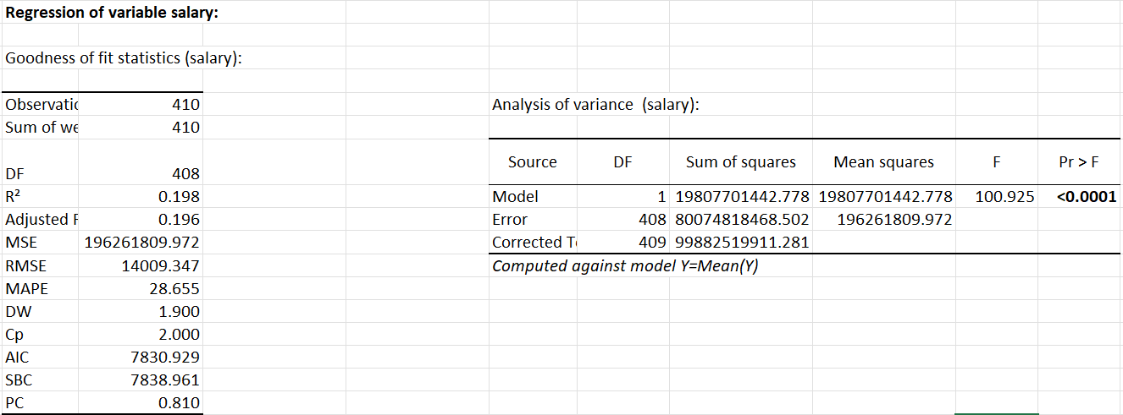

Are the average managers’ salaries for women and men different?
The results of the ANOVA test in the sample of 71 participants indicate that the mean salaries of female and male managers differ significantly (F = 11.02, p = 0.001). The average salary of men is approximately 63,546, while that of women is approximately 46,418, meaning that women receive, on average, about 17,129 units less. Gender explains approximately 13.8% of the variation in salaries. Given that the assumption of normality of the residuals was violated, it would be advisable to confirm this finding using a nonparametric test as well.

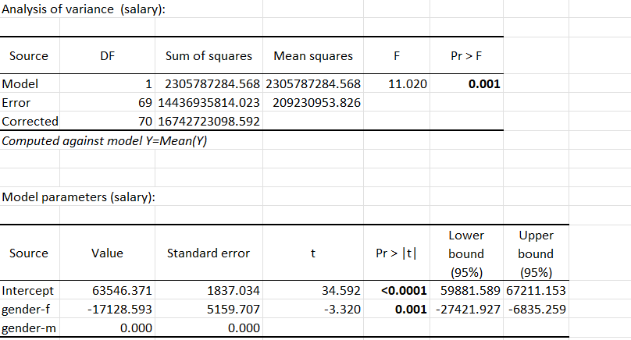

The Mann–Whitney U test comparing the salaries of male and female managers indicated that there is a statistically significant difference between the two groups (U = 471, Z = 3.31, p = 0.001). Therefore, the assumption of equal salaries between the two groups is rejected. The mean salary of male managers (63,546) was significantly higher than that of female managers (46,418), indicating the presence of a significant gender pay gap in this sample.
The sample sizes of the two groups are not equal:
- Men: 62 participants
- Women: only 9 participants
This imbalance may affect the statistical power of the test. However, because the p-value is very small (0.001), the observed difference is large enough to remain statistically significant even with the smaller female group.

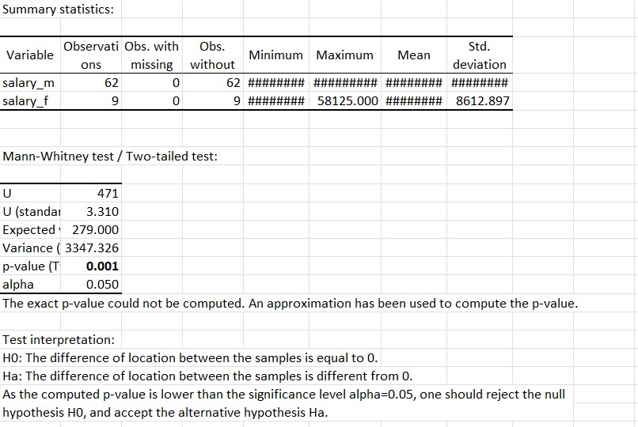

Is the salary growth equal for those with less than 16 years of education (up to a bachelor's degree) and those with more than that?
To examine thad, an independent samples t-test was initially considered. However, because the data violated the assumption of normality, the non-parametric Mann–Whitney U test was used as an alternative.
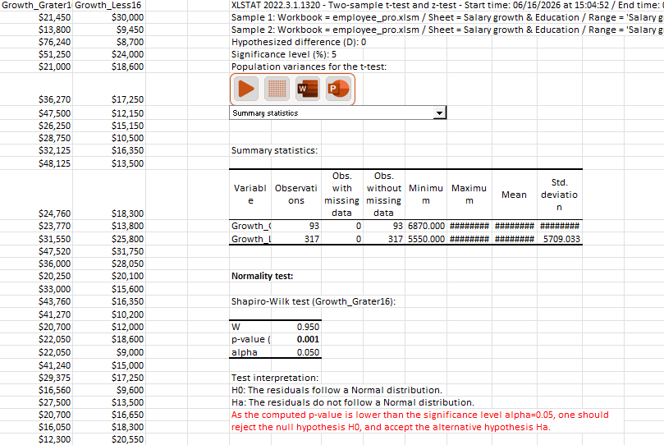
The results of the Mann–Whitney U test revealed a statistically significant difference between the two groups (U = 26,080.5, Z = 11.285, p < 0.0001). Therefore, the null hypothesis was rejected, indicating that the distributions of salary growth for employees with less than 16 years of education and those with more than 16 years of education are significantly different.
Descriptive statistics further showed that employees with more than 16 years of education experienced substantially higher salary growth (Mean = 28,627.9) compared with employees with less than 16 years of education (Mean = 13,649.6). These findings suggest that, within this sample, higher levels of educational attainment are associated with significantly greater salary growth.
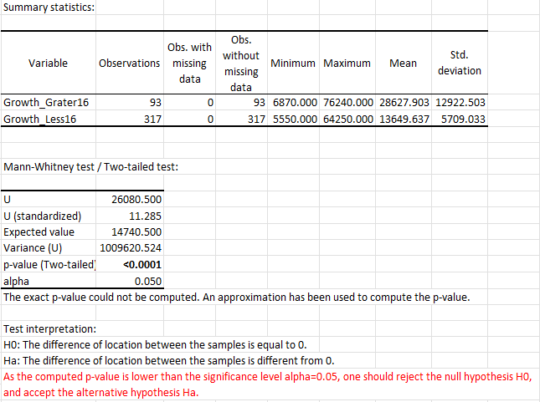
Ancova with Age VS without Age:
Age was removed from the ANCOVA model because it did not have a statistically significant effect on salary after controlling for the other predictors. In the first model, the coefficient for Age was −34.25 with a p-value of 0.513, indicating that age did not contribute meaningfully to explaining salary variation. In addition, Age showed a very strong correlation with previous work experience (prevexp, r = 0.813), suggesting multicollinearity and substantial overlap in the information provided by these two variables. After removing Age, the model's explanatory power remained unchanged (R² = 0.812), while several fit statistics improved slightly (AIC decreased from 7247.68 to 7246.12 and RMSE decreased from 6829.31 to 6824.46). Furthermore, the effect of previous experience became stronger and more statistically significant. Therefore, Age was excluded because it was a non-significant predictor that introduced redundancy, and its removal resulted in a more parsimonious model without any loss of predictive performance.

