PROJECT MODULE FILE (IT DEPARTAMENT)

GROUP DAW2BIO

TITLE
Microarrays in .CEL files

GROUP MEMBERS (The students' names that will develop the project)

Andrés Tenesaca Burgos
Pablo Sebastian Rodriguez

DESCRIPTION (Write in no more than 15 text lines the objectives of the project)

microarray data reading of an GeneChip that will saves data in files .CEL and will be compared or generate graphics with R and storing in DDBB. The project would contain:

- User management
- DDBB management
- .Cel data management
- Client management: researchers can upload .cel files in our web page through a form and must fill input text field with their personal data.
- Data management: data will be stored in DDBB for further modifications, like adding more data o visualizing it through graphics

MATERIALS REQUIRED AND TECHNICAL SPECIFICATIONS OF THE PROJECT

FUNCTIONAL REQUIREMENTS
(Draft version: it is a first version to specify all functionalities and their results, as well as the profile users who may run each functionality)

RF1. USER MANAGEMENT: as a administrator i want to manage DDBB tables that contains users of clients and biologic analyst who can log in to the web page Level: High.
RF1.1 Create new user creation of users of two different types: clients or researcher. Level: high.
RF1.2 Modify user modify username or password of existing user. Level: low
RF1.3 Delete user delete user who already exists. Level: medium

RF2. DDBB MANAGEMENT as a researcher i want to manage DDBB tables that contains .cel files data Level: High
RF2.1 Create table creation of the table that will contain micro array data. Level: high.
RF2.2 Modify table modification of tables. Level: low.
RF2.3 Delete table elimination of tables in case client doesn’t want to continue with analysis or use it for further research. Level: medium.

RF3. .CEL MANAGEMENT as a researcher i want to manage .cel data files Level: high.
RF3.1 Reading data procedures to treat data in .cel files already stored or to be store. Level: high.

RF4. CLIENT MANAGEMENT as a client I want to log in and upload .cell files. Level: high
RF4.1 upload file upload file through our page. Level: high.

Rf5. DATA MANAGEMENT as a researcher I want to manage data of tables to show data in legible format. Level: high
RF5.1 add data chance to add new data in DDBB tables Level: high.
RF5.2 Visualize data visualize data through graphics or web page table. Level: high.

(NOTE: as a result of your initial interviews with the clients, you may use whatever you consider necessary in order to clarify what the client precisely wants: diagram, graphic, description, etc)

NON-FUNCTIONAL REQUIREMENTS

Back-end: apache, php
Front-end: HTML, Bootstrap
DDBB management: phpmyadmin, MySQL
Data management: R and other R-related packages (like BioConductor)
Ubuntu Server

MOCKUPS OR WIREFRAMES

Log in Page

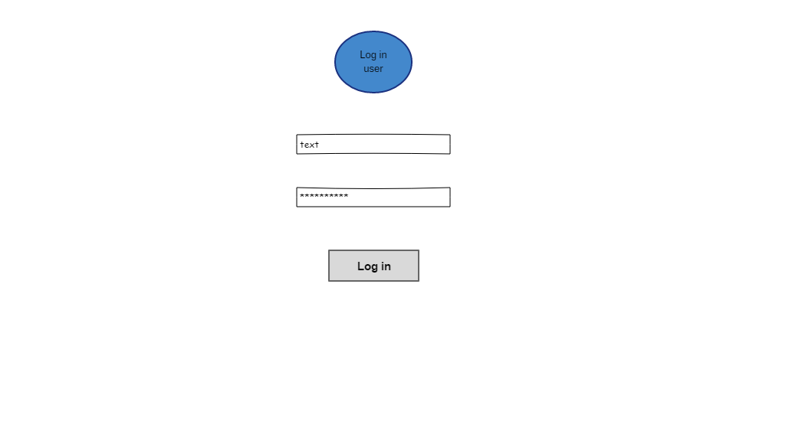

Index client page – About us
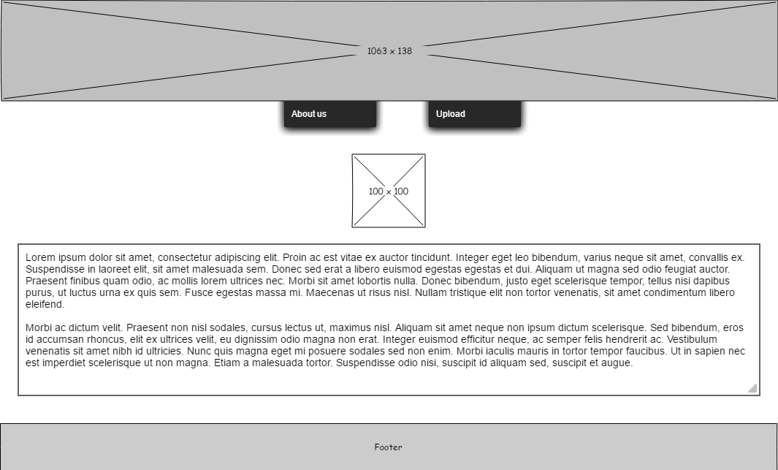

Clinet load files
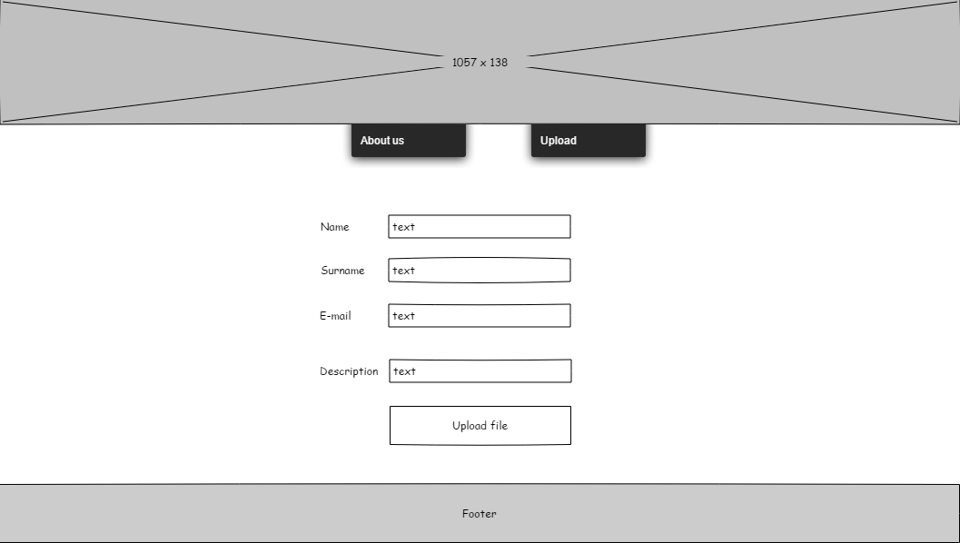

Analyze file
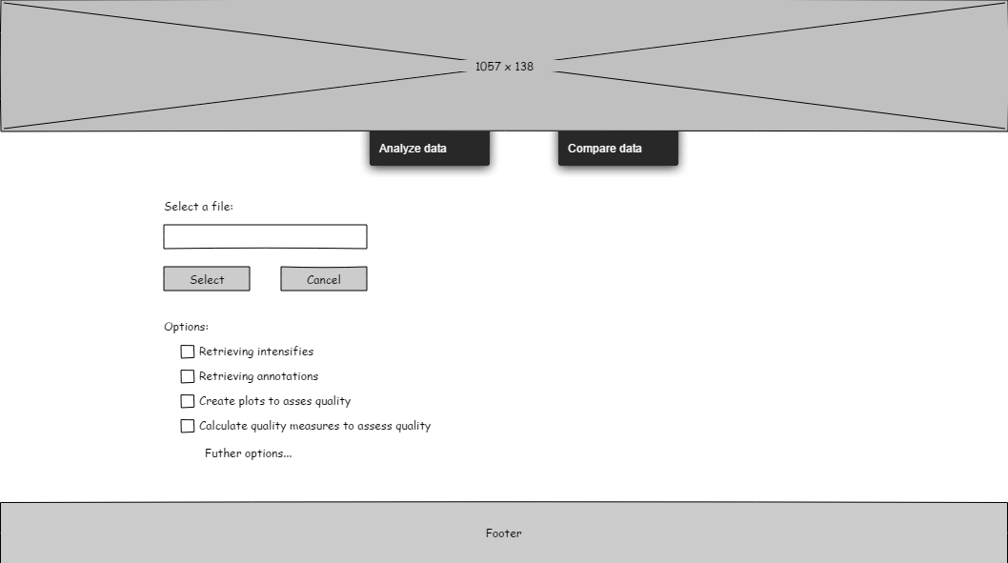

Compare files

