Indice

Title & purposes 1
Functional and non-functional requirements 2
Use Case diagram and their textual description 3
Database 4
Description of the project methodology used 5
Project planning 6

Title & purposes

Micro arrays: Analysis, normalization, quality measurement and gene expression

Continuing down the line of a prototypical pipeline in which micro arrays are generally used, we want to focus our project in 4 layers: loading the micro array experiment, Image Analysis, Normalization and a couple of typical Analysis.

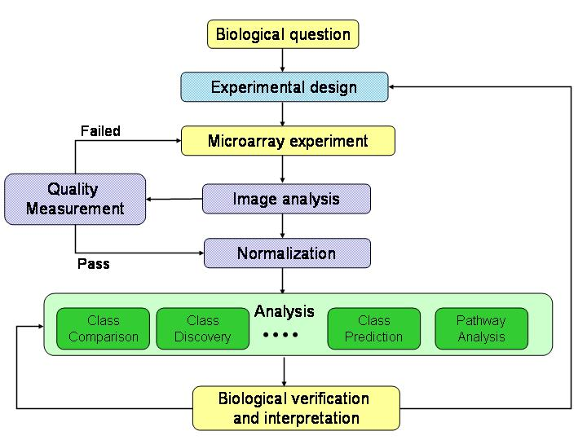

Our initial objective is to try to create a functional application to process and analyses their .cell files or consult them through queries to microarrays database on the Web; and give researchers graphics tool to interpretate results

For that, we’ll work with R packages such as Bioconductor, GEOquery, affy, limma, etc, to treat tests data; and Shiny, to work with graphics.

Our application will be a server-based app, with its own database (for users’.cell files, app’s users and so on).

Functional and non-functional Requirements
RF1. CELL MANAGEMENT | As a researcher I want to upload my .cell files to the web app, for further consultations
RF1. CELL MANAGEMENT | Level: high
RF1.1 Saving .cell | procedures to save .cell files into our database
RF1.1 Saving .cell | Level: high.
RF1.2 Consulting .cell | Procedure to consult saved .cell files in DB
RF1.2 Consulting .cell | Level: medium
RF1.3 Upload .cell | Procedure to upload .cell files for further analysis
RF1.3 Upload .cell | Level: high
RF2. QUERY MANAGEMENT | As a researcher I want to make a query using microarray’s id to GEOQuery or ArrayExpress DB
RF2. QUERY MANAGEMENT | Level: high
RF2.1 Make query | Procedure to make a query into 2 external databases
RF2.1 Make query | Level: high
RF2.2 Saving queries | Procedure to store previous queries in user data
RF2.2 Saving queries | Level: high.
RF2.3 Consulting saved queries | Procedure to access previously saved queries
RF2.3 Consulting saved queries | Level: high
RF2.4 Choose external database | Procedure to choose between GEO query or Array Server db
RF2.4 Choose external database | Level: medium
RF3. DATA MANAGEMENT | As a researcher I want to use different sets of graphics or data tables to see and interpret gene expressions saved in my .cell files or in my micro array queries
RF3. DATA MANAGEMENT | Level: high
RF3.1 Graphics | Methods to print reactive graphics and tools
RF3.1 Graphics | Level: high.
RF3.2 Data tables | Methods to print reactive graphics and tools
RF3.2 Data tables | Level: medium
RF4. USER MANAGEMENT | As a researcher I want to be able to register and log unto this web app to consult saved .cell files and saved queries
RF4. USER MANAGEMENT | Level: high
RF4.1 Register | Register new user
RF4.1 Register | Level: high
RF4.2 Login | Login existing user
RF4.2 Login | Level: high
RF5. VIEW CUSTOMIZATION | As a researcher I want choose the graphic tool templates
RF5. VIEW CUSTOMIZATION | Level: low.
RF5.1 Change template | Changing Shiny app template
RF5.1 Change template | Level: low

- Back-end: Shiny for graphic tools, PHP and MySql to handle login and user’s info
- Front-end: HTML, Bootstrap
- Data management: R and other R-related packages (like BioConductor)
- Server: Ubuntu Server

Use Case diagram and textual description

Case diagram: https://campus.proven.cat/pluginfile.php/88911/mod_resource/content/3/Diagrames_casos_us.pdf

textual description: https://campus.proven.cat/pluginfile.php/50923/mod_resource/content/2/Casos_Us_Fitxa_descriptiva.pdf

Database

(Entity-relation diagram and relational model)

Description of the project methodology used

For our project we’ll use an Agile methodology: we’ll split all our tasks following each functional requirement needed, giving each one of them a score regarding its value for the app, and organizing them into 4 sprints, each one regarding one week of project time

Project planning

User Story | Difficulty
1.1 Saving .cell | 2
1.2 Consulting .cell | 2
1.3 Upload .cell | 3
2.1 Make query | 4
2.2 Save queries | 2
2.3 Consult queries | 2
2.4 Choose external database | 4
3.1 Print graphics | 6
3.2 Print data table | 6
4.1 Register user | 3
4.2 Login user | 3
5.1 Changing Shiny template | 1

Rearranging with difficulty order:

User Story | Difficulty
3.1 Print graphics | 6
3.2 Print data table | 6
2.1 Make query | 4
2.4 Choose external database | 4
1.3 Upload .cell | 3
4.1 Register user | 3
4.2 Login user | 3
1.1 Saving .cell | 2
1.2 Consulting .cell | 2
2.2 Save queries | 2
2.3 Consult queries | 2
5.1 Changing Shiny template | 1

