Cell Files

Pablo Sebastian Rodriguez
Andrés Tenesaca Burgos

DAWBIO2-2018-2019

Functional & non-functional requirements

Functional requeriment

- RF1. CELL MANAGEMENT: As a researcher I want to upload my .cell files to the web app, for further consultations
- RF1.1 Saving .cell: procedures to save .cell files into our database {2}
- RF1.2 Consulting .cell: Procedure to consult saved .cell files in DB {2}
- RF1.3 Upload .cell: Procedure to upload .cell files for further analysis {3}
- RF2. QUERY MANAGEMENT: As a researcher I want to make a query using microarray’s id to GEOQuery or ArrayExpress DB
- RF2.1 Make query: Procedure to make a query into 2 external databases {8}
- RF2.2 Saving queries: Procedure to store previous queries in user data {4}
- RF2.3 Consulting saved queries: Procedure to access previously saved queries {4}
- RF2.4 Choose external database: Procedure to choose between GEO query or Array Server db {7}
- RF3. DATA MANAGEMENT: As a researcher I want to use different sets of graphics or data tables to see and interpret gene expressions saved in my .cell files or in my micro array queries
- RF3.1 Graphics: Methods to print reactive graphics and tools {6}
- RF4. USER MANAGEMENT: As a researcher I want to be able to register and log unto this web app to consult saved .cell files and saved queries
- RF4.1 Register: Register new user {3}
- RF4.2 Login: Login existing user {3}
- RF5. VIEW CUSTOMIZATION: As a researcher I want choose the graphic tool templates
- RF5.1 Change template: Select button to change shiny app template {1}

Non-functional requeriments

- Back-end: Shiny for graphic tools and MySql to handle login and user’s info
- Front-end: Shint who implements HTML and Bootstrap
- Data management: R and other R-related packages (like BioConductor)
- Server: Ubuntu Server

Use Case diagram and textual description

Use case diagram

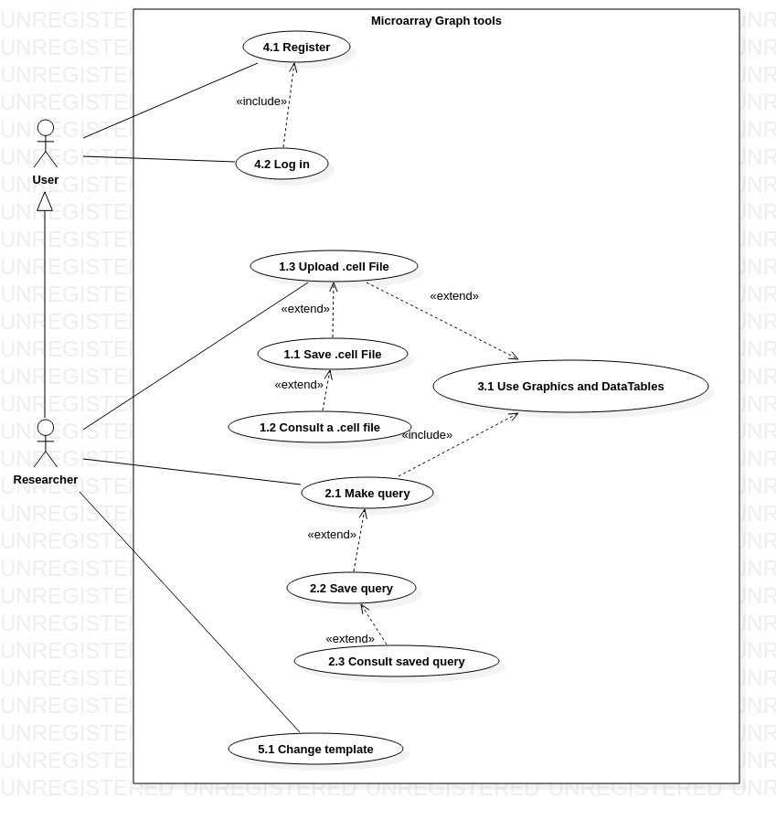

Use case textual description

ID | 1.1
Name | Saving .cell file
Description | Once the user has succesfully uploaded a cell file, it has the option to be saved into its personal user account for further access
Normal Flux
Actors | User
Pre conditions | Bing logged in and have already successfully uploaded a .cell file
Activation | Clicks on «Save» button
Description | 1. User clicks on «Save» option  2. Confirmation box will ask if wants to save file in its account  3. Confirmation message
PostConditions | Returns to upload file view
Alternate Flux 1
Description | 3. User doesn’t accept confirmation box
Post-Condition | File will not be saved in its account
Alternate Flux 2
Description | 3. Error with db occurs and file is not saved
Post-Conditions | Message error informs user about problem

ID | 1.2
Name | Consulting .cell
Description | A view where user can access previously uploaded files
Normal Flux
Actors | User
Pre conditions | Being logged in
Activation | Entering consult .cell file view
Description | 1. User goes to this view  2. View is displayed
PostConditions | Use graph or data table tools to analyze this .cell
Alternate Flux 1
Description | 3. No .cell file was saved
Post-Condition | View will be empty

ID | 1.3
Name | Upload .cell
Description | Action that will let user choose a local file and upload it to the web app for further actions
Normal Flux
Actors | User
Pre conditions | Being logged in
Activation | Clicking the upload button
Description | 1. User clicks «upload» option  2. New window will prompt user to choose a local file  3. Select and accept
PostConditions | Uploaded file will be reproduce will default graph and data table tools for further reactive interaction
Alternate Flux 1
Description | 4. File has wrong format (not a .cell file)
Post-Condition | Message error indicating file has wrong format and could not be uploaded

ID | 2.1
Name | Make a query
Description | User can choose to make a query to microarray database instead of uploading a local file
Normal Flux
Actors | User
Pre conditions | Being logged in and being in possesion of a microarray’s id
Activation | Clicking «Query» view
Description | 1. User selects a database  2. In troduced microarray id and accepts  3. If array exists in the database, it will be analyze with graph tools
PostConditions | Using interactive graph tools to study microarray
Alternate Flux 1
Description | Id doesn’t exist
Post-Condition | Error message: id not found
Alternate Flux 2
Description | No id is introduced
Post-Conditions | Client-side message error informing that id can not be null

ID | 2.2
Name | Saving query
Description | Once a db query has being made, user can choose to save it in its account
Normal Flux
Actors | User
Pre conditions | Being logged in and have made a succesfull query
Activation | Clicking «Save query» option
Description | 1. User clicks save option  2. will be prompted to confirm
PostConditions | Id is saved in its account info
Alternate Flux 1
Description | User doesn’t accept query to be saved
Post-Condition | Query id not saved

ID | 2.3
Name | Consulting save queries
Description | An option in user view to go and check previously saved queries
Normal Flux
Actors | User
Pre conditions | Being logged in
Activation | Once user enters «saved queries» view
Description | 1. User enters saved queries view  2. A new display with saved ids is shown
PostConditions | User can make a new query using that id
Alternate Flux 1
Description | 3. User doesn’t have any saved id
Post-Condition | None special

ID | 3.1
Name | Graphic tools and Data table tools
Description | A set of graph and table tools for data analysis
Normal Flux
Actors | User
Pre conditions | Being logged in and have made a microarray upload (by consulting microarray web database using id or uploading a local .cell file)
Activation | Depends on the view (db query or file upload)
Description | 1. User choose how to retrieve a microarray  2. Once retireved, graph tools are displayed  3. Reactive tools will let user personalize its tools
PostConditions | Printing graphs, exporting them to pdf, saving query id or saving uploaded file in user account

ID | 4.1
Name | Register
Description | A researcher can register as a user in this app
Normal Flux
Actors | Any client or resear who wants to use our app
Pre conditions | None
Activation | Clicking in register option
Description | 1. Visitor clicks register option  2. Classic form will ask user to fill data to make an account  3. Everything is sanitize and checkd, then a user account is created
PostConditions | New user can make queries or upload .cell files
Alternate Flux 1
Description | Error in form inputs
Post-Condition | Message displayed informing about error
Alternate Flux 2
Description | Visitor introduces an already introduced email
Post-Conditions | Message error informing correu electrònic already informed, no new user created

ID | 4.2
Name | Login
Description | A user logs into its account
Normal Flux
Actors | User
Pre conditions | Have created an account
Activation | Clicking in login option
Description | 1. User tries to log in  2. App will ask for credentials  3. User verified
PostConditions | User can access to all user-only views and tools
Alternate Flux 1
Description | Wrong password introduced in login form
Post-Condition | Message error
Alternate Flux 2
Description | Wrong user name introduced
Post-Conditions | Message error or prompting researcher to register

ID | 5.1
Name | View customization
Description | A simple tool to change graph tools’ dashboard view template
Normal Flux
Actors | User
Pre conditions | Being mlogged in and already using the graph tool
Activation | Changin option in a select form
Description | 1. User changes template option  2. View is updated with new template
PostConditions | New color scheme is updated into the dashboard

Class diagram

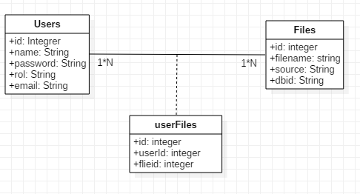

Entity relation diagram and relational model

Description of the methodology used

Project plannning

Dates
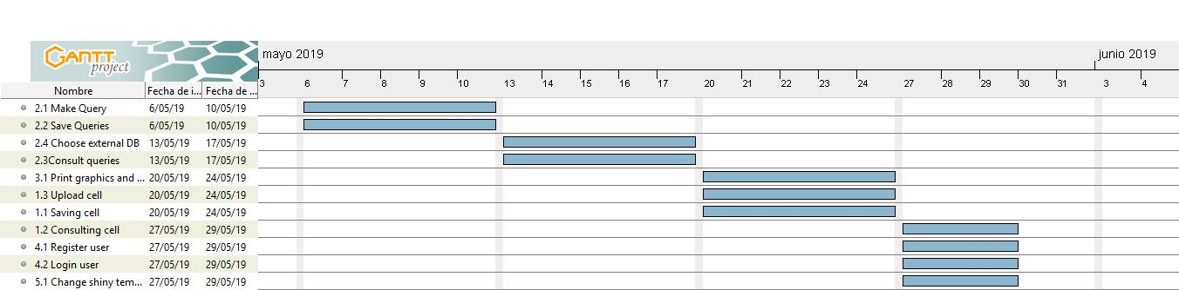

Product backlog & effort Points
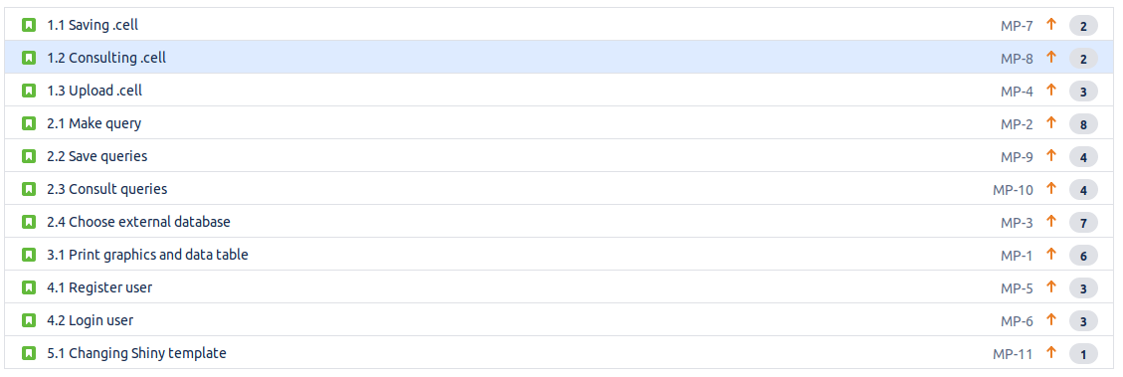

Sprints
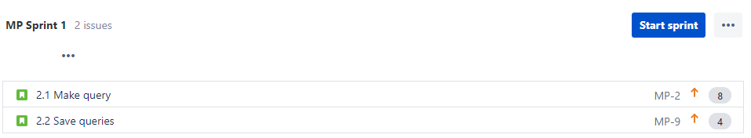

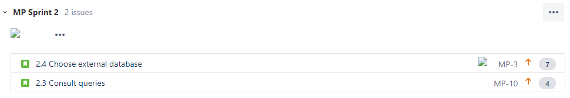

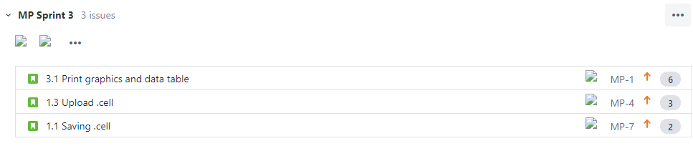

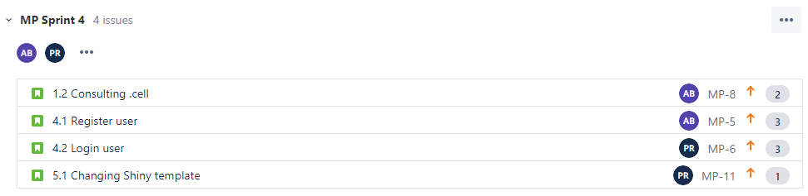

Initial Planning

Diary log

26/05/2019 day 1 Ending Delivery #2

02/05/2019 day 2 Looking for information about GEOQuery and ArrayExpress

03/05/2019 day 3 Looking for information about implementation of MVC inf shiny Dashboard

09/05/2019 day 4
Pablo Sebastian Rodriguez: Back end development
Andrés Tenesaca Burgos: Creation of Front end app, Creation of MySQL file

09/05/2019 day 5

Pablo Sebastian Rodriguez:
Andrés Tenesaca Burgos:

Problems & solutions

- Problem: Uno de los problemas que tuvimos fue pensar en como seria la parte de la apariencia al final de la aplicación.
- Solution: Seguro que a lo largo de este més se nos ocurriria ideas de como podria ser la apariencia.

- Problem: El mayor de los problemas seguramente es pensar como tendríamos que desarollar el codigo de la aplicación ya que nuestro projecto se basa en algo que no hemos hecho en clase y como tendremos que tratar los datos crudos de los ficheros cell.
- Solution: Pasar la mayor parte buscando tutoriales en internet y preguntar a los profesores.

Final conclusions

