PROJECT MODULE FILE (IT DEPARTAMENT)

GROUP DAW2BIO

TITLE
Microarrays: Analysis, normalization, quality measurement and gene expression

GROUP MEMBERS (The students' names that will develop the project)

Andrés Tenesaca Burgos
Pablo Sebastian Rodriguez

DESCRIPTION (Write in no more than 15 text lines the objectives of the project)

Continuing down the line of a prototypical pipeline in which microarrays are generally used, we want to focus our project in analyzing the gene expression of breast cancer cells in a recent experiment (GSE17636/E-‐GEOD-‐17636) through R scripts.

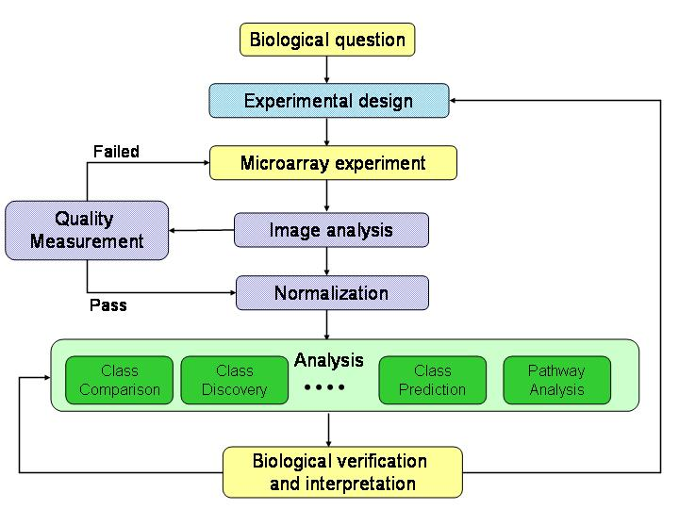

Our initial objective will focus among the lines of Image analysis, Normalization and Quality measurement, to finally reach the Analysis layer, for which we’ll study differential gene expression, lineal-adjusted diferrential expression and hierarchical clustering

We’ll express our results through and array of graphics options provided by Shiny package

MATERIALS REQUIRED AND TECHNICAL SPECIFICATIONS OF THE PROJECT

FUNCTIONAL REQUIREMENTS
(Draft version: it is a first version to specify all functionalities and their results, as well as the profile users who may run each functionality)

RF1. USER MANAGEMENT: as an administrator I want to manage DDBB tables that contains clients and biologic analysis ’users who can log in to the web page Level: High.
RF1.1 Create new user creation of users of two different types: clients or researcher. Level: high.
RF1.2 Modify user modify username or password of existing user. Level: low
RF1.3 Delete user delete user who already exists. Level: medium

RF2. DDBB MANAGEMENT as a researcher I want to manage DDBB tables that contains .cel files data and treat microarraysLevel: High
RF2.1 Create table creation of the table that will contain micro array data. Level: high.
RF2.2 Modify table modification of tables. Level: low.
RF2.3 Delete table elimination of tables in case client doesn’t want to continue with analysis or use it for further research. Level: medium.

RF3. .CEL MANAGEMENT as a researcher I want to manage .cel data files, microarrays and results graphics Level: high.
RF3.1 Reading data procedures to treat data in .cel files already stored or to be store. Level: high.

RF4. CLIENT MANAGEMENT as a client I want to log in and upload .cell files. Level: high
RF4.1 upload file upload file through our page. Level: high.

Rf5. DATA MANAGEMENT as a researcher I want to manage data of tables to show data in legible format; do tests of gene expressions and get graphical data. Level: high
RF5.1 add data chance to add new data in DDBB tables Level: high.
RF5.2 Visualize data visualize data through graphics or web page table. Level: high.

(NOTE: as a result of your initial interviews with the clients, you may use whatever you consider necessary in order to clarify what the client precisely wants: diagram, graphic, description, etc)

NON-FUNCTIONAL REQUIREMENTS

Back-end: apache, php (laravel)
Front-end: HTML, Bootstrap
DDBB management: phpmyadmin, MySQL
Data management: R and other R-related packages (like BioConductor)
Graphics: Shiny
Ubuntu Server

MOCKUPS OR WIREFRAMES

Login Page

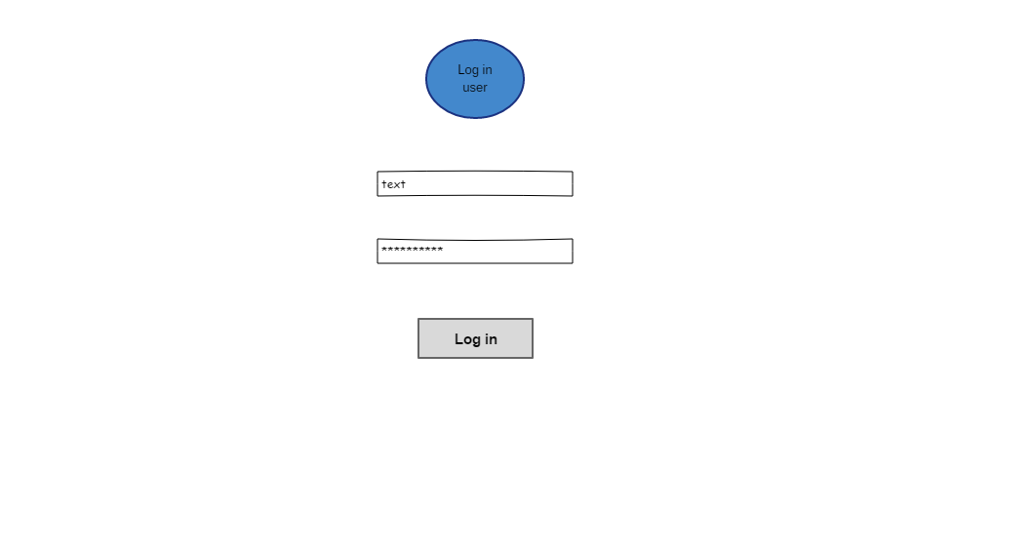

Index client page – About us
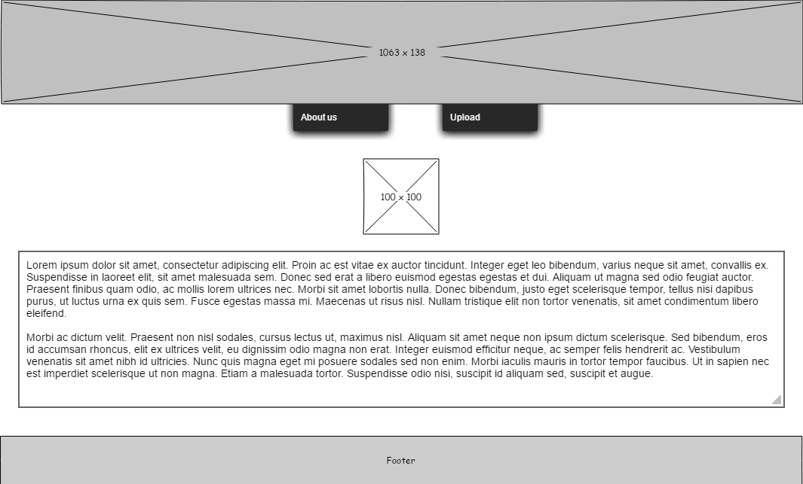

Client load files
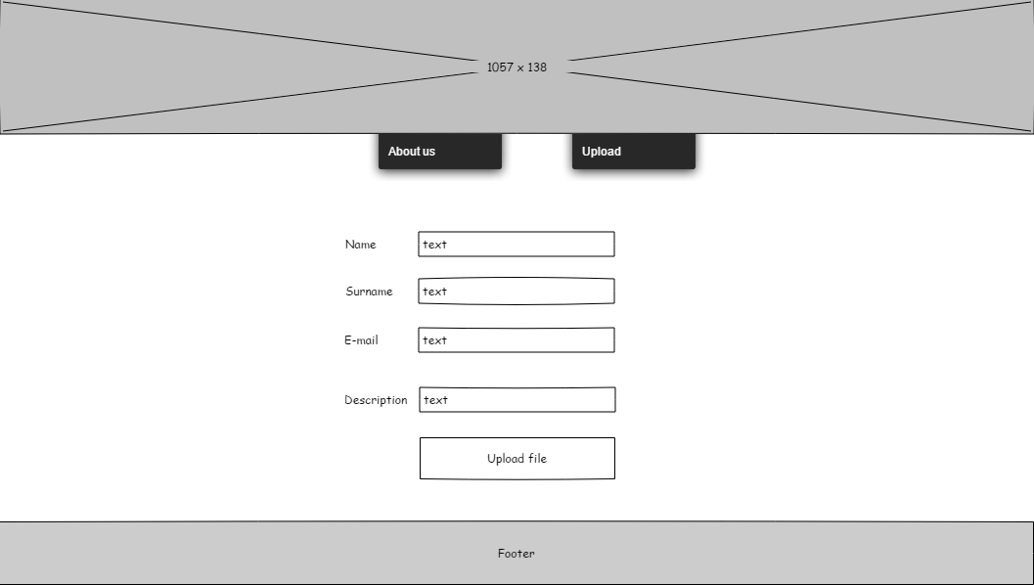

Analyze file
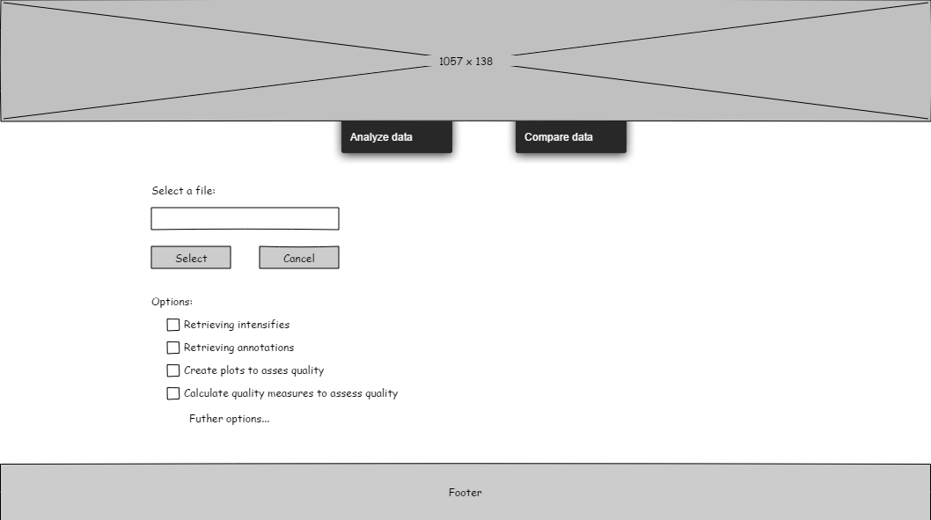

Compare files

