

**BBM103 FOURTH ASSIGNMENT REPORT**

Hacettepe University

Department of Computer Engineering

Name and Surname: Ethem Ateş

Number : 2210356076

TA : Hayriye Çelikbilek

Programming Language : Python

# 1.Problem

Problem is battleship game which can play between two players’s inputs from txt files. Battleship moves must be played with battleship rules. We have to use Python to code it.

# 2. Solutions

## 2.1 Ship Locations and Moves

### 2.1.1 Rules

* In the battleship game a ship can't change its position.
* Ships couldnt overlap letters, numbers or another ships*.*
* *Ships can be places vertically or horizontally not diognally*

### 2.1.2. My solution for ship placement

Firstly, I created boards with “-“ s. As inputs direct, It change “-“ s to which ship inputs says. But the biggest part of the problem is making provide the program

recognize the ships.

### 2.1.3. Recognizing The Ships

My program can recognize the Carrier and the Destroyer as a whole but it doesn’t recognize Battleships and Patrol boats as a whole. It analyzes optional txt file to recognize

them seperately. As an example:

metin içeren bir resim

Açıklama otomatik olarak oluşturuldu

The program recognize the ships like “B1,B2,P1,P2,P3,P4”

### 2.1.4. Shooting Ships

The program analyzing numbers as rows and words as columns. Columns are taken as number from the list named “wordsandnumbers”.

metin içeren bir resim

Açıklama otomatik olarak oluşturuldu

## 2.1.5 Counting Ships

Purpose of “Shipcounter” function is checking the numbers of classified ships according to boards

metin içeren bir resim

Açıklama otomatik olarak oluşturuldu

### *2.1.6 Printing Boards*

The first thing i did is seperating “printing” function into two parts. First part is constant things, Second part is what to print while the tour progressing.

metin içeren bir resim

Açıklama otomatik olarak oluşturuldu

### *2.2.1. Tour Progress*

It is time to combine all the functions we write. We are applying every function for every board.

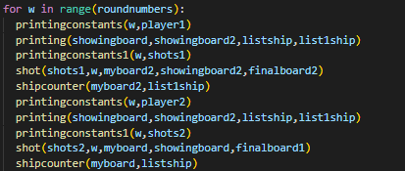

***2.2.2 Final Information***

I used third board to print it. If I hadn’t done so, the desired results would have looked different.

