Assignment 8

Allison Tessman

2024-03-05

# Question 1: Differencing Techniques

* Plot the ACF for the Microsoft stock series for 2023. Investigate the stationarity of the series.
* NOTE: The correlations does not die out to zero, so this series is non-stationary and is not reasonable to model the stock using the AR model.

library(quantmod)

## Loading required package: xts

## Loading required package: zoo

##   
## Attaching package: 'zoo'

## The following objects are masked from 'package:base':  
##   
## as.Date, as.Date.numeric

## Loading required package: TTR

## Registered S3 method overwritten by 'quantmod':  
## method from  
## as.zoo.data.frame zoo

library(forecast)  
getSymbols("MSFT")

## [1] "MSFT"

yt = MSFT$MSFT.Open  
yt <- yt[index(yt) > "2023-01-01"]  
  
acf(yt, lag.max = 100)

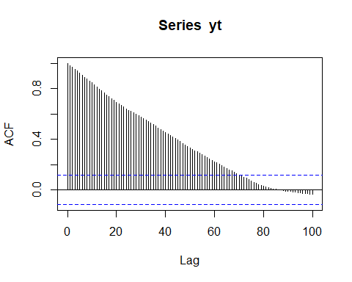

* Using the differencing technique to forecast the next value of the stock series.

#acf plot for difference series  
d_MSFT = ts(as.numeric(diff(yt))[-1])  
acf(d_MSFT, lag.max = 100)

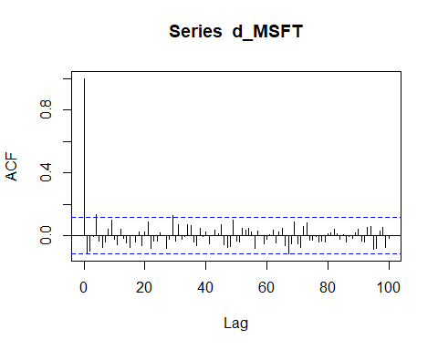

ar_MSFT = arima(d_MSFT, order = c(1,0,0))  
ar_MSFT

##   
## Call:  
## arima(x = d_MSFT, order = c(1, 0, 0))  
##   
## Coefficients:  
## ar1 intercept  
## -0.1164 0.5869  
## s.e. 0.0586 0.2524  
##   
## sigma^2 estimated as 23.16: log likelihood = -873.13, aic = 1752.26

#forecast the next observation  
d_n = forecast(ar_MSFT, h = 1)  
  
y_next = d_n$mean + yt[length(yt)]

## Warning: Incompatible methods ("Ops.ts", "Ops.xts") for "+"

y_next = as.numeric(y_next)  
y_next

## [1] 413.8426

# [1] 413.8426

# Question 2: AR(p)

* Consider the AMD stock from 2023 to present. Use the PACF plot to suggest an AR(p) model to model the stock. Use the model to make a forecast for the next 5 values. Plot the forecasting.

library(quantmod)  
library(forecast)  
getSymbols("AMD")

## [1] "AMD"

yt = AMD$AMD.Open  
yt <- yt[index(yt) > "2023-01-01"]  
pacf(yt)

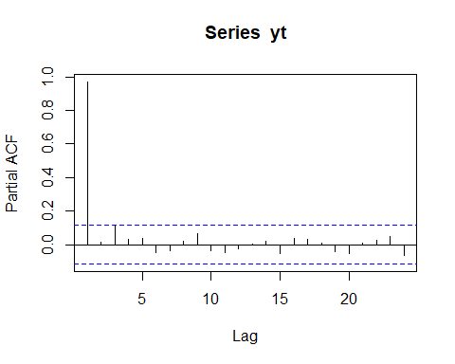

# estimate the series using AR(1) model  
yt_ar = arima(yt, order = c(1,0,0))  
  
# plot the estimated series and the original series  
yt_predicted <- yt - yt_ar$residuals

## Warning: Incompatible methods ("Ops.xts", "Ops.ts") for "-"

plot(yt)  
points(yt_predicted, type = "l",   
 col = "red", lty = 2)

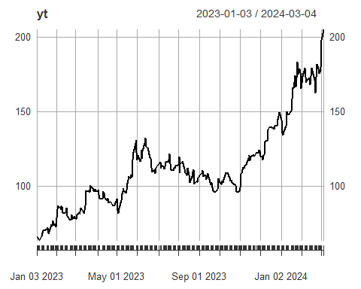

yt_forecasts <- forecast(yt_ar, h=5)  
plot(yt_forecasts)

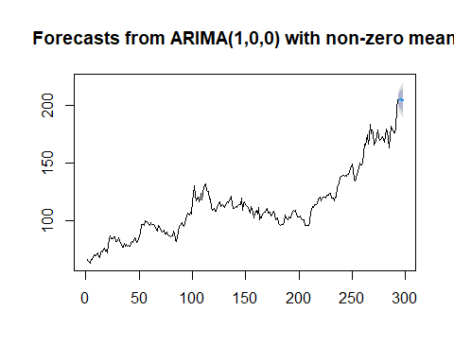

* Redo the above analysis on another stock.

library(quantmod)  
library(forecast)  
getSymbols("DIS")

## [1] "DIS"

yt = DIS$DIS.Open  
yt <- yt[index(yt) > "2022-01-01"]  
pacf(yt)

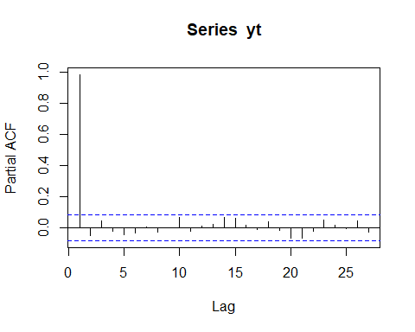

# estimate the series using AR(1) model  
yt_ar = arima(yt, order = c(1,0,0))  
  
# plot the estimated series and the original series  
yt_predicted <- yt - yt_ar$residuals

## Warning: Incompatible methods ("Ops.xts", "Ops.ts") for "-"

plot(yt)  
points(yt_predicted, type = "l",   
 col = "red", lty = 2)

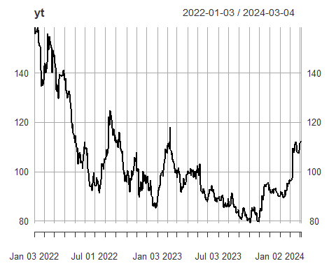

yt_forecasts <- forecast(yt_ar, h=5)  
plot(yt_forecasts)

