INDEX

SPECIFICATION 2

DOMAINS 3

LOGICAL DESIGN 4

RELATIONAL DESIGN 4

DDL 5

DATA 8

JOIN 9

STORED PROCEDURE 10

# SPECIFICATION

CONTEXT

Small database which reflects the ownership of cars and insurance-packages per customer, with some side-information about insurance company, car and customer.

ENTITIES

Car: car_id PK, brand, model

Customer: customer_id PK, first_name, last_name, zip_code

Insurance Company: company_id PK, company_name, company_street, zip_code

Owned Cars: owned_car_id PK, mileage, car_colour_id, package_id, customer;id, car_index_id

Colour: colour_id PK, colour

Insurance Package: package_id PK, package_name, package_cost, company_id

City: city_zip PK, city_name

RELATIONSHIPS

1:N

LocatedCustomerinCity, city to customer 1:N, Customer has to have a city

LocatedCompanyinCity, city to insurance_company 1:N, insurance_company has to have a city

HasCarOwner, customer to owned_cars 1:N, owned_cars has to have a customer

HasColour, car_colour to owned_cars 1:N, owned_cars has to have a colour

IsCar, car_index to owned_cars 1:N, owned_cars has to have a car_index

HasPackage, insurance_package to owned_cars 1:N, owned_cars has to have a insurance_package

FromInsuranceCompany, insurance_company to insurance_package 1:N, insurance_package has to have a

insurance_company

# DOMAINS

|  |  |
| --- | --- |
| Car_index |  |
| car_id | Integers: 1000-9999 |
| Brand | String (varchar 35) |
| model | String (varchar 35) |
|  |  |
| Customer |  |
| Customer_id | Integer: 0-999999 |
| First_name | String (varchar 50) |
| Last_name | String (varchar 50) |
| Zip_code | Integer: 1000-9999 |
|  |  |
| City |  |
| City_zip | Integer: 1000-9999 |
| City_name | String (varchar 50) |
|  |  |
| Insurance_company |  |
| Company_id | Integer: 0-9999 |
| Company_name | String (varchar 50) |
| Company_street | String (varchar 50) |
| Zip_code | Integer: 1000-9999 |
|  |  |
| Insurance_package |  |
| Package_id | Integer: 0-9999 |
| Package_name | String (varchar 50) |
| Package_cost | Float: max. 99999.99 |
| Company_id | Integer: 0-9999 |
|  |  |
| Car_colour |  |
| Colour_id | Integer: 0-999 |
| colour | String (varchar 10) |
|  |  |
| Owned_car |  |
| Owned_car_id | Integers: 0-9999 |
| Mileage | Integer: 0-9999999 |
| Car_colour_id | Integer: 0-999 |
| Package_id | Integer: 0-9999 |
| Customer_id | Integer: 0-999999 |
| Car_index_id | Integers: 1000-9999 |
|  |  |

# LOGICAL DESIGN

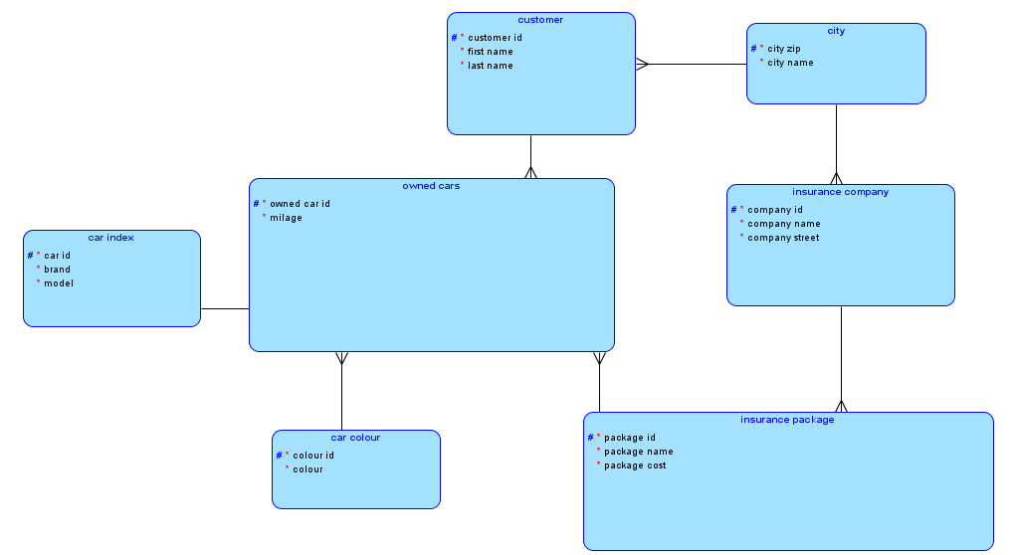

# RELATIONAL DESIGN

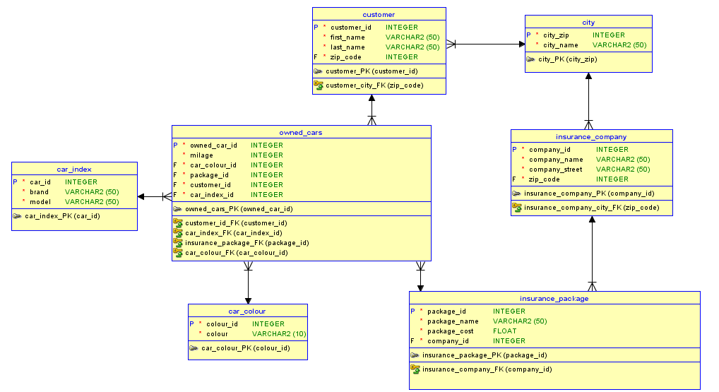

# DDL

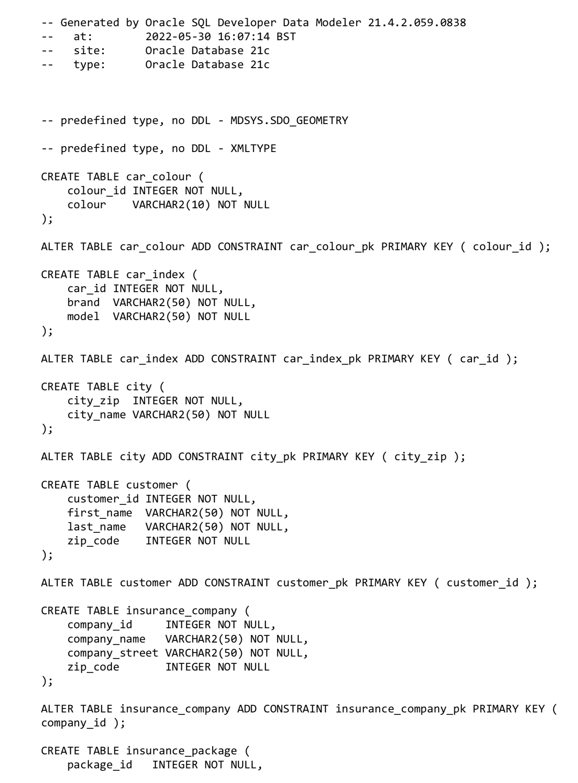

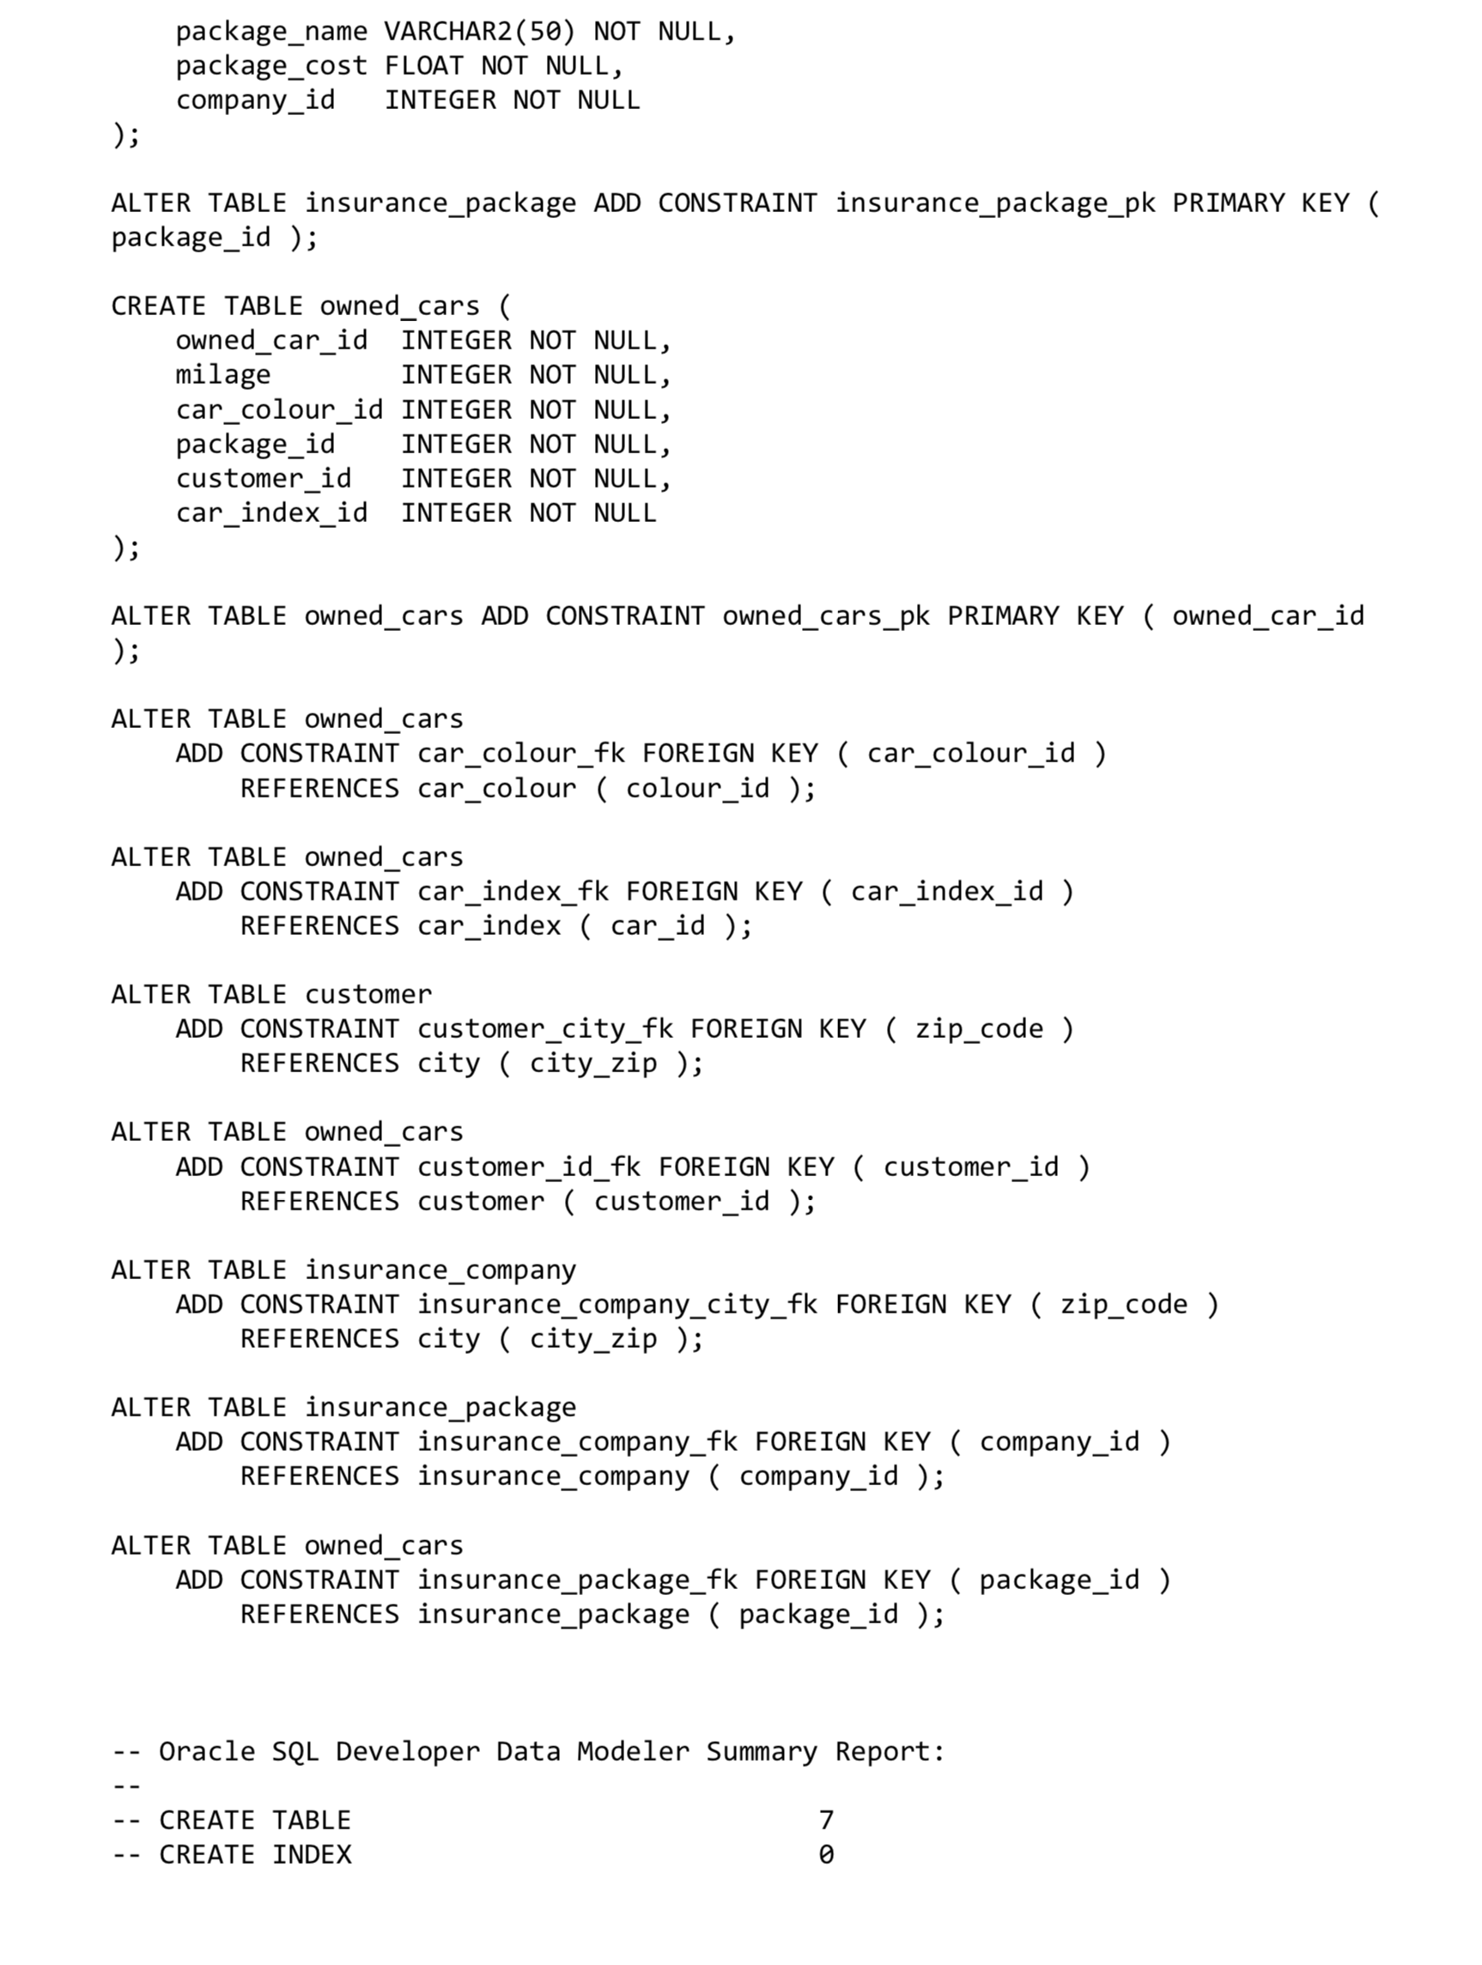

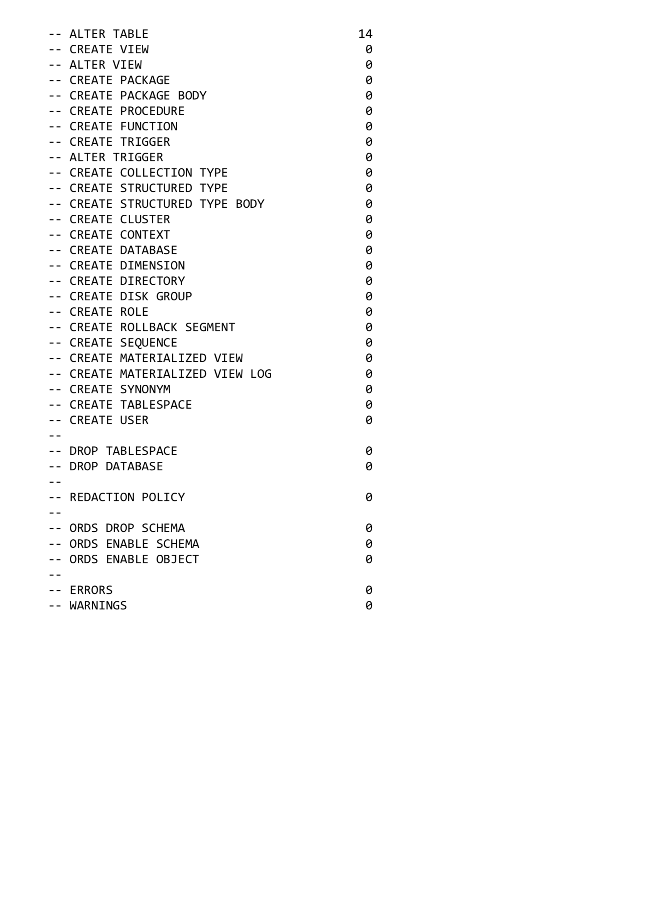

# DATA

# JOIN

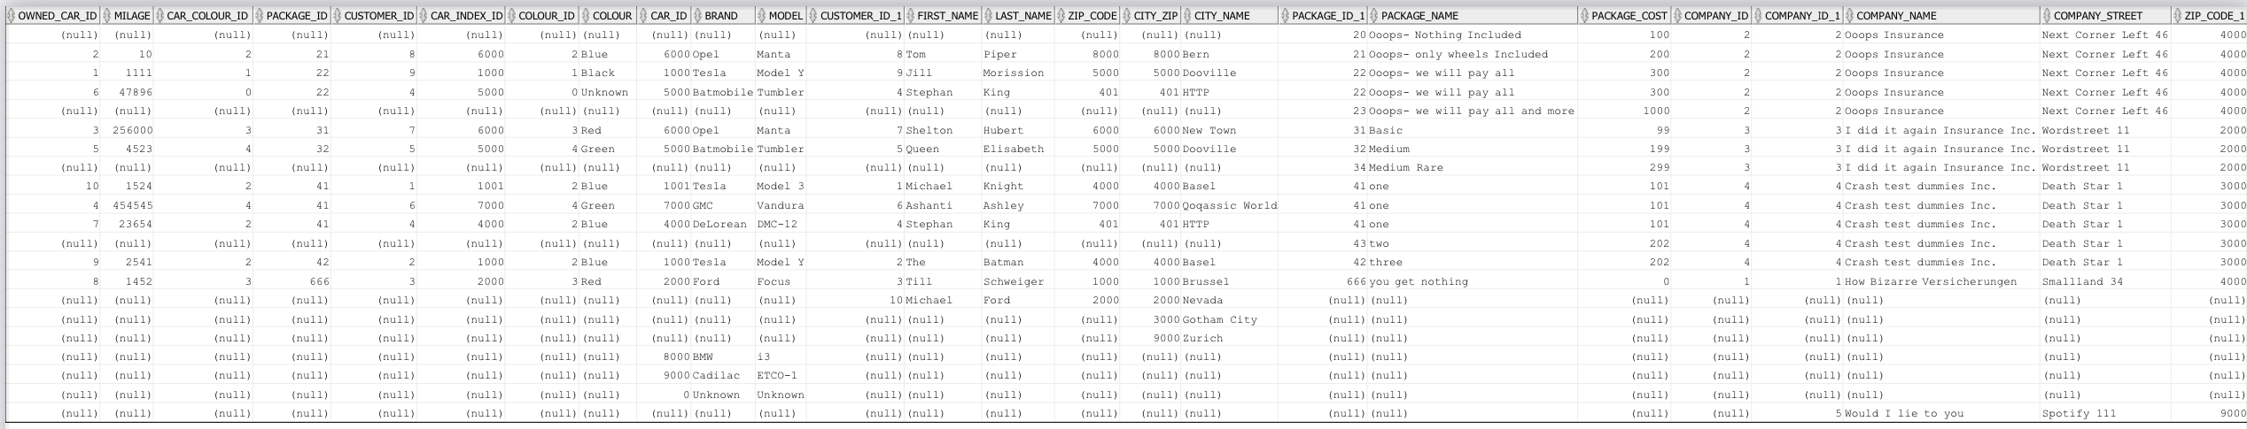

# STORED PROCEDURE

