**Abhijay Gupta**

**Student ID: 260708548**

**Comp 251 Assignment 1**

**Task 1**

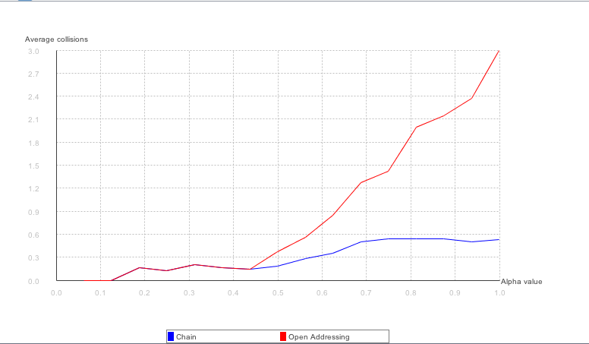

**Task 2**

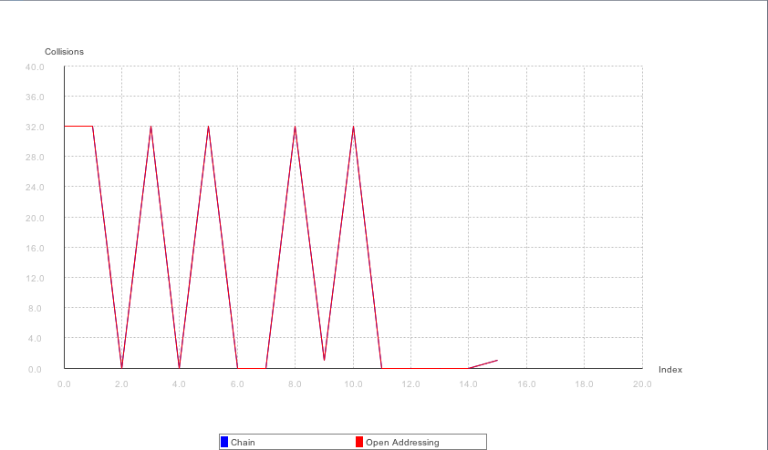

**Task 3**

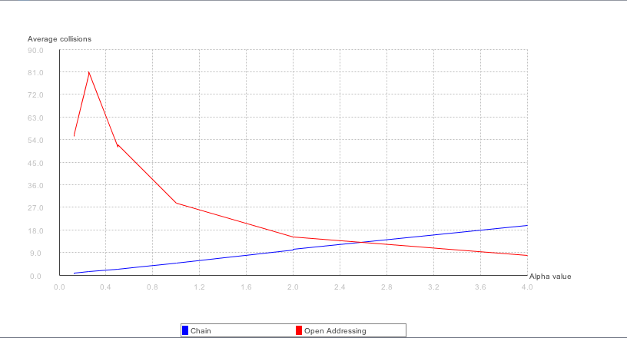

As we can see from the graph, the average number of collisions for a Chaining table increases in a linear fashion with a low slope as the load factor (or alpha value) increases.

The average number of collisions for an Open Addressing table are more sporadic with spikes at the beginning but the average number of collisions decreases as the load factor increases and it even manages to fall below the number of collisions for

the Chaining table after a certain load factor.

In the hash function for Open Addressing, $g\left(k, i\right)=\left(h\left(k\right)+i\right) mod 2^{r}$, the value of *h(k)* is fixed and *g(k, i)* changes with change in i. At times, this causes the function to check consecutive slots in the table which are already filled by the nature of open addressing, which leads to a longer processing time to find an open slot and therefore a higher number of collisions. While the number of collisions do decrease as the load factor increases, on average, they still remain higher than collisions for Chaining.

With Chaining, the hash value gives us a specific slot and our collisions mainly depend on the size of the list at this slot. If the load factor is low, the number of collisions counted for Chaining turns out to be low as well. As previously stated, it can be seen that the number of collisions increases linearly at a low rate as the load factor increases.