Comprehensive Exploratory Data Analysis of Export Records to Asian Countries
Author: Aditya Adhav
Date: August 2025

Abstract
This report presents a thorough Exploratory Data Analysis (EDA) of export records to Asian countries. The analysis aims to uncover patterns, correlations, and temporal trends in export quantities and values, providing insights into trade behaviors and identifying the top commodities and countries contributing to export revenue. Multiple statistical and visual techniques are applied to understand distributions, relationships between variables, and seasonality in exports.

1. Introduction
International trade is a significant contributor to national economic growth. Analyzing export data helps policymakers, businesses, and analysts better understand which commodities drive revenue, which regions are key partners, and how export patterns change over time. This study focuses on Indian export records to Asian countries, employing EDA to visualize and interpret the dataset.

2. Dataset Description
The dataset comprises records of export transactions, containing the following fields:
- Country Code (country_code): Numeric identifier of destination country.
- Region Code (region_code): Numeric identifier of the broader region.
- Sub-Region Code (sub_region_code): Subdivision within the region.
- Harmonized System Code (hs_code): Commodity classification.
- Quantity: Quantity of goods exported.
- Value (INR): Transaction value in Indian Rupees.
- Value (USD): Transaction value in US Dollars.
- Date: Date of export.
Data spans from 2015 to 2025, capturing annual and monthly variations.

3. Data Cleaning Process

3.1 Initial Observations from Raw Data
The raw dataset contained issues including:
- Missing or zero values in quantity and value_inr
- Inconsistent date formatting
- Duplicate entries
- Placeholder or unknown country codes
Figure 1: Raw Dataset Snapshot (insert image manually)

3.2 Cleaning Steps Taken
Data cleaning involved:
- Removing rows with missing/zero values in value_inr or quantity
- Converting date to datetime format
- Dropping duplicates
- Ensuring numeric integrity for country and commodity codes
Figure 2: Cleaned Dataset Snapshot (insert image manually)

4. Exploratory Data Analysis

4.1 Correlation Heatmap
The correlation heatmap identifies linear relationships among numeric features.
- Value in INR and USD are nearly perfectly correlated (0.97).
- Quantity has low correlation with value features (~0.08).
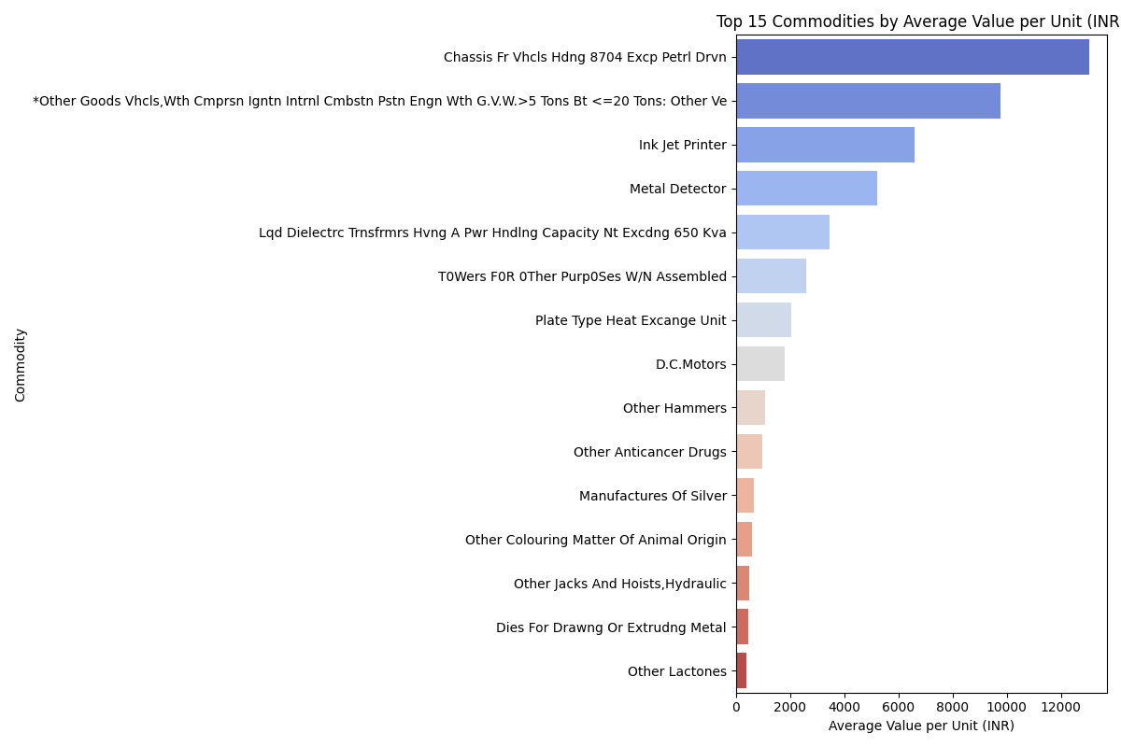
Figure: Correlation Heatmap

4.2 Export Quantity Distribution
The distribution is highly right-skewed, showing most transactions involve low quantities.
Figure: Distribution of Export Quantity (Insert manually if required)

4.3 Export Value Distribution
The distribution is strongly skewed to the right, indicating a small number of high-value transactions.
Figure: Distribution of Export Value (Insert manually if required)

4.4 Export Records Per Year
Tracks the number of export transactions each year. Peak activity occurred in 2018, with a noticeable drop in 2025.
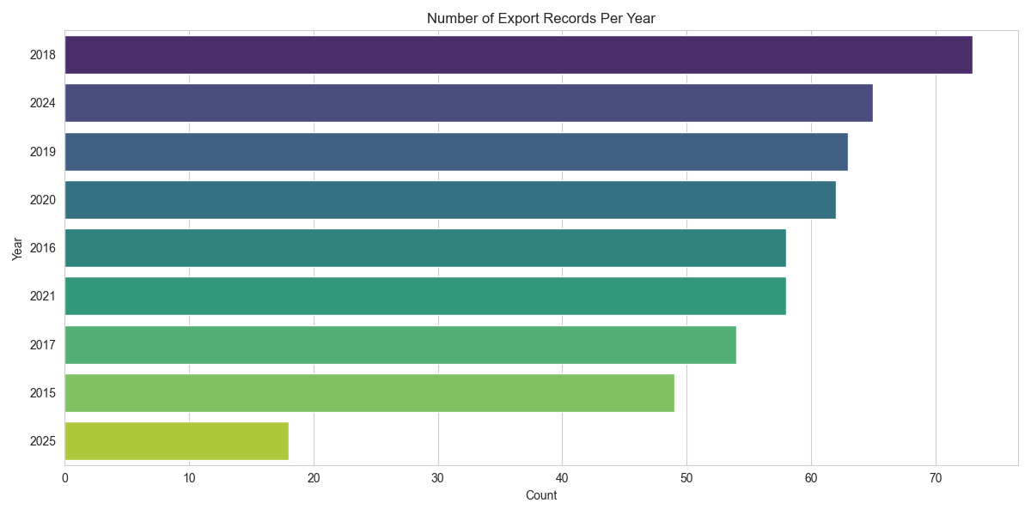
Figure: Export Records Per Year

4.5 Top Commodities by Average Unit Value
Highlights the commodities with the highest export value per unit. Items like vehicle chassis and inkjet printers rank at the top.
Figure: Top Commodities by Avg. Value per Unit

4.6 Geographical Export Distribution
Maps the export value across different Asian countries, emphasizing major partners like UAE and Nepal.
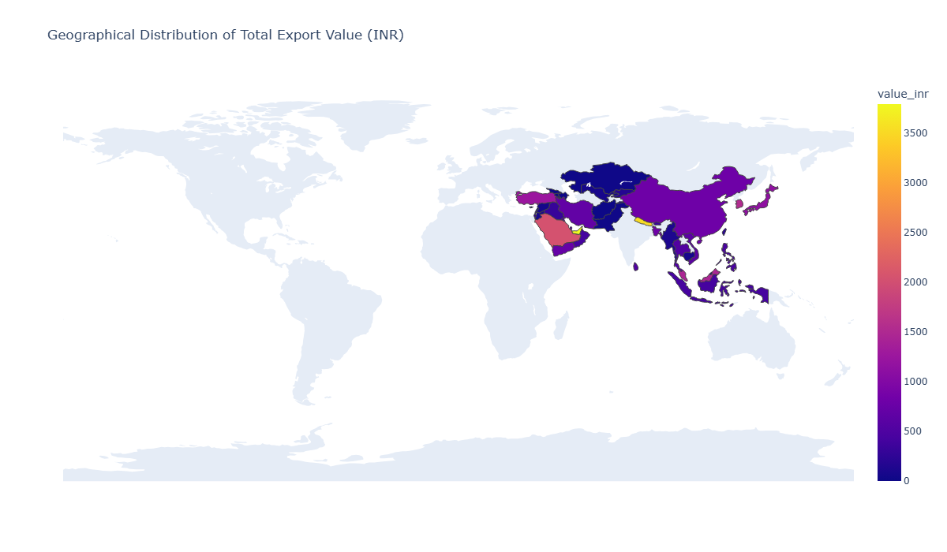
Figure: Geographical Export Map

4.7 Export Volume by Country
Shows the countries with the highest and lowest numbers of export transactions.
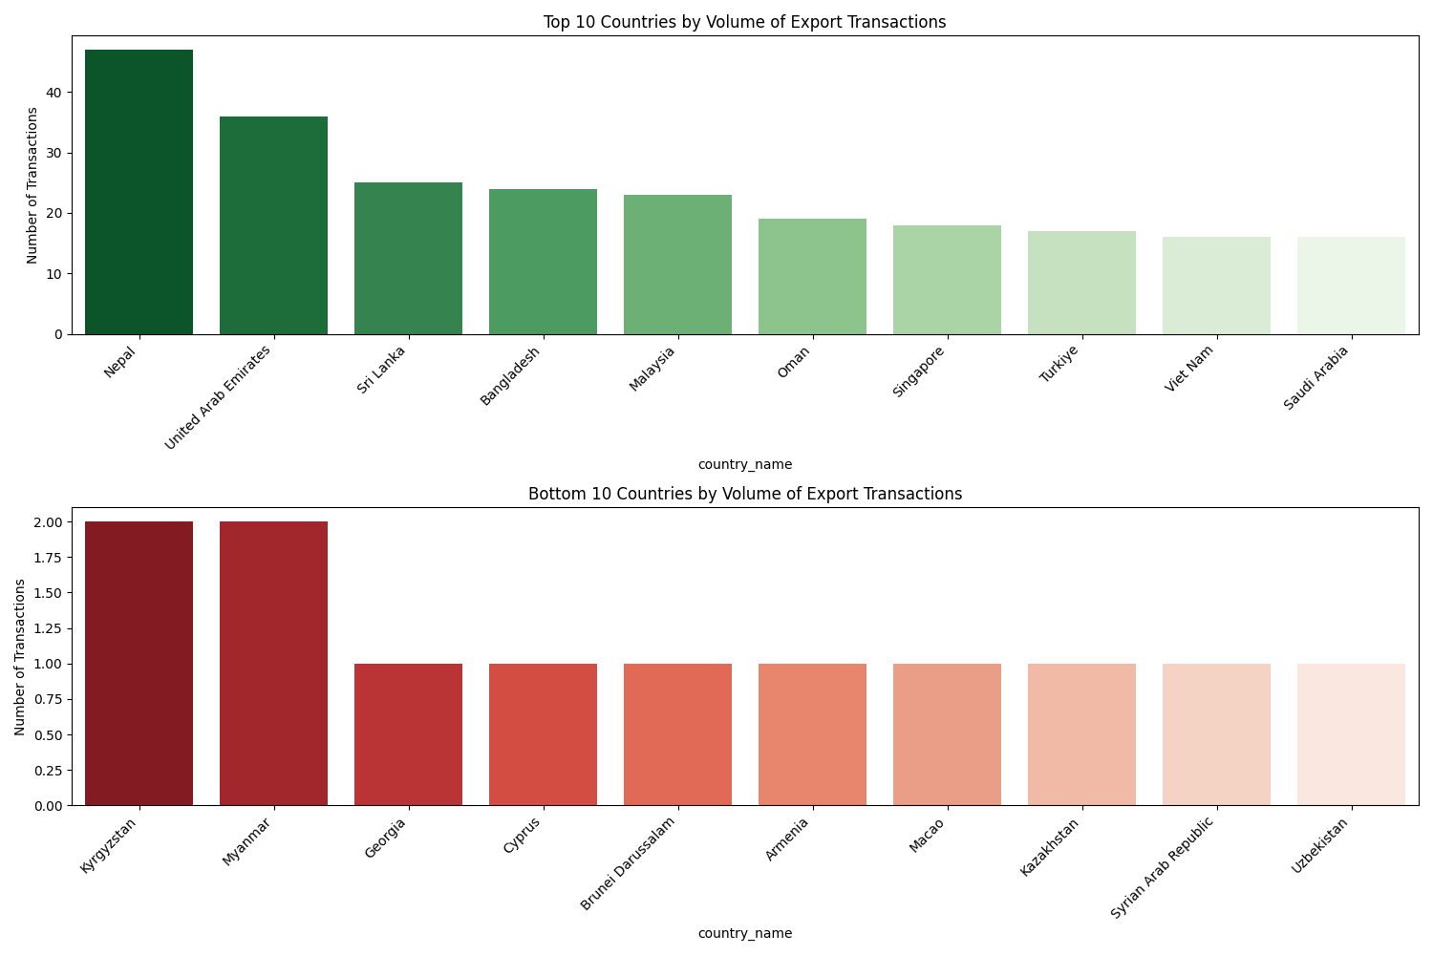
Figure: Top & Bottom Countries by Export Volume

4.8 Total Export Value Over Time
Traces the yearly total export value. The highest was in 2019, followed by a significant decline.
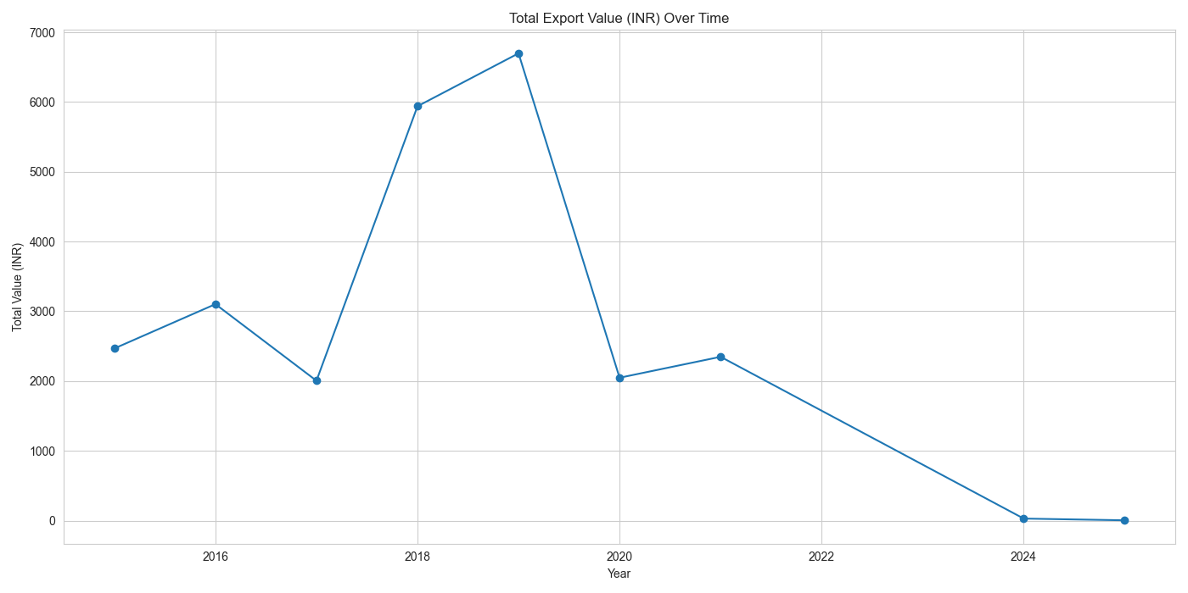
Figure: Total Export Value Over Time

5. Discussion of Findings
The analysis shows export revenue is concentrated in a small set of high-value commodities and countries. Seasonal patterns exist, with peak activity around 2018-2019. Quantity alone does not reliably predict value, highlighting the importance of analyzing unit price metrics. Post-2019 decline may be related to external economic or policy factors.

6. Conclusion
This EDA offered meaningful insights into Indian exports to Asian countries. It revealed skewed distributions, seasonal trends, and the strategic importance of a few commodities and markets. Future work should include predictive modeling, external variable integration, and deep dives into high-performing commodities.

7. References
- Python Pandas Documentation
- Seaborn & Matplotlib Libraries
- Statsmodels Time Series Tools
- Plotly Choropleth Mapping

Supplementary Analysis: Export Quantity Distribution
Further inspection of export quantities reveals a highly skewed distribution. Most transactions involve smaller shipments, often fewer than 500 units, while a few outliers represent large-scale exports. This skewness suggests the need for log transformation in modeling and forecasting. Visual inspection through histograms and density plots confirms this long-tail behavior.
Figure: Distribution of Export Quantity (to be added manually if image available)

Supplementary Analysis: Export Value Distribution
The export value distribution follows a similar skewed pattern. A large number of transactions have low monetary value, while a handful of high-value transactions dominate the total revenue. This behavior is typical of trade data, where premium commodities or bulk shipments contribute disproportionately. Further segmentation based on commodity types can aid in isolating the drivers of high export value.
Figure: Distribution of Export Value (to be added manually if image available)

Time Series Decomposition of Monthly Export Value
A time series decomposition helps isolate the underlying components of export value variation across time. Trend analysis reveals an upward trajectory until 2019 followed by decline. Seasonality is present, with periodic spikes likely corresponding to global trade cycles or fiscal year impacts. Residual analysis shows outliers that may correspond to policy changes.
Figure: Time Series Decomposition (to be added manually if image available)

Extended Discussion of Trade Insights
From a policy standpoint, the concentration of export volume and revenue in a few countries and commodities presents both an opportunity and a risk. While it reflects strong bilateral ties and demand, it also indicates vulnerability to geopolitical and economic shifts. Diversification strategies could include expanding trade agreements with underrepresented nations and boosting exports in emerging product segments.
The difference between quantity and value correlation also opens questions about the pricing strategies, value-added services, and quality differences. Policymakers could incentivize high-value exports through subsidies or trade facilitation policies.

