Day-2

Cloud Computing Fundamentals
Learning objectives
- Understand cloud computing.
- Learn IaaS, PaaS and SaaS.
- Understand public, private and hybrid cloud.
- Learn regions and availability zones.
- Compare AWS, Azure and GCP.
- Understand cloud infrastructure from a DevOps perspective.

Part 1 – What is Cloud Computing?
Cloud computing means delivering computing resources over the internet instead of purchasing and maintaining all the physical infrastructure yourself.
These resources include:
- Virtual machines (servers)
- Storage
- Networking
- Databases
- Load balancers
- Security services
- Monitoring tools
Example:
Suppose a company wants to host an application.
Traditionally, it needs to purchase a physical server, install an operating system, configure networking and maintain the hardware.
With cloud computing, it can create a virtual server using AWS, Azure or GCP in a few minutes.
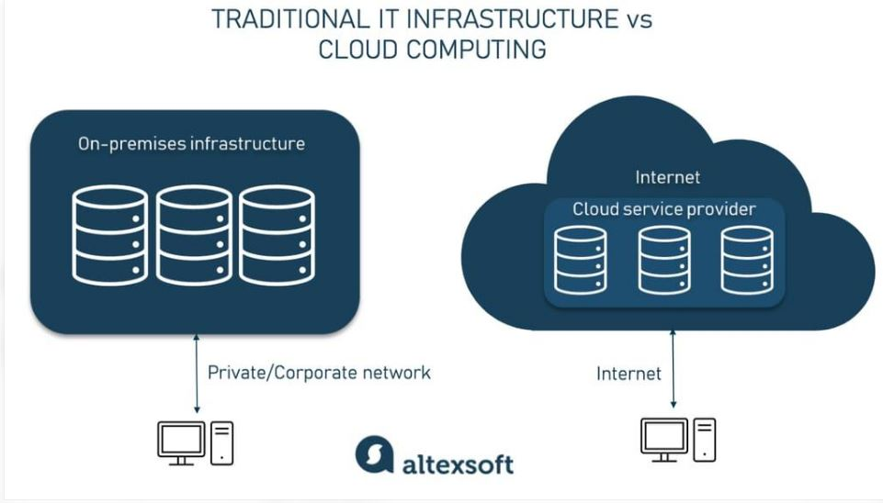

Traditional infrastructure vs Cloud
Traditional IT | Cloud Computing
Buy physical servers | Create virtual servers
High initial investment | Pay for usage
Hardware maintenance | Cloud provider manages physical hardware
Manual capacity expansion | Scale resources as needed
Longer provisioning time | Faster provisioning
Interview answer: What is cloud computing?
"Cloud computing is the delivery of computing services such as servers, storage, networking and databases over the internet. Instead of maintaining physical infrastructure, we can provision resources on platforms like AWS, Azure and GCP and pay according to usage."

Part 2 – Cloud Service Models
This is a very important interview topic.
There are three main service models:

1. IaaS – Infrastructure as a Service
The cloud provider gives you infrastructure such as virtual machines, storage and networking.
You manage the operating system, applications and configurations.
Example: Amazon EC2.
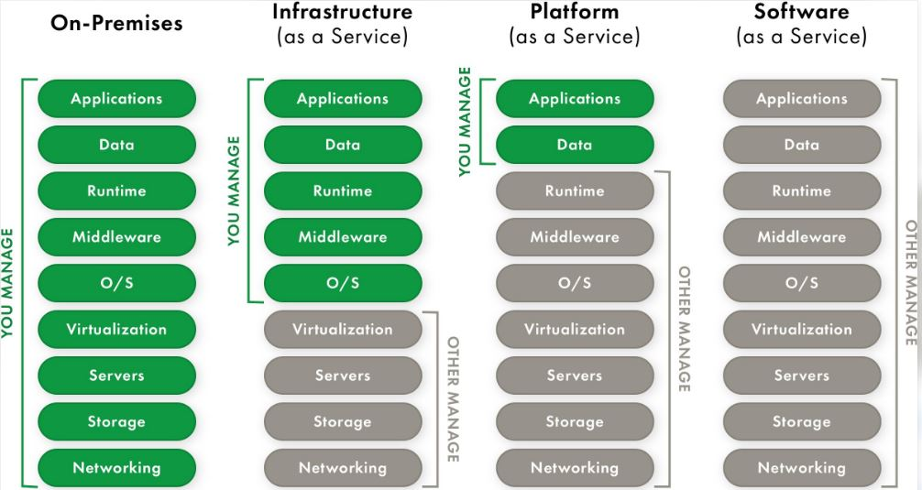
Practical example: Create an RHEL virtual machine in AWS EC2 and configure Apache yourself.

2. PaaS – Platform as a Service
The cloud provider manages the infrastructure and operating system platform. You focus mainly on deploying and managing your applicatio
Example: Azure App Service.
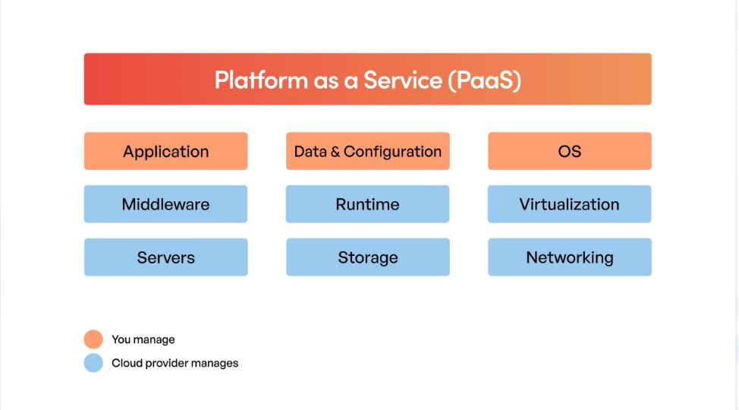
Practical example: Deploy a Python web application to Azure App Service without manually managing the underlying server.

3. SaaS – Software as a Service
The provider delivers a ready-to-use software application over the internet.
You simply use the application.
Examples:
- Gmail
- Microsoft 365
- Salesforce
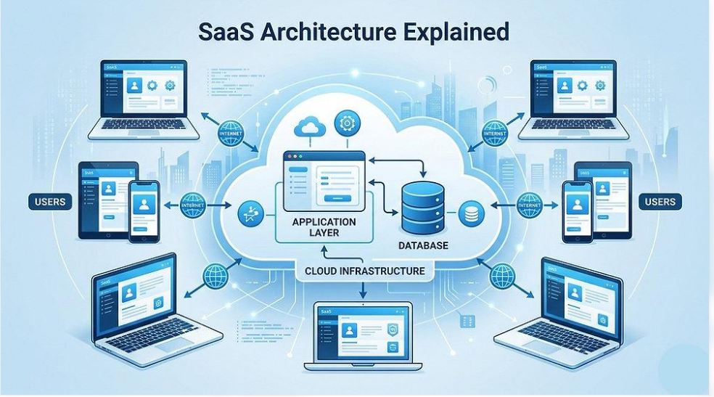

IaaS vs PaaS vs SaaS
Responsibility | IaaS | PaaS | SaaS
Physical infrastructure | Provider | Provider | Provider
Operating system | You | Provider | Provider
Runtime/platform | You | Provider | Provider
Application | You | You | Provider
Usage | Manage infrastructure | Deploy application | Use software

Easy way to remember:
- IaaS = Rent infrastructure.
- PaaS = Rent a platform.
- SaaS = Use ready-made software.

Part 3 – Cloud Deployment Models
Deployment models describe where and how cloud infrastructure is deployed.

1. Public Cloud
Cloud infrastructure is provided by a third-party provider and accessed over the internet.
Examples: AWS, Azure and GCP.

2. Private Cloud
Cloud infrastructure is dedicated to a single organization.
Example: A bank maintains its own private cloud infrastructure using VMware or OpenStack.

3. Hybrid Cloud
A combination of private infrastructure and public cloud.
Example:
- Company's database runs in its own data center.
- Its web application runs on AWS.
- Both environments communicate through a secure network connection.
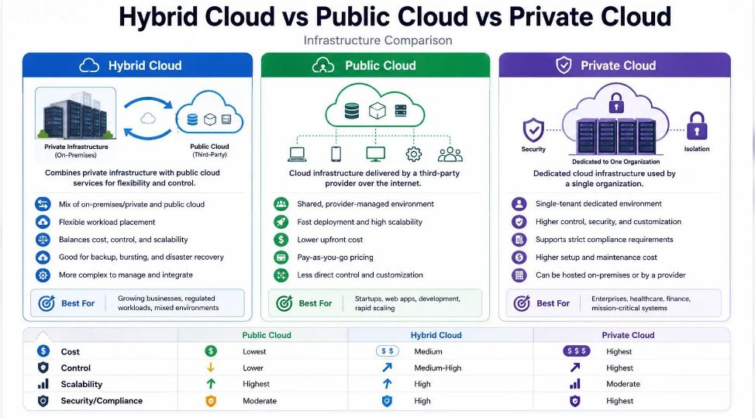
Interview question: What is hybrid cloud?
"Hybrid cloud is an environment where an organization uses both private infrastructure and public cloud services. For example, a company can maintain sensitive databases in its own data center and host applications in AWS."

Part 4 – Cloud Regions and Availability Zones
This is very important when working with AWS, Azure and GCP.

1. Region
A region is a geographical area where a cloud provider operates its infrastructure.
Examples:
- AWS Mumbai: ap-south-1
- AWS Singapore: ap-southeast-1
- AWS US East (N. Virginia): us-east-1

2. Availability Zone (AZ)
An Availability Zone is an isolated location within a cloud region, designed to provide resilience against infrastructure failures.
For example, an AWS region in Mumbai has multiple Availability Zones.

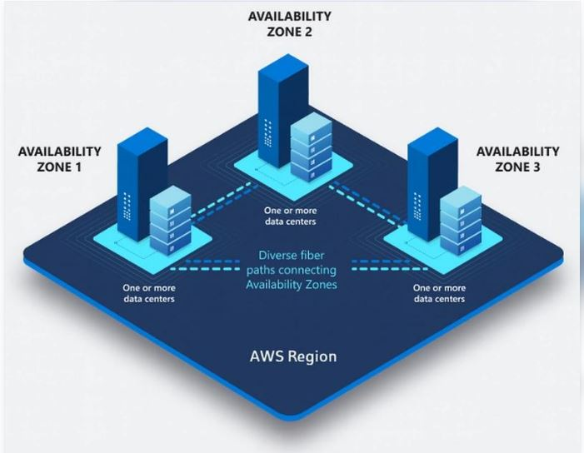

Why do we need multiple Availability Zones?
Imagine your application is running on one virtual machine in one Availability Zone.
If that Availability Zone experiences an outage, your application may become unavailable.
If you deploy your application across multiple Availability Zones and configure load balancing and failover, you can improve availability.
Remember:
- Region = Geographical location.
- Availability Zone = Isolated infrastructure location within a region.

Part 5 – AWS vs Azure vs GCP

Important cloud service comparison
Requirement | AWS | Azure | GCP
Virtual machine | EC2 | Virtual Machines | Compute Engine
Object storage | S3 | Blob Storage | Cloud Storage
Virtual network | VPC | Virtual Network | VPC
Kubernetes | EKS | AKS | GKE
Managed database | RDS | Azure SQL | Cloud SQL
Identity | IAM | Microsoft Entra ID / Azure RBAC | Cloud IAM

Part 6 – Shared Responsibility Model
One important cloud concept is the Shared Responsibility Model.
The cloud provider is responsible for the security of the cloud, while the customer is responsible for security in the cloud, according to the service model.
For example, with an AWS EC2 virtual machine:
AWS manages:
- Physical data centers
- Physical servers
- Physical networking
- Hardware infrastructure
You manage:
- Operating system updates
- User accounts and permissions
- Firewall/security group configuration
- Application security
- Data protection
With SaaS, the provider manages much more of the underlying stack, although customers still have responsibilities such as user access and data handling.
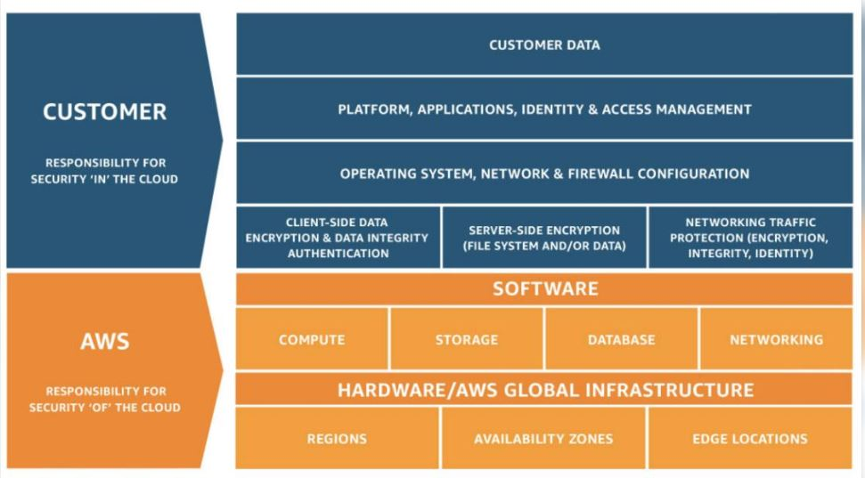

Part 7 – Hands-on learning exercise

Scenario
A company wants to host an online shopping application.
Requirements:
- Web application
- Linux virtual machines
- Database
- Storage for product images
- High availability
- Monitoring
Think about how you would design this using AWS.
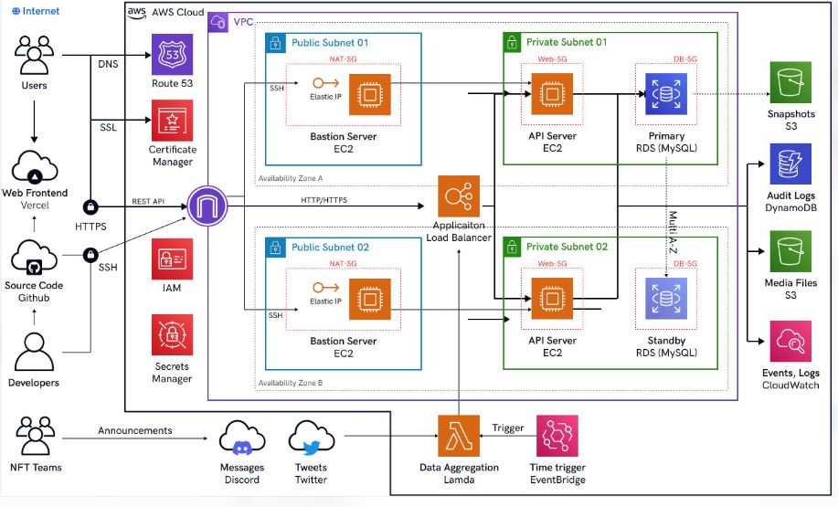
Your task is to identify the appropriate AWS services:
Requirement | Your choice
Linux server | ?
Store product images | ?
Database | ?
Load balancing | ?
Monitoring | ?
Virtual network | ?
Hint: Today's AWS service comparison table contains the answers.

Part 8 – Interview preparation
Prepare these questions in your own words:
- What is cloud computing?
- Explain the difference between IaaS, PaaS and SaaS.
- What is the difference between public cloud and private cloud?
- What is the difference between a Region and an Availability Zone?
- What is the Shared Responsibility Model?
- What is the difference between AWS, Azure and GCP?

