Security Implementation Recommendations
Cloud Resource Assistance
Purpose: This document summarizes the current security features and recommends security enhancements for the Cloud Resource Assistance application.

1. Current Security Features
- Human-in-the-Loop Approval: Users must approve recommendations before any action is performed.
- Privacy Warning: The application checks user requests for sensitive information such as passwords and API keys.
- Action Logging: Processing steps and user actions are logged for traceability.
- Response Validation: AI responses are validated before being presented to the user.
- Input Validation: The backend checks that requests contain valid input.

2. Security Workflow Diagram
User
|
Input Validation
|
Privacy Check
|
AI Recommendation
|
Human Approval
|
Action Logging
Recommended workflow
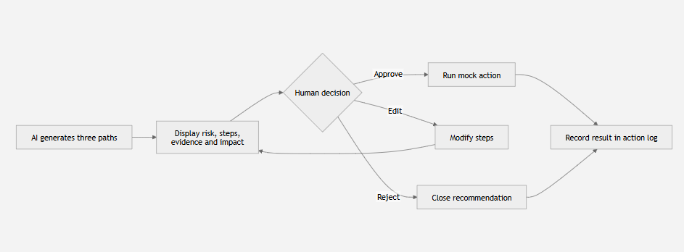

Security Architecture Diagram
┌──────────────────────────────┐
│ End User │
└──────────────────────────────┘
│
HTTPS
▼
┌──────────────────────────────┐
│ Frontend (HTML + JavaScript) │
│ • User Input │
│ • Display Response │
└──────────────────────────────┘
│
POST /chat
▼
┌──────────────────────────────┐
│ Flask Backend (Python) │
│ • Input Validation │
│ • Privacy Check │
│ • Request Logging │
│ • Authentication (Future) │
└──────────────────────────────┘
│
▼
┌──────────────────────────────┐
│ Processing Modules │
│ • String Breakdown │
│ • Filter Request │
│ • EC2 Processor │
│ • Prompt Crafting │
│ • LLM Server │
│ • JSON Handler │
└──────────────────────────────┘
│
▼
┌──────────────────────────────┐
│ AI Recommendation Engine │
│ • Generate Recommendations │
│ • Validate Response │
│ • Block Unsafe Actions │
└──────────────────────────────┘
│
▼
┌──────────────────────────────┐
│ Human-in-the-Loop Approval │
│ • Approve • Edit • Reject │
└──────────────────────────────┘
│
▼
┌──────────────────────────────┐
│ Audit & Action Logs │
│ • Requests │
│ • Decisions │
│ • Security Events │
│ • Error Logs │
└──────────────────────────────┘
Figure: Security architecture showing the flow from the end user through the frontend, Flask backend, processing modules, AI recommendation engine, human approval, and audit logging. Security controls such as HTTPS, input validation, privacy checks, response validation, and logging help protect the application throughout the request lifecycle.

3. Simple Security Architecture
Browser
|
HTTPS
|
Flask Backend
|
Processing Modules
|
LLM Service
|
Validated Response
|
Human Decision
|
Audit Log

4. Best Practices

Never commit API keys to GitHub.

Store sensitive credentials in environment variables (.env) or a secure secrets manager to prevent unauthorized access.

Use least-privilege cloud permissions.

Grant users and services only the minimum permissions required to perform their tasks.

Review AI recommendations before execution.

Verify all AI-generated suggestions to ensure they are safe, accurate, and appropriate before acting.

Monitor logs regularly.

Review application and audit logs to detect unusual activities, security incidents, or system errors.

Perform periodic security testing.

Conduct regular vulnerability scans and security assessments to identify and fix potential weaknesses.

Keep software and dependencies updated.

Regularly update Python packages, libraries, and frameworks to protect against known security vulnerabilities.

Validate and sanitize user input.

Ensure all user inputs are checked and cleaned to prevent malicious data and common web attacks such as Cross-Site Scripting (XSS).

5. Trust and Safety Features
- PII Warning on Requests: The application scans incoming requests for sensitive information such as passwords and API keys and alerts the user when potential private information is detected.
- Risk Label per Recommendation: Each AI-generated recommendation includes a risk level (e.g., Low, Medium, High) to help users understand the potential impact before making a decision.
- Human Approval Gate: All AI recommendations require user approval before any cloud action is taken, ensuring that no operation is executed automatically.
- Action Logging: Every major processing step, user decision, and system event is recorded to provide traceability, support auditing, and simplify troubleshooting.
This section aligns closely with the trust and safety features implemented in your project and addresses the missing risk label per recommendation feature.

6. Recommended Security Improvements

Authentication
Currently, the application does not require users to log in before accessing the system. Implementing user authentication ensures that only authorized users can access the application and interact with the AI recommendation engine. Authentication can be implemented using username/password credentials or third-party identity providers such as Google OAuth or Microsoft Azure Active Directory. This helps prevent unauthorized access and protects sensitive cloud information.

Role-Based Access Control (RBAC)
Different users should have different levels of access based on their responsibilities. For example, administrators can manage the application and system settings, while cloud engineers can review and approve AI recommendations. Read-only users should only be able to view recommendations without making any changes. Implementing RBAC follows the Principle of Least Privilege, reducing the risk of accidental or unauthorized actions.

HTTPS Communication
The application should use HTTPS instead of HTTP when deployed. HTTPS encrypts all communication between the user's browser and the Flask backend, protecting sensitive information such as login credentials and cloud-related requests from interception or man-in-the-middle attacks. This ensures secure data transmission across the network.

Secure API Key Management
Sensitive credentials, such as the OpenAI API key, should never be stored directly in the source code or committed to GitHub repositories. Instead, API keys should be stored securely in environment variables (.env) during development or managed using services such as AWS Secrets Manager or Azure Key Vault in production. Proper secret management minimizes the risk of credential exposure.

Rate Limiting
The application should limit the number of requests a user can send within a specific time period. Rate limiting helps prevent abuse, automated attacks, and denial-of-service (DoS) attempts by restricting excessive requests to the backend. Libraries such as Flask-Limiter can be integrated to implement this functionality.

Input Validation and Sanitization
All user inputs should be validated and sanitized before processing. This includes checking for empty values, excessively long requests, invalid characters, and potentially malicious content such as embedded scripts. Proper input validation helps protect the application against common web vulnerabilities, including Cross-Site Scripting (XSS) and injection attacks.

Audit Logging
In addition to the existing logging functionality, the application should maintain comprehensive audit logs that record important events such as user logins, recommendation approvals, rejected actions, configuration changes, and system errors. Audit logs improve accountability, simplify troubleshooting, and support future security investigations.

Dependency and Package Updates
The project relies on several third-party Python libraries, including Flask and OpenAI SDK. These dependencies should be updated regularly to ensure that known security vulnerabilities are patched. Security scanning tools such as pip-audit or Safety can also be used to identify vulnerable packages before deployment.

7. Conclusion
The Cloud Resource Assistance application already contains a few of the important security-related measures like privacy warning, human-in-the-loop approval, response validation and action logging to make sure recommendations generated by the AI are reviewed to proceed with any of the cloud action. Extra measures like user authentication, RBAC, HTTPS, API key management and logging should also be introduced to make the application more secure. Regular security testing, input validation and updating dependencies will thus improve the reliability and robustness of the application. Implementing these changes will lead to a more secure, maintainable and production ready application, which can be deployed to the cloud.

