CS628 Full-Stack Development Web App
PE03 – ToDo List App
School of Technology & Computing (STC)
City University of Seattle (CityU)

Before You Start
- You already created a private GitHub repository for all your programming exercises, “cs628-pe-your_first_name.”
- You allowed your instructor and the Teaching Assistant to access your GitHub repository for programming assignments.
- The GitHub Codespaces may bill your account according to your usage. Check the price at https://docs.github.com/en/billing/managing-billing-for-github-codespaces/about-billing-for-github-codespaces. Please pay attention to the storage and core hours of use free of charge for personal accounts.
- Some steps are not explained in the assignment. If you are not sure what to do:
  - Consult the resources listed in your course.
  - If you need help solving the problem after a few tries (~15 minutes), ask a TA for help.

Learning Outcomes
Students will be able to:
  - Create a basic ToDo list app using React, utilizing state management with the useState hook to handle dynamic data.
  - Implement event handlers to capture user interactions, and dynamically render components.

Problem Statement:
Your goal is to create a basic ToDo list App using React that allows users to add and remove todos.

Requirements:
- Display an input field where users can enter their ToDo description.
- When the "Add Task" button is clicked, the ToDo should be added to the ToDo list.
- Each ToDo in the list should have a "Delete" button that allows users to remove the ToDo.
- Implement state management using the useState hook to handle the list of ToDos.

Note:
- Create separate components for the ToDo list and ToDo tasks.
- Use the useState hook to manage the state of the ToDos.
- Implement event handlers to capture user interactions, such as clicking the "Add Task" or "Delete" buttons.
- Use the .map() function to dynamically render the list of ToDos.
- Apply CSS styling of your choice to enhance the user interface.

Submission
- Create a GitHub repository for your programming exercises. The repository name will be “cs628-pe-your_first_name.”
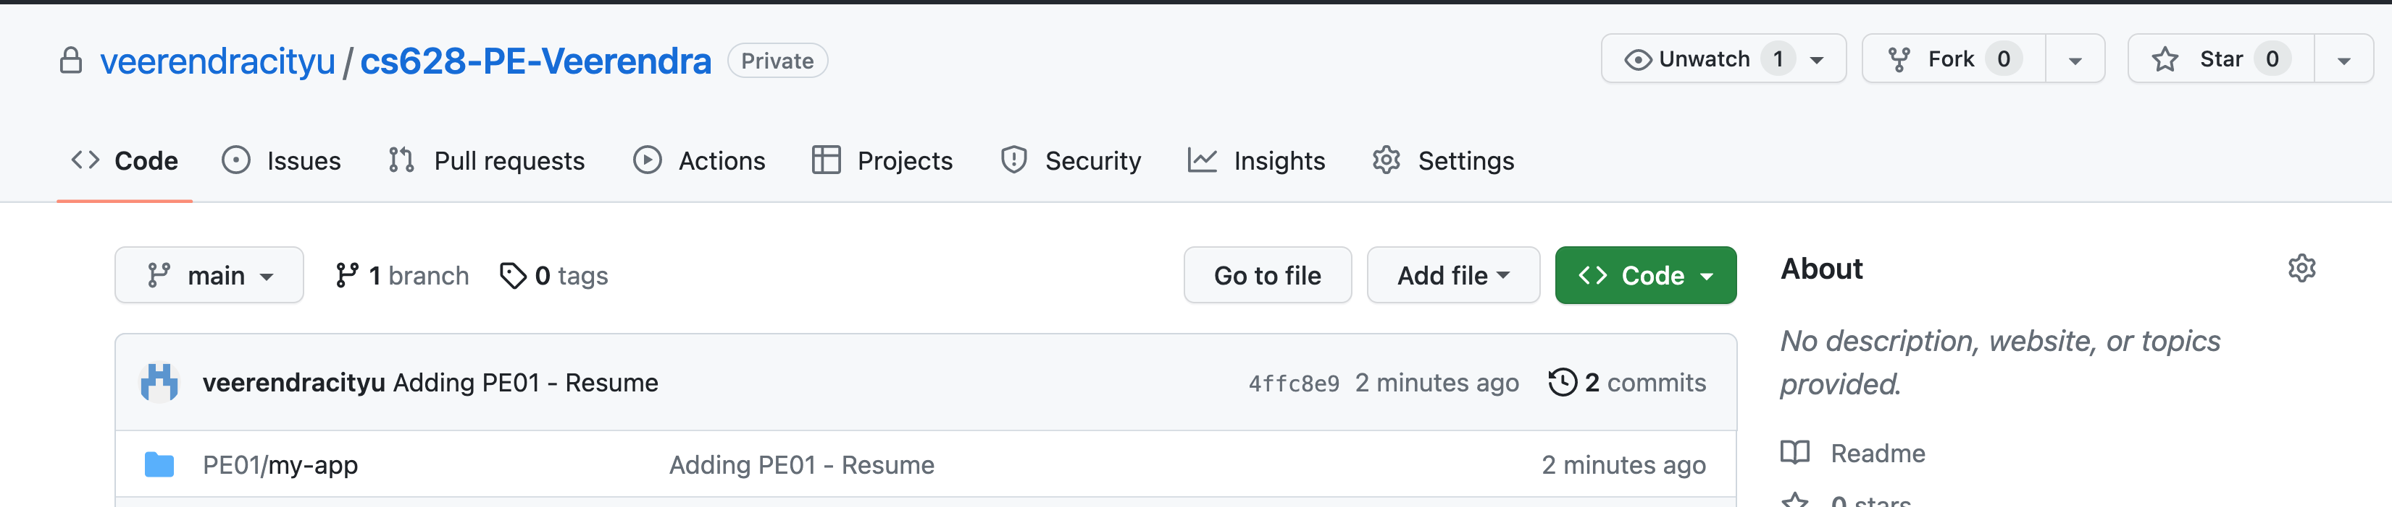
1

- Click the Settings menu. Invite your instructor and TA to collaborators.
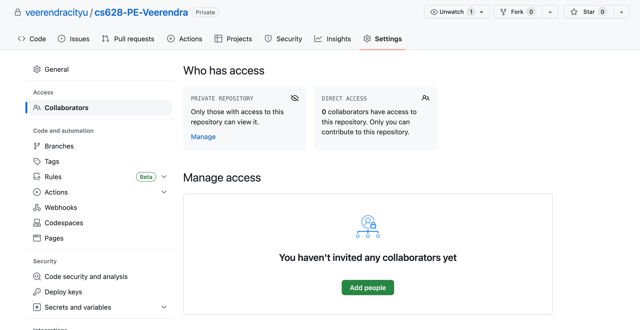
1

- Under the repository, create a directory for the programming exercise 1, “PE03-ToDoList.” For example, the screen below shows the directory created for programming exercise 01.
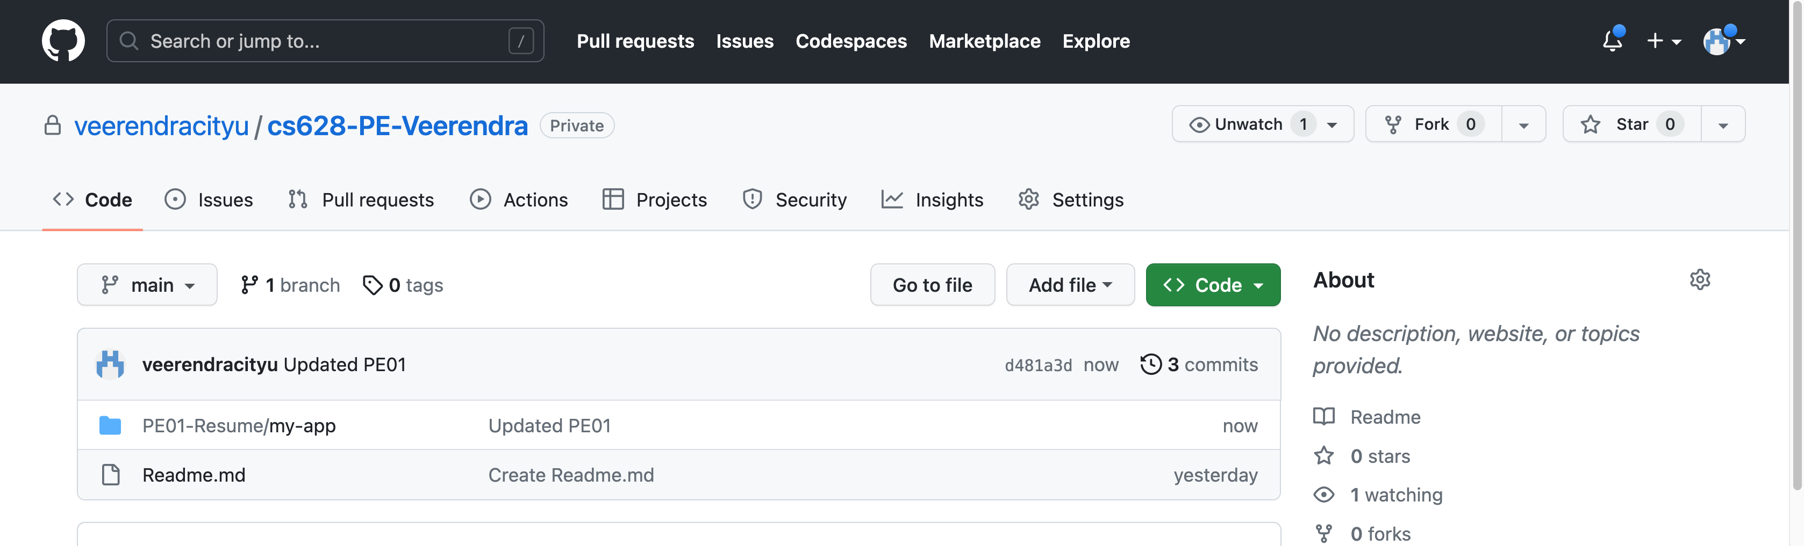
- Finish your programming exercise under the PE03 directory.
- Write a 150-word analysis report to explain how the program works in README.md in terms of the input-process-output model. The README.md has three level-1 headings – Input, Process, and Output.
- Submit the link of your GitHub repository to your course shell through your assignment submission.
