# What Are the Implications of Ever-increasing Globalization through Technology

Globalisation is a significant concept to improve the discussion of international wealth and poverty. But, globalisation is an intricate matter. Globalisation includes not just the what, but in addition the how and the why, the frequency with which something happens, the social consequences of this procedure and the array of people involved. On the flip side, globalisation may also be regarded as hybridisation. If globalisation is just viewed concerning good and bad, we are not going to appreciate the multifaceted nature of global processes.

Globalization has put the individuals of the world on the identical vessel but in various cabins. In fact, it offers essential opportunities for global developments but it is not progressing in an evenly pace. While it has played a role in these trends, the story is much more complex. At the same time, just as it has a long way to run, the adjustment process is far from finished.

The Tried and True Method for What Are the Implications of Ever-increasing Globalization through Technology to the Global Economy ? in Step by Step Detail

A warming planet thus contributes to a change in climate which may influence weather in many ways, as discussed further below. Recent warming was demonstrated to be a result of human industrialization processes. International warming and climate change refer to a growth in average worldwide temperatures.

States have attempted to deal with the challenges of poverty at a worldwide level in several ways. In terms of relative price changes, the Bank attempts to look through one-off alterations, since these only temporarily have an effect on inflation. First, it needs to be mindful of the possibility that movements in the terms of trade may affect the relationship between core and total CPI inflation.

What solutions work best needs to be set in the neighborhood context. Additional analysis provides more evidence to demonstrate the way the digital divide also impacts the economy in places throughout the world. Both of these risks are, clearly, related.

The origin of the cooling trend isn’t known with certainty. Fourth, global trends might increase the danger of premature deindustrialisation. Until that time, the financialisation trend is probably going to continue unabated. Creating sufficient jobs to fulfill this demand is an immense challenge. The human economy features loads of chances for employment generation. Denmark’s economy have lately grown by 50% without a gain in greenhouse emissions, thereby disproving the very first assumption.

Three significant shifts can be recognized. A third important shift in the worldwide economy is that multinational businesses are getting to be transnational. Another key change is in the essence of worldwide trade. These effects might be behind a part of Canada’s disappointing productivity record in late decades.

The vital challenge is then to develop liveable cities. Its purpose is to find and implement long-term, sustainable solutions which will raise the access to educational technology and resources to domestic and worldwide communities. If human skills are the real key to the future of work, policymakers will need to set a limit on the brain drain at all price. To be able to use computer technology, a specific degree of information literacy is required. Still, it appears that neoliberalism has passed its peak, and could soon start to reverse. To begin with, I’ll chat about the way the present wave of globalization differs from prior periods of financial integration, and after that I will tackle a number of the financial impacts of globalization.

<https://www.texasgateway.org/node/10076>

# Texas Gateway for Online Resources

In the previous section, the implications of globalization were briefly described. In this section, you will delve a little deeper into some of those implications and determine if they impact our world positively or negatively. Read more about the implications of globalization below.

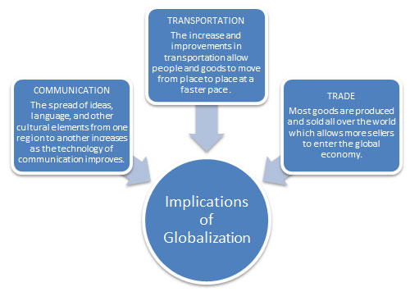



### Communication

Technology has provided a means for better global communication. No longer is a long distance phone call or a telegram the only method of reaching someone across the seas. The use of the Internet and satellite coupled with the widespread availability of mobile devices allows communication to flow farther and faster. Although these modes of communication are not available everywhere, they will become available to more locations as technology increases.

The iPad (pictured left) is a mobile device that can be used to access the Internet and download applications (apps) for games, music, movies, social media, and more. This mobile device is available in more than 200 countries worldwide.

How can the iPad increase communication globally?Interactive popup. Assistance may be required.

Click here for possible answers.

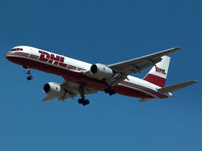

### Transportation

As the technology of transportation improves, it becomes easier for people to move from place to place with greater ease. People are able to travel to more locations around the world where they can experience new languages, foods, and customs. Improvements in transportation have led to the increase and improvements in moving people and products globally. As a result, the global economy has seen an increase in global trade.  
Products can be moved at a faster pace, which impacts the economy of both the selling and buying society. This airplane (pictured right) flies for a delivery company that delivers products internationally. Travel and trade impact global economies as a result.

How does transportation impact the global economy (an economy where several countries participate)?Interactive popup. Assistance may be required.

Click here for possible answers.



### Trade

Goods are sold from region to region. Through this exchange different societies are able to experience products from other areas in the world. This allows others to experience what people in other societies enjoy. Some companies have gone “global” by becoming[multinational](https://www.texasgateway.org/mask/http:/www.ontrack-media.net/worldgeography/worldgeographyglossary.html#descriptive investigation) companies. These companies are headquartered in one country, but they move jobs and production to lower-wage countries, a practice generally known as [outsourcing](https://www.texasgateway.org/mask/http:/www.ontrack-media.net/worldgeography/worldgeographyglossary.html#descriptive investigation). This practice cuts costs for the company, which translates into lower prices for consumer. However, the country that loses the high-paying jobs suffers higher unemployment rates.

The picture of chocolate pieces above represents one multinational company. The Nestlé Corporation is known for its chocolate products, but throughout the years the corporation has grown to produce much more. Nestlé is headquartered in Switzerland, but they employ more than 330,000 people in more than 150 countries. The company runs nearly 500 factories in 83 countries.

Click here to learn more about the company's products.  
[Nestlé Products](http://www.nestle.com/AboutUs/Pages/AboutUs.aspx)

→ **Quick Thought**: After looking at the brands of the Nestlé Corporation, have you ever purchased or used one or more of its products? If you or someone else purchased one of Nestlé’s products, are you participating in globalization?

Interactive exercise. Assistance may be required. Read the statements regarding globalization in the chart below and determine if each implication is positive or negative.

Sources for images used in this section, as they appear from top to bottom:

* 1stGen-iPad-HomeScreen, Evan-Amos, Wikipedia
* BIKC DHL 1, philmarin, Wikipedia