**SWE 645 – Assignment 4**

**Aachal Thapa**

**Abhinav Gupta**

The error we are getting is mentioned in the video at the following time: 05:40.

**Rest is explained below:**

This project was generated with Angular CLI

We generated the components using

*ng generate component component-name*

To run this project,

*ng serve* on the command line and navigate to <http://localhost:4200>

The angular app will automatically reload if we change any of the source files

Production build

*ng build --prod –aot*

The build artifacts will be stored in the dist/ directory

We uploaded the dist folder on S3 bucket, link: <http://sweangular.s3-website-us-east-1.amazonaws.com/student-survey-form>

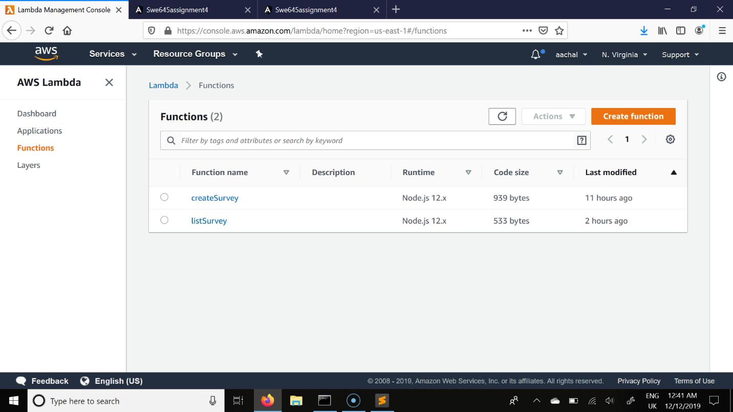

*Fig 1: Screenshot to the lambda functions “createSurvey” and “listSurvey”*

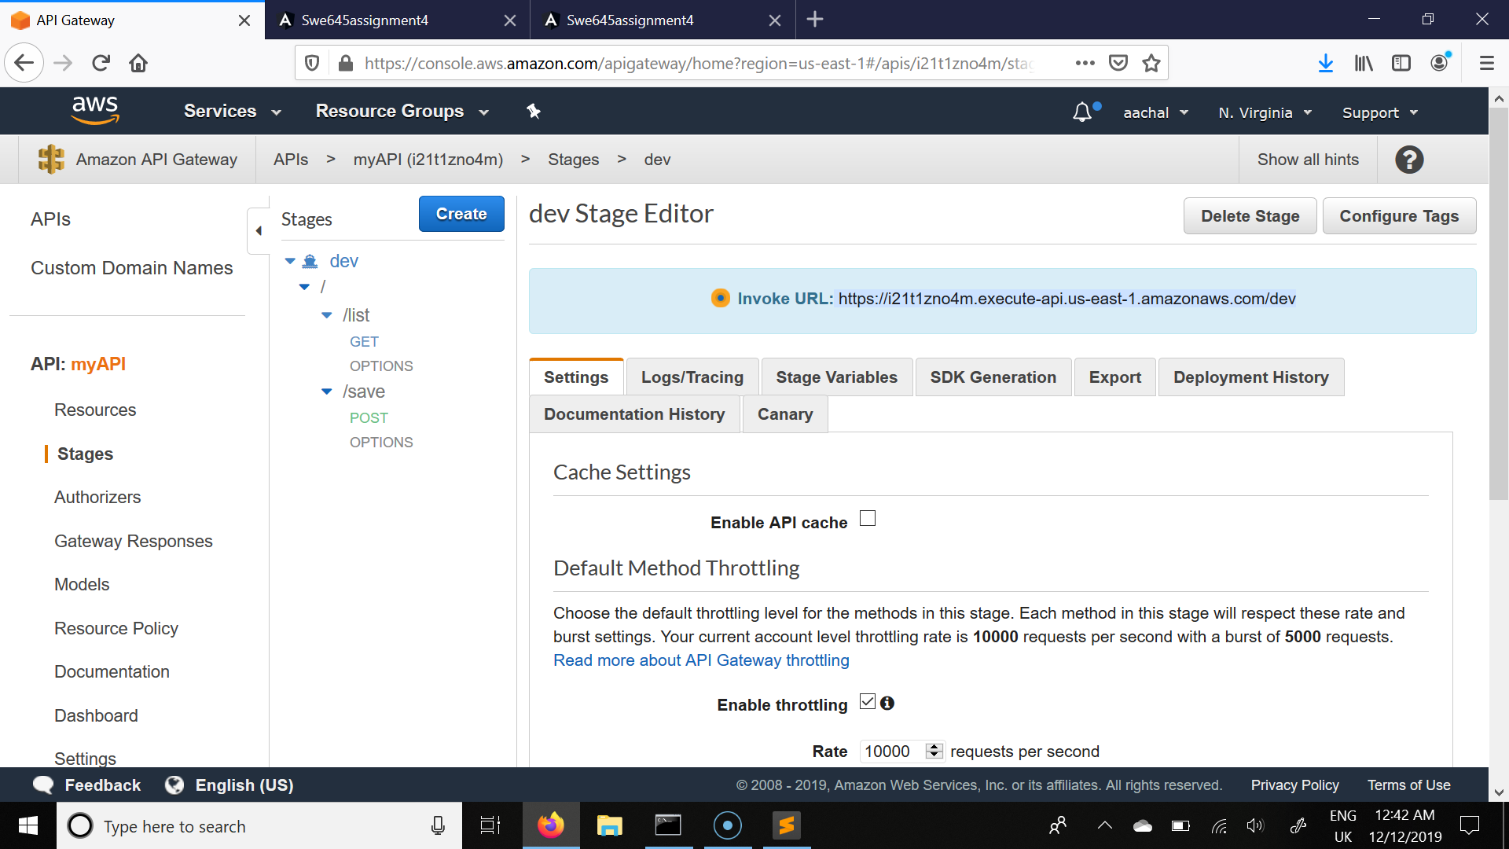

*Fig 2: Screenshot to API gateway deployment stage*

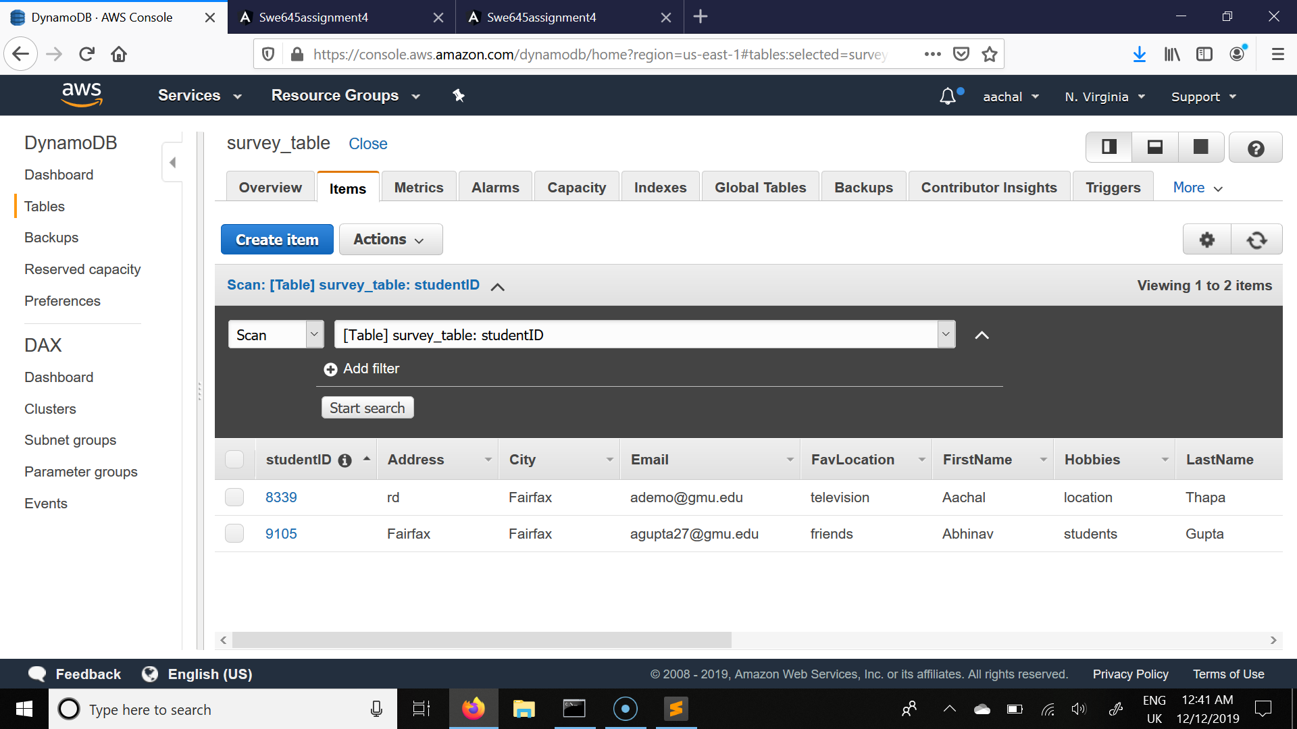

*Fig 3: Screenshot to the table in dynamodb “survey_table”*

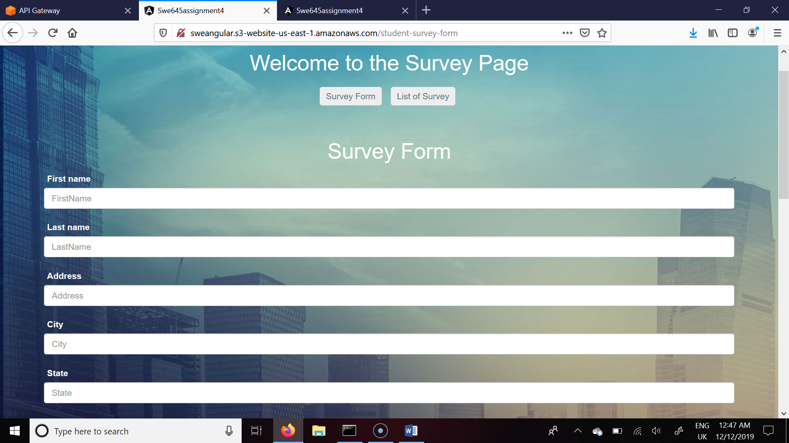

*Fig 4: Screenshot to our main page from s3 bucket*