The data structures provided by the Java utility package are very powerful and perform a wide range of functions. These data structures consist of the following interface and classes −

* Enumeration
* Vector
* Stack
* Dictionary
* Hashtable
* Properties

All these classes are now legacy and Java-2 has introduced a new framework called Collections Framework, which is discussed in the next chapter. –

The Vector

The Vector class is similar to a traditional Java array, except that it can grow as necessary to accommodate new elements.

Like an array, elements of a Vector object can be accessed via an index into the vector.

The nice thing about using the Vector class is that you don't have to worry about setting it to a specific size upon creation; it shrinks and grows automatically when necessary.

For more details about this class, check [The Vector](https://www.tutorialspoint.com/java/java_vector_class.htm).

The Stack

The Stack class implements a last-in-first-out (LIFO) stack of elements.

You can think of a stack literally as a vertical stack of objects; when you add a new element, it gets stacked on top of the others.

When you pull an element off the stack, it comes off the top. In other words, the last element you added to the stack is the first one to come back off.

For more details about this class, check [The Stack](https://www.tutorialspoint.com/java/java_stack_class.htm).

The Dictionary

The Dictionary class is an abstract class that defines a data structure for mapping keys to values.

This is useful in cases where you want to be able to access data via a particular key rather than an integer index.

Since the Dictionary class is abstract, it provides only the framework for a key-mapped data structure rather than a specific implementation.

For more details about this class, check [The Dictionary](https://www.tutorialspoint.com/java/java_dictionary_class.htm).

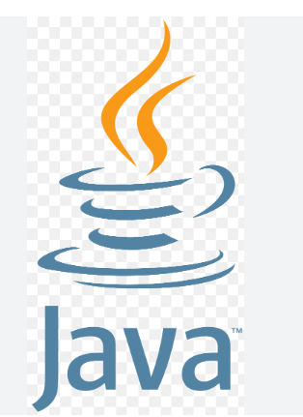

|  |  |
| --- | --- |
| Java | JSP |
| HTML | AWS |
| Server | Mainframe |

public class Main {

public static void main (String [] args) {

System.out.println("Hello World").

}

}