Supermarket Sales Analysis
Data Analytics with AI — Internship Project Report

Student: Atharav Tayade
Program: AICTE | IBM SkillsBuild Data Analytics with AI Internship 2026
Organization: BharatCares
Domain: Data Analytics with AI
Date: October 2026

Table of Contents
- 1. Abstract
- 2. Introduction
- 3. Problem Statement
- 4. Objectives
- 5. Dataset Description
- 6. Tools and Technologies
- 7. Methodology
- 8. Data Cleaning and Preprocessing
- 9. Exploratory Data Analysis
- 10. Machine Learning Model
- 11. Results and Findings
- 12. Business Recommendations
- 13. Limitations
- 14. Conclusion
- 15. References

1. Abstract
This report presents a comprehensive data analytics study of supermarket sales transactions. The dataset comprises 1,000 transactions from three supermarket branches, totaling $322,966.75 in recorded sales. The analysis covers product line performance, branch comparisons, customer segmentation, payment method preferences, temporal trends, and customer satisfaction ratings. A Random Forest regression model was developed for sales prediction as a demonstration of the machine learning pipeline. Key findings reveal performance variations across product categories and branches, with actionable recommendations for revenue optimization and customer experience improvement.

2. Introduction
The retail industry generates vast amounts of transactional data that, when analyzed systematically, can reveal actionable insights for business optimization. This project applies data analytics techniques to a supermarket sales dataset as part of the AICTE | IBM SkillsBuild Data Analytics with AI Internship program conducted through BharatCares. The study demonstrates a complete data analytics workflow from data loading and cleaning through exploratory analysis, visualization, machine learning, and insight generation.

3. Problem Statement
The supermarket management requires data-driven answers to the following questions:
- Which product lines generate the most revenue and transactions?
- How do the three branches compare in sales performance?
- What are the purchasing patterns of Member vs Normal customers?
- Which payment methods are preferred, and do they affect transaction values?
- What are the peak sales periods (hourly, daily, monthly)?
- How satisfied are customers, and does satisfaction vary across segments?
- Can transaction totals be predicted from purchase characteristics?

4. Objectives
- Load, inspect, and validate the supermarket sales dataset
- Clean and preprocess data for reliable analysis
- Conduct exploratory data analysis across multiple business dimensions
- Create professional visualizations to communicate findings
- Build and evaluate a machine learning model for sales prediction
- Generate evidence-based business insights and recommendations

5. Dataset Description
The dataset is sourced from the Kaggle Supermarket Sales dataset by Aung Pyae (https://www.kaggle.com/datasets/aungpyaeap/supermarket-sales). It contains 1,000 sales transactions from three supermarket branches in Myanmar (Yangon, Mandalay, Naypyitaw) recorded between January and March 2019.

Dataset Summary
Attribute | Value
Records | 1,000
Columns | 17
Time Period | Jan–Mar 2019
Branches | 3 (A, B, C)
Product Lines | 6
Customer Types | 2 (Member, Normal)
Payment Methods | 3 (Cash, Ewallet, Credit card)

6. Tools and Technologies
Tool | Purpose
Python 3.9+ | Primary programming language
Pandas | Data manipulation & analysis
NumPy | Numerical operations
Matplotlib | Visualization
Seaborn | Statistical visualization
Scikit-learn | Machine learning
Jupyter Notebook | Interactive notebook
python-docx | Report generation
Pytest | Unit testing

7. Methodology
The project follows a structured data analytics workflow:
1. Data Collection: Obtained the publicly available Kaggle dataset
2. Data Quality Assessment: Schema validation, missing values, duplicates, type checks
3. Data Cleaning: Column standardization, date/time parsing, type conversions
4. Exploratory Data Analysis: Descriptive statistics, group comparisons, temporal trends
5. Visualization: Professional charts for all key dimensions
6. Machine Learning: Random Forest regression with baseline comparison
7. Insight Generation: Evidence-based findings with recommendations and limitations

8. Data Cleaning and Preprocessing
The raw dataset contained 1000 rows and 17 columns.

Cleaning Steps Performed
- Column name standardization (whitespace trimming)
- Duplicate detection: 0 duplicates removed
- Date column parsed to datetime; extracted Day, Month, Month_Name, Day_of_Week, Week_Number
- Time column parsed; extracted Hour
- Numeric columns validated and coerced to proper types
- Categorical values validated against expected categories
Missing Values: No missing values were found in the dataset.
Numerical Validation: All numerical values are within expected ranges.
Final cleaned dataset: 1000 rows × 23 columns (including derived features).

9. Exploratory Data Analysis

9.1 Overall Performance
Table: Key Performance Indicators
Metric | Value
Total Transactions | 1,000
Total Sales | $322,966.75
Average Transaction | $322.97
Median Transaction | $253.85
Total Quantity Sold | 5,510
Total Gross Income | $15,379.37
Average Rating | 6.97 / 10

9.2 Product Line Analysis
Table: Total Sales by Product Line
Product line | Total_sum
Food and beverages | 56,144.84
Sports and travel | 55,122.83
Electronic accessories | 54,337.53
Fashion accessories | 54,305.89
Home and lifestyle | 53,861.91
Health and beauty | 49,193.74

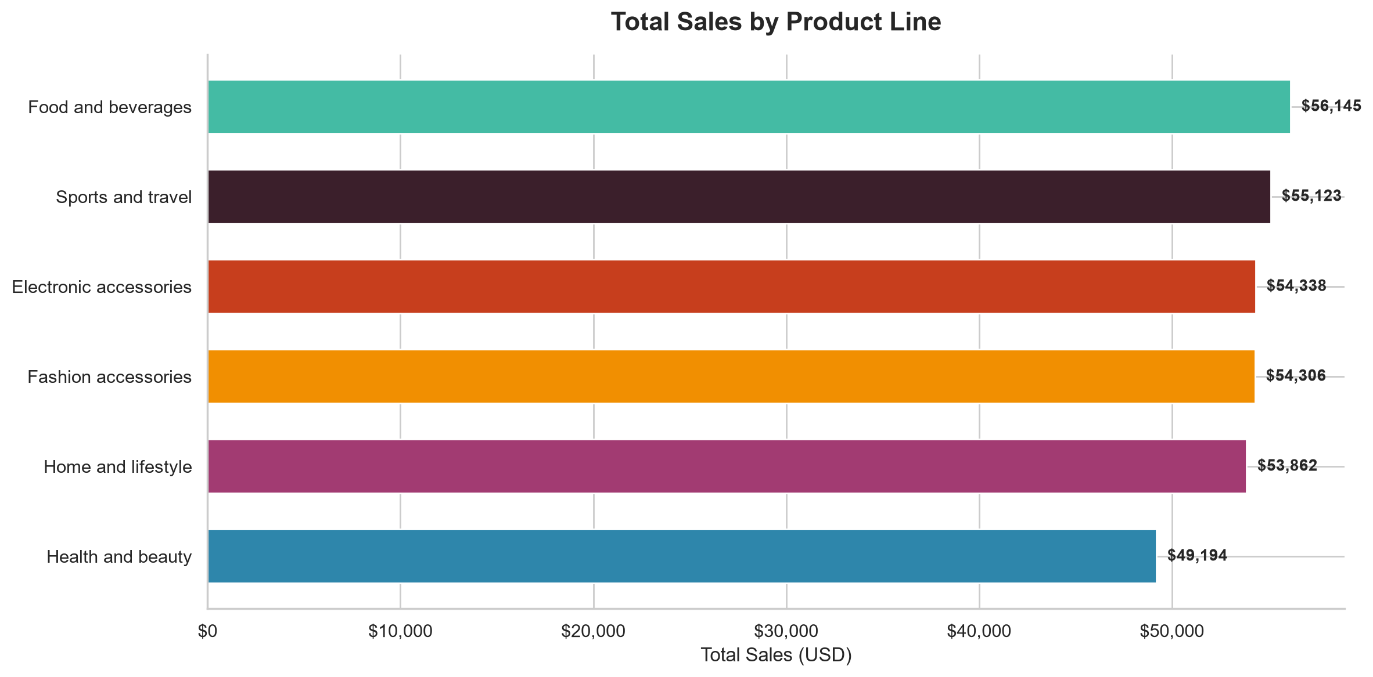
Figure: Total Sales by Product Line
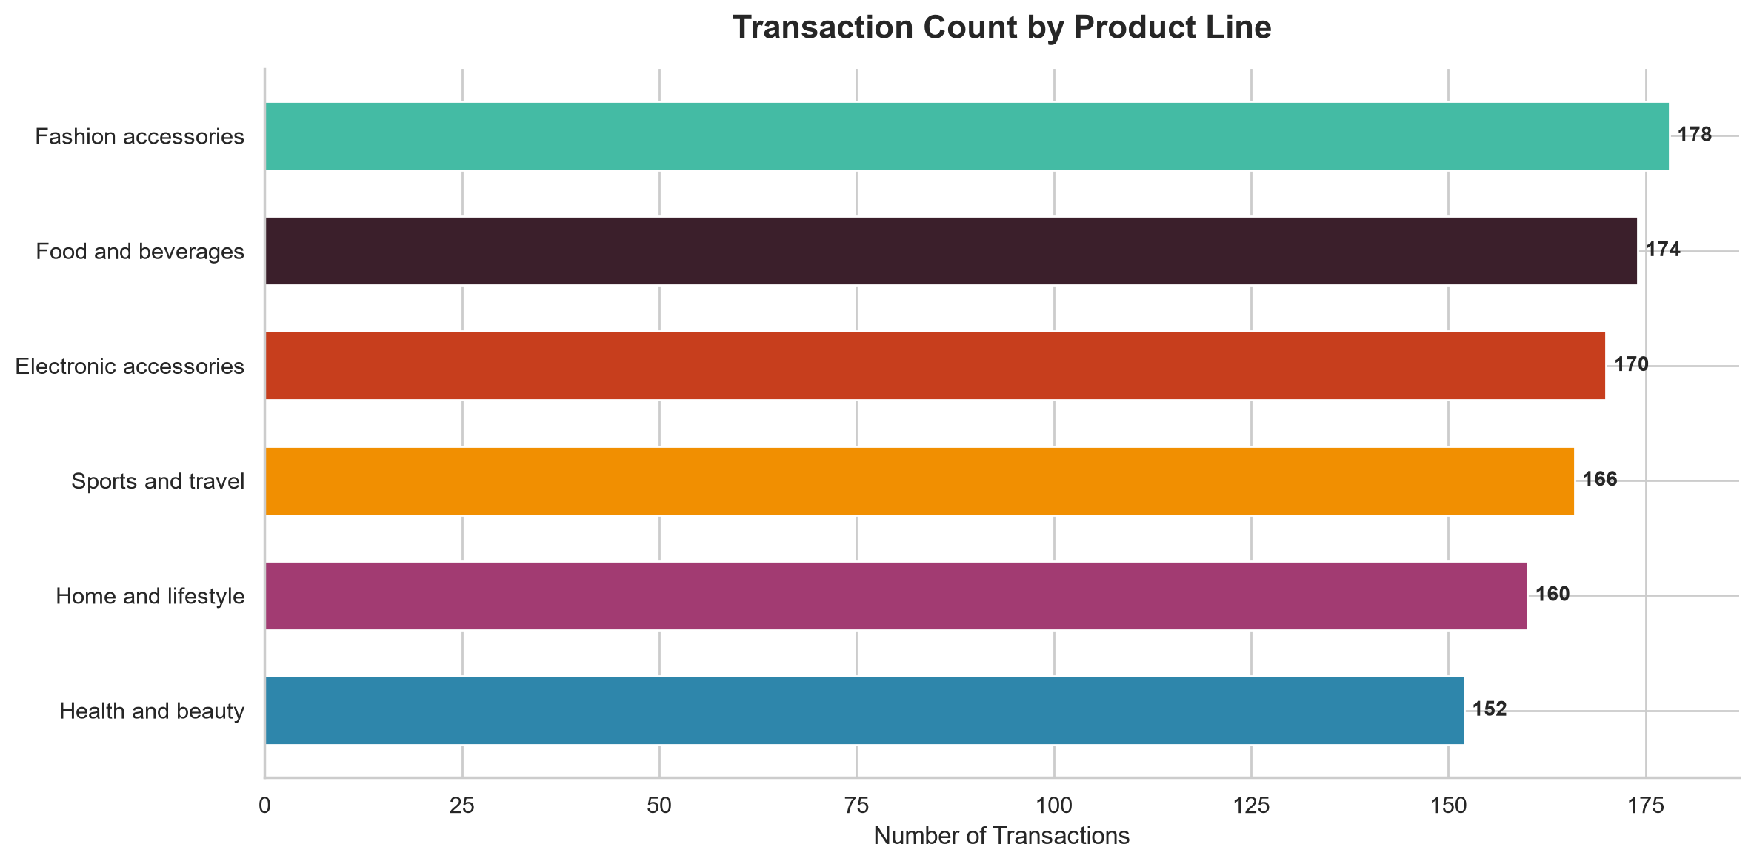
Figure: Transaction Count by Product Line

9.3 Branch Analysis
Table: Total Sales by Branch
Branch | Total_sum
C | 110,568.71
A | 106,200.37
B | 106,197.67

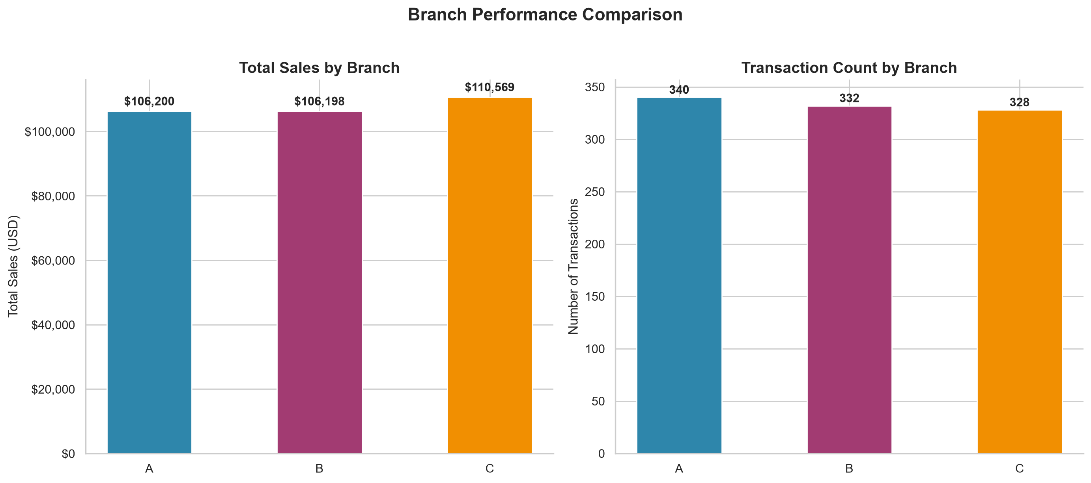
Figure: Branch Performance Comparison

9.4 Customer Analysis
Table: Sales by Customer Type
Customer type | Total_sum
Member | 164,223.44
Normal | 158,743.30

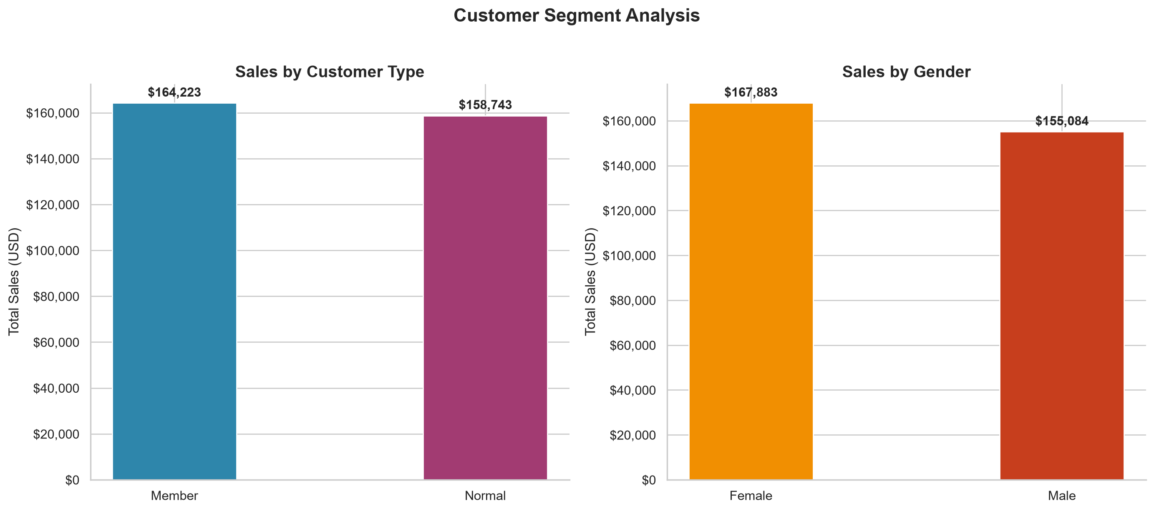
Figure: Customer Segment Analysis

9.5 Payment Method Analysis
Table: Sales by Payment Method
Payment | Total_sum
Cash | 112,206.57
Ewallet | 109,993.11
Credit card | 100,767.07

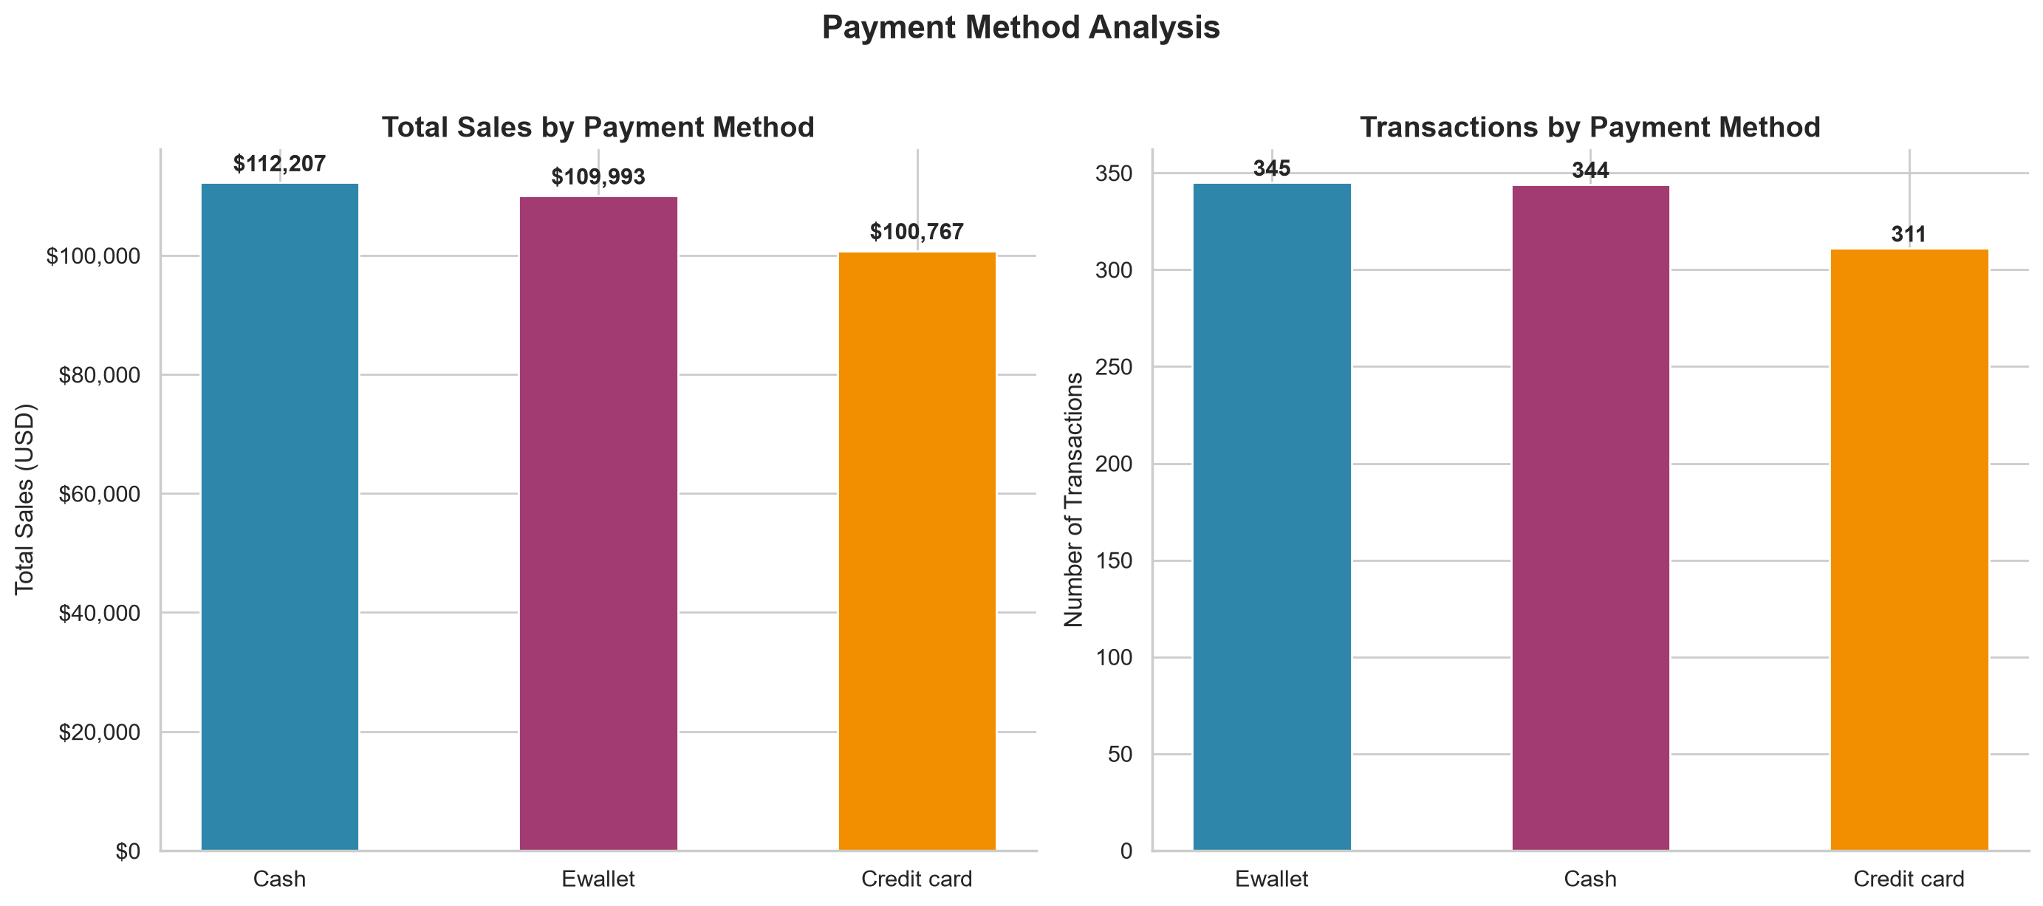
Figure: Payment Method Analysis

9.6 Temporal Analysis
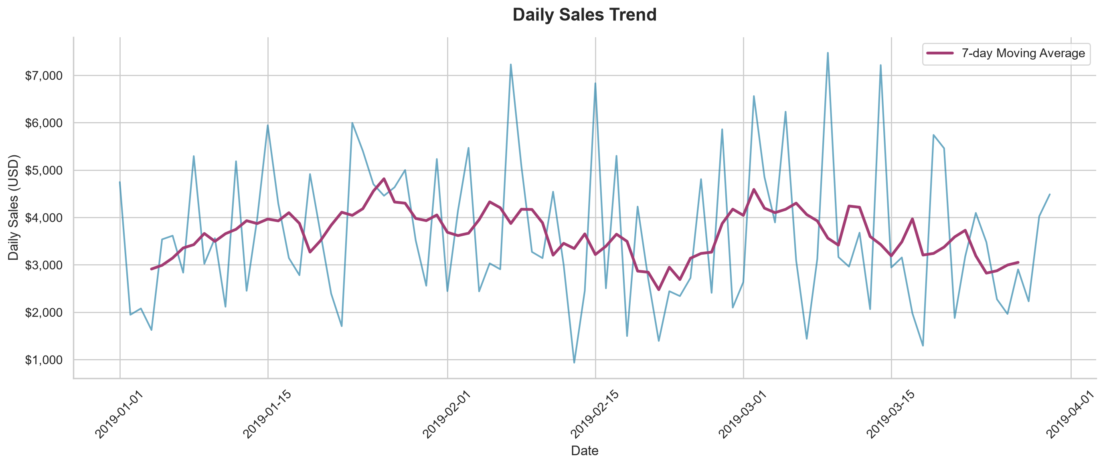
Figure: Daily Sales Trend
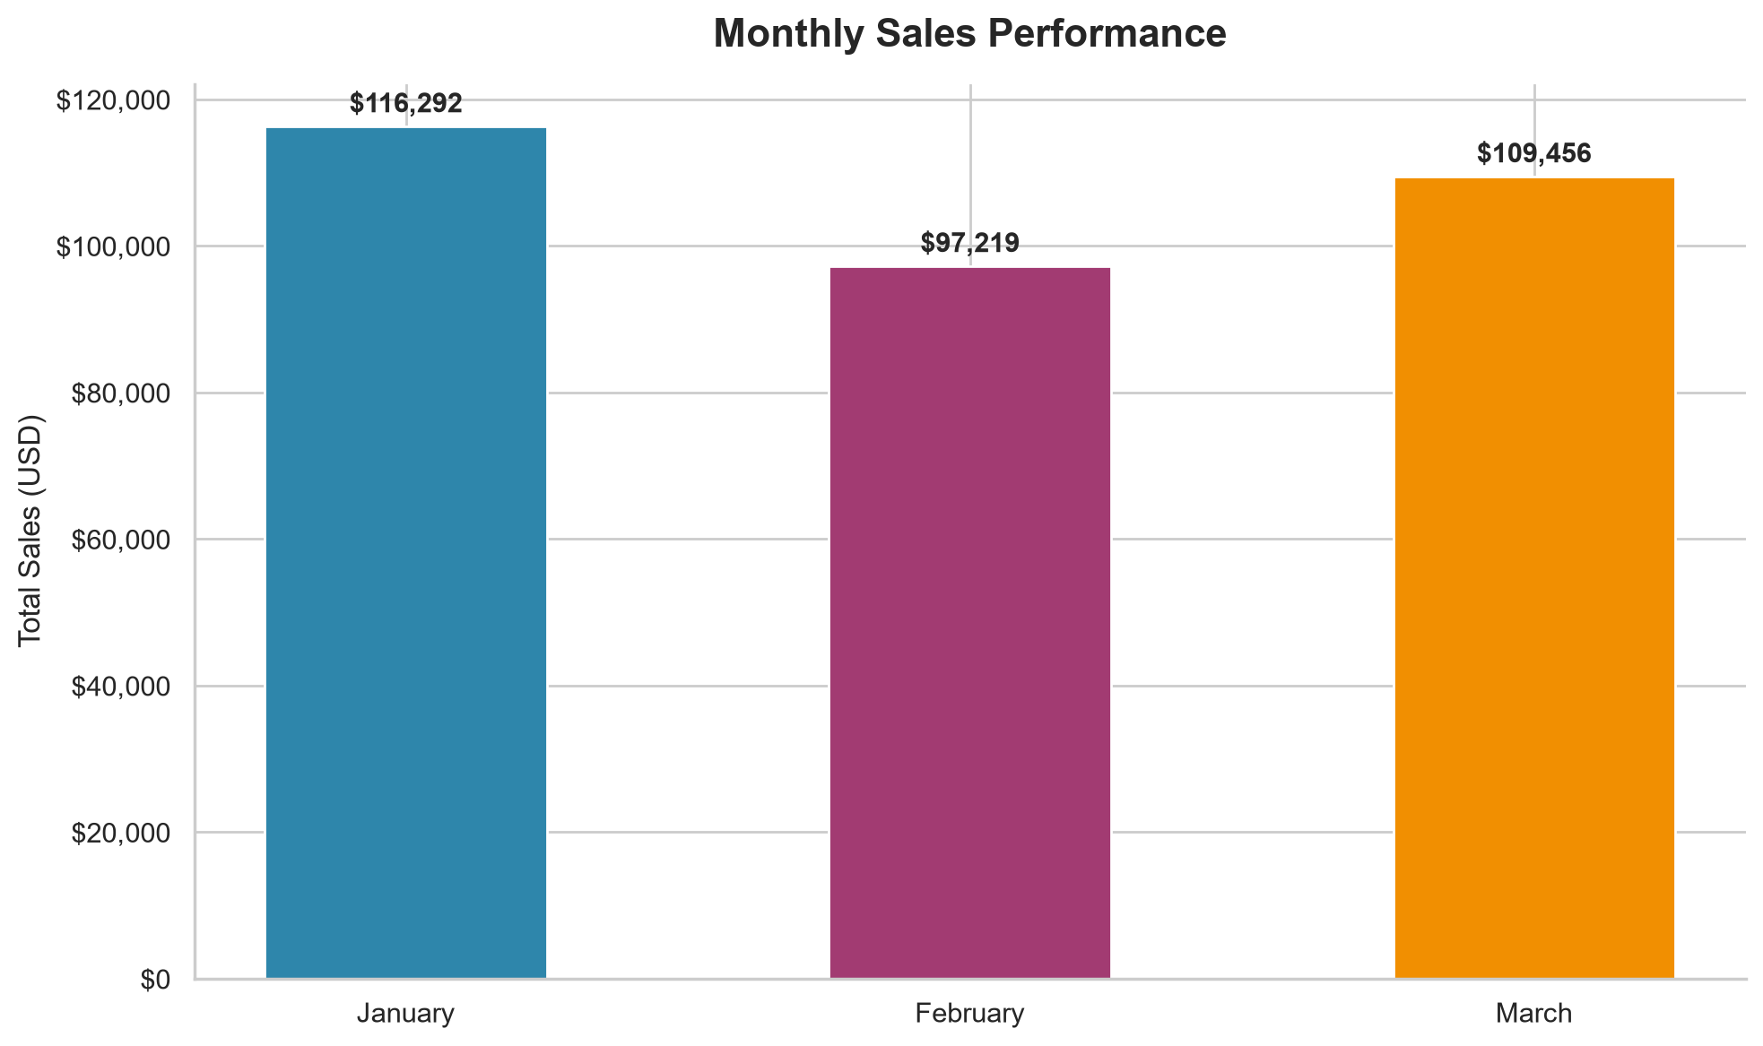
Figure: Monthly Sales Performance
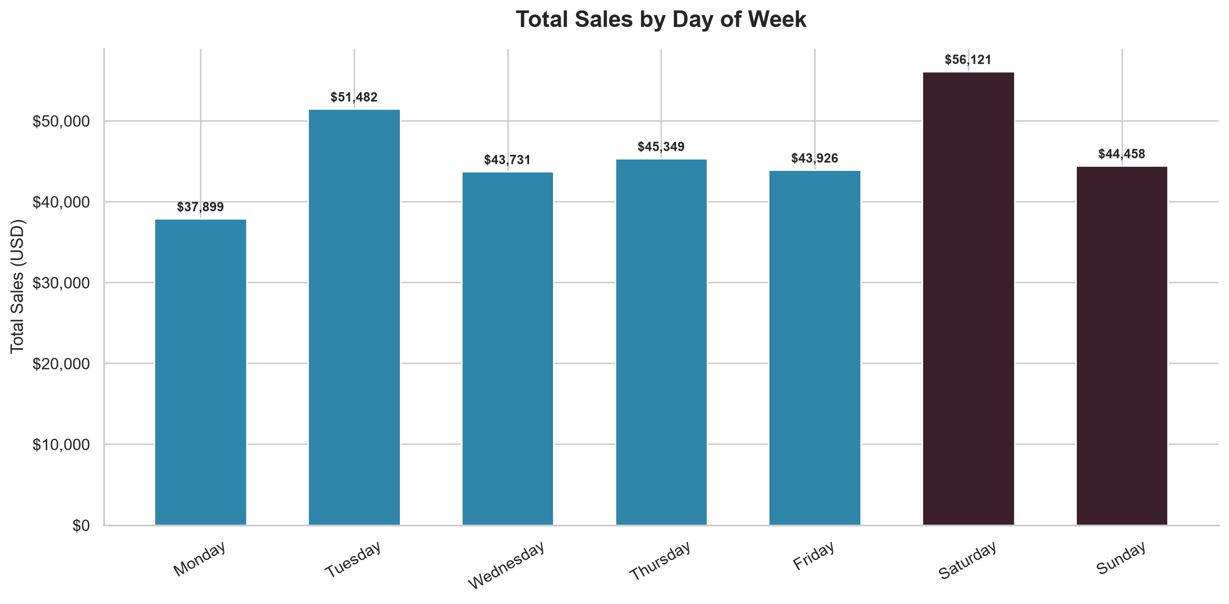
Figure: Sales by Day of Week
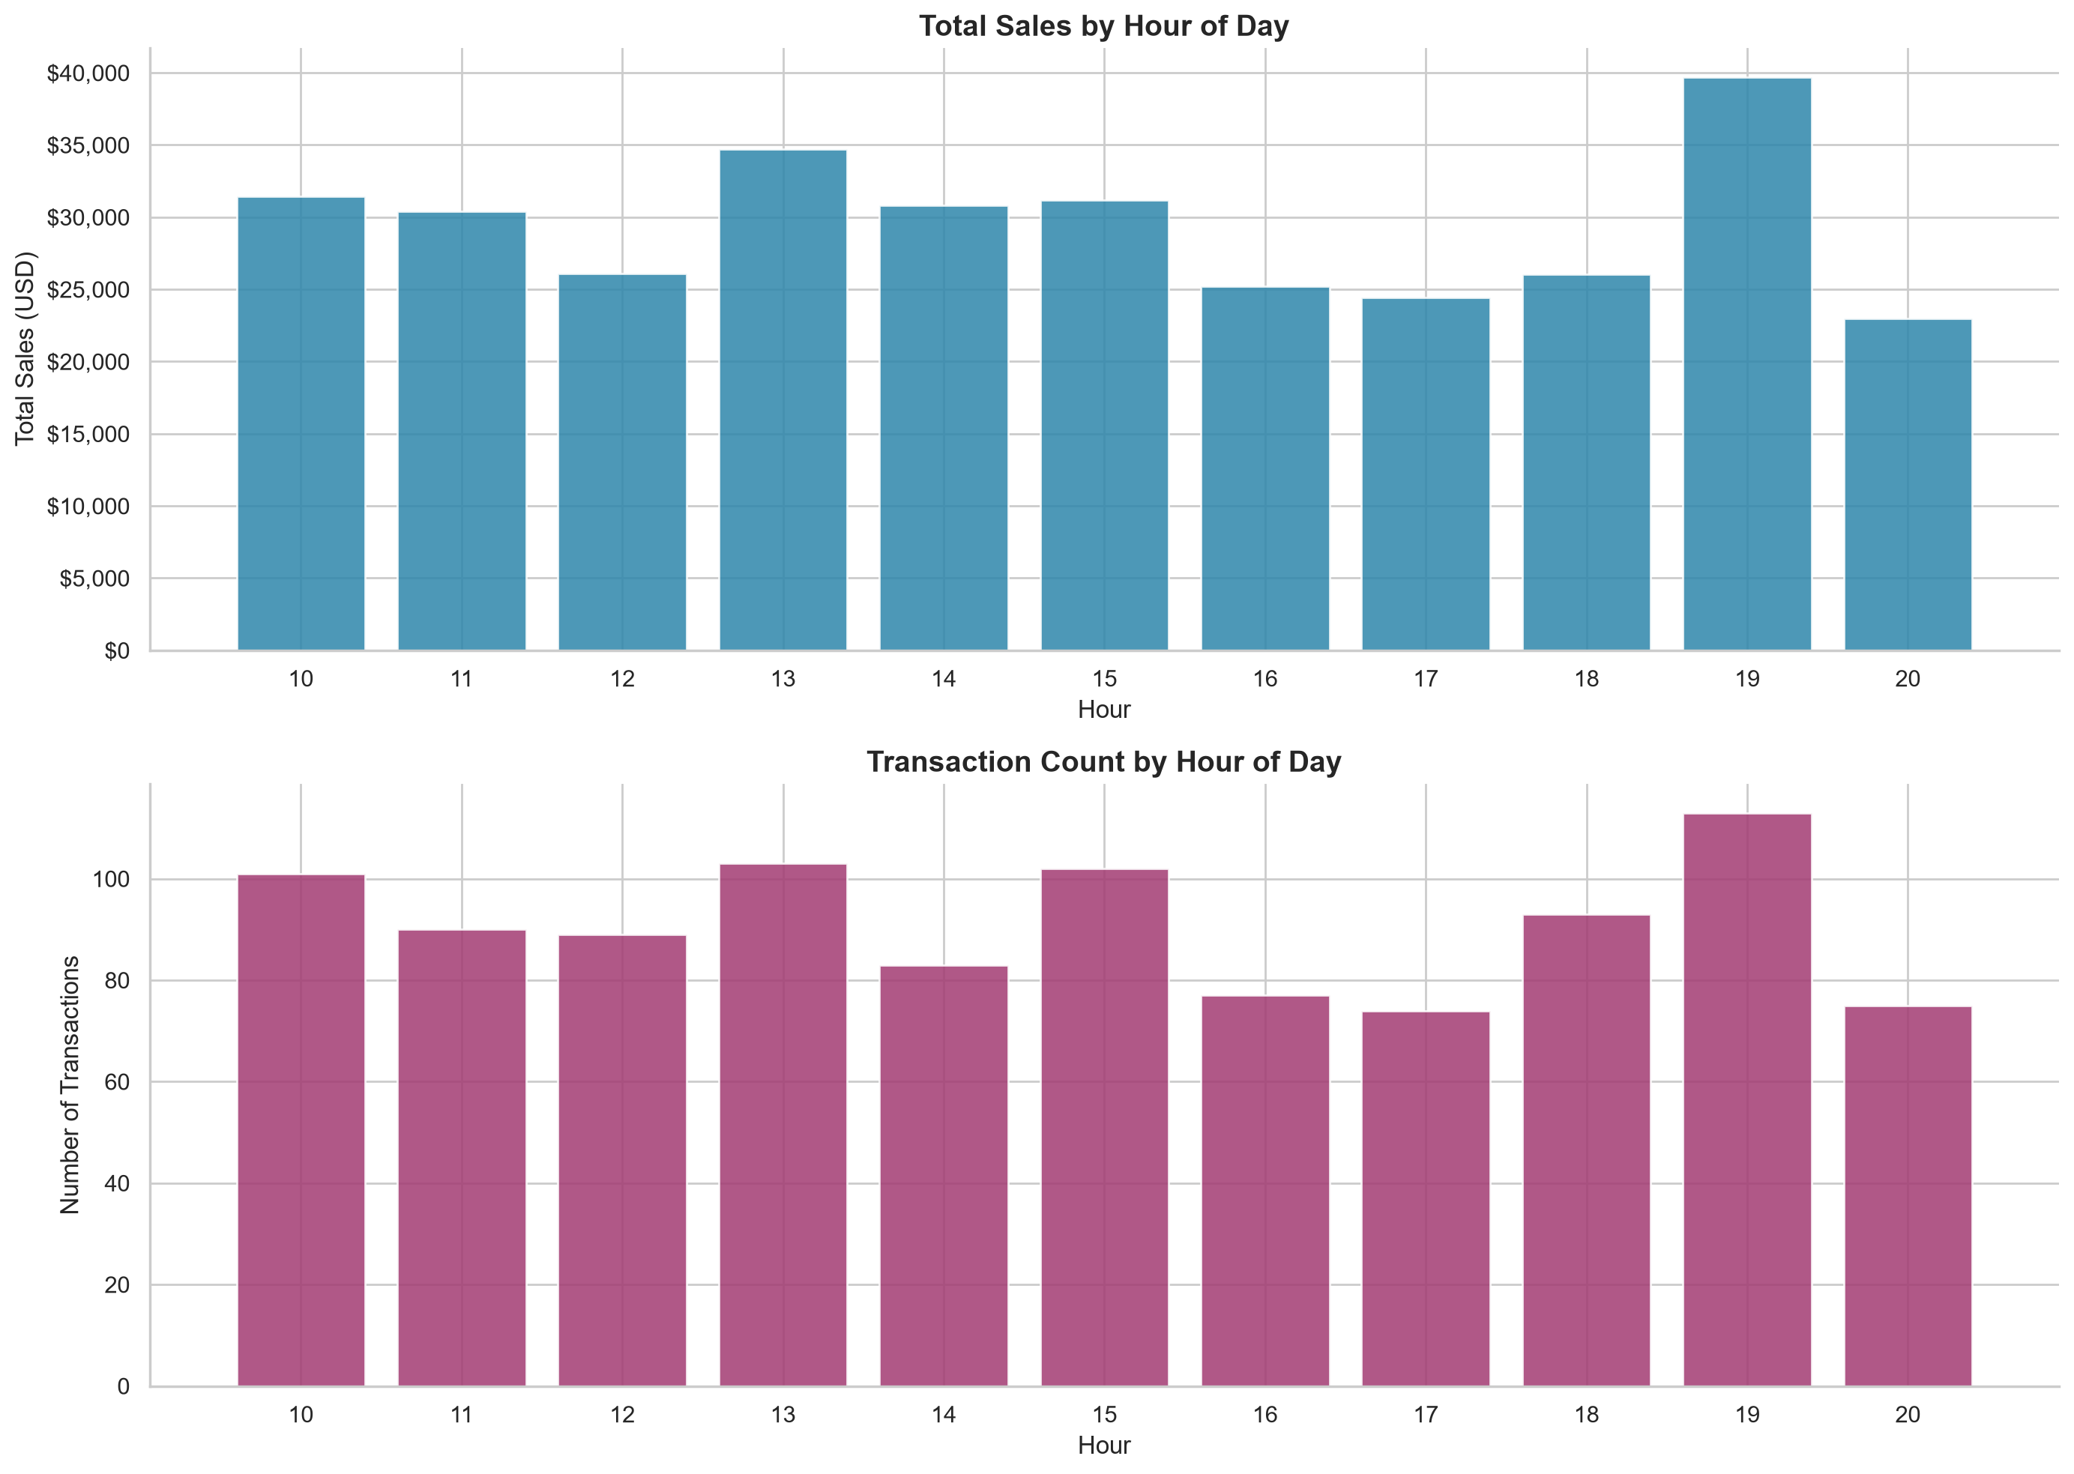
Figure: Hourly Sales Distribution

9.7 Customer Rating Analysis
Table: Rating Statistics
Statistic | Value
Mean | 6.97
Median | 7.00
Std Dev | 1.72
Min | 4.00
Max | 10.00

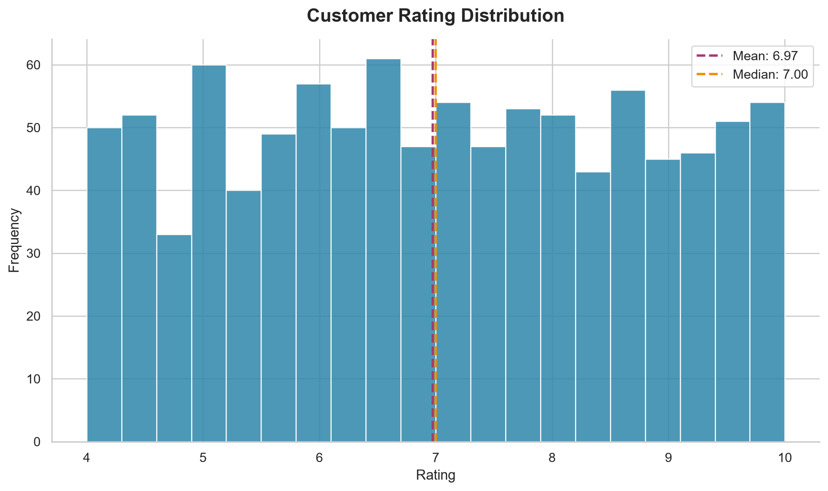
Figure: Customer Rating Distribution
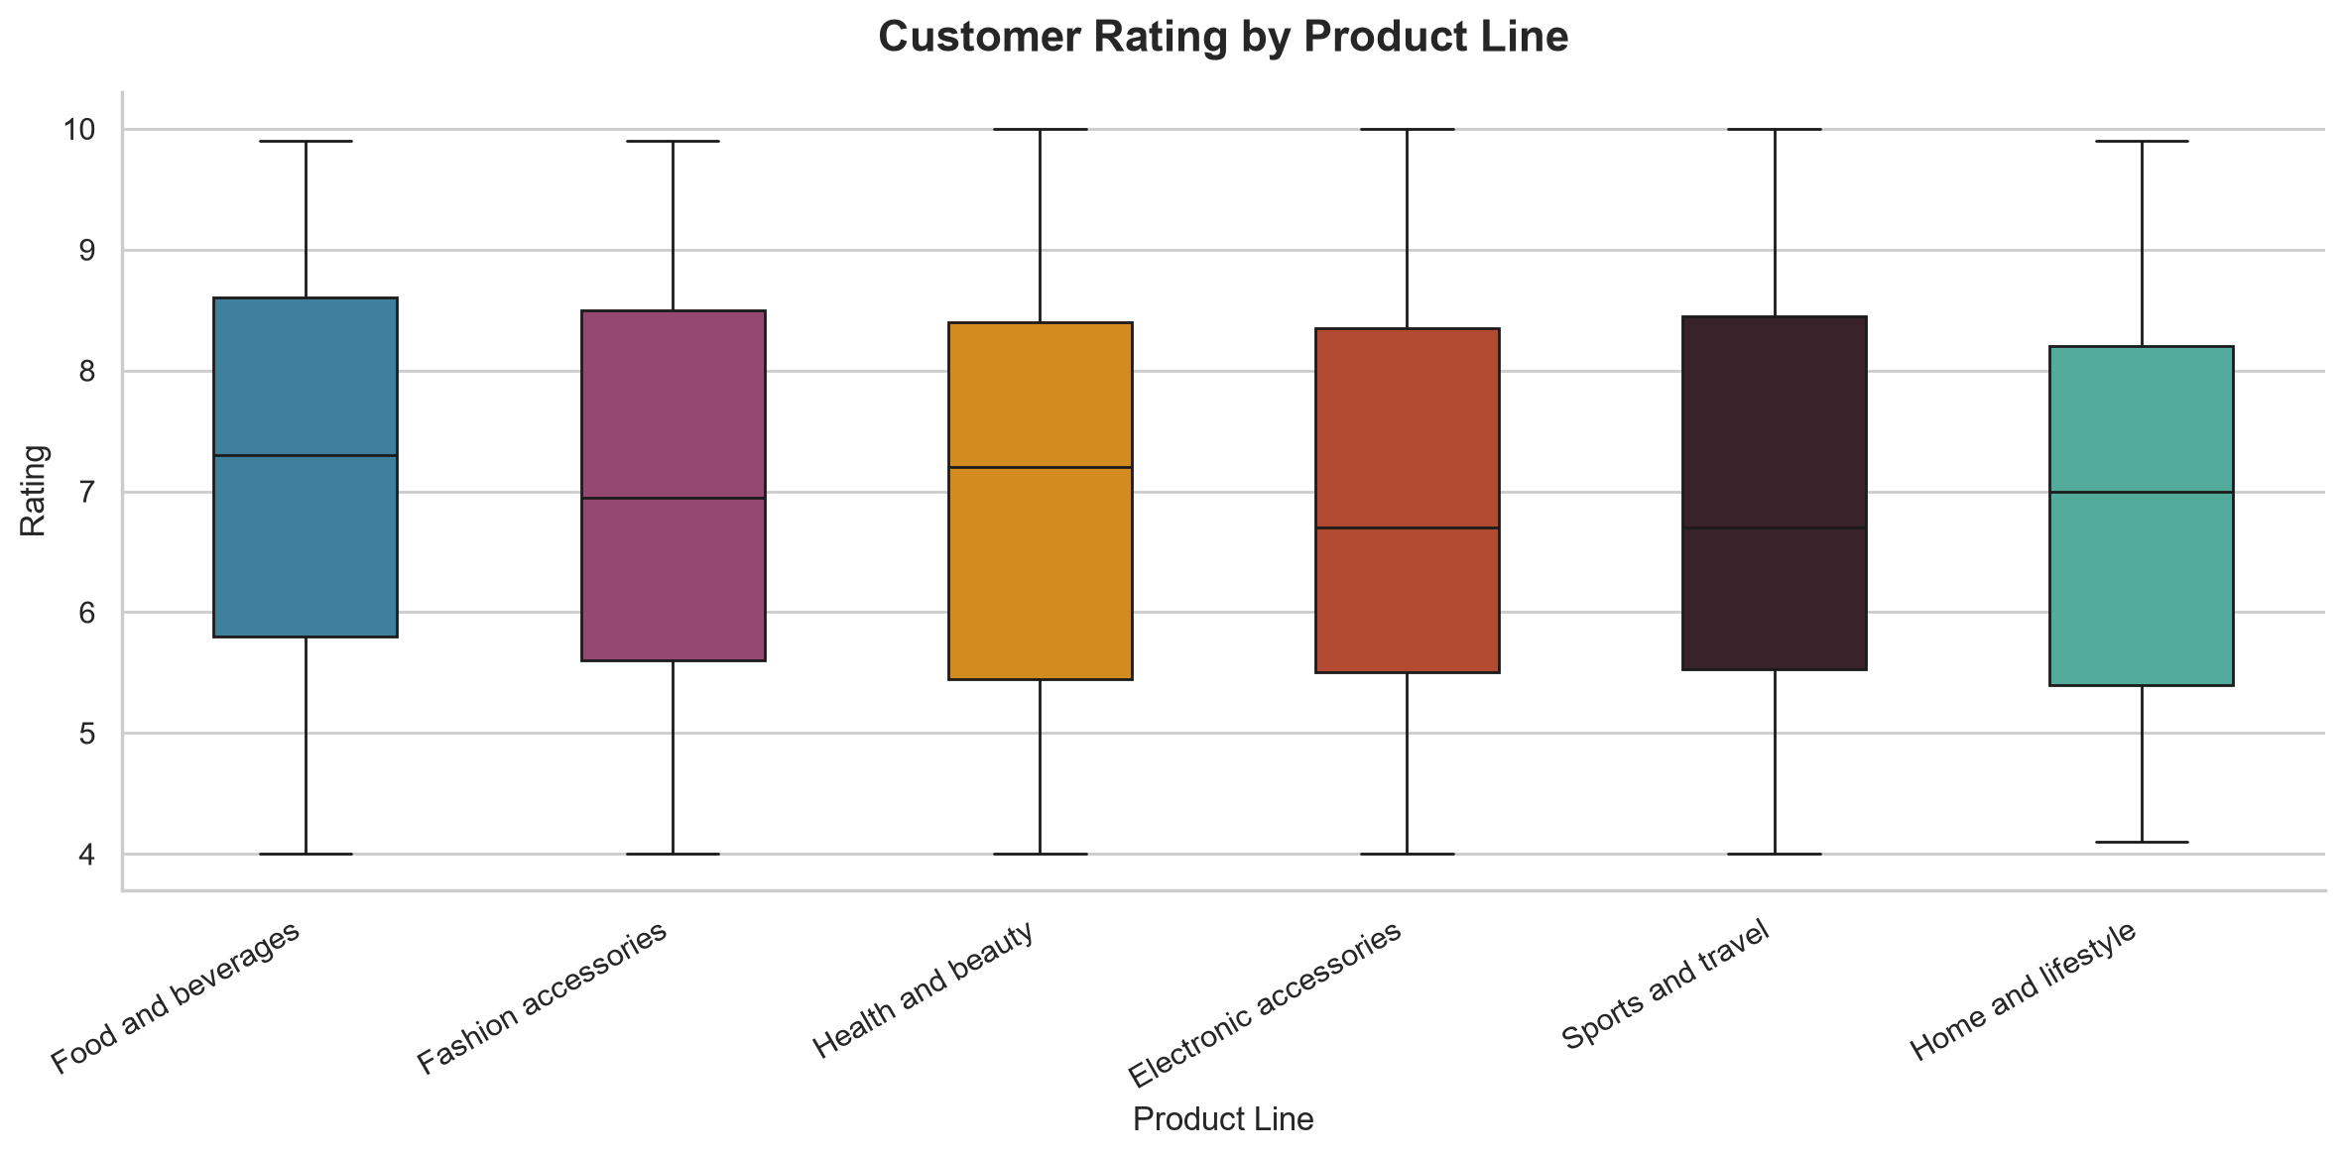
Figure: Rating by Product Line

9.8 Correlation Analysis
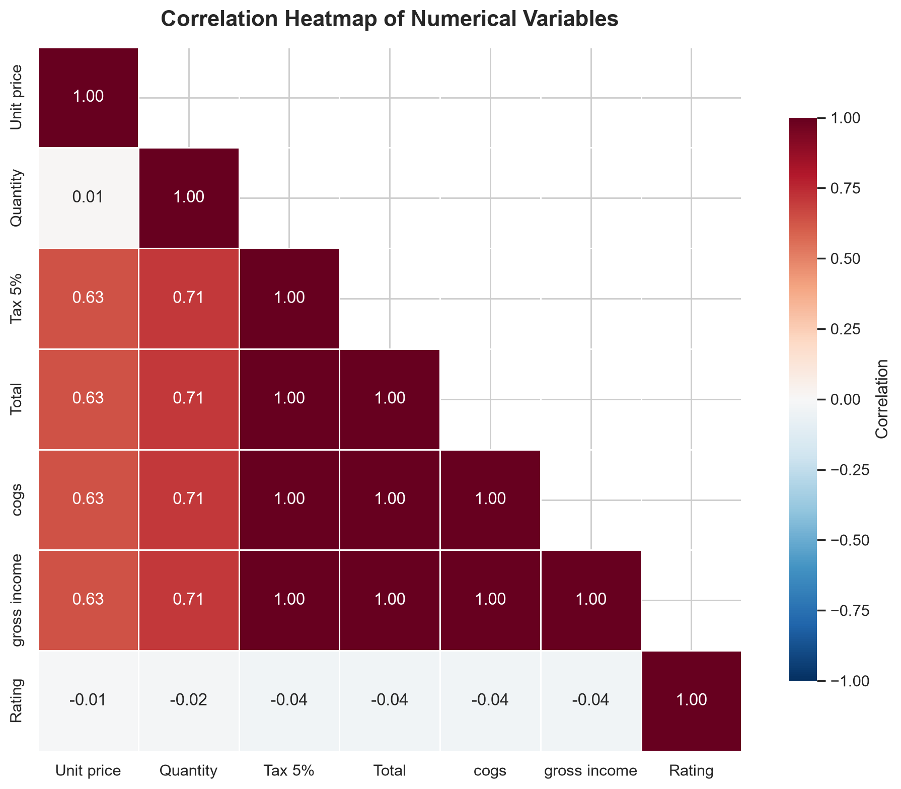
Figure: Correlation Heatmap
Note: High correlations between Total, cogs, Tax 5%, and gross income are expected because they are mathematically derived from each other (Total = cogs × 1.05). These correlations are trivial and do not represent independently discovered patterns.
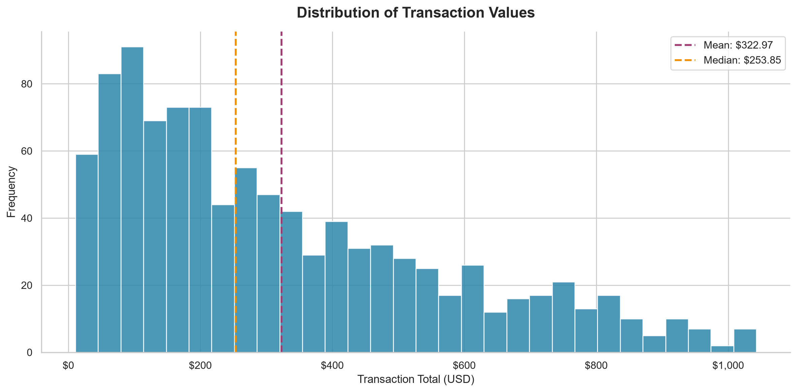
Figure: Distribution of Transaction Values

10. Machine Learning Model

10.1 Approach
A Random Forest Regressor was trained to predict transaction Total from product and transaction attributes. Features excluded: Tax 5%, cogs, gross income (to avoid target leakage, as these are mathematically derived from Total).

10.2 Important Caveat
Total = Unit price × Quantity × 1.05. Since Unit price and Quantity are included as features, the model is learning a near-deterministic relationship. This section demonstrates the ML pipeline methodology rather than genuine predictive modeling.
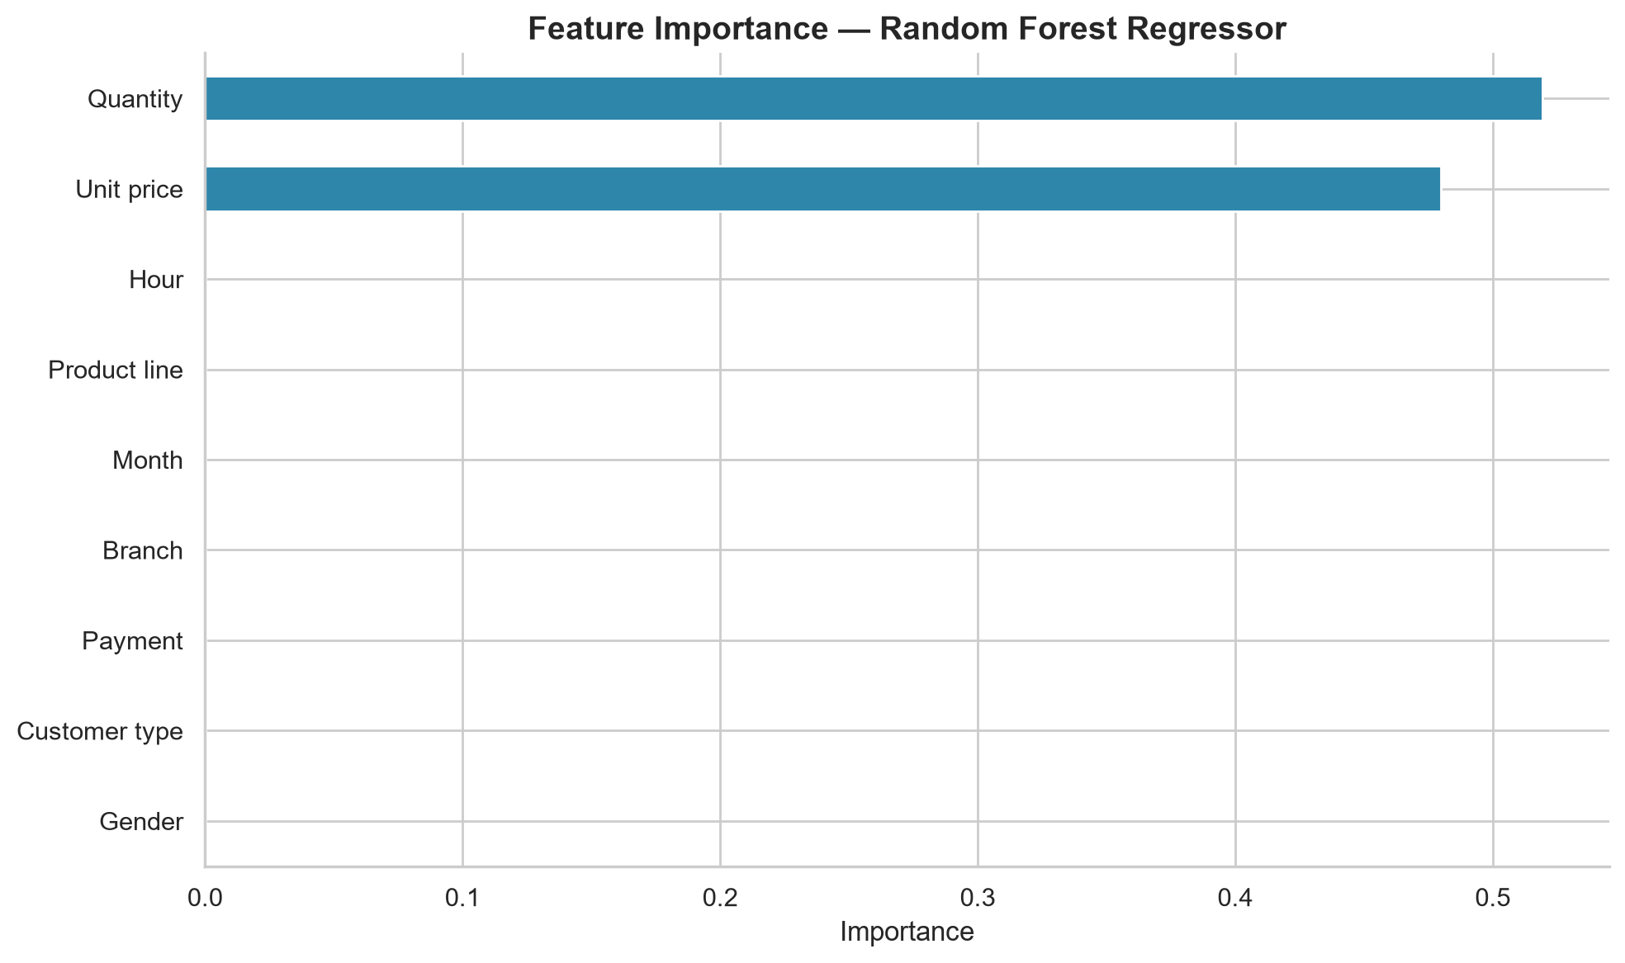
Figure: Feature Importance — Random Forest
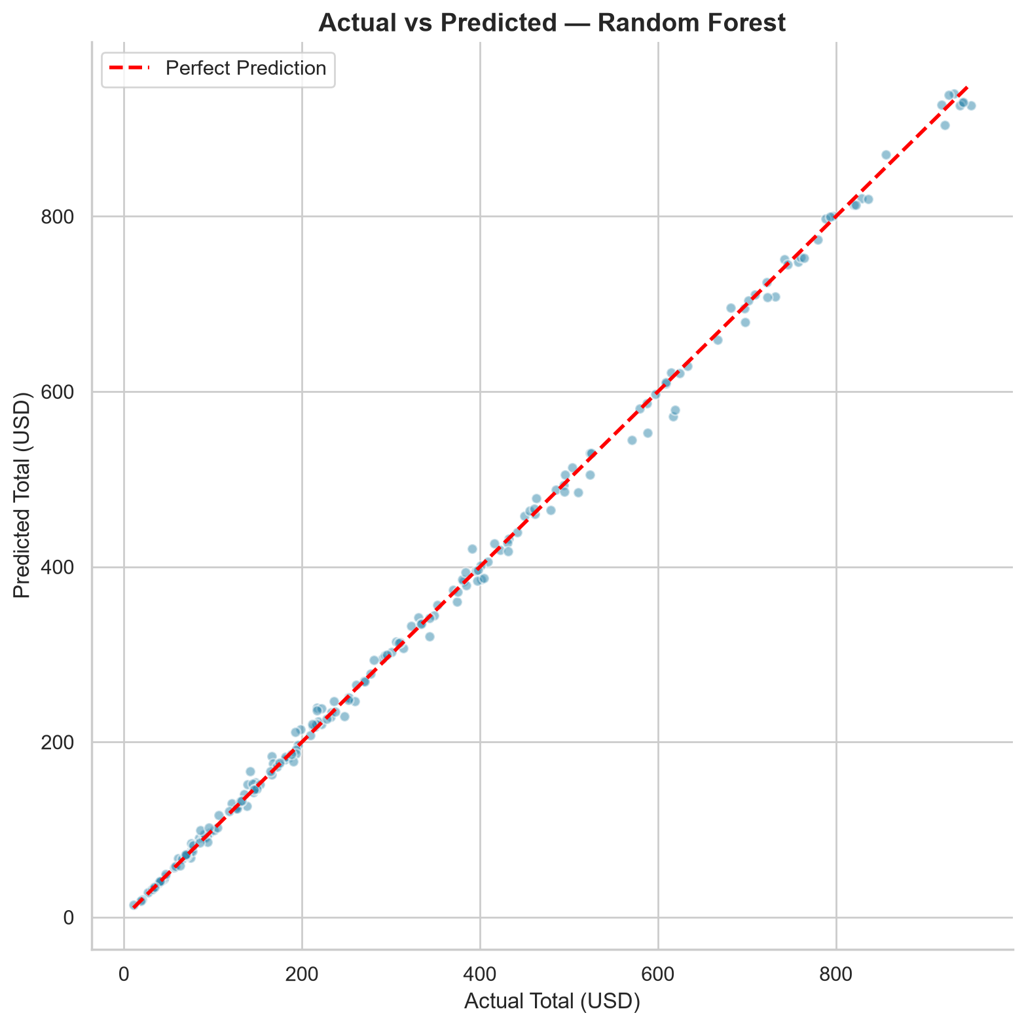
Figure: Actual vs Predicted Values

11. Results and Findings

Finding 1: Overall Performance
Observation: The dataset contains 1,000 transactions with total recorded sales of $322,966.75.
Key Metric: Average transaction value: $322.97, Median: $253.85
Recommendation: Use the average transaction value as a baseline for setting promotional thresholds (e.g., 'spend $X more to unlock a reward').
Limitation: The dataset covers a limited time window. Overall performance metrics may not represent long-term trends.

Finding 2: Product Performance
Observation: 'Food and beverages' is the top-selling product line with $56,144.84 in total sales, while 'Health and beauty' has the lowest sales at $49,193.74.
Key Metric: Top: $56,144.84 | Bottom: $49,193.74 | Difference: $6,951.10
Recommendation: Investigate why 'Health and beauty' underperforms. Consider targeted promotions or better shelf placement. Capitalize on 'Food and beverages' momentum with premium or bundled offerings.
Limitation: Sales differences could reflect product availability, pricing, or seasonal demand rather than intrinsic popularity.

Finding 3: Branch Performance
Observation: Branch C leads in total sales ($110,568.71), while Branch B has the lowest ($106,197.67).
Key Metric: Sales gap: $4,371.03
Recommendation: Examine the operational factors at Branch C that contribute to its success. Apply best practices to other branches. Conduct a localized assessment at Branch B for improvement.
Limitation: Branch differences may be influenced by location demographics, store size, and local competition.

Finding 4: Customer Segments
Observation: Member customers account for $164,223.44 in sales vs Normal customers at $158,743.30.
Key Metric: Member: $164,223.44 | Normal: $158,743.30
Recommendation: Strengthen the membership program by offering exclusive discounts or early access to promotions. Incentivize Normal customers to become Members.
Limitation: The 'Member' vs 'Normal' split is based on the dataset labels. Actual loyalty program details are unknown.

Finding 5: Payment Methods
Observation: 'Ewallet' is the most frequently used payment method with 345 transactions.
Key Metric: Top method: Ewallet (345 txns)
Recommendation: Ensure seamless checkout for all payment methods. Consider partnerships with e-wallet providers for loyalty promotions.
Limitation: Payment preferences may be influenced by demographics, promotions, or infrastructure availability.

Finding 6: Peak Hours
Observation: The peak sales hour is 19:00 with $39,699.51 in total sales.
Key Metric: Peak: 19:00 ($39,699.51)
Recommendation: Ensure adequate staffing during peak hour (19:00). Schedule restocking and promotional activities to align with high-traffic periods.
Limitation: Hourly patterns may vary by branch, day of week, and season.

Finding 7: Customer Satisfaction
Observation: The average customer rating is 6.97 out of 10. Ratings range from 4.0 to 10.0.
Key Metric: Mean: 6.97, Median: 7.00
Recommendation: Investigate factors behind lower ratings. Conduct customer feedback surveys and implement targeted improvements to boost satisfaction.
Limitation: Ratings may reflect immediate post-purchase sentiment and may not capture long-term satisfaction or repeat purchase intent.

12. Business Recommendations
- Optimize inventory for top-performing product lines while investigating underperforming categories for improvement opportunities.
- Implement branch-level best practices from the highest-performing branch across all locations.
- Strengthen the membership program with exclusive benefits to convert Normal customers to Members.
- Ensure seamless checkout across all payment methods; consider e-wallet promotions to drive digital adoption.
- Align staffing levels with peak sales hours to maximize service quality during high-traffic periods.
- Conduct targeted customer satisfaction surveys to understand drivers of lower ratings and implement improvements.
- Expand data collection to enable longitudinal analysis and customer lifetime value tracking.

13. Limitations
- Limited 3-month time window prevents seasonal and long-term trend analysis.
- All branches are in Myanmar, limiting geographic generalizability.
- No customer-level tracking for repeat purchase or lifetime value analysis.
- Constant gross margin percentage limits profitability analysis depth.
- Self-reported ratings may not reflect long-term customer satisfaction.
- ML model learns a deterministic formula, not genuine prediction.
- Observed correlations do not establish causal relationships.

14. Conclusion
This project successfully analyzed 1,000 supermarket sales transactions totaling $322,966.75 across three branches. The comprehensive exploratory data analysis revealed meaningful patterns in product performance, branch operations, customer behavior, and temporal trends. Professional visualizations effectively communicated key findings, and a machine learning pipeline was demonstrated with appropriate caveats. The evidence-based insights and recommendations provide actionable guidance for supermarket management to optimize revenue, improve customer experience, and make data-driven decisions.

15. References
[1] Aung Pyae, "Supermarket Sales" dataset, Kaggle (2019). https://www.kaggle.com/datasets/aungpyaeap/supermarket-sales
[2] McKinney, W. "pandas: a foundational Python library for data analysis and statistics." Python for High Performance and Scientific Computing (2011).
[3] Pedregosa, F., et al. "Scikit-learn: Machine Learning in Python." JMLR 12 (2011): 2825-2830.
[4] Hunter, J.D. "Matplotlib: A 2D Graphics Environment." Computing in Science & Engineering (2007).
[5] Waskom, M. "seaborn: statistical data visualization." Journal of Open Source Software (2021).

