**Warewulf Assigment**

**Name : Ankur jadhav**

**PRN : 240340127039**

Requirements :

Master host machine:

With centos 7 and two network interfaces one in NAT for internet connection and another one Host Only where ware Wulf services would run.

Client node Machine : no os , 8 gb ram , 60 gb hardisk, 1 interface hostonly

Steps to do :

1 : **disable selinux and firewalld**.

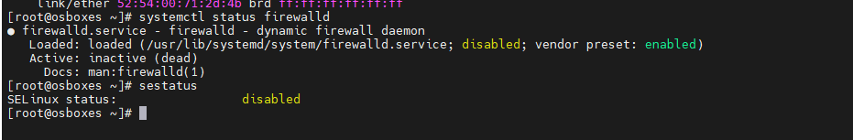

2 **: add an static ip address to hostonly interface using nmtui, ipconfig or ip**

Eg : ip address add <ip address>/subnet dev <hostonly interface name> * ip is added temporary

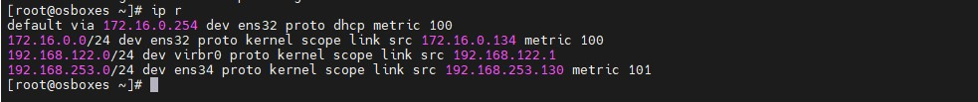

3 : **make host entry in /etc/hosts**

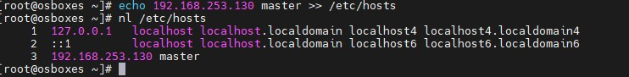

4 : **enable openhpc repository for local use**

yum install <http://build.openhpc.community/OpenHPC:/1.3/CentOS_7/x86_64/ohpc-release-1.3-1.el7.x86_64.rpm>

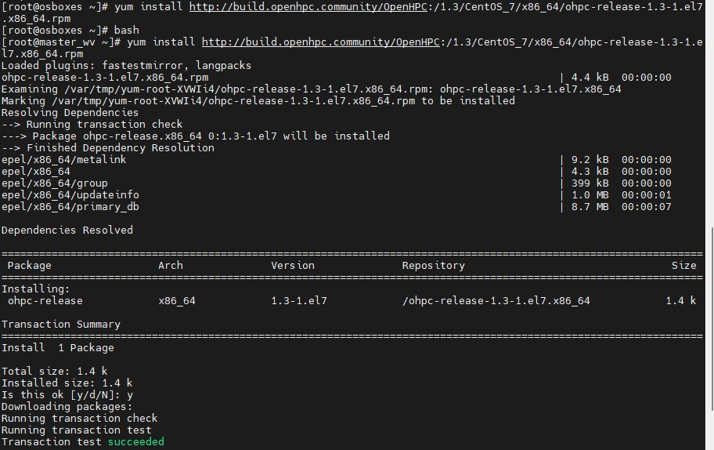

5: **install base meta packages**

yum -y install ohpc-base

yum -y install ohpc-warewulf

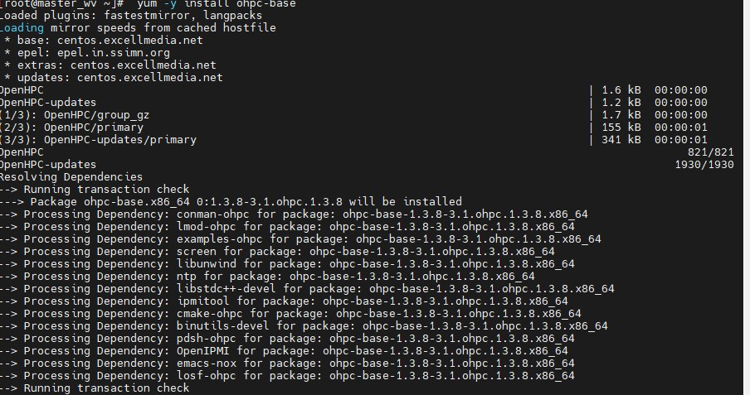

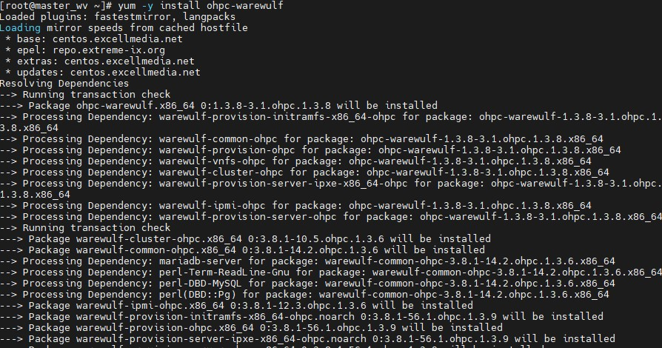

6 : **configure warewulf :**

perl -pi -e "s/device = eth1/device = <hostonly interface name>/" /etc/warewulf/provision.conf

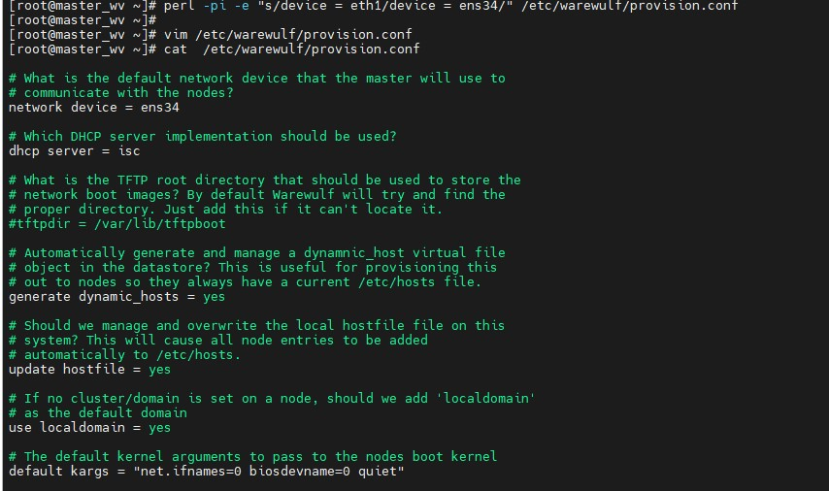

7: **enable tftp services, enable einternal interface and restart and enable services**

perl -pi -e "s/device = eth1/device = <hostonly interface name>/" /etc/warewulf/provision.conf

perl -pi -e "s/^\s+disable\s+= yes/ disable = no/" /etc/xinetd.d/tftp

ifconfig <hostonly interface name> <hostonly ip > netmask <hostonly subnet> up

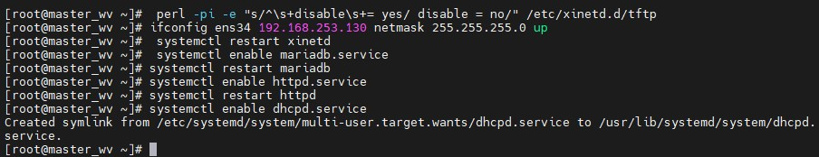

8: **defining chroot location and build initial chroot image**

export CHROOT=/opt/ohpc/admin/images/centos7.7

wwmkchroot centos-7 $CHROOT

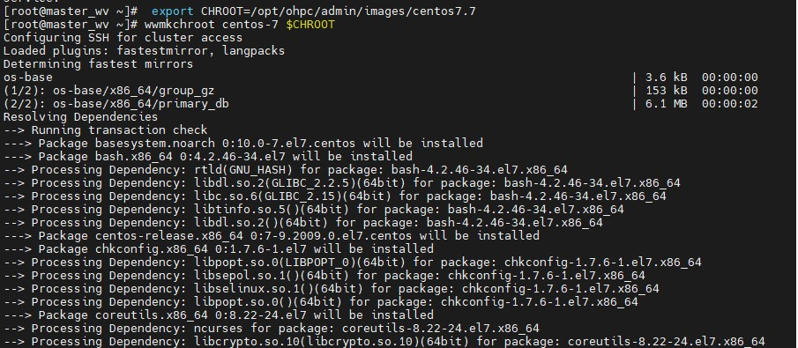

9: **Install compute node base meta-package**

yum -y --installroot=$CHROOT install ohpc-base-compute

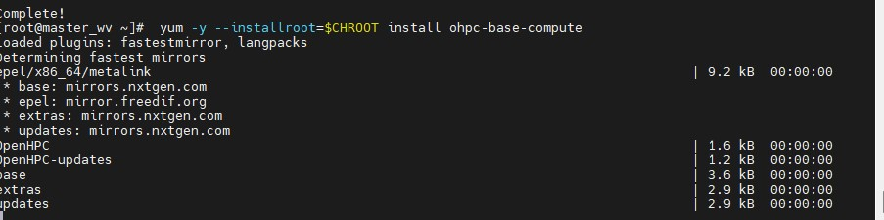

10 : **copy resolv file to chroot image path**

cp -p /etc/resolv.conf $CHROOT/etc/resolv.conf

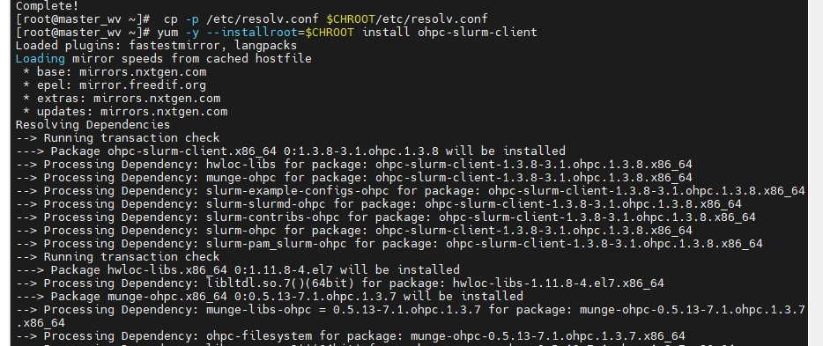

12: **install kernel package in iso**

yum -y --installroot=$CHROOT install kernel

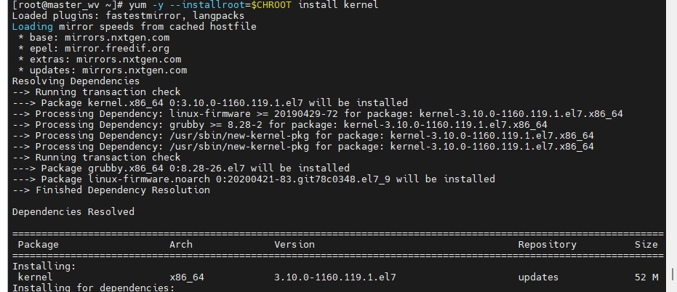

13 : **install modules user environment**

yum -y --installroot=$CHROOT install lmod-ohpc

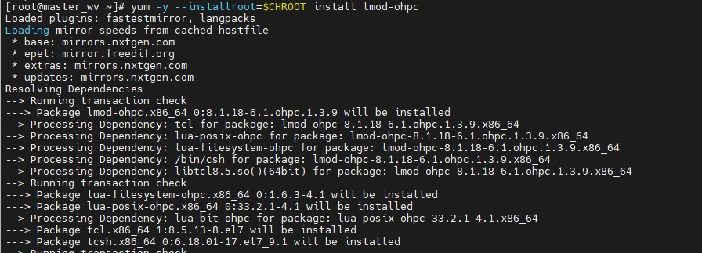

14 : Init**ialize warewulf database and ssh_keys**

wwinit database

wwinit ssh_keys

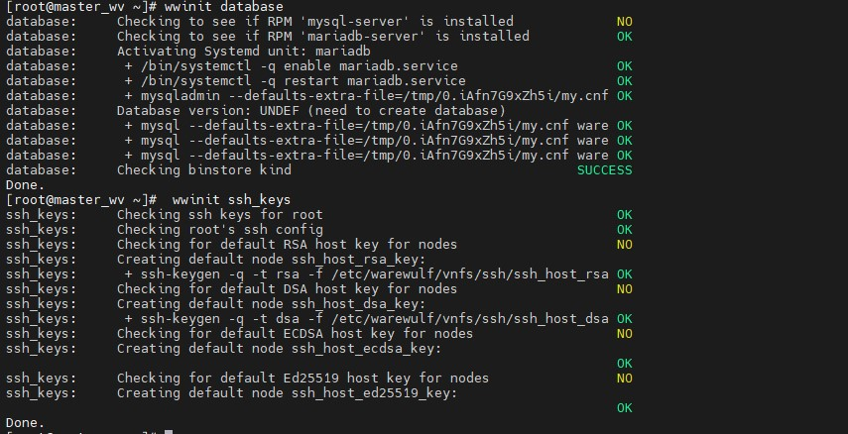

15 : **Import files**

wwsh file import /etc/passwd

wwsh file import /etc/group

wwsh file import /etc/shadow

**# (Optional) Include drivers from kernel updates; needed if enabling additional kernel modules on computes**

[sms]# export WW_CONF=/etc/warewulf/bootstrap.conf

[sms]# echo "drivers += updates/kernel/" >> $WW_CONF

**# (Optional) Include overlayfs drivers; needed by Singularity**

[sms]# echo "drivers += overlay" >> $WW_CONF

**# Build bootstrap image**

[sms]# wwbootstrap `uname -r`

**Ansible virtual node file system:**

wwvnfs --chroot $CHROOT

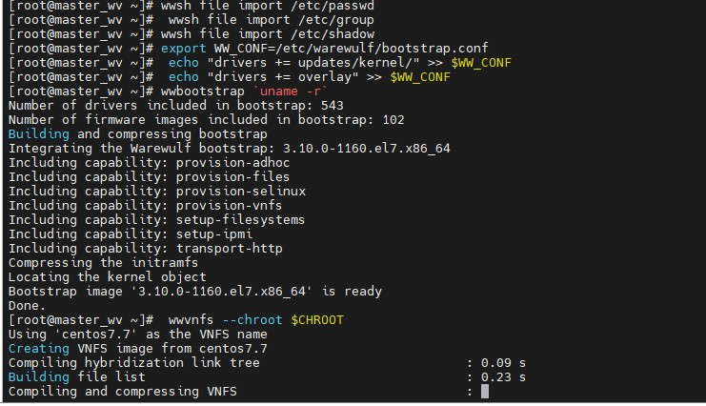

16:

**# Set provisioning interface as the default networking device**

[sms]# echo "GATEWAYDEV=${eth_provision}" > /tmp/network.$$

[sms]# wwsh -y file import /tmp/network.$$ --name network

[sms]# wwsh -y file set network --path /etc/sysconfig/network --mode=0644 --uid=0

**# Add nodes to Warewulf data store**

wwsh -y node new <node name> --ipaddr=<ip for client> --hwaddr=<client > -D <enterface name>

**# Define provisioning image for hosts**

wwsh -y provision set <node naem> --vnfs=centos7.7 --bootstrap=`uname -r` --files=dynamic_hosts,passwd,group,shadow,network

**# Restart dhcp / update PXE**

[sms]# systemctl restart dhcpd

[sms]# wwsh pxe update

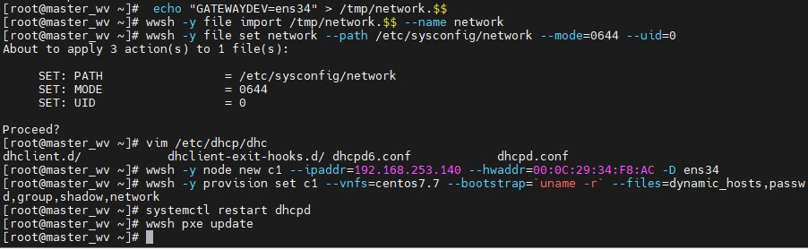

17 **: restart client vm device make sure client vm has minimum of 8 gb ram and 60 gb hardisk and an interface configured in hostonly network same as host master vm .**

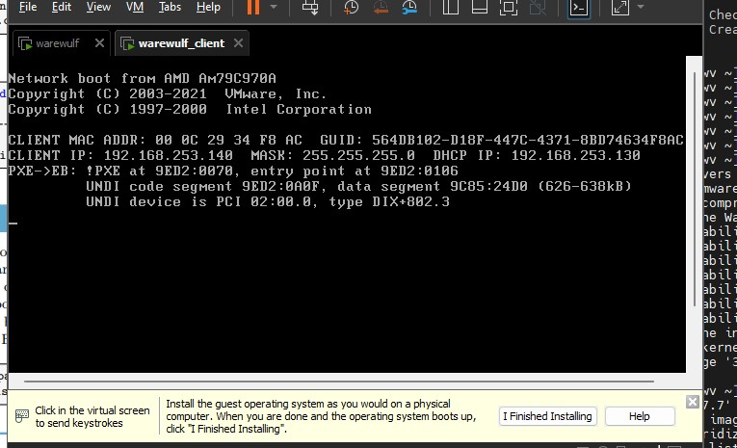

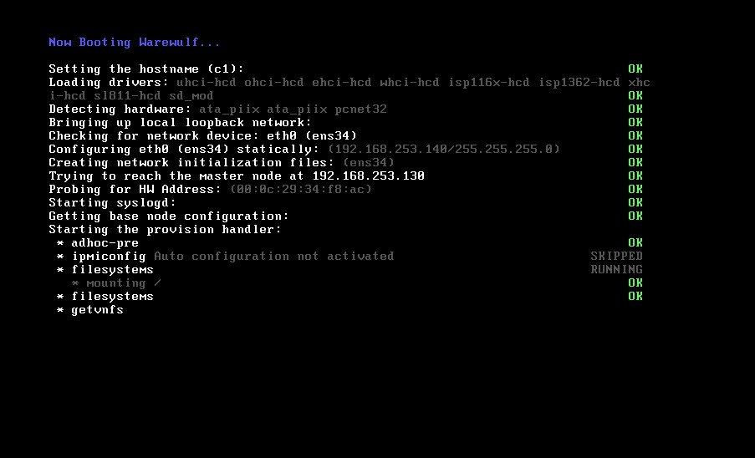

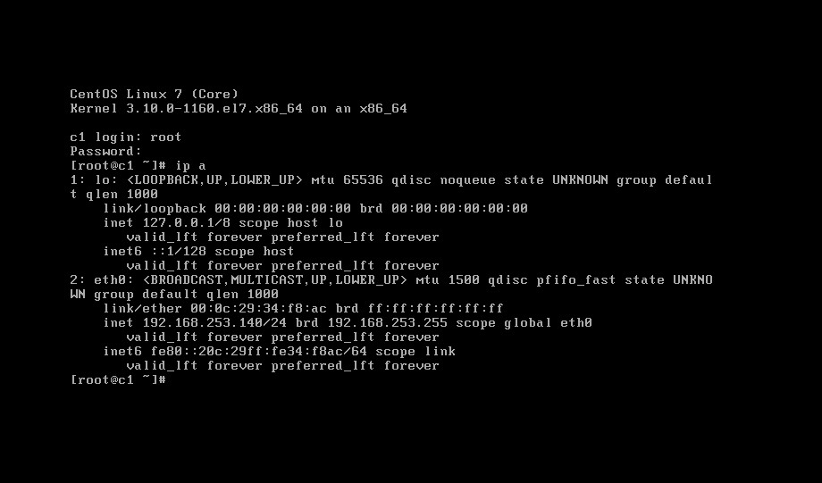

18 : **try doing ssh login to the client vm from host master**

