HPCSAM

ASSIGNMENT:nagios

NAME: ankur jadhav

PRN: 240340127039

**Add Nagios monitoring**

**1:** Install Nagios meta-package on master host

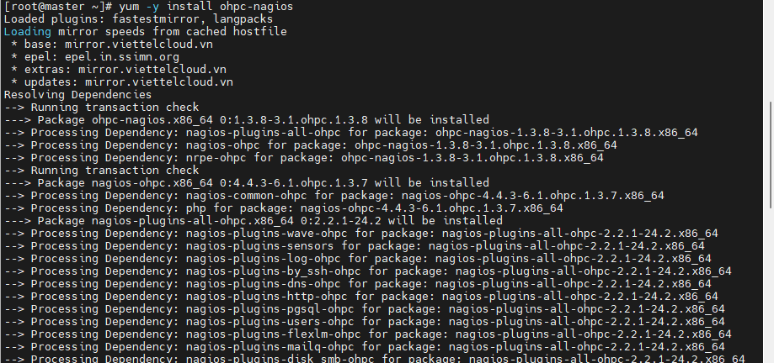

2: Install plugins on compute nodes

psh compute yum -y install nagios-plugins-all-ohpc nrpe-ohpc

3:Enable and configure NRPE on compute nodes

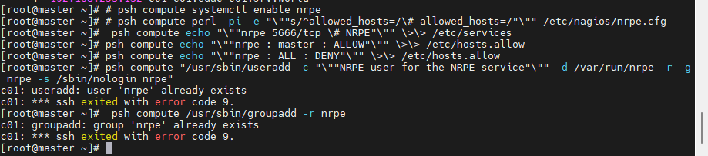

4:Configure remote services to test on compute nodes

Define compute nodes as hosts to monitor

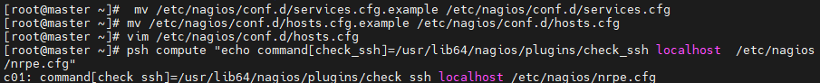

5: vim /etc/nagios/conf.d/hosts.cfg

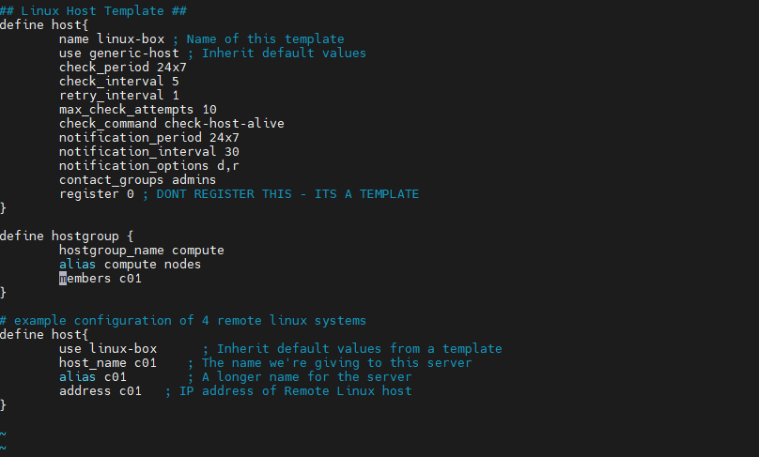

6: # Enable Nagios on master, and configure

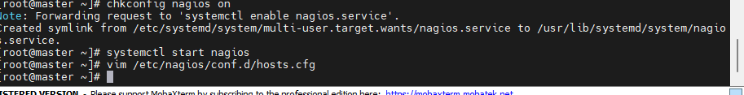

7: open nagio web portal

