HPCSAM

ASSIGNMENT: slurm

NAME: ankur jadhav

PRN: 240340127039

Add resource management services on master node

1: Install slurm server meta-package

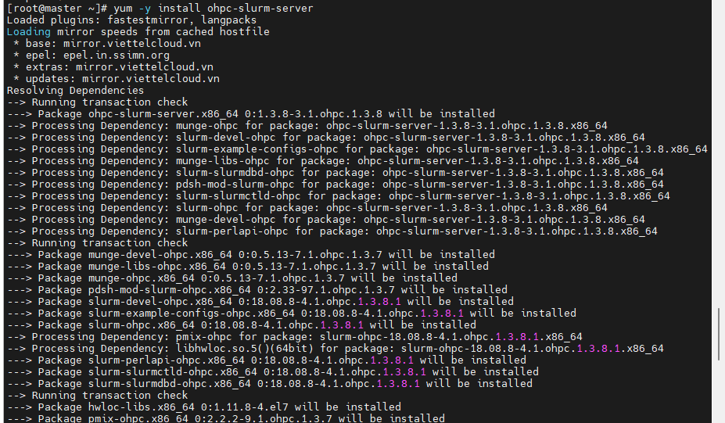

2:Add Slurm client support meta-package

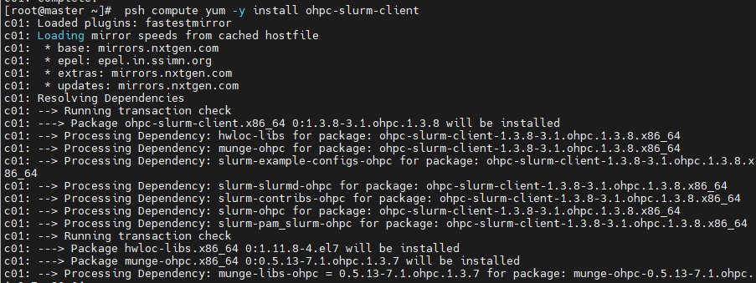

3:Enable ssh control via resource manager

Register as SLURM's health check program

Resource Manager Startup

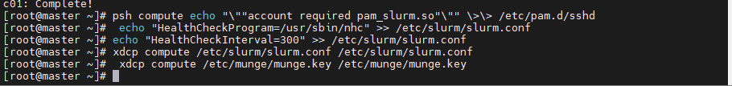

4:Start munge and slurm controller on master host

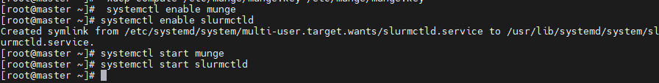

5# Start slurm clients on compute hosts

psh compute systemctl start munge

psh compute systemctl start slurmd

6: check slurm

