HPCSAM

ASSIGNMENT: XCAT

NAME: ankur jadhav

PRN: 240340127039

1: PRESETUP DISABLE selinux and firewalld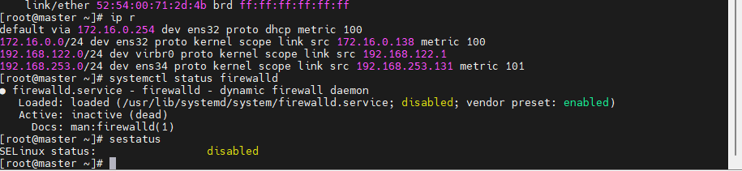

2: install utils repos

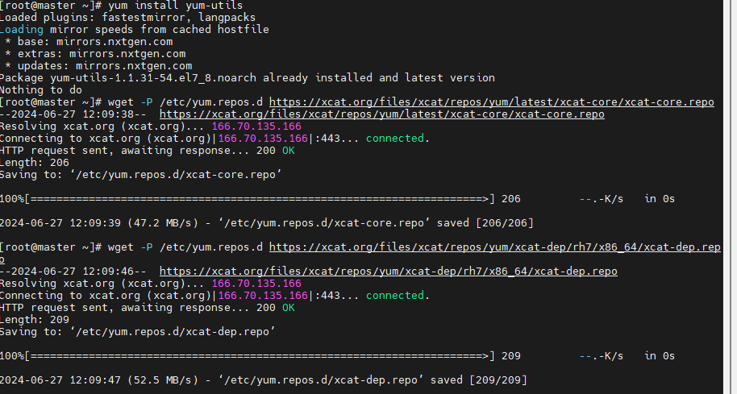

3: Complete basic xCAT setup for master node

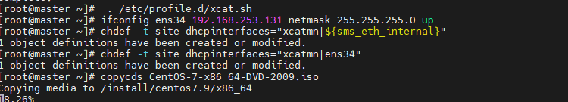

4:

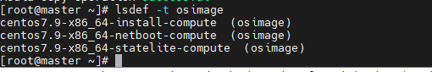

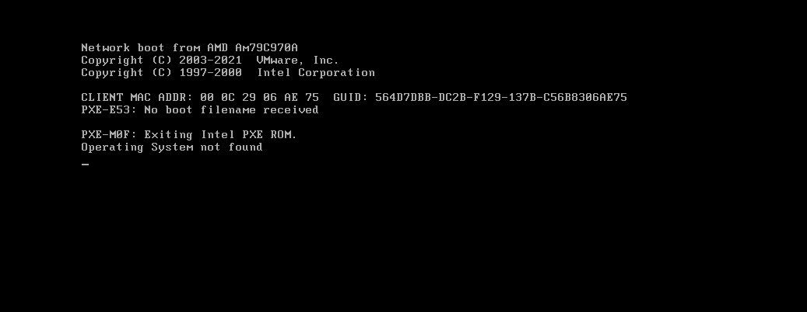

5:Add compute nodes into xCAT database

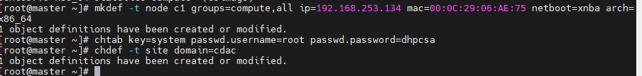

6:Complete network service configurations

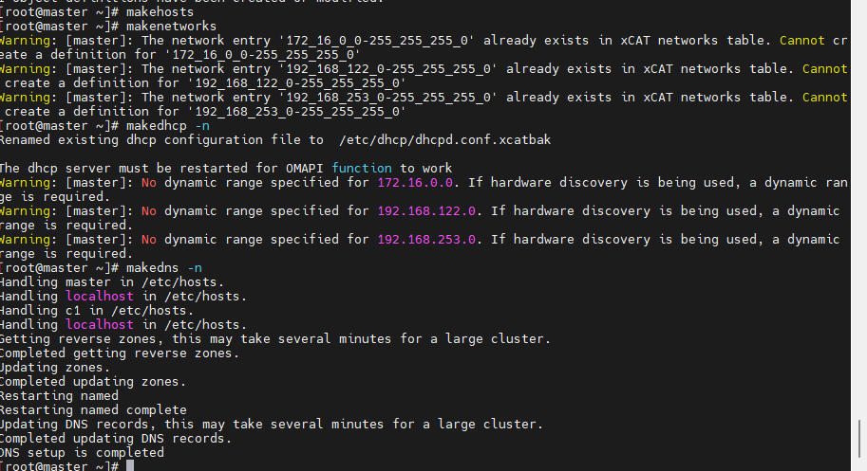

7:Associate desired provisioning image for computes

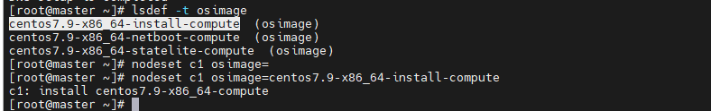

8:Boot compute nodes

