# Design 1

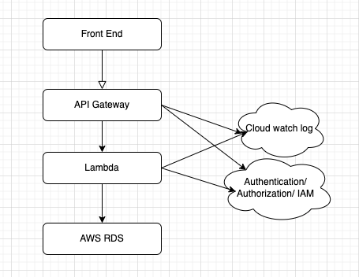

The architecture will consist of four main components: the database, API layer, authentication/authorization module, and separate interfaces for each team.

* Database: This will include three tables, item, member, and member transaction, as described in the schema provided. The database will be responsible for storing and managing the data.
* API layer: This layer will sit between the database and the team interfaces. It will expose the necessary endpoints for each team to access the data they need. The API layer will also be responsible for enforcing data validation and access control rules.
* Authentication/Authorization module: This module will be responsible for authenticating each user and ensuring that they have the necessary permissions to access the data. It will use role-based access control (RBAC) to assign roles to each user and determine their level of access.
* Team interfaces: There will be separate interfaces for each team - Logistics, Analytics, and Sales. Each interface will be tailored to the specific needs of the team and will allow them to access the data they need. The interfaces will be designed to be user-friendly and intuitive, allowing each team to interact with the data in a way that makes sense to them.

# Design 2

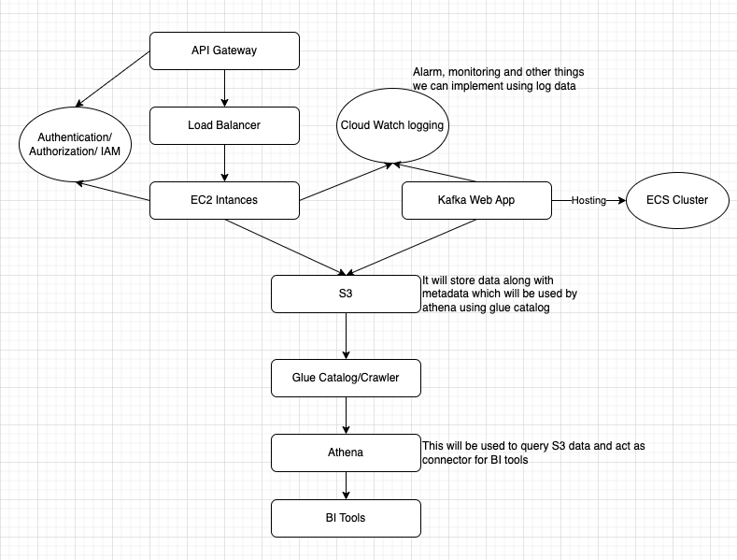

* AWS is the chosen cloud provider.
* The web application and Kafka stream are already built and deployed.
* The processing code is already written and can be containerized for deployment in AWS.
* AWS S3 is used to store the images and its metadata.
* AWS Glue is used to extract, transform and load data from S3 bucket to AWS Athena for business intelligence queries.
* AWS Athena is used to perform analytical computations on data stored in S3.
* AWS Elastic Load Balancer (ELB) is used to manage the incoming traffic and distribute it across EC2 instances.
* EC2 instances are used to host the processing code.
* AWS IAM is used for authorization.
* AWS CloudWatch is used for logging.