Valentine's Day Website Template
A customizable, interactive Valentine's Day website template built with React and Vite. Perfect for expressing your love with a personalized touch!

🎁 Features
- Personalized Names: Customize sender and receiver names
- Interactive Gifts: Three clickable gifts with animations
- Music Player: Play your favorite love songs with full media controls
- Photo Gallery: Showcase your special moments with captions
- Love Letter: Animated envelope with a heartfelt message
- Responsive Design: Works beautifully on all devices
- Easy Customization: Simple JSON configuration

🚀 Quick Start

1. Download & Setup
# Download the template files

# Extract to your desired location

2. Customize Your Content
Edit config.json to personalize your website. Use config.template.json as a reference for all available options:

{

"names": {Keerthana

"sender": "Nithin",

"receiver": "My cuttestest Angry bird👀🎀"

},

"content": {

"title": "Will you be my Valentine?",

"yesButtonText": "YES ❤️",

"noButtonText": "NO 💔"

}

}

Note:

- config.json - Your personalized configuration (edit this file)
- config.template.json - Complete template with all options (reference only)

3. Add Your Media
- Photos: Place in src/assets/couple_photo/ and update config.json
- Songs: Place audio files in src/assets/ and update config.json
- Gifts: Replace gift images in src/assets/gift/

4. Test Locally (Optional)
npm install

npm run dev

Visit http://localhost:5173 to see your changes.

5. Deploy for Free
Choose your preferred platform:

- Netlify (Recommended)
- Vercel
- GitHub Pages

📁 File Structure
valentine-website/

├── config.json # Main configuration file

├── config.template.json # Template reference

├── src/

│ ├── App.jsx # Main application

│ ├── config.js # Configuration loader

│ ├── assets/

│ │ ├── couple_photo/ # Your photos

│ │ ├── gift/ # Gift images

│ │ └── *.mp3 # Audio files

│ └── components/

├── public/

├── package.json

└── README.md

⚙️ Configuration Guide

Basic Settings
{

"names": {

"sender": "Your Name",

"receiver": "Your Partner's Name"

},

"theme": {

"primaryColor": "#ff7ab2",

"secondaryColor": "#ff4d8d",

"fontFamily": "Arial, sans-serif"

}

}

Adding Photos
{

"couplePhotos": [

{
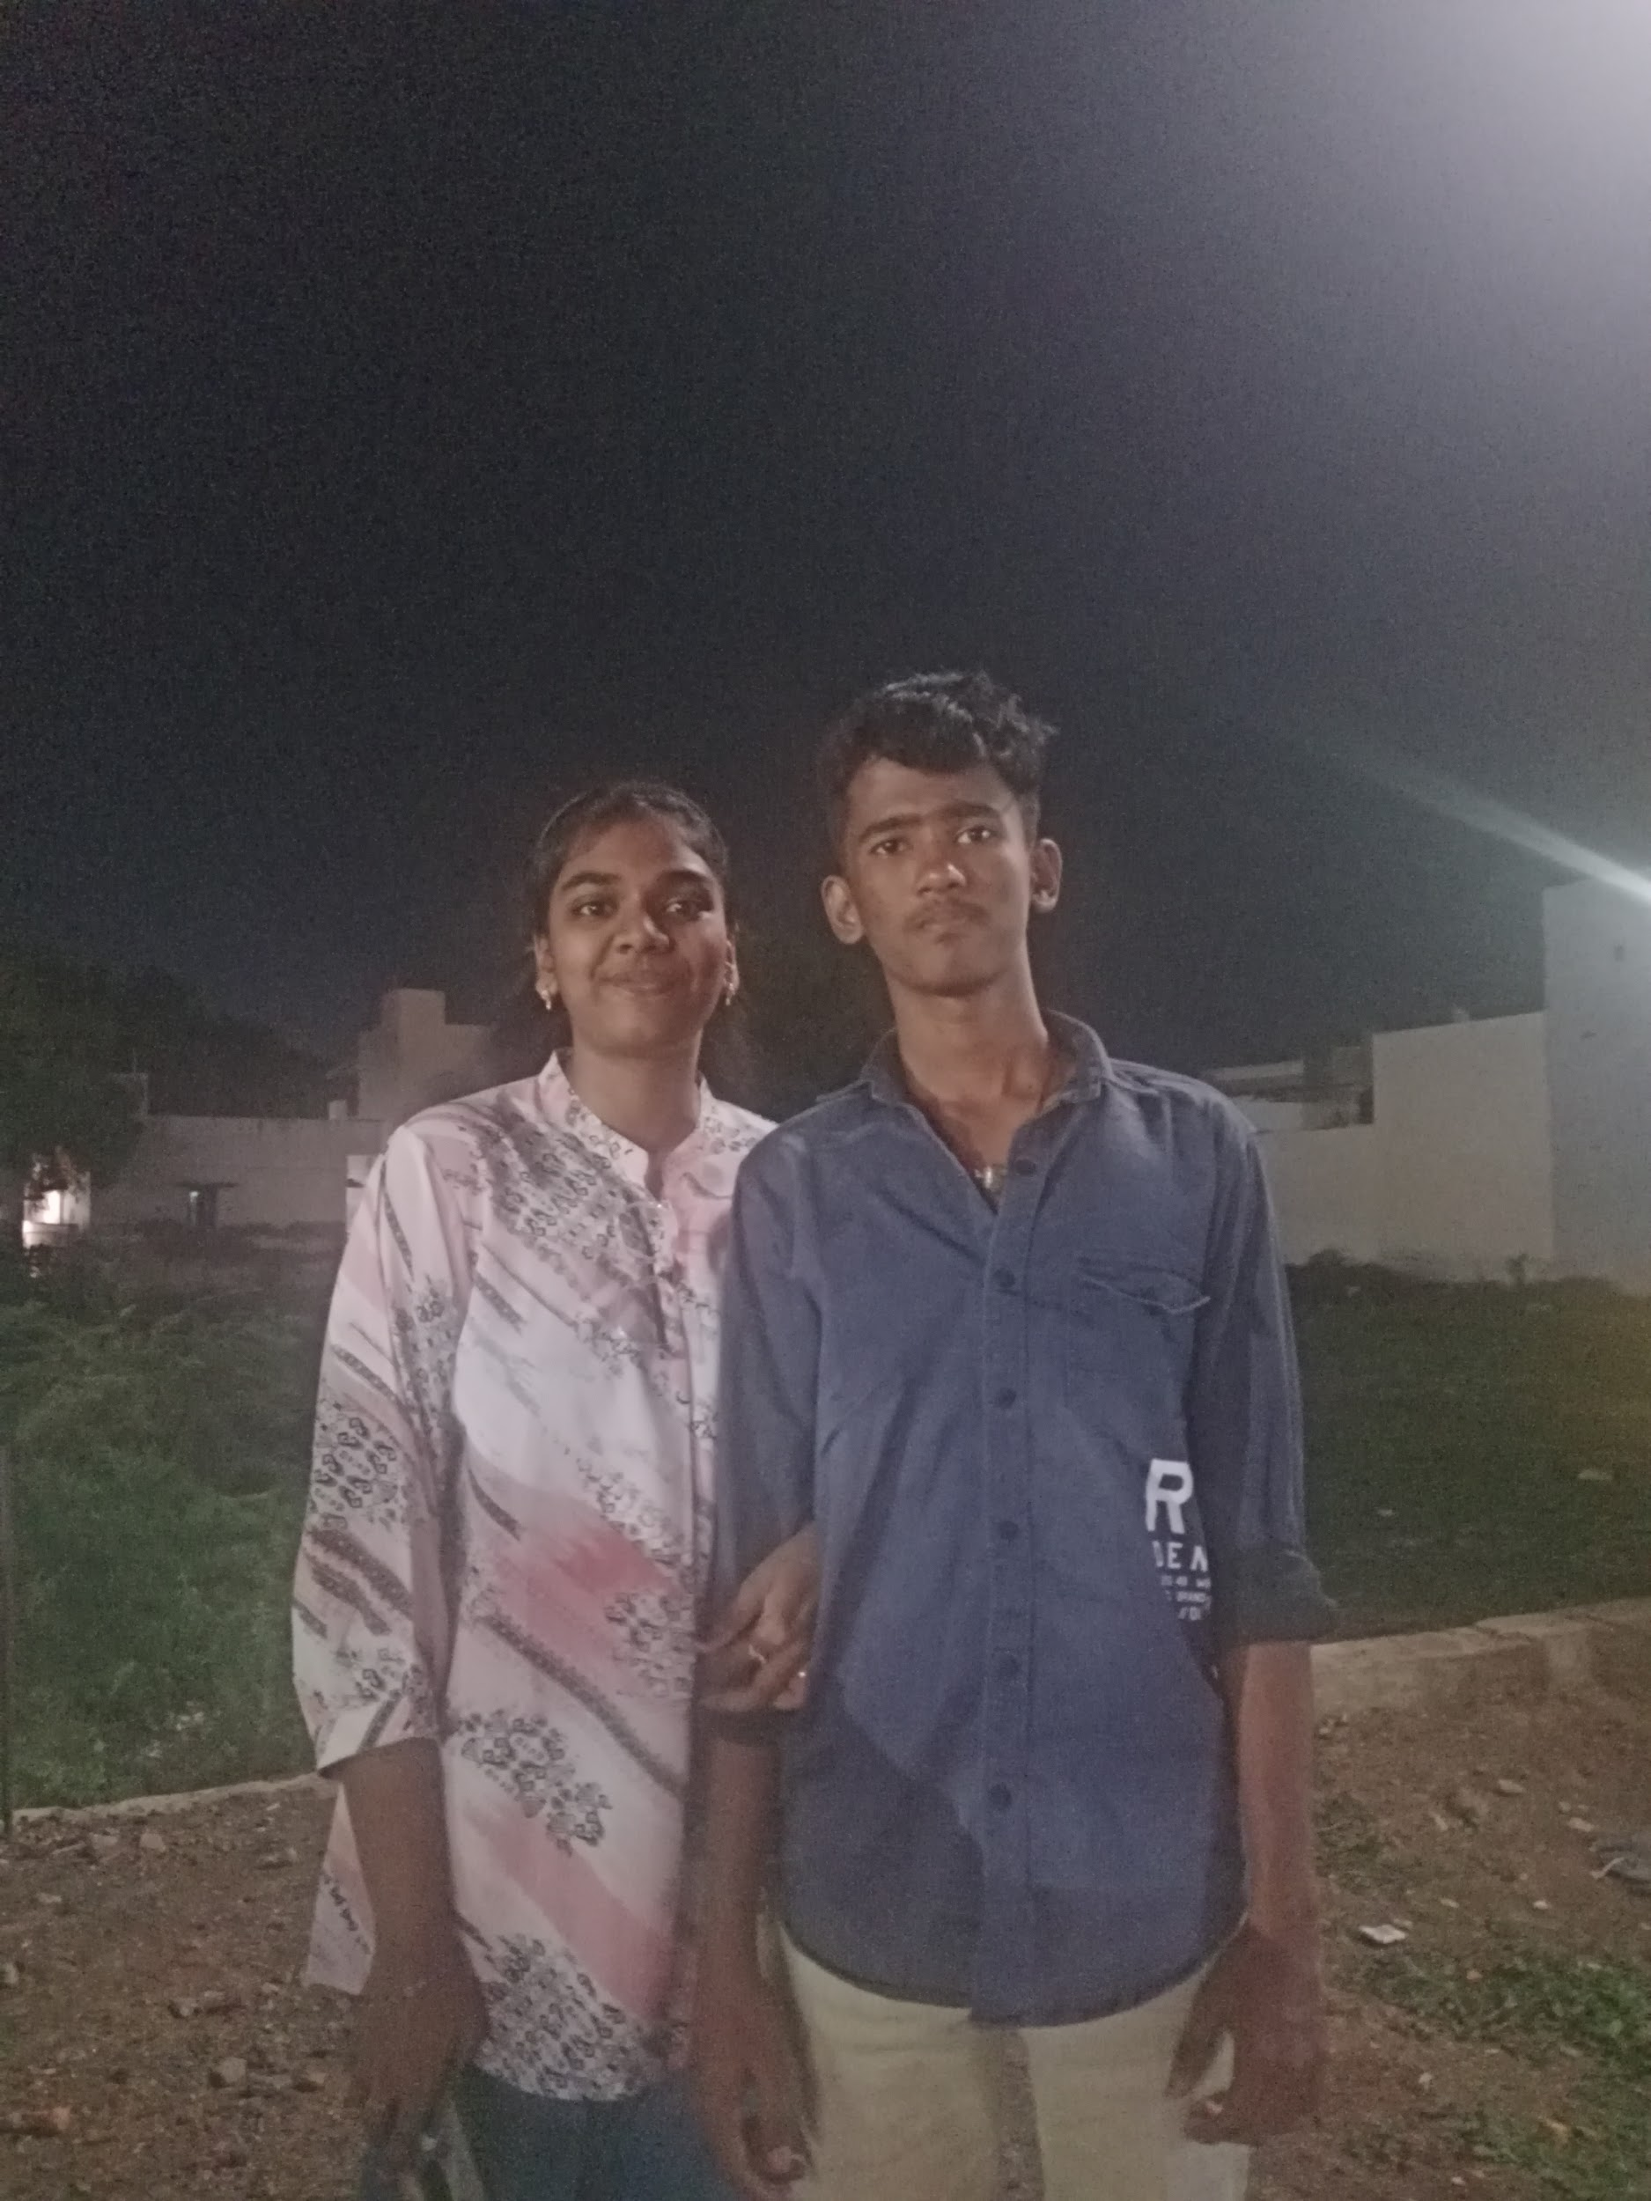
"image": "/src/assets/couple_photo/photo1.jpg",

"caption": "Our first date"

}

]

}

Adding Songs
{

"songs": [

{

"id": 1,

"title": "Your Song",

"duration": "3:45",

"album": "Album Name",

"artist": "Artist",

"cover": "/src/assets/cover.jpg",

"audio": "/src/assets/song.mp3"

}

]

}

Customizing Content
{

"content": {

"title": "Your custom title",

"successMessage": "Your custom success message",

"giftsTitle": "Your gifts title"

},

"letter": {

"title": "My Dearest [Name],",

"content": ["Your message here..."],

"signature": "Love,\n[Your Name]"

}

}

🌐 Deployment

Netlify (Easiest)
- Go to netlify.com
- Drag your project folder to the dashboard
- Wait for deployment
- Share your custom URL!

Vercel
- Go to vercel.com
- Drag your project folder
- Deploy and share!

GitHub Pages
- Create a GitHub repository
- Push your files
- Enable GitHub Pages in settings
- Visit https://yourusername.github.io/your-repo/

🎨 Customization Tips
- File Paths: Always use forward slashes (/) in paths
- File Names: Avoid spaces and special characters
- Image Sizes: Compress large images for faster loading
- Audio Files: Keep under 5MB for better performance
- Testing: Test all features before deployment

🔧 Troubleshooting

Common Issues
- Images not showing: Check file paths and extensions
- Audio not playing: Verify MP3 format and file paths
- Build errors: Ensure valid JSON syntax in config.json
- Site not loading: Check all file paths are correct

Getting Help
- Check the Valentine_Template_Guide.pdf
- Verify JSON syntax with an online validator
- Test with minimal changes first
- Ask a tech-savvy friend for help

📋 Checklist Before Deployment
- All names and text customized
- Photos added and paths updated
- Songs added and paths updated
- All buttons tested
- Mobile responsiveness checked
- Spelling and grammar verified
- File paths double-checked

💡 Pro Tips
- Backup First: Keep a copy of the original template
- Test Gradually: Make small changes and test frequently
- File Organization: Use descriptive file names
- Performance: Compress images and audio files
- Privacy: Be mindful of what you share publicly

🎯 What's Included
- ✅ Interactive Valentine's Day website
- ✅ Three customizable gifts
- ✅ Music player with playlist
- ✅ Photo gallery with captions
- ✅ Animated love letter
- ✅ Responsive design
- ✅ Easy configuration system
- ✅ Free deployment options
- ✅ Comprehensive guide

💌 Support
This template is designed for users with minimal technical experience. If you encounter issues:

- Refer to the Valentine_Template_Guide.pdf
- Check your config.json syntax
- Test with the original template first
- Make gradual changes

📄 License
This template is free to use for personal Valentine's Day projects. Please don't use it for commercial purposes.

Happy Valentine's Day! ❤️

May your website be as special as your love story!

